Git Branch and merge

- created new branch – design (git branch design)
- Switch to the new branch using the command (git checkout design).
- added new content to design
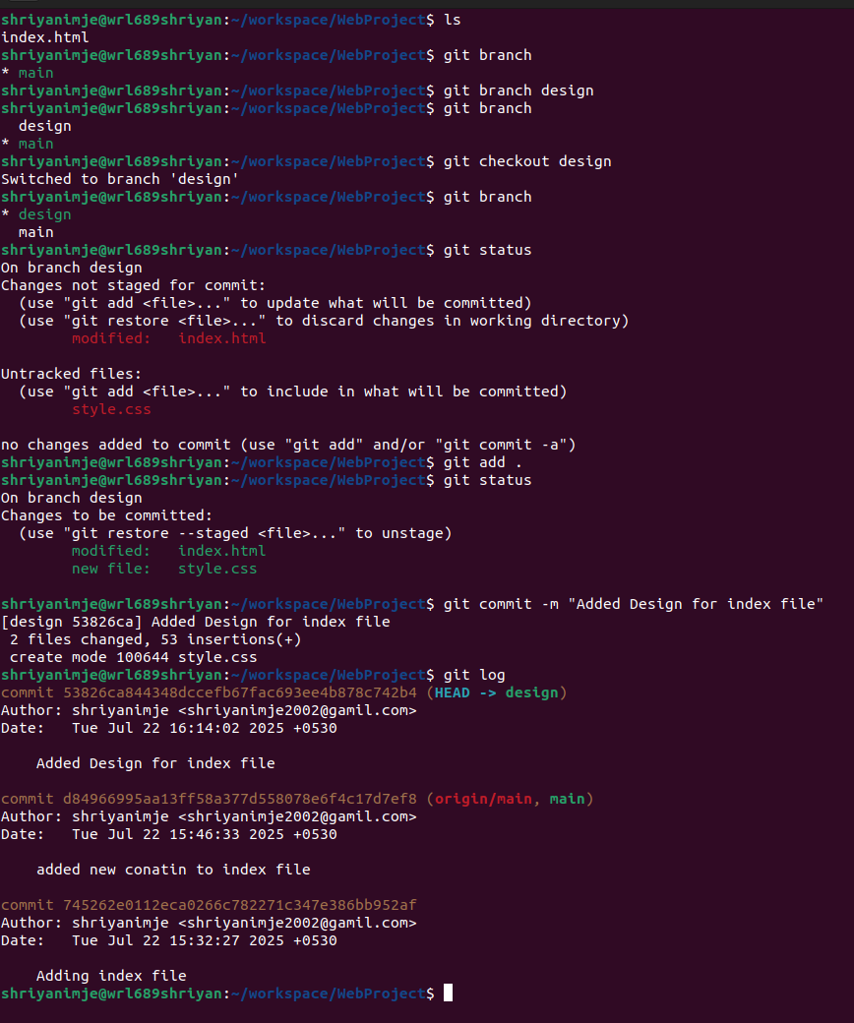
- Currently we are in design branch.
- using git log to see the commit.
- switching back to the main branch to check whether whatever changes we have made in the design branch are reflected in the main branch or not.

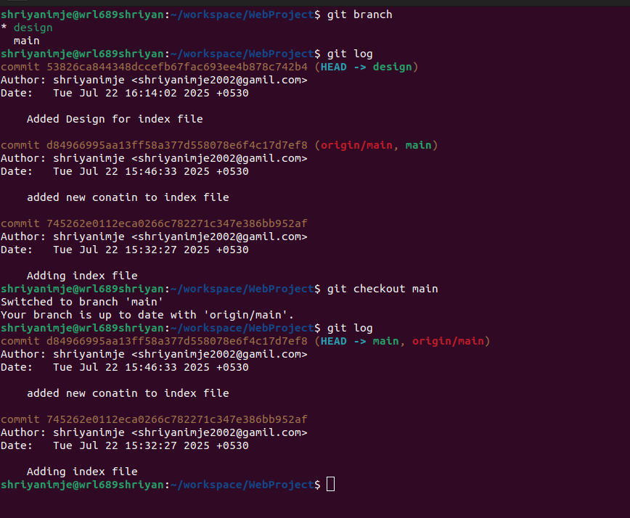
- merging changes to main branch

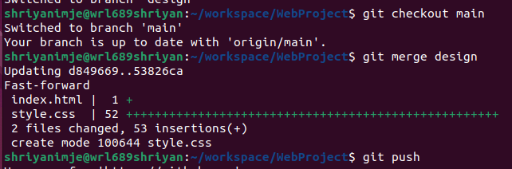

Rebase
- alternative to merging
- clean up tool (clean up commit)
In Git, rebase is a command used to move or combine a sequence of commits to a new base commit
It reapplies commits from your current branch on top of another base branch.
git rebase main: Rebase your current branch onto main.
- git rebase --continue: Continue rebase after resolving conflicts.
- git rebase --abort: Cancel the rebase and restore the original state.
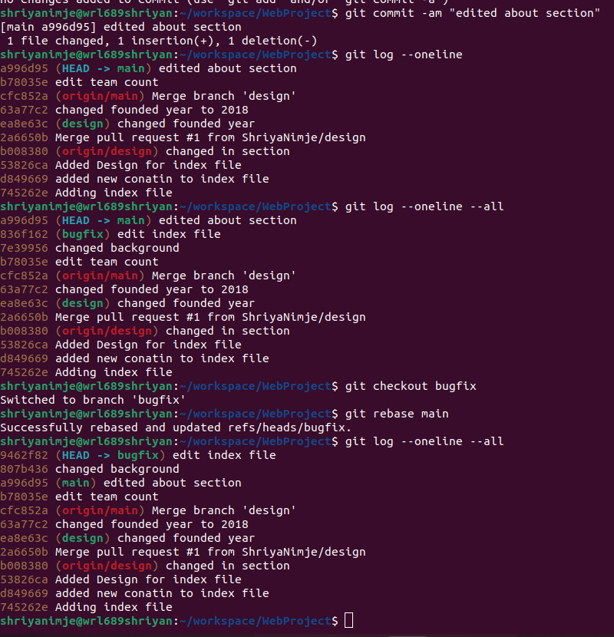

Conflict
A Git conflict occurs when Git can't automatically combine changes from two branches because the same part of a file was modified in both.

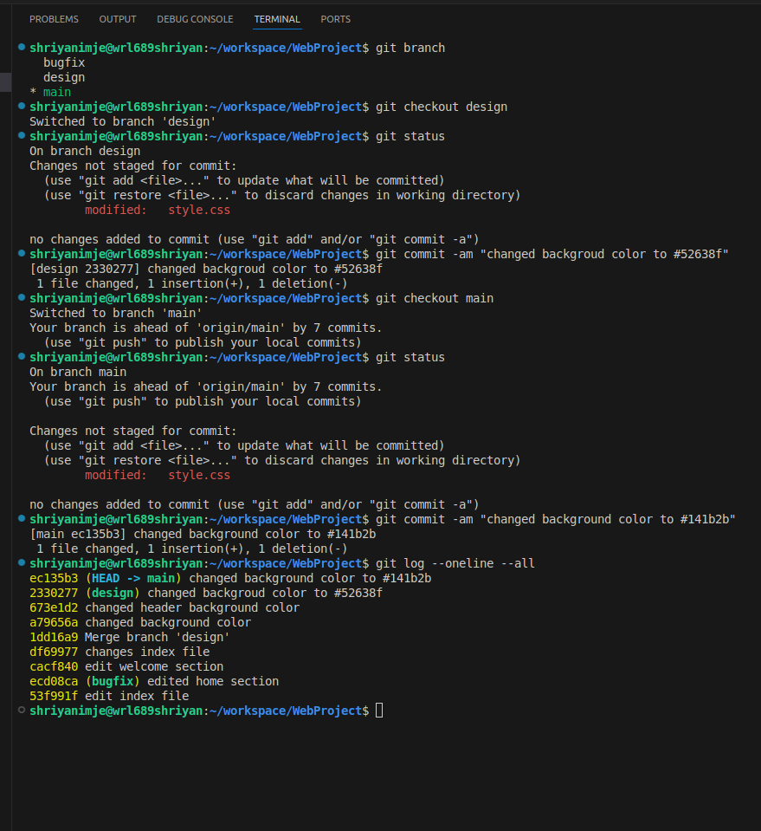
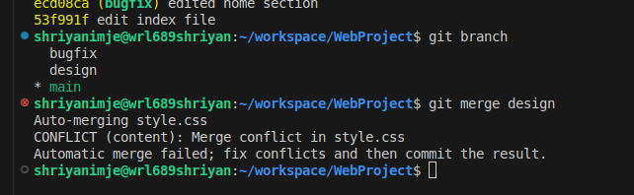
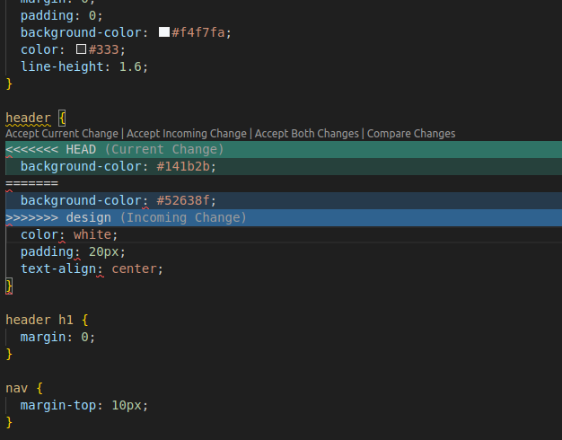
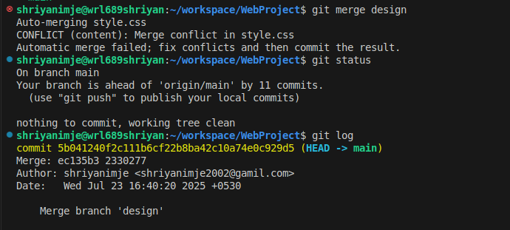
fast – forward
A fast-forward in Git is a type of merge where no new commit is created — instead, Git just moves the branch pointer forward.
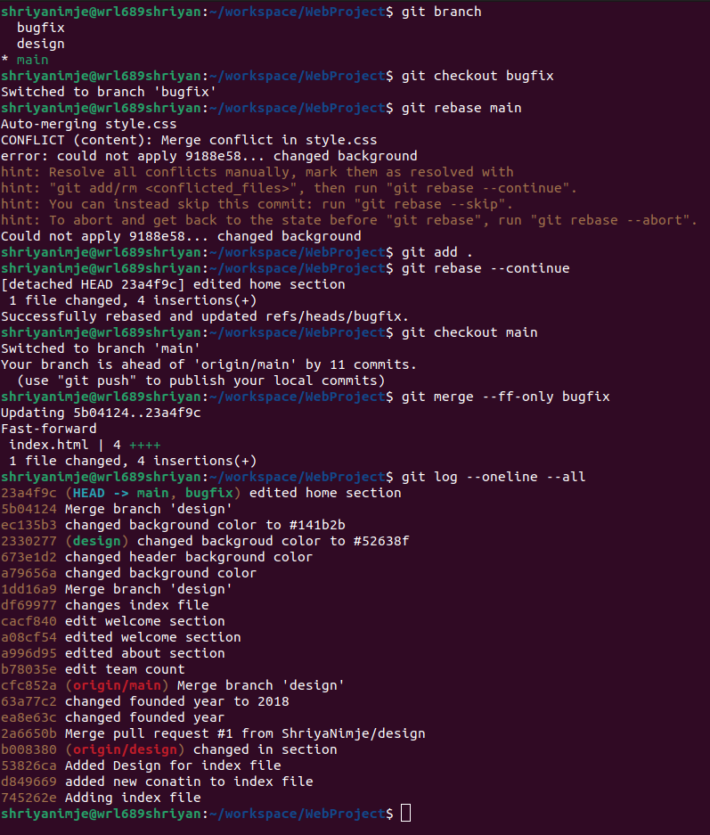

Cherry -pick
used when only one specific commit from another branch you want to add to our branch — not all of them.
