Game Design Document

Fill up the following document

1. Write the title of your project.

Photosynthesis

1. What is the goal of the game?

To become an adult tree

1. Write a brief story of your game.

You start off the game as a seed. You have to slowly develop by performing photosynthesis by getting the necessary elements(sunlight, water,etc). However there will also be humans moving around which you need to avoid. If you get stepped on by a human you go back a stage and if you get stepped on when you are a seed, you lose. If you can finish the last stage and become a big tree, you win the game.

1. Which are the playing characters of this game?

* Playing characters are the ones who respond to the user based on the input from the user.
* Cars, monkeys, dinos, wizards, etc., are the playing characters in the game.

|  |  |  |
| --- | --- | --- |
| Number | Character Name | What can this character do? |
| 1 | seed | It can move in different directions using arrow keys and can develop as a plant after meeting the necessary requirements |

1. Which are the Non-Playing Characters of this game?

* Non-Playing characters are the ones that don't have an action or behavior when the user interacts with the game.
* Hurdles, stones, bananas, coins, etc., are non-playing characters in the game.

|  |  |  |
| --- | --- | --- |
| Number | Character Name | What can this character do? |
| 1 | Humans | They move around randomly and if they touch the seed, the seed will move down a stage and eventually die. |
| 2 | Sun,Water,Carbon dioxide,Fertilizer | They also move around randomly and if caugh by the seed help it develop to the next stage |

Draw your imagination of this game. What does this game look like?

* Draw the game either on your computer or on paper.
* Add images of the game scenes to show each of the playing and non-playing characters at least once.

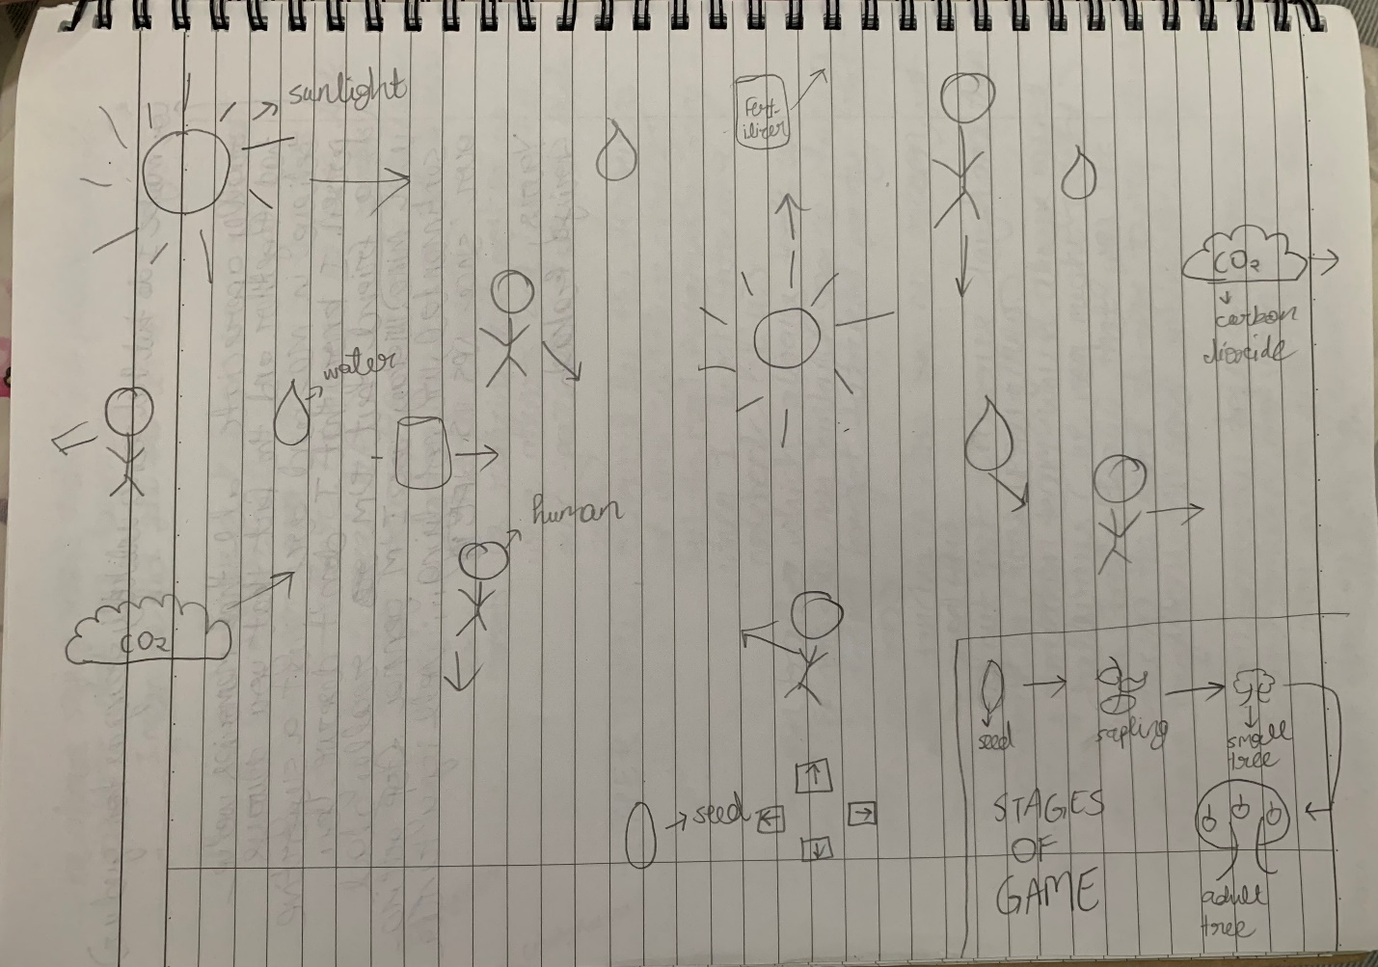

How do you plan to make your game engaging?

I will include feedback for the player such a sounds when they collect sunlight or get stepped on by the humans. I will also increase the dificulty of the game with each stage by increasing the number of things the player has to collect in order to develop. This way the player will stay engaged with the game.