USER MANUAL AND ACRONYMS

User Manual
This system enables users to detect Autism Spectrum Disorder (ASD) from preprocessed resting-state fMRI data. It classifies patients and visualizes important brain regions in both static and dynamic 3D formats.
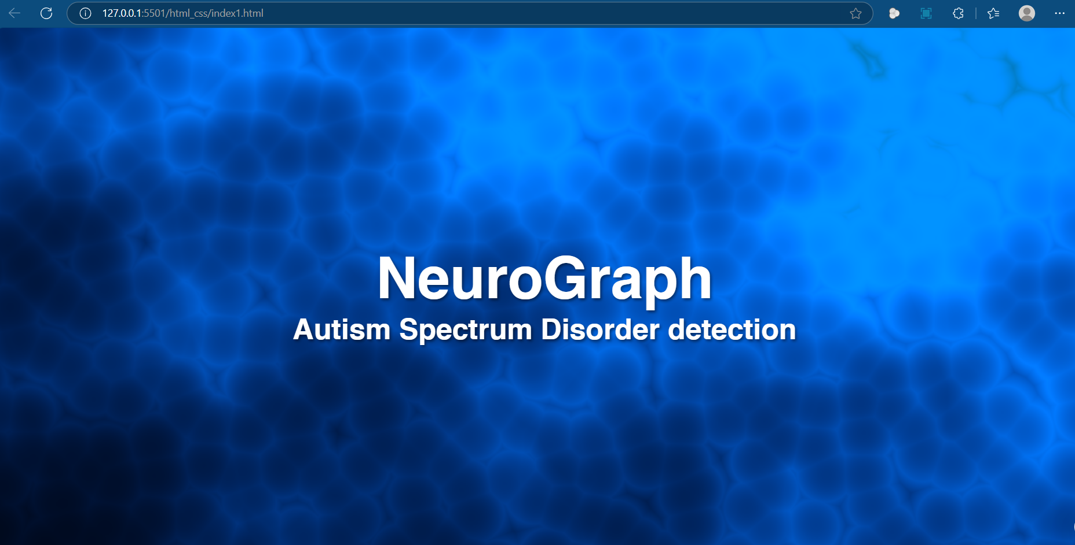
Fig 1: Landing Page of ASD Detection software

Steps to Use the System:
- Enter File ID:
  - The user begins by entering a valid File_ID corresponding to a patient's preprocessed fMRI dataset.
  - The system verifies and loads the associated data.
- Upload and Model Processing:
- Upon entering the File ID, the system automatically uploads the linked data and processes it through a trained classification model.
- The model outputs a prediction: either ASD (Autism Spectrum Disorder) or TC (Typically Developed Control).

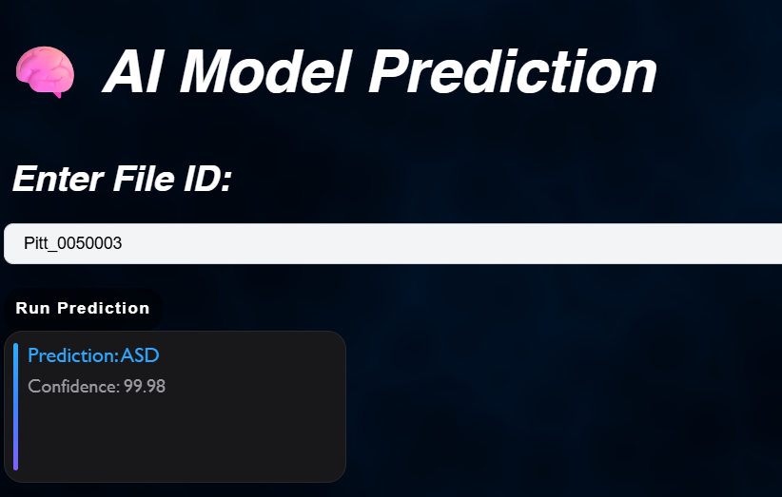
Fig 2: AI Model Prediction

- 3D Brain Visualization:
    - After classification, the system provides two types of visualizations:
    - Static Visualization:
      - Displays important Regions of Interest (ROIs) identified as contributing to the diagnosis.
      - The user can interact with the brain model by clicking or hovering over regions to see names or importance scores.
    - Dynamic Visualization:
      - Animates how activity within the selected important ROIs changes over the time series.
      - Offers insights into temporal brain dynamics associated with ASD or typical patterns.
- Interpreting the Results:
    - The system visually emphasizes brain areas relevant to the decision.
    - Users can explore how specific ROIs behave differently in ASD compared to TC cases.
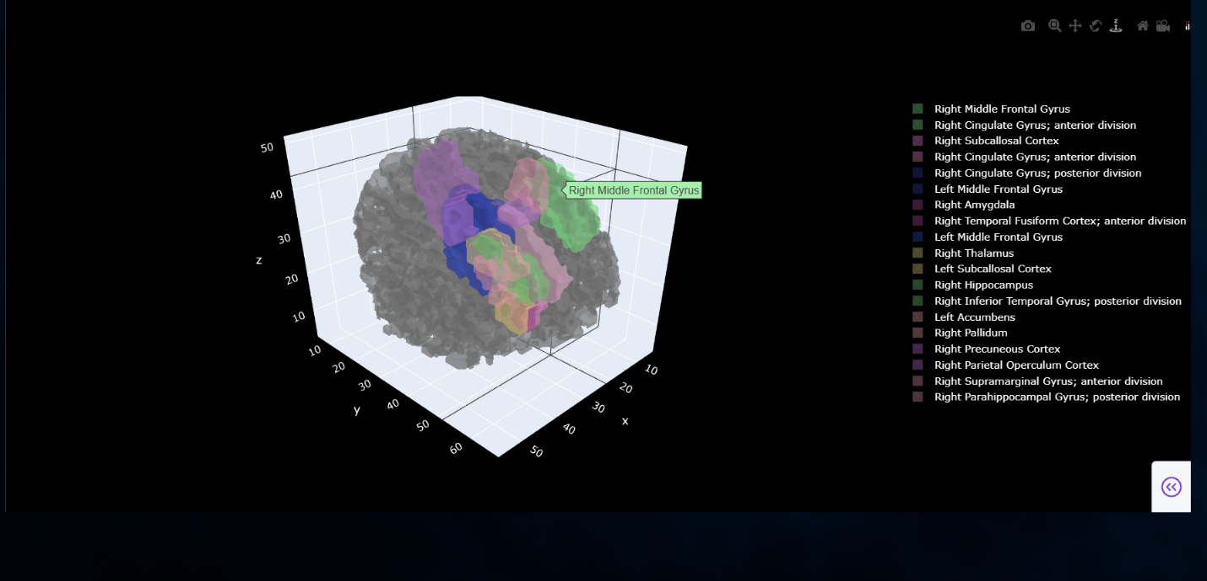
Fig 3: Visualization of Important ROI’s for ASD Detection

- System Requirements:
  - Ensure the input file corresponds to valid preprocessed fMRI data.
  - A stable internet connection and modern browser are recommended for 3D interactions.

Acronyms
Acronym | Full Form
ASD | Autism Spectrum Disorder
TC | Typical Controls
fMRI | Functional Magnetic Resonance Imaging
Rs-fMRI | Resting State - fMRI
ROI | Region of Interest
GCN | Graph Convolutional Network
MLP | Multi-Layer Perceptron
GUI | Graphical User Interface
AUROC | Area Under the Receiver Operating Characteristic Curve
BOLD | Blood Oxygen Level Dependent (signal)
MRI | Magnetic Resonance Imaging
ReLU | Rectified Linear Unit (activation function)
DTI | Diffusion Tensor Imaging
HO | Harvard-Oxford Atlas
ABIDE | Autism Brain Imaging Data Exchange
PC | Pearson Correlation

