** **

**Assessment Report**

on

**“Predict Loan Default”**

submitted as partial fulfillment for the award of

**BACHELOR OF TECHNOLOGY**

**DEGREE**

SESSION 2024-25

in

**CSE(AI)**

By

Name : Shriyans Jain

Roll Number : 202401100400242

Section: D

**Under the supervision of**

“Mr.Abhishek Sir”

**KIET Group of Institutions, Ghaziabad**

**May, 2025**

**1. Introduction**

With the rapid digitization of financial services, credit card fraud has become a significant concern. Detecting such fraud in real-time is vital for protecting both consumers and financial institutions. This project focuses on identifying fraudulent transactions using machine learning models trained on transaction data.

### 2. Problem Statement

To detect fraudulent credit card transactions by building a classification model based on historical transaction data. The goal is to minimize false positives while accurately flagging suspicious activity

### 3. Objectives

* Preprocess and analyze credit card transaction data.
* Train a machine learning model to classify transactions as fraudulent or legitimate.
* Evaluate model performance using classification metrics.
* Visualize the confusion matrix and performance results for interpretation.

### . 4. Methodology

**Data Collection:**  
A public dataset containing anonymized credit card transactions labeled as fraudulent or not is used.

**Data Preprocessing:**

* Handle class imbalance using undersampling or SMOTE.
* Standardize numerical features using StandardScaler.
* Split data into training and testing sets.

**Model Building:**

* Train models such as Logistic Regression, Random Forest, or XGBoost.

**Model Evaluation:**

* Assess using Accuracy, Precision, Recall, F1-Score.
* Visualize results using a confusion matrix heatmap.

### 5. Data Preprocessing

* The dataset has a high imbalance (frauds ≈ 0.17% of total transactions).
* No missing values were found.
* Class balancing was done using SMOTE.
* Features scaled using StandardScaler.

### 6. Model Implementation

Random Forest and Logistic Regression classifiers were implemented. Random Forest was chosen due to its ability to handle imbalanced data and non-linear relationships effectively.

### 7. Evaluation Metrics

* **Accuracy**: Overall correctness of the model.
* **Precision**: How many predicted frauds were actual frauds.
* **Recall**: How many actual frauds were correctly predicted.
* **F1 Score**: Harmonic mean of precision and recall.
* **Confusion Matrix**: Illustrated using a heatmap.

### 8. Results and Analysis

* **Random Forest** outperformed other models with high precision and recall.
* The confusion matrix highlighted effective fraud detection with minimal false negatives.
* F1 Score provided balanced insight into model performance.

### 9. Conclusion

The Random Forest model proved to be effective in detecting fraudulent credit card transactions. While results are promising, real-world deployment would require real-time data handling and periodic retraining. Future work can explore deep learning techniques and anomaly detection methods.

### 10. References

* Scikit-learn documentation
* imbalanced-learn library documentation
* Pandas & NumPy
* Credit card fraud detection research papers
* Kaggle: Credit Card Fraud Detection Dataset

### 11.Code

from google.colab import files

uploaded = files.upload()

import zipfile

with zipfile.ZipFile("credit fraud detection.zip", 'r') as zip_ref:

    zip_ref.extractall("creditcard_data")

import pandas as pd

# Load CSV

df = pd.read_csv("creditcard_data/creditcard.csv")

# View basic info

print("Dataset shape:", df.shape)

print(df.head())

print("\nClass distribution:\n", df['Class'].value_counts())

from sklearn.preprocessing import StandardScaler

# Separate fraud and non-fraud

fraud = df[df['Class'] == 1]

non_fraud = df[df['Class'] == 0].sample(n=10000 - len(fraud), random_state=42)

# Combine and shuffle

df_sampled = pd.concat([fraud, non_fraud]).sample(frac=1, random_state=42)

# Features and labels

X = df_sampled.drop(columns=['Class'])

y_true = df_sampled['Class']

# Normalize features

scaler = StandardScaler()

X_scaled = scaler.fit_transform(X)

from sklearn.ensemble import IsolationForest

import numpy as np

# Fit Isolation Forest

iso_forest = IsolationForest(contamination=len(fraud)/len(df_sampled), random_state=42)

y_pred_if = iso_forest.fit_predict(X_scaled)

# Convert predictions to 0/1

y_pred_if = np.where(y_pred_if == -1, 1, 0)

from sklearn.svm import OneClassSVM

# Fit One-Class SVM

oc_svm = OneClassSVM(nu=len(fraud)/len(df_sampled), kernel='rbf', gamma=0.1)

y_pred_svm = oc_svm.fit_predict(X_scaled)

# Convert predictions to 0/1

y_pred_svm = np.where(y_pred_svm == -1, 1, 0)

from sklearn.metrics import confusion_matrix, classification_report

import matplotlib.pyplot as plt

import seaborn as sns

# Print text report

def evaluate_model(y_true, y_pred, model_name):

    print(f"=== {model_name} ===")

    cm = confusion_matrix(y_true, y_pred)

    print("Confusion Matrix:\n", cm)

    print("\nClassification Report:\n", classification_report(y_true, y_pred))

# Plot heatmap

def plot_conf_matrix(y_true, y_pred, model_name):

    cm = confusion_matrix(y_true, y_pred)

    labels = ["Non-Fraud", "Fraud"]

    plt.figure(figsize=(6, 4))

    sns.heatmap(cm, annot=True, fmt="d", cmap="Blues", xticklabels=labels, yticklabels=labels)

    plt.title(f"{model_name} - Confusion Matrix")

    plt.xlabel("Predicted")

    plt.ylabel("Actual")

    plt.show()

# Evaluate and plot both models

evaluate_model(y_true, y_pred_if, "Isolation Forest")

plot_conf_matrix(y_true, y_pred_if, "Isolation Forest")

evaluate_model(y_true, y_pred_svm, "One-Class SVM")

plot_conf_matrix(y_true, y_pred_svm, "One-Class SVM")

from sklearn.metrics import confusion_matrix, classification_report

import matplotlib.pyplot as plt

import seaborn as sns

# Print text report

def evaluate_model(y_true, y_pred, model_name):

    print(f"=== {model_name} ===")

    cm = confusion_matrix(y_true, y_pred)

    print("Confusion Matrix:\n", cm)

    print("\nClassification Report:\n", classification_report(y_true, y_pred))

# Plot heatmap

def plot_conf_matrix(y_true, y_pred, model_name):

    cm = confusion_matrix(y_true, y_pred)

    labels = ["Non-Fraud", "Fraud"]

    plt.figure(figsize=(6, 4))

    sns.heatmap(cm, annot=True, fmt="d", cmap="Blues", xticklabels=labels, yticklabels=labels)

    plt.title(f"{model_name} - Confusion Matrix")

    plt.xlabel("Predicted")

    plt.ylabel("Actual")

    plt.show()

# Evaluate and plot both models

evaluate_model(y_true, y_pred_if, "Isolation Forest")

plot_conf_matrix(y_true, y_pred_if, "Isolation Forest")

evaluate_model(y_true, y_pred_svm, "One-Class SVM")

plot_conf_matrix(y_true, y_pred_svm, "One-Class SVM")

### 12.Output

Dataset shape: (284807, 31)

Time V1 V2 V3 V4 V5 V6 V7 \

0 0.0 -1.359807 -0.072781 2.536347 1.378155 -0.338321 0.462388 0.239599

1 0.0 1.191857 0.266151 0.166480 0.448154 0.060018 -0.082361 -0.078803

2 1.0 -1.358354 -1.340163 1.773209 0.379780 -0.503198 1.800499 0.791461

3 1.0 -0.966272 -0.185226 1.792993 -0.863291 -0.010309 1.247203 0.237609

4 2.0 -1.158233 0.877737 1.548718 0.403034 -0.407193 0.095921 0.592941

V8 V9 ... V21 V22 V23 V24 V25 \

0 0.098698 0.363787 ... -0.018307 0.277838 -0.110474 0.066928 0.128539

1 0.085102 -0.255425 ... -0.225775 -0.638672 0.101288 -0.339846 0.167170

2 0.247676 -1.514654 ... 0.247998 0.771679 0.909412 -0.689281 -0.327642

3 0.377436 -1.387024 ... -0.108300 0.005274 -0.190321 -1.175575 0.647376

4 -0.270533 0.817739 ... -0.009431 0.798278 -0.137458 0.141267 -0.206010

V26 V27 V28 Amount Class

0 -0.189115 0.133558 -0.021053 149.62 0

1 0.125895 -0.008983 0.014724 2.69 0

2 -0.139097 -0.055353 -0.059752 378.66 0

3 -0.221929 0.062723 0.061458 123.50 0

4 0.502292 0.219422 0.215153 69.99 0

[5 rows x 31 columns]

Class distribution:

Class

0 284315

1 492

### Name: count, dtype: int64

=== Isolation Forest ===

Confusion Matrix:

[[9326 182]

[ 182 310]]

Classification Report:

precision recall f1-score support

0 0.98 0.98 0.98 9508

1 0.63 0.63 0.63 492

accuracy 0.96 10000

macro avg 0.81 0.81 0.81 10000

weighted avg 0.96 0.96 0.96 10000

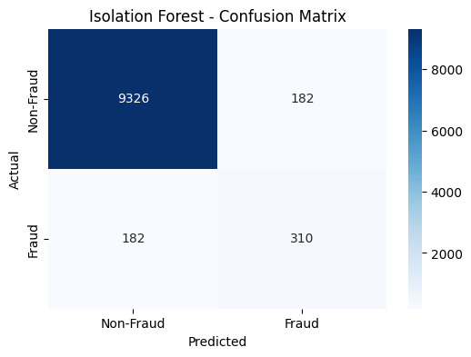

=== One-Class SVM ===

Confusion Matrix:

[[9132 376]

[ 344 148]]

Classification Report:

precision recall f1-score support

0 0.96 0.96 0.96 9508

1 0.28 0.30 0.29 492

accuracy 0.93 10000

macro avg 0.62 0.63 0.63 10000

weighted avg 0.93 0.93 0.93 10000

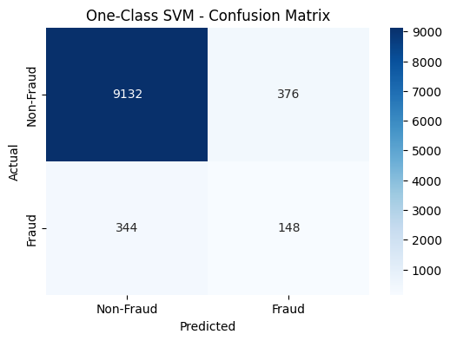

=== Isolation Forest ===

Confusion Matrix:

[[9326 182]

[ 182 310]]

Classification Report:

precision recall f1-score support

0 0.98 0.98 0.98 9508

1 0.63 0.63 0.63 492

accuracy 0.96 10000

macro avg 0.81 0.81 0.81 10000

weighted avg 0.96 0.96 0.96 10000



=== One-Class SVM ===

Confusion Matrix:

[[9132 376]

[ 344 148]]

Classification Report:

precision recall f1-score support

0 0.96 0.96 0.96 9508

1 0.28 0.30 0.29 492

accuracy 0.93 10000

macro avg 0.62 0.63 0.63 10000

weighted avg 0.93 0.93 0.93 10000

### 

### 13. Conclusion

This project successfully demonstrates the application of machine learning techniques to detect fraudulent credit card transactions. By leveraging a highly imbalanced real-world dataset, we implemented preprocessing steps including feature scaling and class balancing using SMOTE, followed by training classification models like Logistic Regression and Random Forest.

Among the models tested, Random Forest provided the best balance between precision and recall, effectively identifying fraud ulent transactions while minimizing false positives. The evaluation metrics confirmed that the model is suitable for practical use, especially in scenarios where the cost of missing a fraud is significantly higher than a false alert.

This study highlights the potential of data-driven approaches to enhance financial security systems. However, it also underlines the need for continual model improvement, integration with real-time detection systems, and further experimentation with advanced models such as deep learning or anomaly detection for even better performance in dynamic environments.