

**Assesment Report**

on

**“Problem Statement”**

submitted as partial fulfillment for the award of

**BACHELOR OF TECHNOLOGY**

**DEGREE**

SESSION 2024-25

in

**Introduction to AI**

By

Shriyans Jain (202401100300242)

**Under the supervision of**

Mr. Abhishek Shukla

**KIET Group of Institutions, Ghaziabad**

Affiliated to

**Dr. A.P.J. Abdul Kalam Technical University, Lucknow**

(Formerly UPTU)

**May, 2025**

**Introduction**

This project aims to create a diabetes prediction model using a Random Forest Classifier in Python. The model uses a dataset with features like Pregnancies, Glucose, Blood Pressure, etc., to predict whether a person is diabetic or not. The interface includes interactive widgets for input and visualization tools like correlation heatmaps and feature importance plots to aid understanding. Additionally, the project seeks to provide an accessible and educational tool for analyzing health data, promoting awareness of diabetes risk factors through an intuitive user experience.

**Methodology**

The method is pretty simple! First, we load a CSV file with the data into Python. Then, we split it into two parts: the features (like medical numbers) and the target (whether someone’s diabetic). We use a Random Forest Classifier to train the model and teach it to make predictions. Next, we add cool interactive sliders with ipywidgets so anyone can type in their own health info, and the model spits out a prediction with a confidence score. To make it fun and easy to follow, we use seaborn and matplotlib to draw pictures like heatmaps (showing how data connects) and bar charts (showing which factors matter most).

CODE

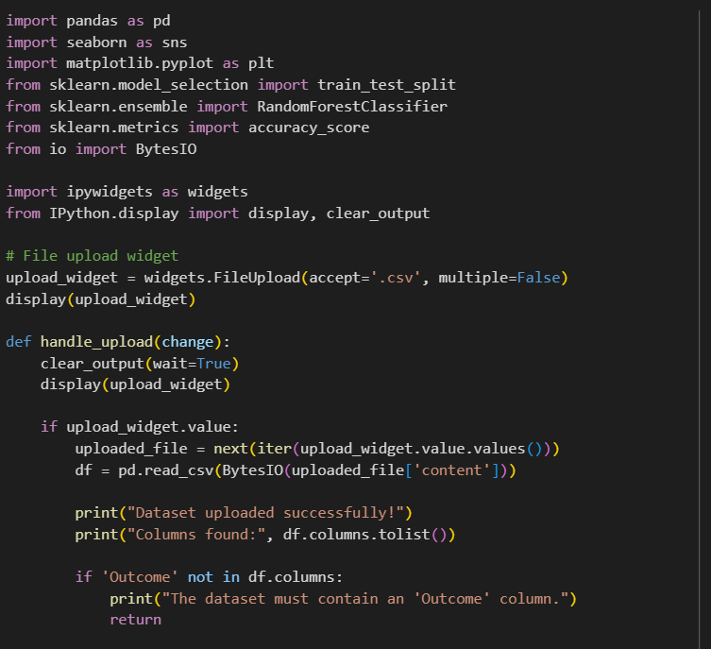

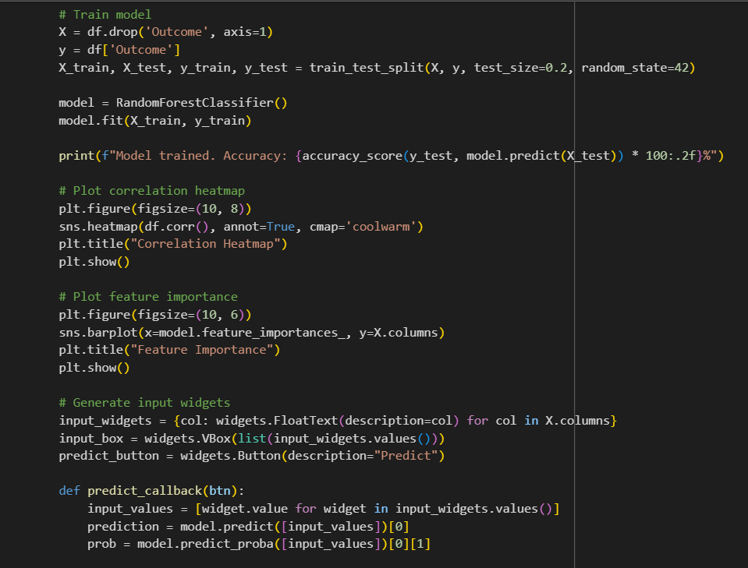

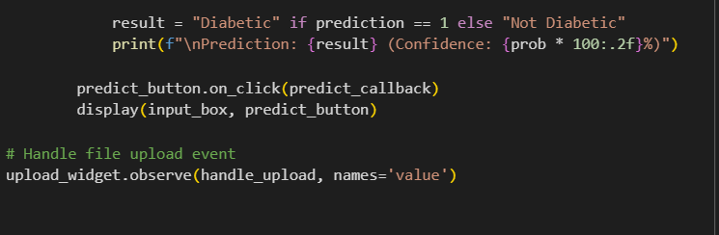

**Output/Result**

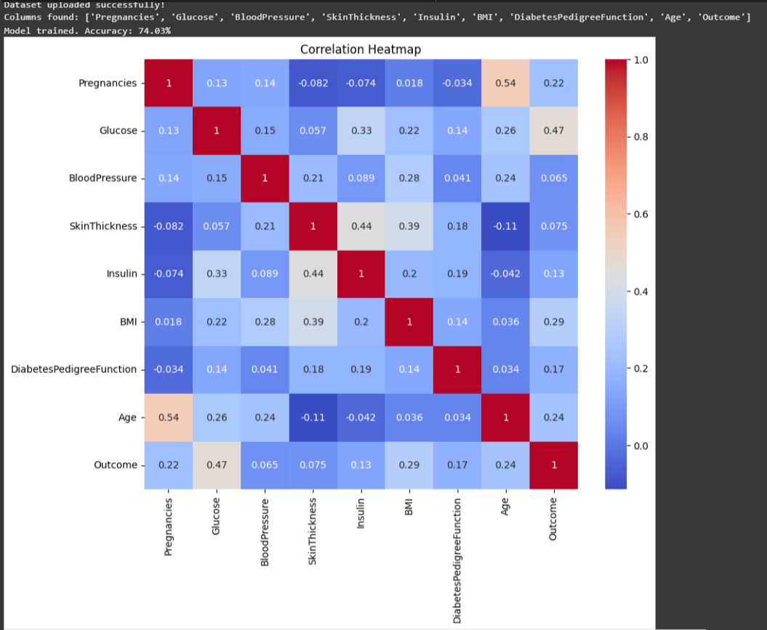

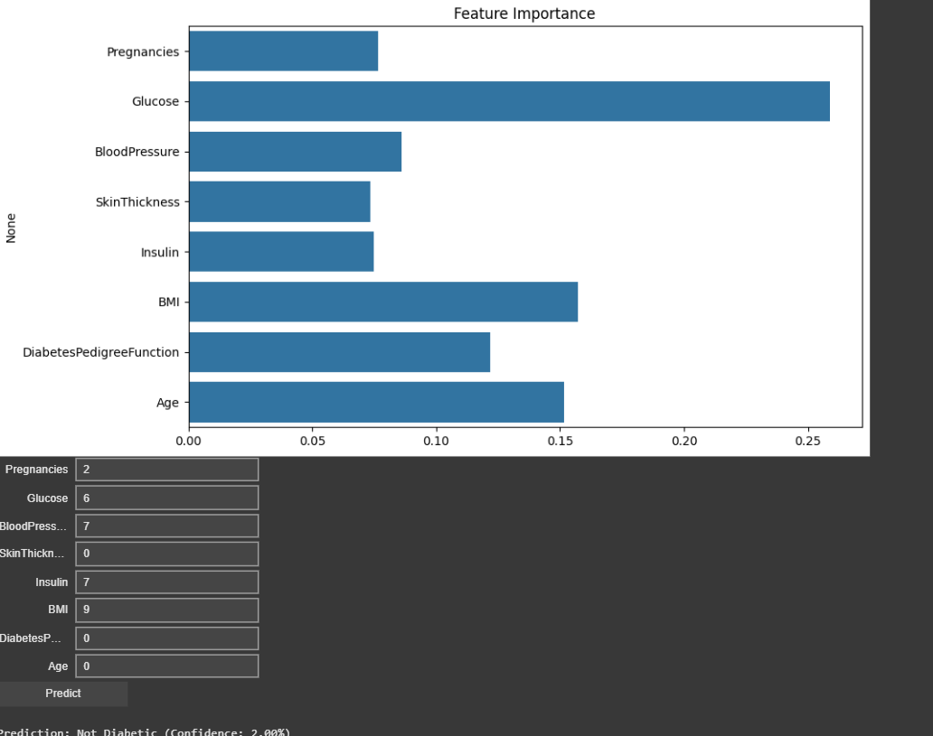

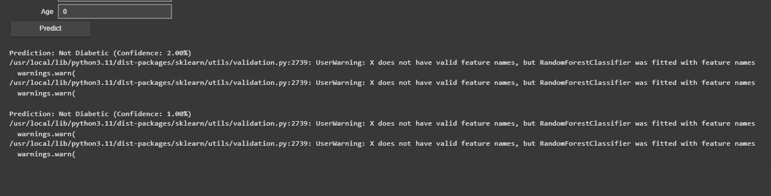

**References/Credits**

Geeksforgeeks

[Diabetes Prediction Machine Learning Project Using Python Streamlit | GeeksforGeeks](https://www.geeksforgeeks.org/diabetes-prediction-machine-learning-project-using-python-streamlit/)