 Logo

**About US**

* An organization built exclusively for enriching and promoting better quality of life for everyone in the world
* A one-stop destination for all your travel management needs. Our sheer love & commitment towards it and the dedication with which we serve distinguishes us from the rest
* If you are an individual traveller for work/leisure/sports, team or an organization – our tight-knit team of providers & exceptional creators are hot to trot in partnering with you
* Enthusiastic group of experienced professionals from the travel, education, luxury, business and marketing industry
* A one-stop travel and tours management company
* Catering to multiple needs of an out-of-country traveller from India
* Wide range of tourism services Ever-growing roster of clients in India
  + Individual people/families
  + corporate clients including well-known educational institutions like Gundecha group of schools/colleges, etc.

**Who we are?**

1. Hardworking and a committed person. Number of leadership roles he has taken so far. Played 14,16 ,19 school national in cricket & Under-22 BCCI trophy 2011 & part of Russian National cricket Team 2018 (continental cup Romania). Currently working as a Director with Cricket Russia (Associate Member of ICC) & founder of Sambhav events & Sports,100 sportz, CricFine Academy. Strong interest in Youth & Grassroots Development in Sports. Organized high performance cricket training program with BCCI level 3 & ECB coaches. He has managed International Cricket tours for youth cricket players (UK, Europe, U.A.E, Sri Lanka, Thailand).
2. Travel and tours company located in the business heartland of India - Mumbai. Serve all segments of tourism as a marketing consultant and execution partner and an expert team with a unique self graphed strategy at a prominent cost that makes us stand tall from all other marketing companies as a host
3. Fulfilling what would be every marketing professional's ultimate dream - to create a team and hopefully an institution of Brand/Marketing Engagement. Applying the sales, marketing and advertising skills learned during almost the two decades plus of advertising & marketing services experience in India & Malaysia.

Specialties: Marketing, Branding, Business Management, Strategic Planning, Operations, Business Development/Sales, Mass Media Communication/Advertising, PR/Corporate Communication, Direct Marketing, Brand Engagement through Digital/Online marketing, Events, Promotions, CRM & Analytics, Retail & Trade/Channel Marketing, Financial Management, etc.

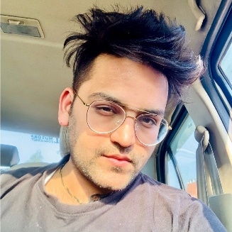  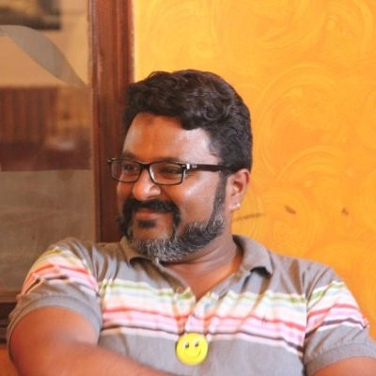

Sambhav Jain – Founder Vedica Dwivedi – CEO S. M. Nishad – CMO

Saunak – Head Operatons

[Study Abroad](https://gstempire.com/visa/study-abroad) : Make this page same as ref website copy contents as well (https://www.visa-consultant.com/study-abroad.php)

[Visa Services](https://gstempire.com/visa/visa-services) : Make this page same as ref website copy contents as well (https://www.visa-consultant.com/visa-services.php)

[Value Added Services](https://gstempire.com/visa/our-services):

**What do we provide**

* Education Tourism
* Sports Tourism
* International events
* Work Travel
* Leisure Travel
* Temporary Residency
* Permanent Residency
* Citizenship, etc. etc.

**Why Choose US**

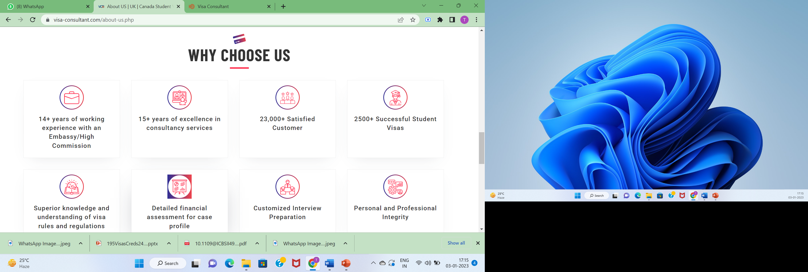

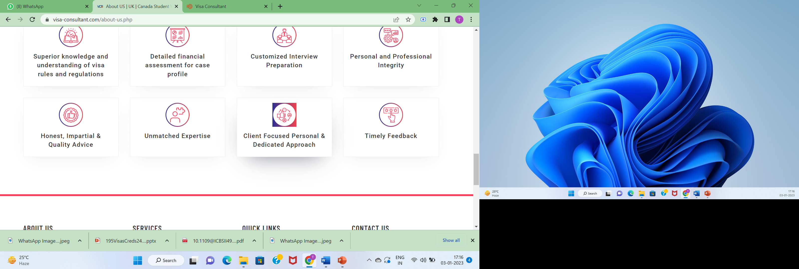

**Social Media Links:**

**Instagram:** https://instagram.com/195visa?igshid=YmMyMTA2M2Y=  
**Linkedin:** <https://www.linkedin.com/company/195visas/>

**Contact Us:** add this 2 contact no

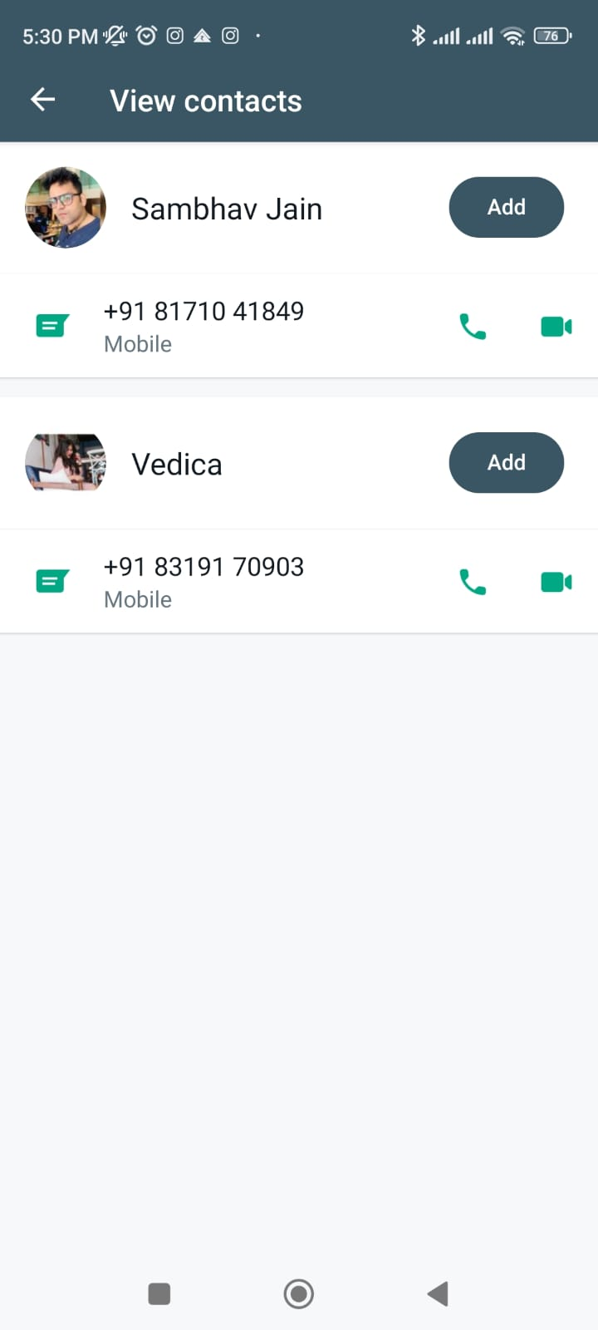

Gmail: 195visa@gmail.com