Pancreatic Tumor Detection using Image Processing

In this project you ask to develop 3DCNN and 2.5CNN algorithms to detect and classify pancreatic tumor and then calculate approximate affected area. So we have implemented 3DCNN algorithm with multi atlas registration and 2.5CNN is not working.

To train 3DCNN we have used Pancreas tumor dataset with multi atlas registration. Multi atlas register several atlases pairwise to an image, propagate the labels of the atlases in image space, and choose the final label for each voxel using majority voting.

In below screen we can see dataset image contains several organ in a single image

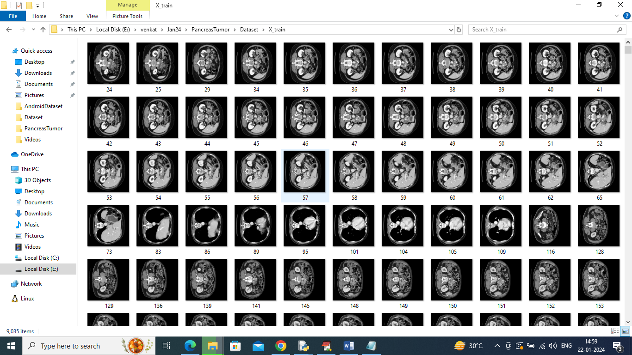

So by using above images we will train and test 3DCNN algorithm to detect pancreas tumor with affected %. To calculate percentage we are calculating detected tumor size to get affected percentage.

In below screen showing usage of 3DCNN algorithm

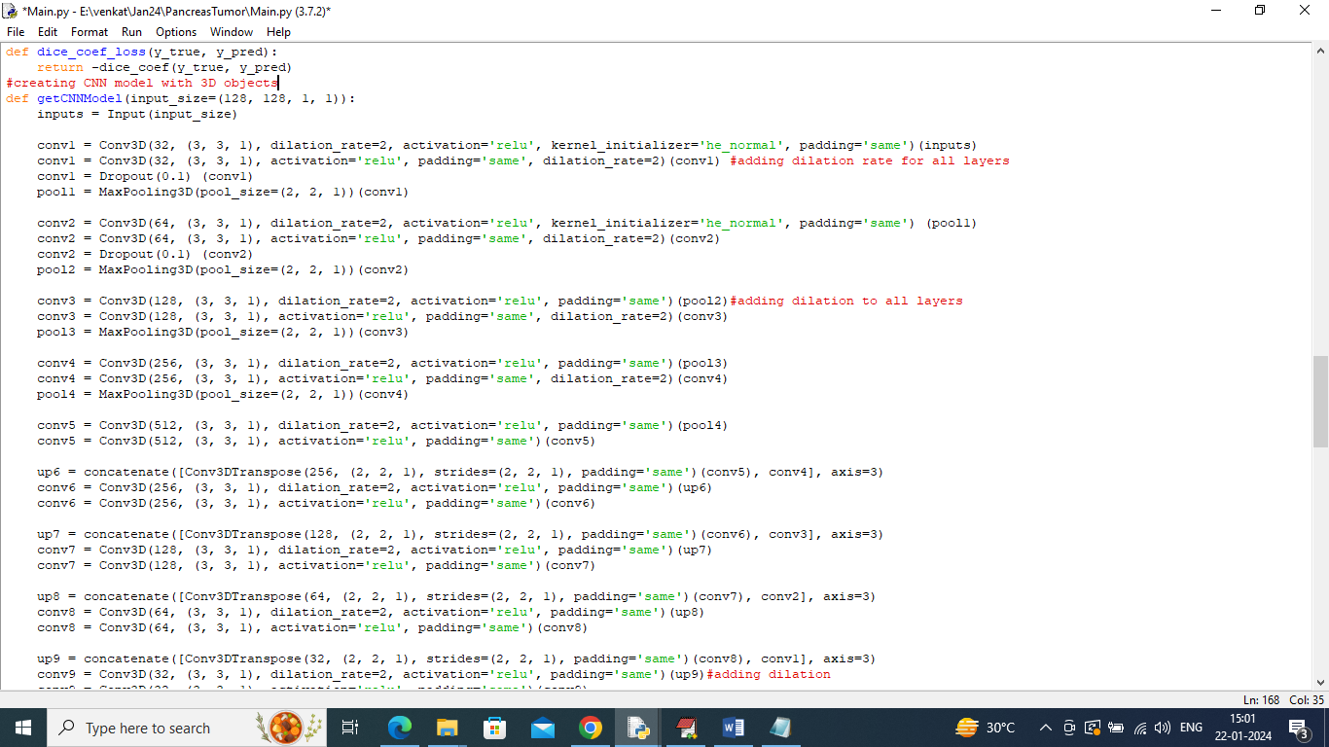

In above screen can see we are creating CNN layer objects with 3DCNN classes

To implement this project we have designed following modules

1. Upload Multi Atlas Pancreas Dataset: using this module we will upload dataset to application and then application will read and resize all images for training
2. Process Dataset: using this module we will normalize all images pixels
3. Train & Test Split: using this module will split dataset images into train and test where application using 80% images for training and 20% for testing
4. Run 3DCNN Algorithm: 80% processed dataset images will be input to 3DCNN algorithm to train a model and this model will be applied on 20% test images to calculate prediction accuracy
5. Cancer % Detection from Test Image: using this module will upload test image and then 3DCNN will detect pancreas tumor with affected percentage
6. 3DCNN Training Graph: will plot 3DCNN training and validation accuracy graph

SCREEN SHOTS

To run project double click on ‘run.bat’ file to get below screen

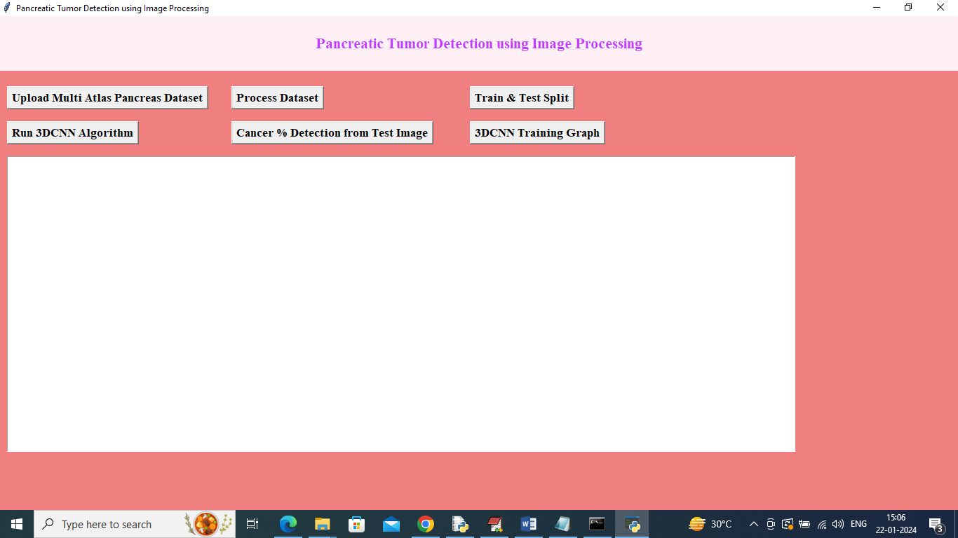

In above screen click on ‘Upload Multi Atlas Pancreas Dataset’ button to upload dataset and then will get below output

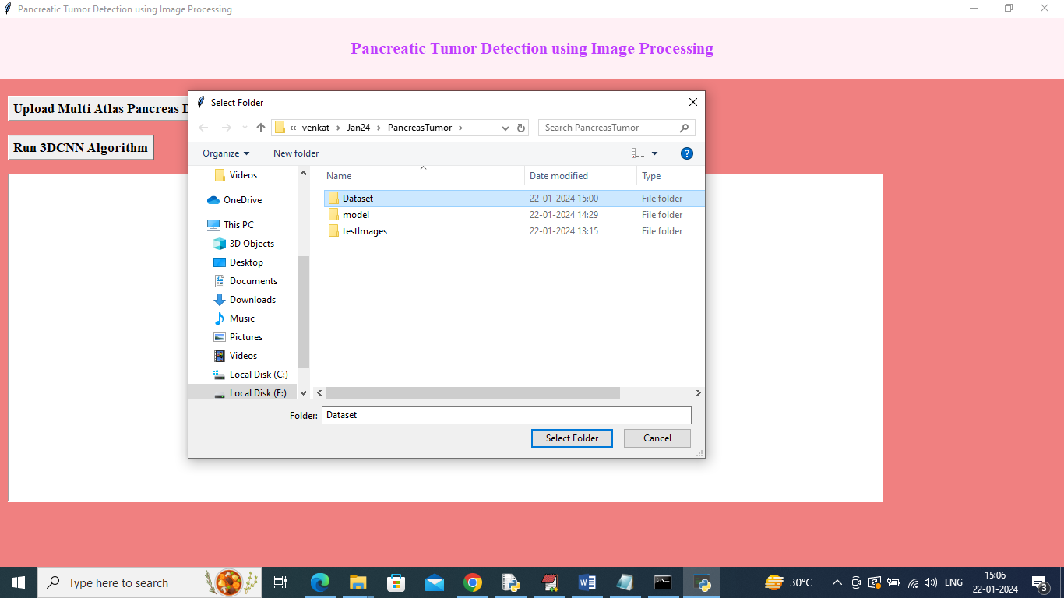

In above screen selecting and uploading ‘Dataset’ folder and then click on ‘Select Folder’ button to load all images and then will get below output

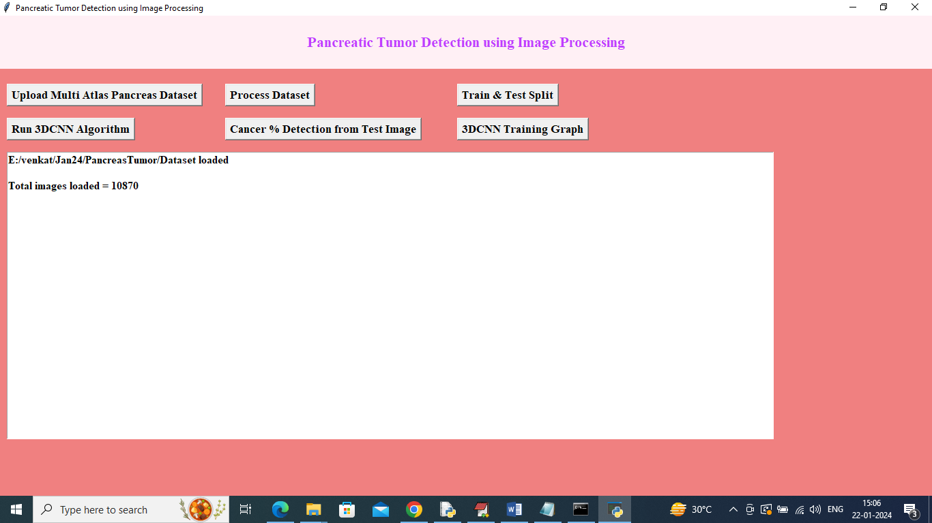

In above screen dataset loaded and total images loaded are 10870 and now click on ‘Process Dataset’ button to normalize all images and then will get below output

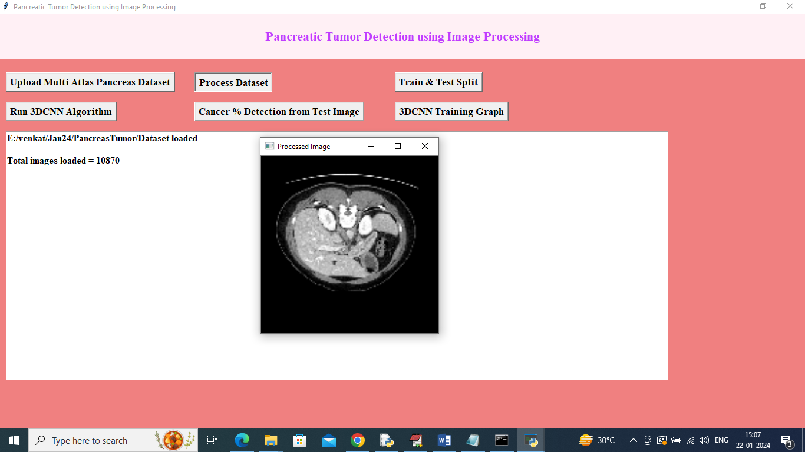

In above screen dataset normalization completed and can see sample process image and now close above image and then click on ‘Train & Test Split’ button to split dataset into train and test and then will get below output

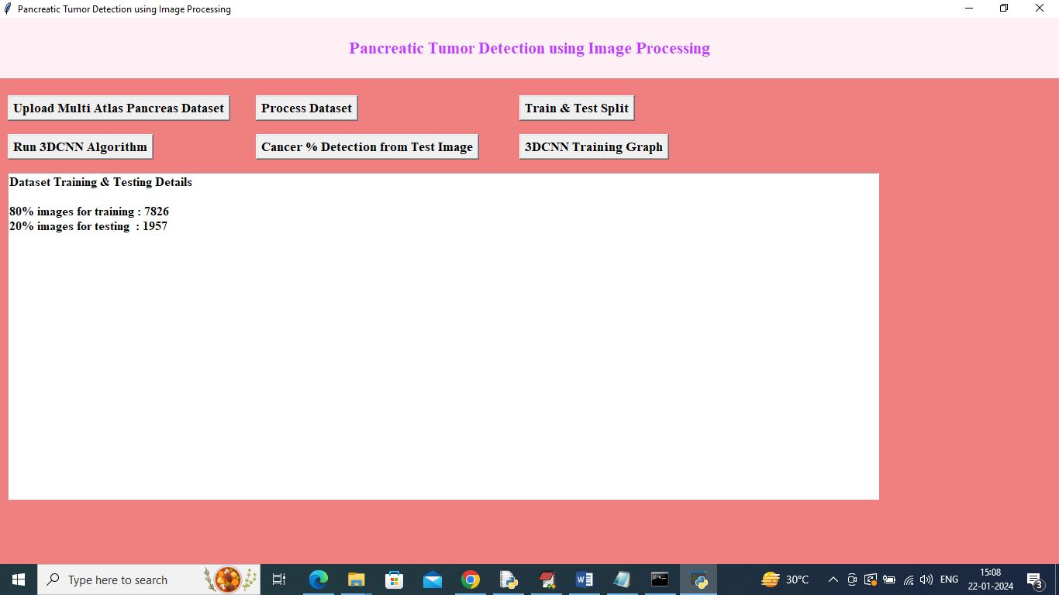

In above screen can see training and testing images size and now click on ‘Run 3DCNN Algorithm’ button to train 3DCNN and get below output

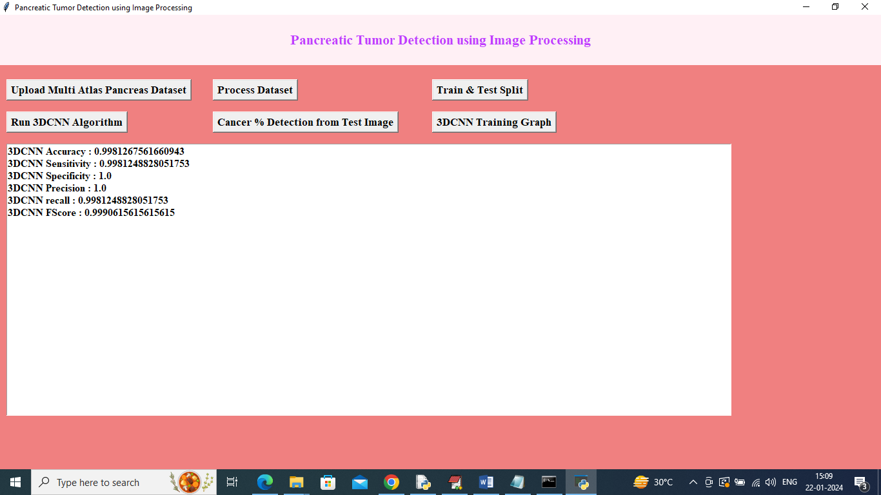

In above screen 3DCNN training completed and it get an accuracy of 99% and can see other metrics output and now click on ‘Cancer % Detection from Test Image’ button to get below output

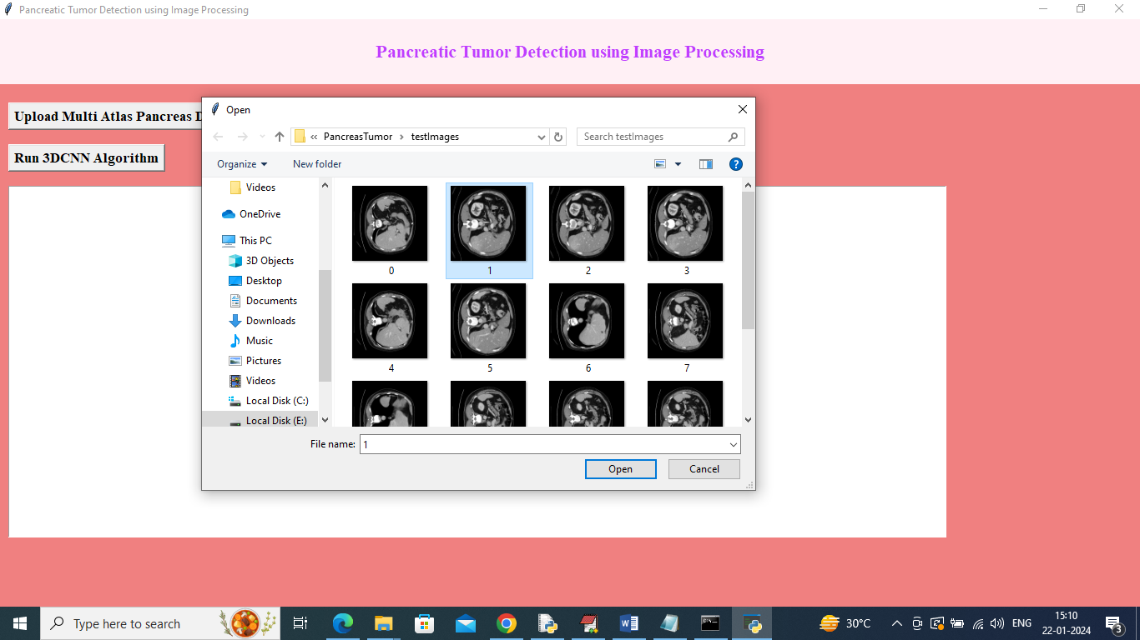

In above screen selecting and uploading 1.png image and then click on ‘Open’ button to get below output

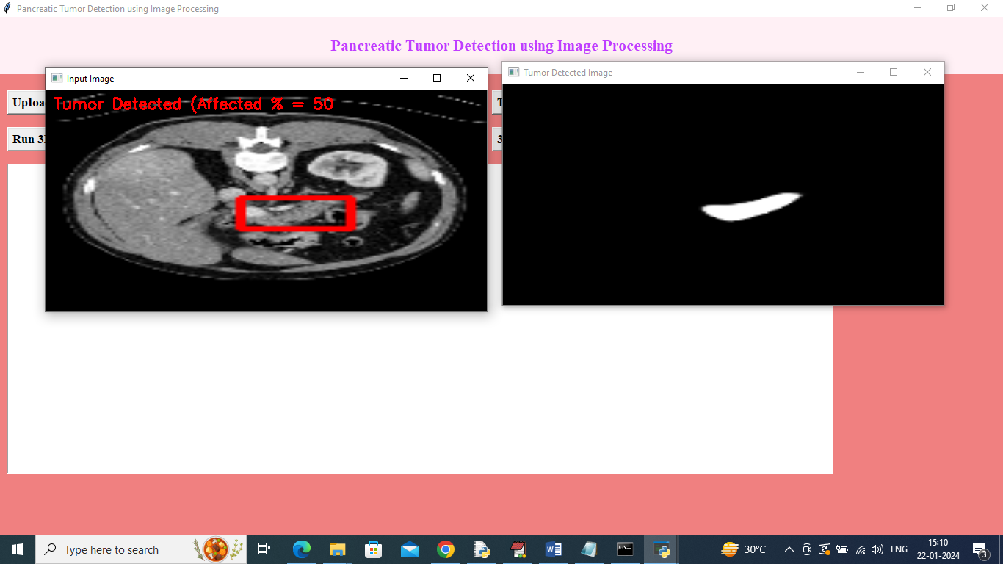

In above screen in uploaded image can see tumor detected region with red bounding box and in red colour text can see affected % and in second image can see segmented part of pancreas tumor. Similarly you can upload and test other images

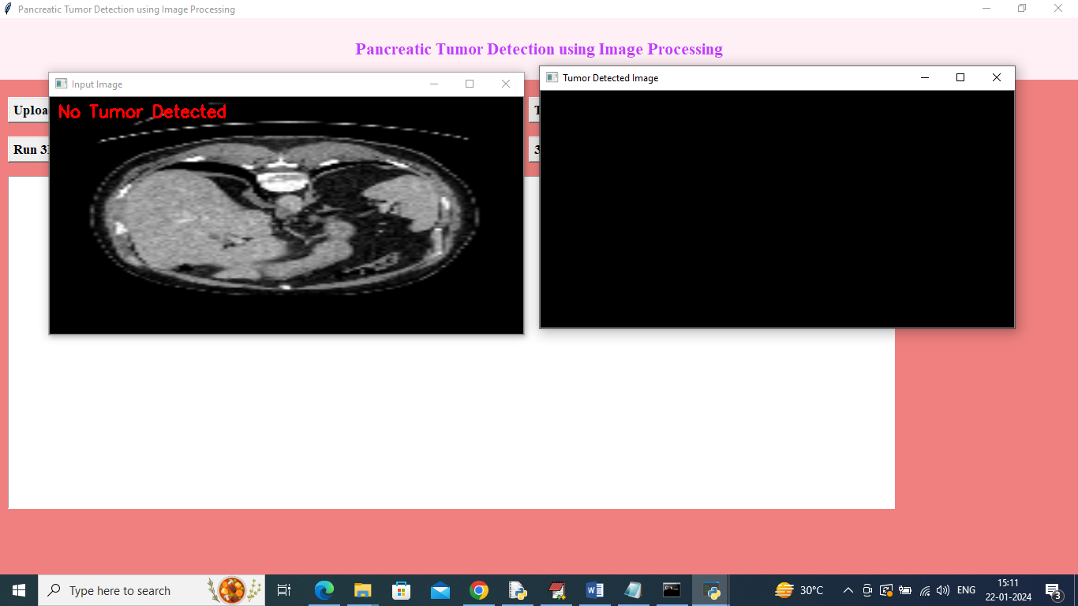

In above screen image no tumor detected so segmented tumor region will be blank

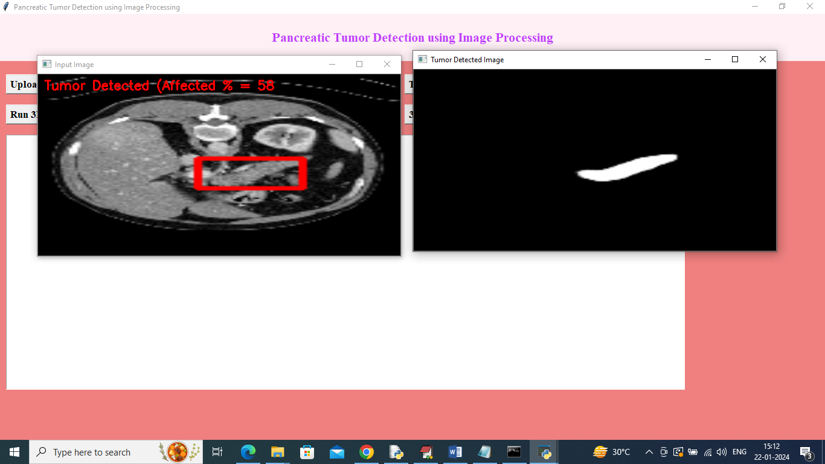

In above test image tumor affected % is 58%

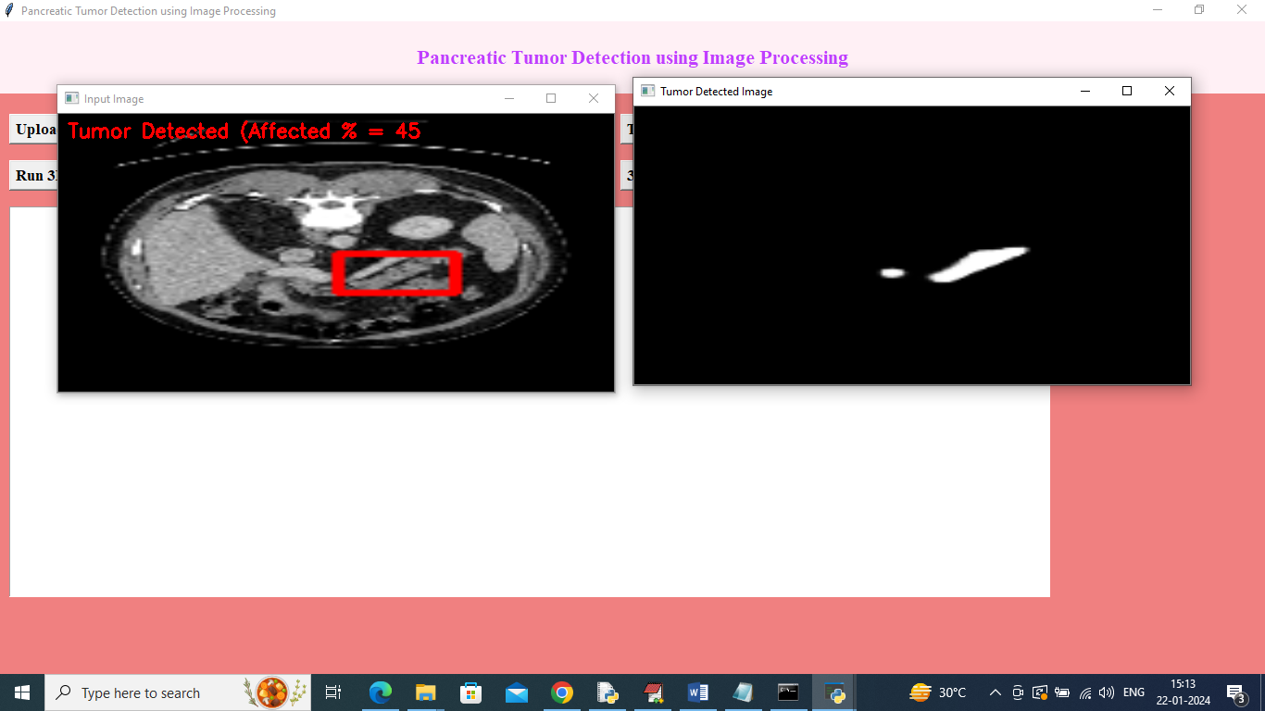

In above screen tumor affected area is 45% and now click on ‘3DCNN Training Graph’ button to get below training graph

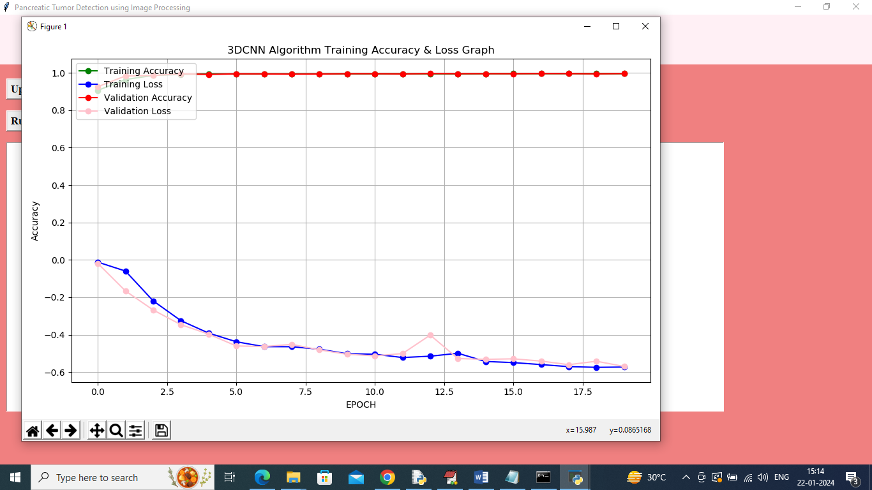

In above screen x-axis represents training epochs and y-axis represents accuracy and loss values and in above graph can see training and validation accuracy increase with each increasing epochs and reached closer to 1 and loss line decrease and reached closer to 0. So 3DCNN can get accuracy of more than 99%