AIM:

* To create an online voting System using Linear Data Structures.

OBJECTIVES:

* Implementation of the Linear Data Structure-LINKED LISTS.
* Multiple methods creation for various tasks under the project.
* In this system, authorized voters can give his\her votes online without going to any physical polling station.

METHODOLOGY:

* Creation of singly linked list data structure using structures
* Linked list is a linear data structure ,in which elements are not sorted over contiguous memory locations. The elements in linked list are linked using pointers .
* Singly linked list is a unidirectional data structure,that is , it can be traversed in only one direction from head to last node.
* A linked list is preferred over other structures is the that they are dynamic in nature and have faster deletion/insertion time.
* Singly linked list is preferred when we need to save memory and searching is not required as pointer of single index is stored.
* Linked lists are always better than Arrays as they do not lead to Memory Fragmentation.
* In our Application ,we take input from the users to check they belong in the voter list and the candidate they vote and we display the winner.
* 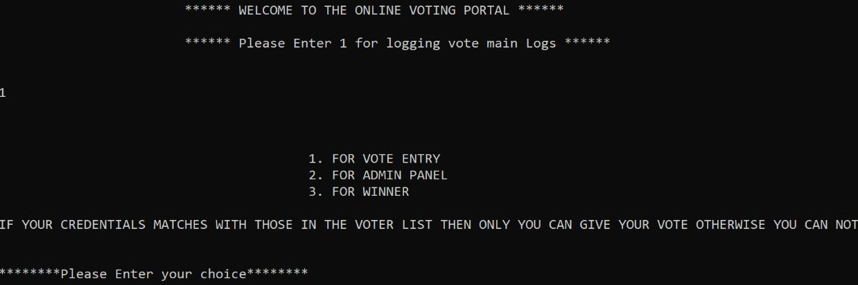

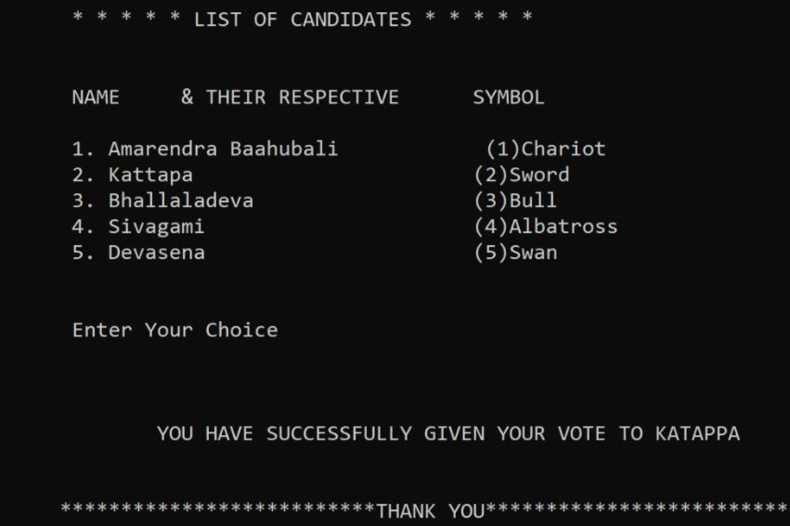

RESULTS OBTAINED:

* Program Displays the current winner everytime the winner function is called.

* You can also access the voting count of all the candidates using the admin panel.

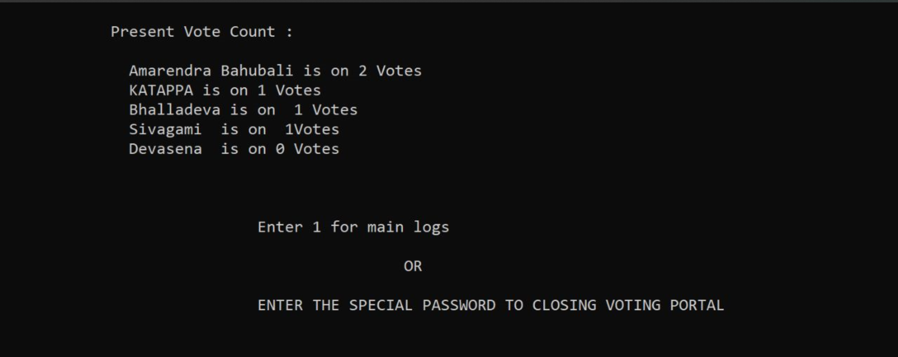

CONTRIBUTIONS:

* This project has been a very good assignment for me as I have learnt the importance and implementation of linked lists in the real time applications.
* I have helped in the process of developing the code for the voter_ insert() function which takes the Reg.no ,DOB,Name as input and checks if the voter is present in the voting list by comparing the Reg.no in the voting list.
* This will return to re enter if the voter is not present in the voting list.
* Voter will not be able to vote more than once for which I have called not_again() function in my code snippet.
* I am very much thankful to our teachers for coming up with this kind of evaluation which involves individual and also team work which makes the concept easy to grasp .
* 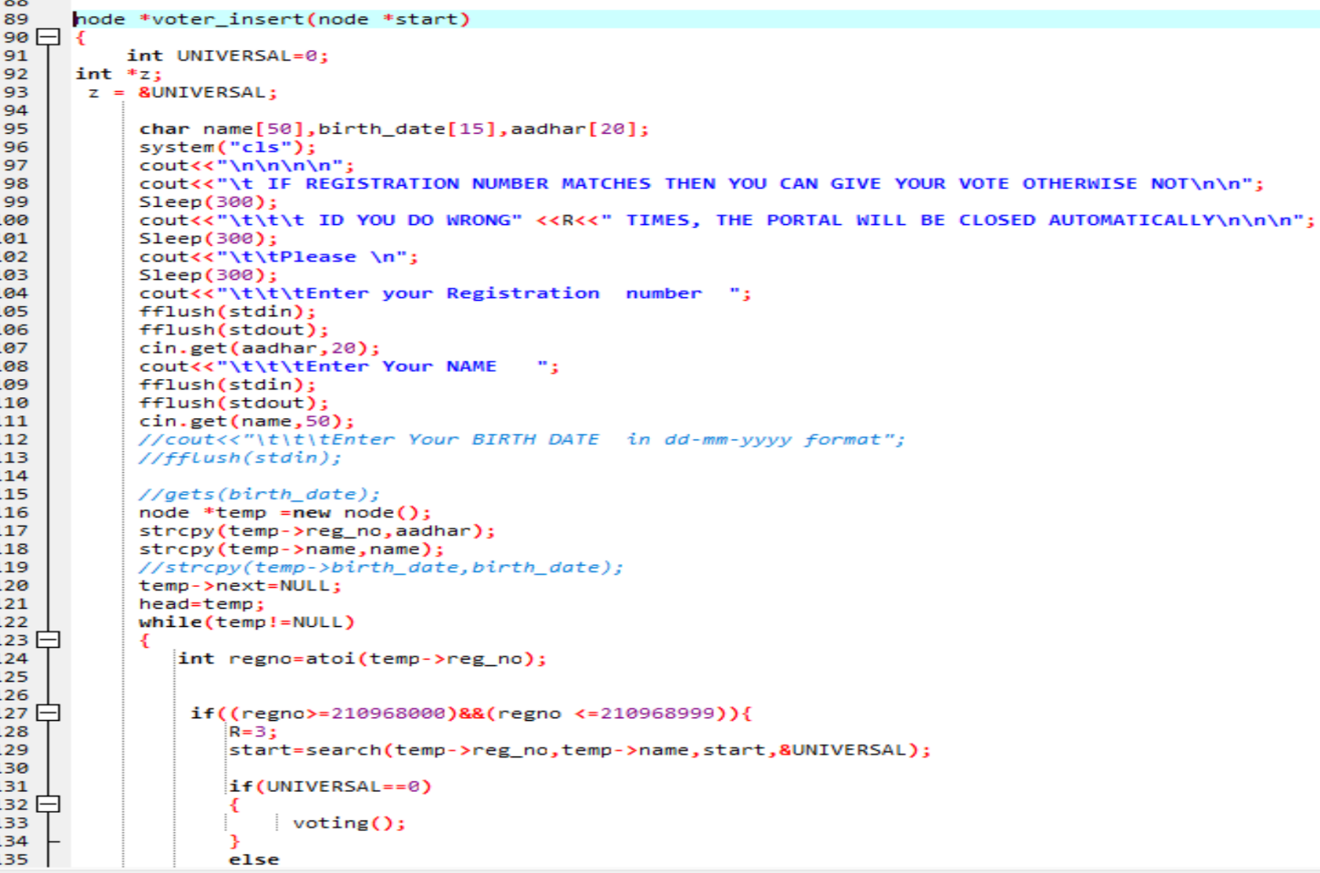

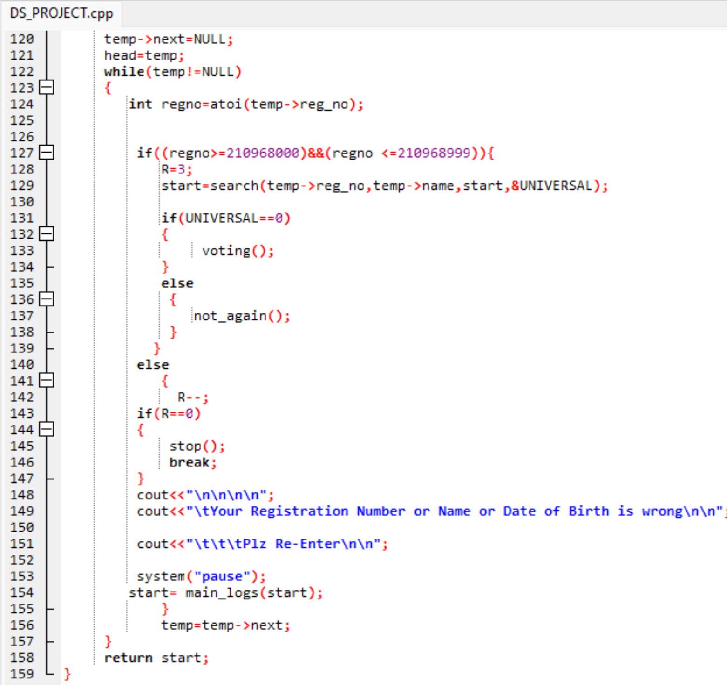

CONCLUSIONS:

* Practiced implementation of data structures
* Singly linked lists are useful data structures, especially if you need to automatically allocate and de-allocate space in a list.
* The code and complexity of these algorithms is bigger, but the tradeoff is ease of use.
* Structures for data encapsulation.
* Dynamic memory allocation using a new operator.

REFERENCES:

* <https://www.geeksforgeeks.org/category/linked-list/>
* https://stackoverflow.com/questions/1127396/struct-constructor-in-c

CODE REPOSITORY:

Github: https://github.com/Shrock-221B/DS_PROJECT_FISAC.git

TEAM:

* Hari Sai Polishetty- 210968168
* Saketh Reddy Bobbala, 210968188
* Anirudh Derangula - 210968052
* **Shreyas Allani – 210968022(This Report)**
* Darla Venkat Santhosh Kumar - 210968090