Then we design it as an automated, continuously operating commercial intelligence system, not a research assistant that waits for instructions.
The default operating mode should be autonomous discovery, investigation, cross-analysis and monitoring, with human intervention reserved for consequential decisions, uncertain evidence and governance boundaries.
Operating model: autonomous discovery loop
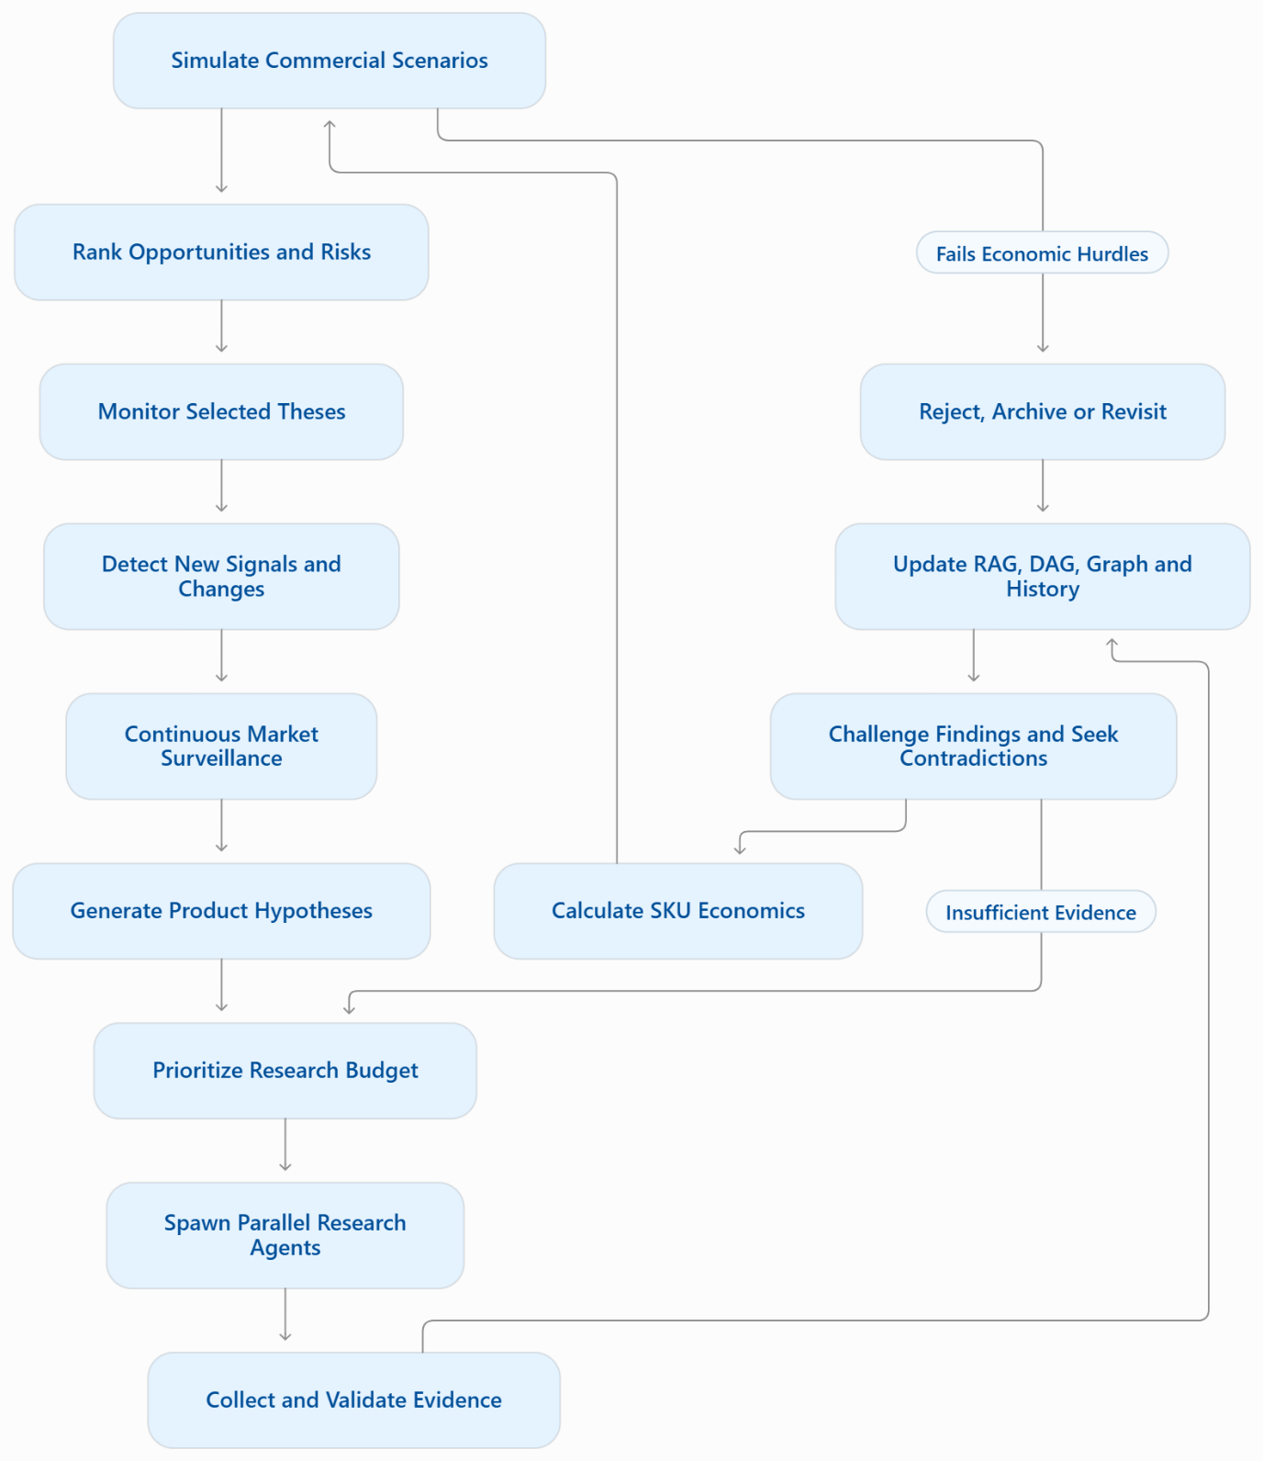
The loop should continue without requiring you to manually launch every research task. However, automation must not mean that agents can spend without limits, trust arbitrary webpages or silently change validated financial results.
The autonomy we should design for
- Self-directed discovery: identify emerging categories, new suppliers, pricing anomalies, regulatory developments and supply-chain constraints.
- Dynamic agent spawning: create specialist research tasks when a hypothesis needs further investigation, with configurable concurrency and budgets.
- Adversarial verification: independently test promising findings, search for contradictory evidence and identify unsupported assumptions.
- Dependency-triggered recomputation: when material inputs change, identify affected products, scenarios and investment theses, then recompute what is necessary.
- Persistent learning: compare forecasts with subsequently observed prices, demand and commercial outcomes; update model reliability without rewriting historical evidence.
- Autonomous prioritization: allocate research effort according to expected commercial value, uncertainty, information gain, downside risk and cost.
- Continuous monitoring: revisit active opportunities, detect deteriorating economics and generate actionable alerts.
- Bounded execution: require explicit policies for source access, inference costs, data retention, concurrency and approval-sensitive actions.
The next architectural decision: what drives the agents?
I see three possible approaches, which can coexist but should have a deliberate hierarchy.
A. Event-driven automation
Agents react to new listings, price changes, regulatory notices, supplier updates and other incoming signals. Efficient and auditable, but may miss opportunities that generate no obvious trigger.
B. Scheduled autonomous exploration
Agents periodically explore categories, search for new sources, generate hypotheses and investigate market gaps even when no alert has fired.
C. Hypothesis-driven research allocation
The system evaluates its existing beliefs and evidence gaps, then decides which research action is most valuable to run next. It can abandon weak hypotheses and expand promising ones.
My recommendation is to combine all three: event-driven monitoring for responsiveness, scheduled exploration for discovery, and hypothesis-driven allocation as the decision layer coordinating the research budget.
One important implementation detail: the agents should be able to propose new research branches dynamically, but execution should flow through a durable scheduler with bounded resources, typed task contracts, provenance and reproducible runs. That gives us autonomous behavior without an uncontrolled swarm.
The next question we should resolve is the scope of autonomy: should this system monitor only India initially while discovering globally relevant inputs, or should it explore and compare global markets from day one, with India as the primary selling destination? This determines the initial source coverage, currency normalization, regulatory data model and research priorities.
Combine all three
Agreed. All three become core operating mechanisms, coordinated by one autonomous research scheduler. None is an optional future add-on.
Decision 01 — Hybrid autonomous orchestration
Three independent signal sources
Events · Scheduled exploration · Hypothesis-driven research
Autonomous Research Orchestrator
Deduplication · Prioritization · Budget allocation · Agent spawning · Scheduling
Research workers
Browser agents, extraction, supplier verification and price discovery.
Challenge workers
Independent validation, contradiction searches and adversarial review.
Shared intelligence and evidence layer
RAG + DAG + knowledge graph + temporal observations + deterministic economics
Feedback and reprioritization
Forecast errors · New opportunities · Changed dependencies · Updated research priorities
How the three mechanisms work together
Mechanism | Trigger | Purpose
Event-driven | A meaningful change is detected | React quickly to market movements and new evidence.
Scheduled exploration | A recurring schedule or exploration budget becomes available | Discover opportunities beyond the existing watchlist.
Hypothesis-driven | Evidence gaps, uncertainty or expected information value justify further work | Decide what to investigate next and when to stop.
A single observation might activate all three mechanisms. The orchestrator must deduplicate the resulting tasks rather than launching three redundant investigations.
A concrete example
Suppose the system detects rising stainless-steel input costs.
- Event-driven: flags potentially affected products, suppliers and active investment theses.
- Scheduled exploration: investigates substitute materials, alternative suppliers and adjacent product categories.
- Hypothesis-driven: asks whether the change creates a sourcing advantage, a pricing opportunity or an unattractive cost shock, and chooses the next research tasks based on the missing evidence.
- Challenge workers: independently test the supplier-price evidence and search for counterexamples.
- Economics engine: recalculates affected scenarios using validated inputs.
- Feedback loop: updates the affected theses and records what changed, why, and which conclusions remain uncertain.
The system must not assume that higher input costs automatically create an opportunity. It could instead reveal that competitors have better contracts, that demand is weakening or that the relevant product price is unaffected.
Non-negotiable orchestration rules
- Every task has a unique ID, objective, parent task where applicable, budget, deadline and typed inputs and outputs.
- Agents can propose additional tasks, but the orchestrator authorizes and schedules execution within policy.
- Research workers and challenge workers must not simply share the same unexamined conclusion.
- Failed, blocked and inconclusive research remains visible.
- Changes to evidence invalidate dependent analyses selectively, not through uncontrolled full-system reruns.
- Historical observations and prior financial runs remain reproducible.
- Autonomous research does not authorize purchases, supplier commitments or changes to the frozen financial engine.
These rules will form part of the master planning prompt and its acceptance criteria.
Decision 02 — Global or India-first market intelligence?
We have settled the operating model. The remaining question is the geographic scope of discovery and commercial execution, which affects the initial architecture and source integrations.
My recommendation is global discovery, India-first commercialization: discover products, suppliers, input costs, technological shifts and regulatory signals worldwide, but evaluate initial selling strategies against Indian marketplace and B2B economics.
That would allow a US or European market signal to uncover an opportunity in India without requiring us to build complete operational support for every country immediately.
Should we adopt that as the default ?

