We are modelling a commercial trading firm, not merely a product arbitrage scanner. Its inventory is the underlying economic position; its capital is exposed to real product-market risks; and its marketplace transactions are the equivalent of acquiring, holding, and liquidating positions. The initial firm, its accounts, tax treatment and transactions are hypothetical, but the market evidence and economic assumptions should reflect reality wherever data is available.
1. The HFT architecture we should mirror
The most useful takeaway from real HFT systems is that they are not one giant algorithm. They are interconnected subsystems with explicit interfaces, controlled state transitions, risk checks and independent monitoring. The reference architecture describes this as a pipeline from market data to strategy, risk, execution and post-trade processing.

how high-frequency trading actually works
+1
For POC-001, I'd adapt that into the following architecture.
01 · Commercial data feeds
Marketplaces · suppliers · manufacturers · B2B quotations · fees · demand signals
02 · Feed handlers and evidence normalization
Deduplication · timestamps · product matching · source reliability · stale-data detection
03 · Live commercial state
Product and SKU state · supplier availability · price history · inventory · cash · open commitments
04 · Strategy and opportunity engine
Arbitrage detection · expected contribution · demand forecasts · edge decay · opportunity ranking
05 · Pre-trade risk and capital controls
Capital limits · downside scenarios · tax assumptions · working capital · supplier and SKU concentration
Mandatory gate
06 · Simulated order management
Proposed purchases · inventory allocation · listings · simulated sales · returns · liquidation
07 · Reconciliation and surveillance
Realized versus forecast economics · cash recovery · inventory valuation · strategy performance · alerts
Every stage produces auditable events. Surveillance feeds new observations back into the system.
The risk gate is deliberately separate from the strategy engine. A strategy may identify an attractive opportunity, but it must not be able to bypass the capital controls that govern whether the opportunity is admissible.
2. Translating the specific HFT concepts
These are proposed design adaptations, not claims that physical-product markets behave identically to securities exchanges.
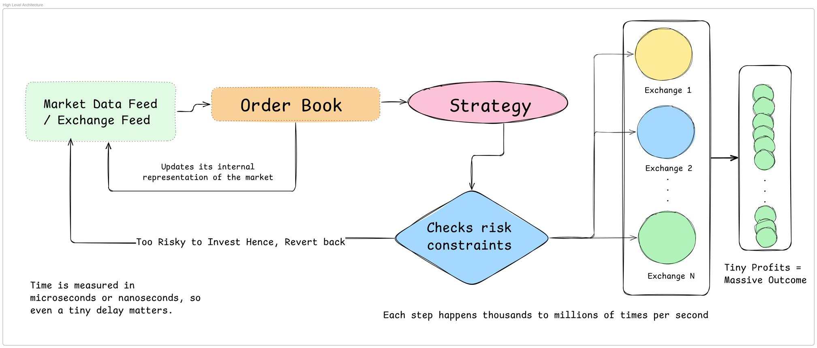
A. Market data feed handlers → Commercial intelligence ingestion
Real HFT systems decode incoming market messages and update their internal representation of the market.

HFT Architecture
+1
Ours should ingest product listings, supplier quotations, fees, stock availability and transaction observations into a normalized event stream. Product identity resolution is especially important: two apparently identical products may have different materials, grades, sizes or pack counts.
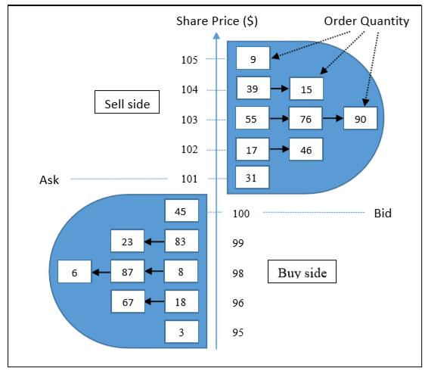
B. Order book → Commercial opportunity book
Instead of bids and asks for financial instruments, maintain comparable acquisition offers and executable selling opportunities.
For each SKU and sales channel, retain the best verified sourcing options, alternative suppliers, competitive prices, available quantities, fees and evidence timestamps. Unlike an exchange order book, marketplace listings are not necessarily executable orders, so the model must account for availability uncertainty and price changes.
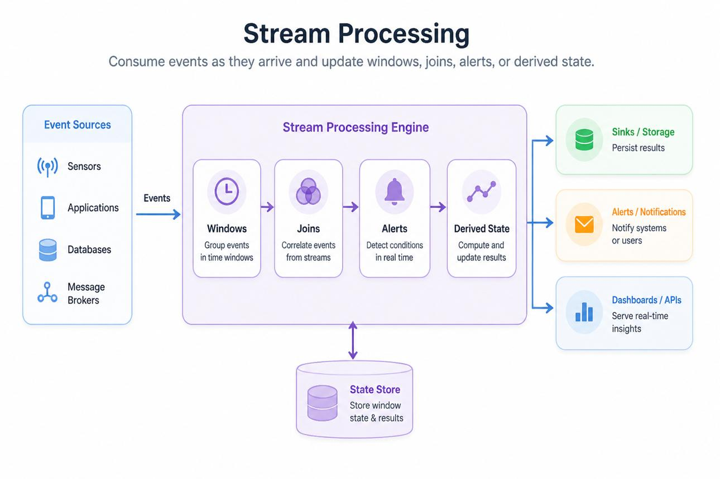
C. Event-driven engine → Commercial state machine
A new supplier quote, a marketplace price change, an order return or an inventory impairment should produce a discrete event.
Those events update the relevant state and trigger only the calculations that need to be rerun. Every decision must be reproducible from the events and rules that existed when it was made.
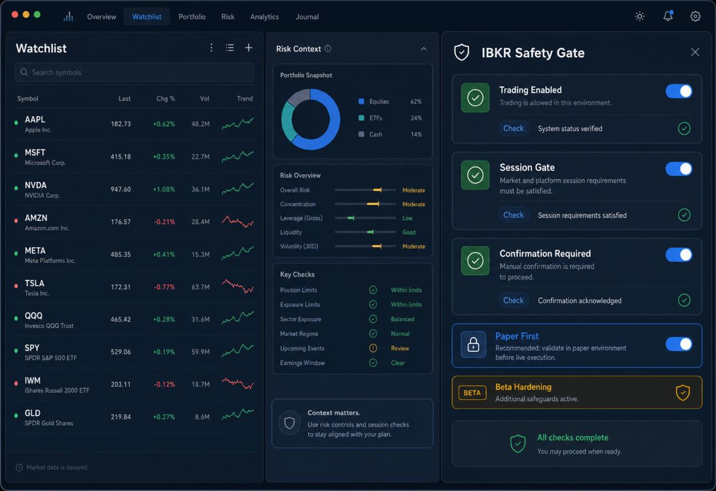
D. Pre-trade risk management → Capital admission control
Before simulated capital is committed, check available cash, maximum exposure, expected downside, inventory capacity, supplier reliability and minimum risk-adjusted returns.
A strategy cannot override these controls. A system-wide kill switch should suspend new allocations when data integrity, reconciliation or risk limits fail.
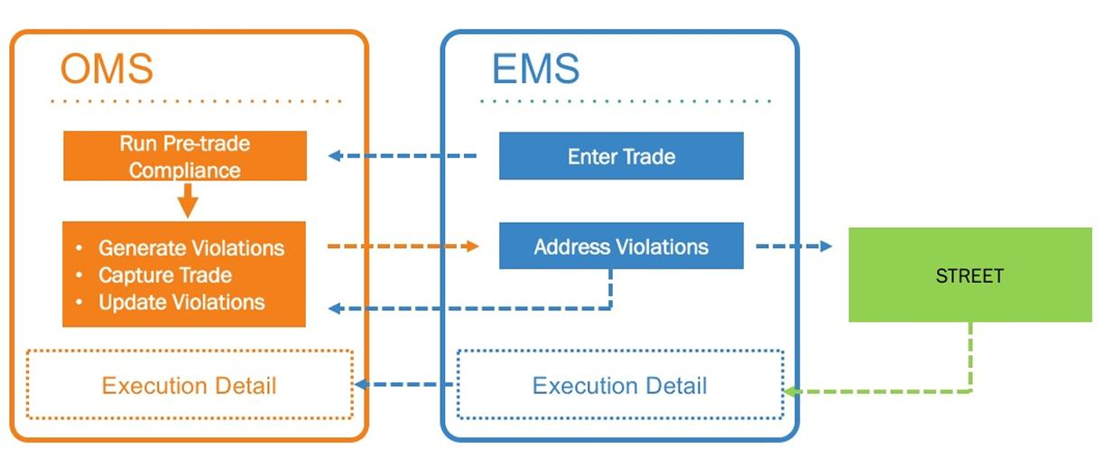
E. Order management → Inventory and transaction lifecycle
Model proposed purchases, approved commitments, goods received, inventory lots, marketplace listings, orders, cancellations, refunds and settlement.
Every transaction should have a lifecycle and a unique identifier. An order being proposed is not the same as inventory being purchased; a customer order is not the same as settled cash.
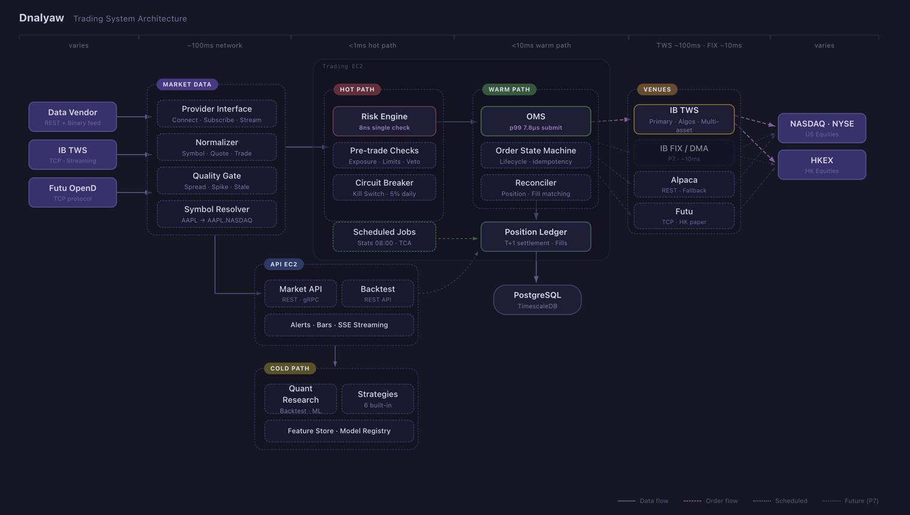
F. Monitoring and replay → Forensic commercial audit
Capture decision timestamps, input versions, model outputs, rejected opportunities, simulated executions, forecast errors and reasons for exiting a strategy.
Given the same event history, configuration and model version, deterministic calculations should reproduce the same financial results. This lets us distinguish a bad commercial thesis from a faulty calculation or unreliable data.
3. The critical difference: inventory is our position
In conventional HFT, a position may be repriced and traded within seconds. Physical inventory has a different risk profile.
It can deteriorate, become obsolete, be damaged, incur storage costs or remain unsold while cash is tied up. It also has a liquidation value that may be materially lower than its original acquisition cost.
I'd represent every inventory position with at least these attributes:
Position attribute | Why it matters
Acquisition cost | Original capital committed
Quantity available and reserved | What can actually be sold
Current replacement cost | Cost of replenishing the position
Estimated net realizable value | Expected proceeds after selling costs
Holding and storage costs | Economic drag over time
Expected sales velocity | Forecast capital recovery
Realized contribution | Actual economics of completed sales
Cash recovered | Liquidity available for redeployment
Impairment and liquidation scenarios | Downside if the thesis fails
The system should track both realized profit and unrealized economic changes. It must not report forecast profit as realized profit, or assume the entire inventory can be liquidated at the latest listed price.
Your earlier requirement for a timer now becomes a formal part of the position model: every position should have a projected recovery date, an opportunity-expiry estimate, a review deadline and predefined exit conditions.
4. The hypothetical Indian trading entity
I'd model the entity as a separate economic and accounting boundary from the outset, even though it remains hypothetical.
Its model would contain:
- Opening capital and subsequent capital contributions.
- Cash, inventory, receivables, payables and outstanding commitments.
- Purchases, sales, marketplace charges, advertising, logistics and returns.
- Applicable GST treatment and input-tax-credit assumptions.
- Income-tax calculations under configurable legal-entity scenarios.
- Working capital, profit, cash-flow and return-on-capital reports.
- A clear distinction between tax expense, tax collected or withheld, recoverable credits and actual cash movements.
Tax optimization should be a constrained scenario analysis, not an assumed tax rate. The system should compare legally available structures and elections under documented assumptions, with professional verification before treating any scenario as executable. Marketplace-related withholding and GST treatment can affect cash flow and reconciliation independently of the entity's ultimate income-tax expense.
194-O
+1
I'd keep this in a dedicated tax-and-accounting module rather than embedding tax logic inside the arbitrage strategy itself. That way, the same opportunity can be evaluated under different hypothetical entity structures without changing its underlying product-market evidence.
5. What I would add to the POC-001 architecture
There are three capabilities I would elevate to first-class system components:
1. An event ledger. A chronological, append-only record of observations, simulated transactions, state changes and decisions. Corrections should be recorded as new events rather than silently rewriting historical evidence.
2. A replay and backtesting engine. Replay historical or captured observations through a particular strategy version to determine what it would have detected, approved, bought, sold or rejected. Use only information that would have been available at the time to prevent look-ahead bias.
3. A commercial risk management system. Centralized capital limits, inventory exposure, supplier concentration, stale-data controls, loss limits, and an emergency suspension mechanism. These controls should remain independent of the strategy that proposes an allocation.
These three components create the foundation for trustworthy simulation. Without them, the system might produce attractive dashboards while being unable to demonstrate that its historical decisions were justified by the evidence available at the time.
6. How I would phase the implementation on Antigravity
- Foundation: Audit and preserve the current POC-001 repository, its Step 6 implementation and existing financial calculators. Establish the authoritative event schema and invariants.
- Market-state engine: Normalize commercial observations and maintain the current state of each product, supplier, channel and inventory position.
- Strategy and risk: Build deterministic opportunity evaluation, capital admission, exposure limits and rejection reasons.
- Paper execution: Simulate the complete lifecycle from capital commitment through procurement, inventory, sales, returns and cash recovery.
- Replay and surveillance: Replay prior observations, measure forecast accuracy, detect opportunity decay and trigger reviews or simulated exits.
- Portfolio and entity accounting: Add cross-opportunity capital allocation, inventory valuation, entity-level financial statements and configurable tax scenarios.
I would not begin with FPGA-style acceleration, kernel bypass, nanosecond timing or a distributed microservice architecture. The useful HFT lesson is to make the processing path deterministic, the state explicit, the risk checks unavoidable and the entire decision history auditable. The physical-market system can optimize throughput and monitoring frequency later, when measured requirements justify it.
One final point: the HFT model should not assume that every opportunity is a fleeting price discrepancy. Some of the most valuable commercial edges may be persistent sourcing advantages, pack-size optimization, procurement relationships or inefficient distribution channels. The system needs to discover and manage both temporary and durable edges.
The resulting system is an inventory-backed commercial trading simulator with an HFT-inspired architecture—not simply a D2C product finder. It can test strategies against actual market observations while keeping capital, transactions and returns hypothetical until separately authorized.

