SENTIMENT ANALYSIS OF MOVIE REVIEWS USING A MULTI-STAGE NLP PIPELINE
Submitted in partial fulfilment of the requirements in the subject of

Natural Language Processing Laboratory (DJS23ELMD701)

by

SHRUTIK ACHARYA (Roll No. E149, SAP ID: 60002231068)


Electronics & Telecommunication Engineering Dwarkadas J. Sanghvi College of Engineering 2026 - 2027

Table of Contents

TOPIC | PAGE
Certificate | 3
Abstract | 4
1. Introduction | 5
1.1 Problem Statement | 5
1.2 Overview | 5
1.3 Objectives | 5
2. Review of Literature | 6
2.1 Recent Sentiment Analysis Approaches | 6
2.2 Sarcasm, Emotion and Aspect-Level Analysis | 6
2.3 Comparative Analysis of Recent Methods | 6
3. System Model/Architecture | 7
3.1 System Overview | 7
3.2 Overall Workflow | 7
3.3 System Architecture Diagram | 7
3.4 System Components | 8
4. Algorithm Implementation | 8
4.1 Data Pre-Processing | 8
4.2 Model Implementation | 9
4.3 Code Implementation | 10
4.4 Results and Analysis | 11
5. Conclusions & Future Scope | 13
5.1 Conclusion | 13
5.2 Future Scope | 13
6. IEEE References | 14

Certificate

This is to certify that the project entitled “SENTIMENT ANALYSIS OF MOVIE REVIEWS USING A MULTI-STAGE NLP PIPELINE” is a bonafide work of
- SHRUTIK ACHARYA (Roll No. E149, SAP ID: 60002231068)
- SHAKTHI RAVISHANKAR (Roll No. E143, SAP ID: 60002231015)
- SHANTANOO AHER (Roll No. E145, SAP ID: 60002230155)
submitted in partial fulfilment of the requirements in the subject of Natural Language Processing Laboratory (DJS23ELMD701) in Electronics & Telecommunication Engineering.

Teacher-in-charge | Head of Department
Prof. Supriya Dicholkar | Dr. Amit Deshmukh

Abstract
A movie review conveys more than a binary positive or negative judgement: it may contain sarcasm, imply a star rating, express specific emotions and discuss aspects such as acting, plot, music or pacing. This project develops a multi-stage Natural Language Processing (NLP) pipeline on IMDb reviews to report these signals together. A TF-IDF (1-3)-gram LinearSVC classifies polarity and achieves 91.71% accuracy on 9,917 unseen reviews. A sarcasm engine cross-checks the SVM with a DistilBERT sentiment model, a RoBERTa irony classifier and a clause-contrast rule to produce negative, mixed/possible sarcasm or agreed-polarity labels. A Ridge regression model trained on star-labelled IMDb reviews predicts a 1-10 rating with a mean absolute error of
1.55 stars. A RoBERTa GoEmotions model supplies the two most relevant emotions after polarity-based filtering, while six keyword sets provide clause-level aspect sentiment. The implementation uses Python, scikit-learn and Hugging Face Transformers in Google Colab and demonstrates how lightweight classical models and contextual transformers can be combined in an explainable review-analysis workflow.

INTRODUCTION

Problem Statement
Online movie reviews are an important source of audience opinion, and sentiment analysis converts these free-form opinions into structured information. Recent work continues to show that sentiment analysis has moved from conventional machine-learning pipelines toward deep neural, transformer and large-language-model approaches, while challenges such as context, domain shift, explainability and nuanced emotion remain active research problems [1], [2]. A plain positive/negative classifier is useful, but it has three major blind spots: sarcastic language can reverse literal meaning; a binary label hides the difference between mild and strong sentiment; and document-level polarity does not identify what the reviewer liked or disliked.
The problem is therefore to build a single analysis system that accepts a raw movie review and returns overall polarity with sarcasm handling, an estimated 1-10 star rating, dominant emotions and sentiment toward individual film aspects such as acting, plot, visuals, music, dialogue and pacing.

Overview
The proposed pipeline combines complementary models rather than replacing every stage with one large model. The first stage uses TF-IDF word n-grams with a LinearSVC for fast polarity classification. The second stage adds contextual checks using DistilBERT sentiment, a RoBERTa irony detector and clause-level polarity contrast. The third stage estimates a star rating with Ridge regression and profiles emotions using a GoEmotions transformer. The final analysis stage assigns sentiment to six movie aspects using keyword-triggered clause classification. This modular design reflects current research trends in combining strong baselines, pre-trained contextual models and finer-grained analysis [3]-[6].

Objectives
    - Train and evaluate a TF-IDF (1-3)-gram LinearSVC polarity classifier on a stratified hold-out set.
    - Build a sarcasm-aware decision engine using SVM/DistilBERT agreement, RoBERTa irony detection and clause contrast.
    - Predict a 1-10 star rating using Ridge regression and report mean absolute error.
    - Profile the two most relevant emotions while filtering emotions that conflict with the predicted polarity.
    - Extract aspect-level sentiment for acting, plot, visuals, music, dialogue and pacing and combine all outputs in one interactive analyser.

REVIEW OF LITERATURE

Recent Sentiment Analysis Approaches
Recent sentiment-analysis literature emphasizes the continued value of both efficient baselines and context-aware deep models. Jim et al. [1] review modern NLP-based sentiment analysis across machine learning, deep learning, pre-trained models and LLMs, identifying context, domain adaptation and robustness as key open issues. Islam et al. [2] similarly survey deep-learning methods and highlight the trade-off between improved representation learning and higher training cost. For movie reviews specifically, Atandoh et al. [3] propose a scalable deep-learning framework for online movie-review sentiment, while Ouyang [4] studies IMDB sentiment classification using n-gram features with a deep-learning architecture. These studies support retaining a strong n-gram baseline as a transparent reference point while adding contextual models where nuance is needed.

Sarcasm, Emotion and Aspect-Level Analysis
Sarcasm is difficult because the intended sentiment can oppose the literal wording. Liu et al. [5] introduce a sentiment-aware hierarchical fusion approach for sarcasm detection, while Khan et al. [6] show the continued usefulness of transformer attention for sarcasm recognition. More recent work by Oprea and Bara [7] evaluates supervised transformer fine-tuning with LLM-based judging, reinforcing the importance of contextual modelling and careful evaluation. In this project, these ideas motivate a multi-signal sarcasm engine rather than trusting one classifier.
Aspect-based sentiment analysis (ABSA) is also a major recent direction. Hua et al. [8] provide a 2024 systematic review showing the shift toward transformer and graph-based methods. Aziz et al. [9] combine BERT with multi-layer graph convolution, Zou et al. [10] integrate syntactic features with interactive learning, and Su et al. [11] propose a Clause Graph Transformer. Mao et al. [12] apply deep-learning ABSA directly to movie reviews. These methods are more sophisticated than the keyword-based aspect module used here, but they establish the value of reporting sentiment at aspect level rather than only at document level.

Comparative Analysis of Recent Methods
Study | Year | Method / Focus | Relevance to this Project
Jim et al. [1] | 2024 | Survey of ML, DL, pre-trained and LLM sentiment models | Frames recent trends and limitations
Atandoh et al. [3] | 2024 | Deep framework for online movie-review sentiment | Movie-review domain comparison
Liu et al. [5] | 2024 | Sentiment-aware sarcasm detection | Motivates explicit sarcasm handling
Hua et al. [8] | 2024 | Systematic review of ABSA | Motivates aspect-level outputs
Aziz et al. [9] | 2024 | BERT + graph convolution for ABSA | Shows value of contextual and structural cues
Mao et al. [12] | 2024 | Deep-learning ABSA for movie reviews | Directly relevant to movie aspects
Table 1: Recent literature relevant to the multi-stage sentiment analysis pipeline
The literature indicates that no single technique is ideal for every output. Linear n-gram models remain efficient and interpretable, transformers improve contextual understanding, sarcasm requires explicit contextual or incongruity modelling, and ABSA benefits from representations that connect an aspect with its surrounding context. The present system therefore adopts a modular architecture so that each stage can be evaluated or replaced independently.

SYSTEM MODEL

System Overview
The system is a modular pipeline that transforms a raw movie review into four primary outputs: overall polarity, estimated star rating, an emotion pair and an aspect-sentiment map. Two review sources are used internally: IMDB_Dataset.csv for polarity training and the star-labelled aclImdb_v1 corpus for rating regression. Three pre-trained transformer models are used without task-specific retraining. The modular structure allows any stage to be replaced later by a fine-tuned model.

Overall Workflow
The polarity dataset is loaded, duplicate reviews are removed, HTML tags are stripped and text is lower-cased. Labels are mapped to positive and negative, followed by a stratified 80/20 train-test split. A TF-IDF + LinearSVC pipeline is trained and evaluated, then retrained on all available polarity data. For a new review, the SVM label, DistilBERT label, RoBERTa irony flag and clause-contrast signal are combined through deterministic rules. Independently, Ridge regression predicts a rating, the GoEmotions model returns ranked emotions, and the aspect module scores clauses containing predefined movie-aspect terms.

System Architecture Diagram
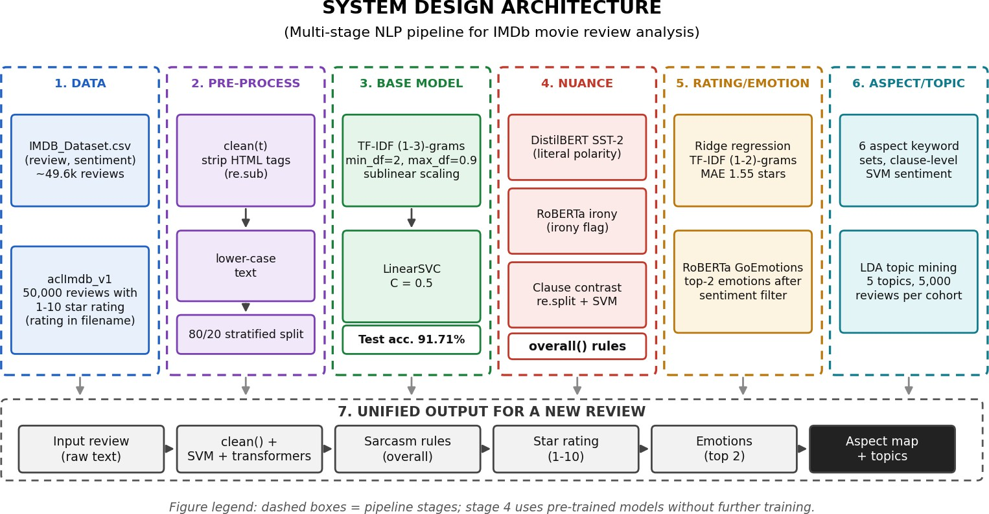

Figure 1: System architecture of the multi-stage sentiment analysis pipeline

System Components
    - Data Input: IMDB_Dataset.csv for polarity/aspect analysis and aclImdb_v1 for 1-10 star-rating regression.
    - Pre-processing: removal of HTML tags using a regular expression, lower-casing and duplicate removal.
    - Base Classifier: TfidfVectorizer using 1-3 word n-grams, min_df = 2, max_df = 0.9 and sublinear scaling, followed by LinearSVC with C = 0.5.
    - Nuance Engine: DistilBERT sentiment, a RoBERTa irony classifier and a clause-contrast test.
    - Rating: Ridge regression on TF-IDF unigrams and bigrams, with output clamped to 1-10.
    - Emotion: RoBERTa GoEmotions with polarity-based filtering; the top two remaining emotions are displayed.
    - Aspect Analysis: six keyword sets (acting, plot, visuals, music, dialogue and pacing) scored clause by clause with the SVM.
    - Implementation: Python, scikit-learn and Hugging Face Transformers in Google Colab.
    - Evaluation: accuracy/F1 for polarity, mean absolute error for rating and qualitative inspection for sarcasm, emotion and aspects.
Chapter 4

ALGORITHM IMPLEMENTATION

Data Pre-Processing
After removing duplicates, 20% of the remaining polarity reviews are held out with stratification, giving 9,917 test examples: 4,940 negative and 4,977 positive. The clean() function removes HTML tags with the pattern
<[^>]+> and converts text to lower case. Positive labels are mapped to 1 and negative labels to 0. For star-rating prediction, 50,000 labelled aclImdb reviews are read and the rating is obtained from each filename. In this corpus, negative reviews have ratings 1-4 and positive reviews 7-10, so ratings 5 and 6 are absent from training.

Dataset | Used for | Size | Label
IMDB_Dataset.csv | Polarity and aspect scoring | ~49.6k after duplicate removal (9,917 test) | positive / negative
aclImdb_v1 | Ridge rating model | 50,000 labelled reviews | 1-10 stars (1-4, 7-10)
Table 2: Datasets used in the project

Model Implementation
Base classifier. The TF-IDF vectoriser uses word n-grams from one to three words, ignores extremely rare/common terms and applies sublinear term-frequency scaling. A LinearSVC with C = 0.5 is trained on the sparse vectors. After evaluation, the pipeline is retrained on all polarity data and saved as sentiment_model.joblib.
Sarcasm engine. Three cues are used: SVM/DistilBERT literal polarity, the RoBERTa irony flag and clause-level polarity contrast. If a positive literal label appears together with both irony and contrast, the review is interpreted as negative sarcastic. If only one sarcasm cue is present, the result is mixed / possible sarcasm. If neither cue is present, agreement is retained; disagreement becomes mixed / uncertain.
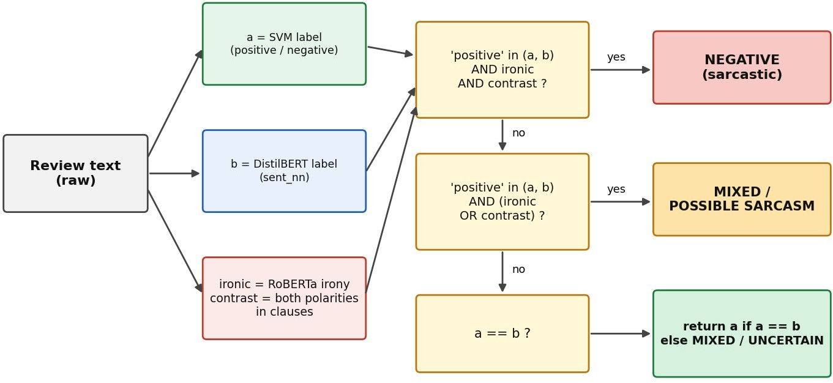
Figure 2: Decision logic of the overall() sarcasm engine

SVM / DistilBERT | Irony | Contrast | Output | Illustrative review
positive in (a,b) | TRUE | TRUE | negative (sarcastic) | “Oh wow, what a total masterpiece. Truly an extraordinary waste of time.”
positive in (a,b) | TRUE | FALSE | mixed / possible sarcasm | “Oh yeah, totally top-tier acting right there.”
positive in (a,b) | FALSE | TRUE | mixed / possible sarcasm | “Great visual effects! But the story was a complete disaster.”
positive in (a,b) | FALSE | FALSE | a if a=b, else mixed / uncertain | “Outstanding direction and breathtaking musical score throughout.”
Table 3: Sarcasm classification rules with illustrative reviews
Rating and emotion. The Ridge model uses TF-IDF unigrams and bigrams. It is evaluated on a random 20% split and then retrained on all 50,000 star-labelled reviews. The output is clamped to 1-10 and converted to an integer. The GoEmotions model returns ranked emotions; emotions that conflict with the final polarity are removed before displaying the top two remaining labels.
Aspect sentiment. Six aspects are represented by keyword lists: acting, plot, visuals, music, dialogue and pacing. The review is split into clauses at punctuation and the word “but”. A clause containing an aspect keyword is classified using the SVM, and its sentiment is assigned to that aspect.

Code Implementation
The notebook is executed from top to bottom in Google Colab. The following condensed code fragments show the main stages used in the implementation.
Cell 1: Base classifier
import re, joblib, pandas as pd
from sklearn.model_selection import train_test_split from sklearn.pipeline import make_pipeline
from sklearn.feature_extraction.text import TfidfVectorizer from sklearn.svm import LinearSVC

def clean(t): return re.sub(r"<[^>]+>", " ", t).lower()
df = pd.read_csv("IMDB_Dataset.csv").drop_duplicates()
X, y = df.review.map(clean), (df.sentiment == "positive").astype(int)
Xtr, Xte, ytr, yte = train_test_split(X, y, test_size=0.2, stratify=y, random_state=42)
model = make_pipeline(TfidfVectorizer(ngram_range=(1,3), min_df=2, max_df=0.9, sublinear_tf=True), LinearSVC(C=0.5)) model.fit(Xtr, ytr)
Cell 2: Sarcasm engine
from transformers import pipeline
sent_nn = pipeline("sentiment-analysis", model="distilbert-base-uncased-finetuned-sst-2-english", truncation=True) irony = pipeline("text-classification", model="cardiffnlp/twitter-roberta-base-irony", truncation=True)

def contrast(review):
parts = [p for p in re.split(r"[.!?;]", clean(review)) if p.strip()] return len({classify([p])[0] for p in parts}) == 2
def overall(review):
a = classify([review])[0]
b = sent_nn(review)[0]["label"].lower() ironic = irony(review)[0]["label"] == "irony"
if "positive" in (a,b) and ironic and contrast(review): return "negative"
if "positive" in (a,b) and (ironic or contrast(review)): return "mixed / possible sarcasm" return a if a == b else "mixed / uncertain"
Cell 3: Rating, emotion and aspects
reg = make_pipeline(TfidfVectorizer(ngram_range=(1,2), min_df=2, sublinear_tf=True), Ridge()) emotion = pipeline("text-classification", model="SamLowe/roberta-base-go_emotions", truncation=True)
ASPECTS = {
"acting": ["acting", "actor", "actress", "cast", "performance", "lead"],
"plot": ["plot", "story", "script", "ending", "twist"],
"visuals": ["visual", "effects", "cinematography", "scenery", "costume"], "music": ["music", "soundtrack", "score", "songs"],
"dialogue": ["dialogue", "writing"],
"pacing": ["pacing", "drags", "slow", "rushed"]
}
Cell 4: Interactive review analyser
while True:
review = input("Enter a review (or type 'quit' to stop): ") if review.strip().lower() == "quit": break
sent = overall(review) print("Overall:", sent)
print("Rating:", rating(review), "/ 10") print("Emotion:", get_emotion(review, sent))
print("Aspects:", aspect_sentiment(review) or "none found")

Results and Analysis

Result 1: Polarity classification accuracy on the 9,917 test reviews
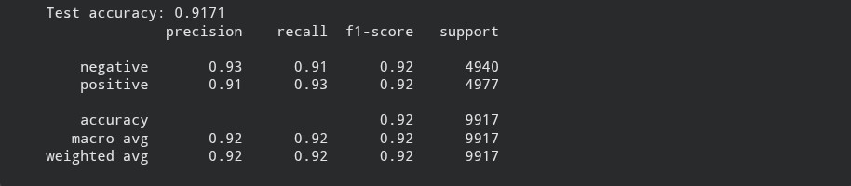
Figure 3: Test accuracy and classification report of the LinearSVC

Class | Precision | Recall | F1-Score | Support
Negative | 0.93 | 0.91 | 0.92 | 4,940
Positive | 0.91 | 0.93 | 0.92 | 4,977
Macro avg | 0.92 | 0.92 | 0.92 | 9,917
Table 4: Classification report of the SVM (test accuracy 91.71%)
The SVM reaches 91.71% test accuracy and both classes have an F1-score of approximately 0.92. Precision is higher for the negative class, while recall is higher for the positive class, indicating a small tendency toward positive predictions. The result shows that an n-gram linear baseline remains highly competitive for this dataset, consistent with the continued use of efficient text representations alongside deeper contextual models in recent sentiment-analysis research [1]-[4].

Result 2: Star-rating prediction error
Figure 4: Mean absolute error of the Ridge rating model
On the 20% hold-out set the Ridge model is off by 1.55 stars on average on the 1-10 scale. Because the training corpus contains ratings 1-4 and 7-10 but no 5- or 6-star examples, mixed reviews may be mapped into an under-represented middle range. The final int() conversion also truncates decimals, which can introduce a small downward bias.

Result 3: End-to-end inference on example reviews
Table 5 shows the complete pipeline on four reviews chosen to exercise different decision paths of the sarcasm engine.

Review | Overall | Rating | Emotion | Aspects
“Brutal, devastating, and almost impossible to watch. I sobbed through the last hour and I’d call it the best film I’ve seen in years.” | positive | 8 / 10 | admiration, approval | none found
“A dull, predictable script with wooden acting. The film drags and I couldn’t wait for it to end.” | negative | 2 / 10 | disappointment, annoyance | plot, acting, pacing: negative
“Better than the first one, which isn’t saying much. The lead tries really hard, bless him, and the soundtrack was nice, I guess.” | mixed / uncertain | 5 / 10 | admiration, optimism | acting, music: positive
“Oh yeah, totally top-tier acting right there.” | mixed / possible sarcasm | 6 / 10 | amusement, admiration | acting: positive
Table 5: Pipeline output for four example reviews
The examples demonstrate both the value and the limits of a modular approach. The first review contains harsh words but expresses praise, while the second is consistently negative. The third produces disagreement between the linear and transformer sentiment models, so it is marked mixed/uncertain. The fourth is flagged as possible sarcasm. The aspect module still operates on literal clause polarity, so a sarcastic aspect phrase can remain labelled positive; recent ABSA and sarcasm literature suggests that contextual and graph/transformer-based replacements could address this limitation [5]-[12].

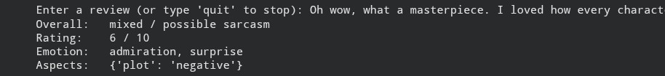
Figure 5: Interactive analysis of a review (console output)

Summary of results

Module | Metric | Result
LinearSVC polarity | Test accuracy / macro F1 | 91.71% / 0.92
Ridge star rating | Mean absolute error | 1.55 stars (1-10 scale)
Sarcasm engine | Qualitative examples | All four decision paths demonstrated
GoEmotions profile | Qualitative examples | Top-2 emotions consistent with polarity
Aspect sentiment | Qualitative examples | Six aspects detected by keywords
Table 6: Summary of results

Conclusion
This project demonstrates a multi-stage NLP pipeline that analyses movie reviews from several perspectives. A TF-IDF (1-3)-gram LinearSVC achieves 91.71% accuracy on 9,917 unseen IMDb reviews, while a Ridge model predicts star ratings with a mean absolute error of 1.55 stars. A sarcasm engine combines the SVM, DistilBERT, a RoBERTa irony classifier and a clause-contrast rule so that obvious negative, uncertain and possible-sarcasm cases can be distinguished more carefully than with a single polarity classifier. Emotion profiling and aspect sentiment add information about how a reviewer feels and which parts of the film are being discussed.
The main limitations are that only polarity and rating have numerical test metrics; sarcasm, emotions and aspect outputs are evaluated qualitatively. The irony model is not adapted specifically to movie reviews, keyword-based aspect matching can miss implicit aspects, and literal clause classification can fail when sarcasm occurs inside an aspect phrase. The rating model also lacks 5- and 6-star training examples. Even with these limitations, the pipeline shows that combining a fast, interpretable baseline with pre-trained contextual models is a practical way to move beyond a single positive/negative label.

Future Scope
    - Create a labelled movie-review sarcasm test set and report precision, recall and F1 for the rule-based sarcasm engine.
    - Fine-tune transformer models directly on IMDb-style text and compare them against the LinearSVC baseline.
    - Replace integer truncation with better-calibrated or ordinal rating prediction trained on data that include neutral ratings.
    - Replace keyword-based aspects with learned ABSA models using transformer, graph or clause-aware representations as suggested by recent work [8]-[12].
    - Explore parameter-efficient fine-tuning of modern LLMs and deploy the final pipeline as an API for interactive
applications.

- J. R. Jim, M. A. R. Talukder, P. Malakar, M. M. Kabir, K. Nur, and M. F. Mridha, “Recent advancements and challenges of NLP-based sentiment analysis: A state-of-the-art review,” Natural Language Processing Journal, vol. 6, Art. no. 100059, 2024, doi: 10.1016/j.nlp.2024.100059.
- M. S. Islam, M. N. Kabir, N. A. Ghani, K. Z. Zamli, N. S. A. Zulkifli, M. M. Rahman, et al., “Challenges and future in deep learning for sentiment analysis: a comprehensive review and a proposed novel hybrid approach,” Artificial Intelligence Review, vol. 57, Art. no. 62, 2024, doi: 10.1007/s10462-023-10651-9.
- P. Atandoh, F. Zhang, M. A. Al-antari, et al., “Scalable deep learning framework for sentiment analysis prediction for online movie reviews,” Heliyon, vol. 10, no. 10, Art. no. e30756, 2024, doi: 10.1016/j.heliyon.2024.e30756.
- S. Ouyang, “Deep learning for sentiment analysis on IMDB movie reviews using N-gram features,” Applied and Computational Engineering, vol. 35, pp. 56-63, 2024, doi: 10.54254/2755-2721/35/20230361.
- H. Liu, R. Wei, G. Tu, J. Lin, C. Liu, and D. Jiang, “Sarcasm driven by sentiment: A sentiment-aware hierarchical fusion network for multimodal sarcasm detection,” Information Fusion, vol. 108, Art. no. 102353, 2024, doi: 10.1016/j.inffus.2024.102353.
- S. Khan, I. Qasim, W. Khan, K. Aurangzeb, J. A. Khan, and M. S. Anwar, “A novel transformer attention-based approach for sarcasm detection,” Expert Systems, vol. 42, no. 1, Art. no. e13686, 2025, doi: 10.1111/exsy.13686.
- S.-V. Oprea and A. Bâra, “LLM-as-a-judge for sarcasm detection using supervised fine-tuning of transformers,” Journal of King Saud University - Computer and Information Sciences, vol. 37, Art. no. 357, 2025, doi: 10.1007/s44443-025-00379-7.
- Y. C. Hua, P. Denny, J. Wicker, et al., “A systematic review of aspect-based sentiment analysis: domains, methods, and trends,” Artificial Intelligence Review, vol. 57, Art. no. 296, 2024, doi: 10.1007/s10462-024-10906-z.
- K. Aziz, D. Ji, P. Chakrabarti, T. Chakrabarti, M. S. Iqbal, et al., “Unifying aspect-based sentiment analysis BERT and multi-layered graph convolutional networks for comprehensive sentiment dissection,” Scientific Reports, vol. 14, Art. no. 14646, 2024, doi: 10.1038/s41598-024-61886-7.
- W. Zou, W. Zhang, Z. Tian, W. Wu, et al., “A syntactic features and interactive learning model for aspect-based sentiment analysis,” Complex & Intelligent Systems, vol. 10, pp. 5359-5377, 2024, doi: 10.1007/s40747-024-01449-5.
- Z. Su, B. Gao, X. Pan, Z. Liu, Y. Ji, and S. Liu, “CGT: A Clause Graph Transformer Structure for aspect-based sentiment analysis,” Data & Knowledge Engineering, vol. 153, Art. no. 102332, 2024, doi: 10.1016/j.datak.2024.102332.
- H. Mao, Y. Fan, and M. Tong, “Research on aspect-based sentiment analysis of movie reviews based on deep learning,” Journal of Information Science, online first, 2024, doi: 10.1177/01655515241292353.

