Shrouq Ramadan Saad

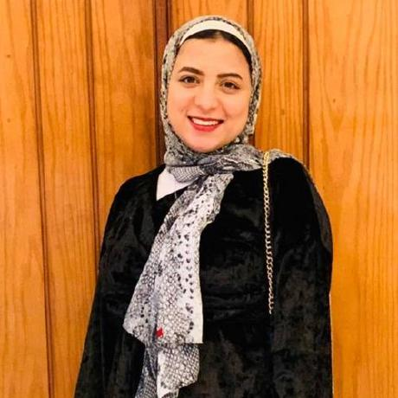

Contact

**Phone:**

01021479716

**Email:**

[shrouqramada8@gmail.com](mailto:shrouqramada8@gmail.com)

**Github:**

<https://github.com/ShrouqRamadan>

**LinkedIn:**

linkedin.com/in/shrouq-ramadan-a84289202/

**Date of Barth:**

28.jul.1997

Summary.

**Design and build websites using Html, CSS, JavaScript, JQuery with ES6, and angular • php and mysql &laravel web Developer • Built an ecommerce webapp to sell products online.**

Skill Highlights

|  |  |
| --- | --- |
| * Language:HTML,CS , JSwithES6, * UI Framework:bootstrap,Semantic-ui * SPA Frammework:anglular * DOM javaScript,jQuery * Php and mysql * laravel |  |

Education

Bachelor of information technology: **Computer Information Systems** – 2021

**Grade**: very good

**Misr University for Science and Technology (Must)**