Java Coding Test

Name : Shruti Gopalrao Gangane
Dept. : CSE ( Final Sec – B)

Problem Statement 1: Student Marks Analysis (Array Scenario)
A teacher entered marks of N students. She wants to find: Highest marks
Lowest marks Average marks

Input: 5
10 20 30 40 50

Output:
Highest: 50
Lowest: 10
Average: 30
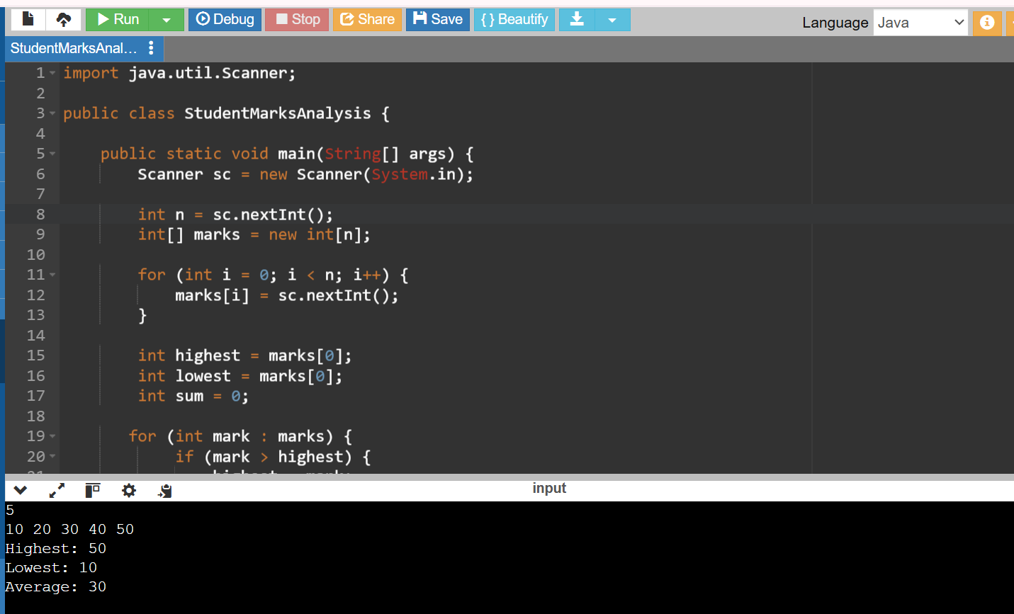

Problem Statement 2: Bank Transaction Analyzer

A bank stores daily transactions: Positive → deposit
Negative → withdrawal

Find:
Total deposit Total withdrawal Final balance

Input:

5
1000 -200 300 -400 500

Output:

Deposit: 1800
Withdrawal: 600
Balance: 1200

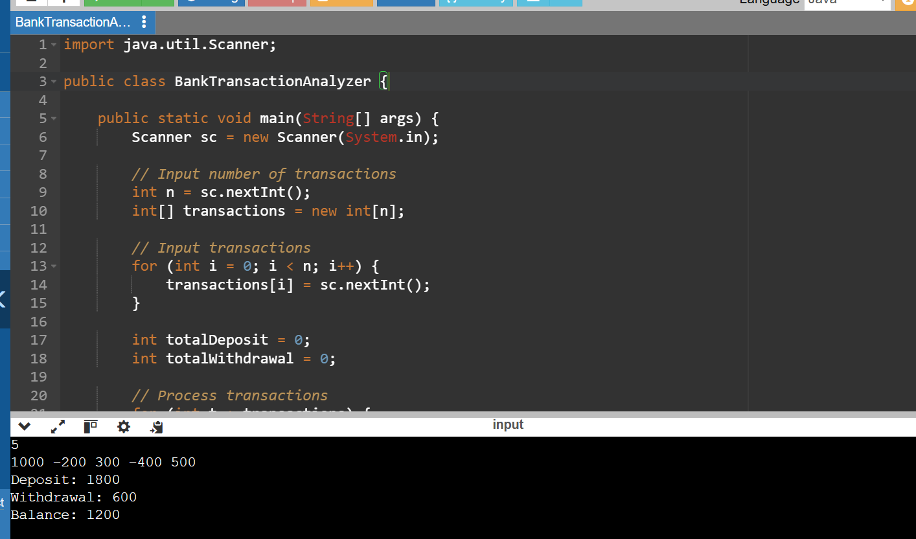

Problem Statement 3: Employee ID Validator
An employee ID is valid if:
Length ≥ 5
Contains at least one digit
Contains at least one uppercase letter

Input: Emp12
Output: Valid

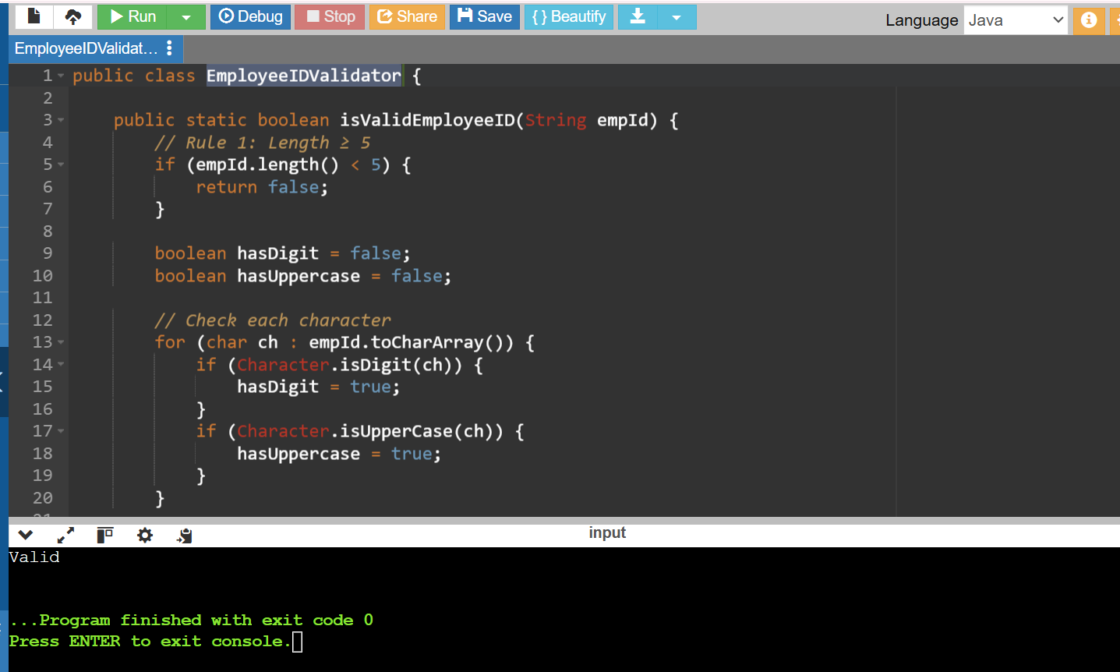

Problem Statement 4: Lower Triangular Matrix (TCS 2024 question type)
Given an N×N matrix, print lower triangular matrix. Input:
3
1 2 3
4 5 6
7 8 9

Output:
1 0 0
4 5 0
7 8 9

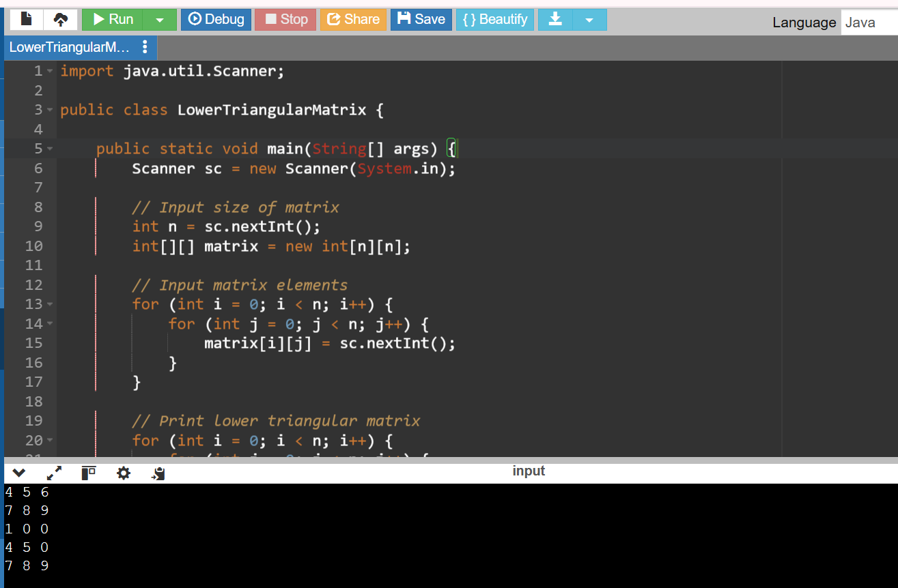

Problem Statement 5: Message Encryption System
Encryption rule:
Replace vowel with next alphabet Replace consonant with previous alphabet

Input: cat
Output: bbu

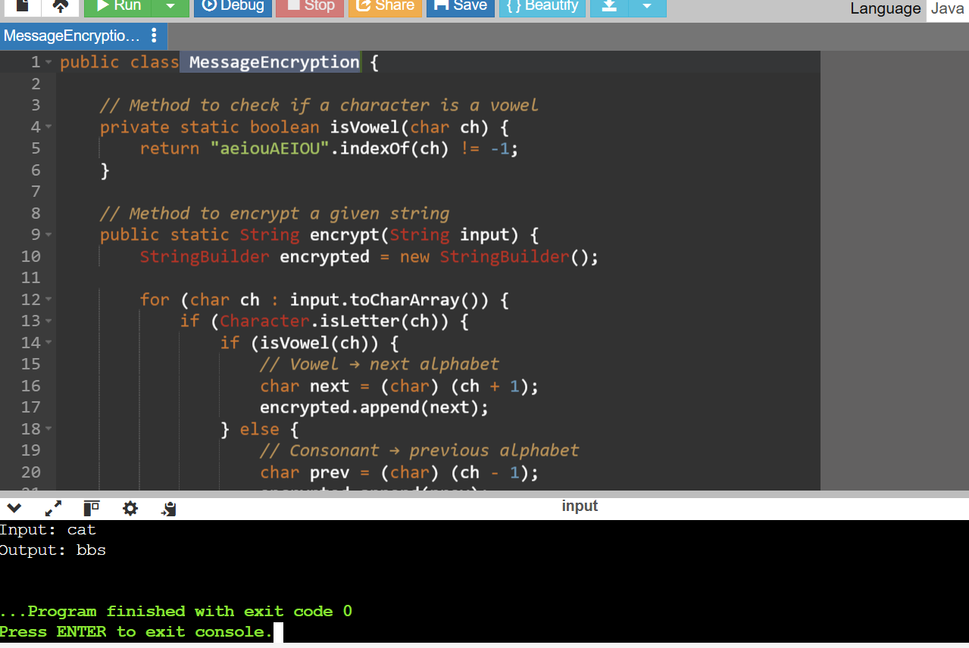

Problem Statement 6: Cab Fare Calculation Cab fare rules:

First 5 km → ₹10/km Next 5 km → ₹8/km After 10 km → ₹5/km
Input: 12
Output: Fare: 101

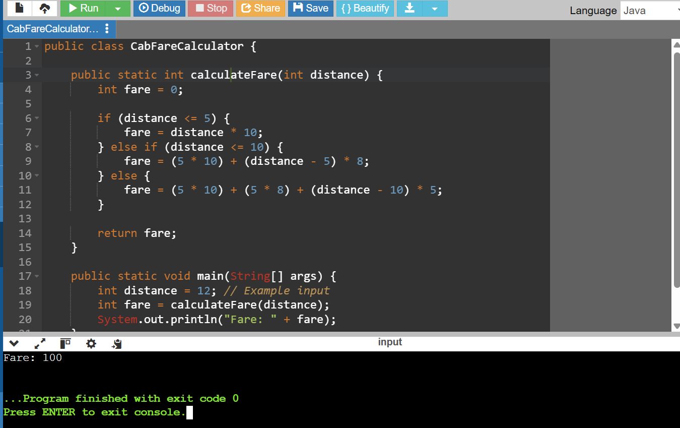

Problem Statement 7: String Frequency Analyzer Count frequency of each character.

Input: hello Output: h:1 e:1
l:2
o:1

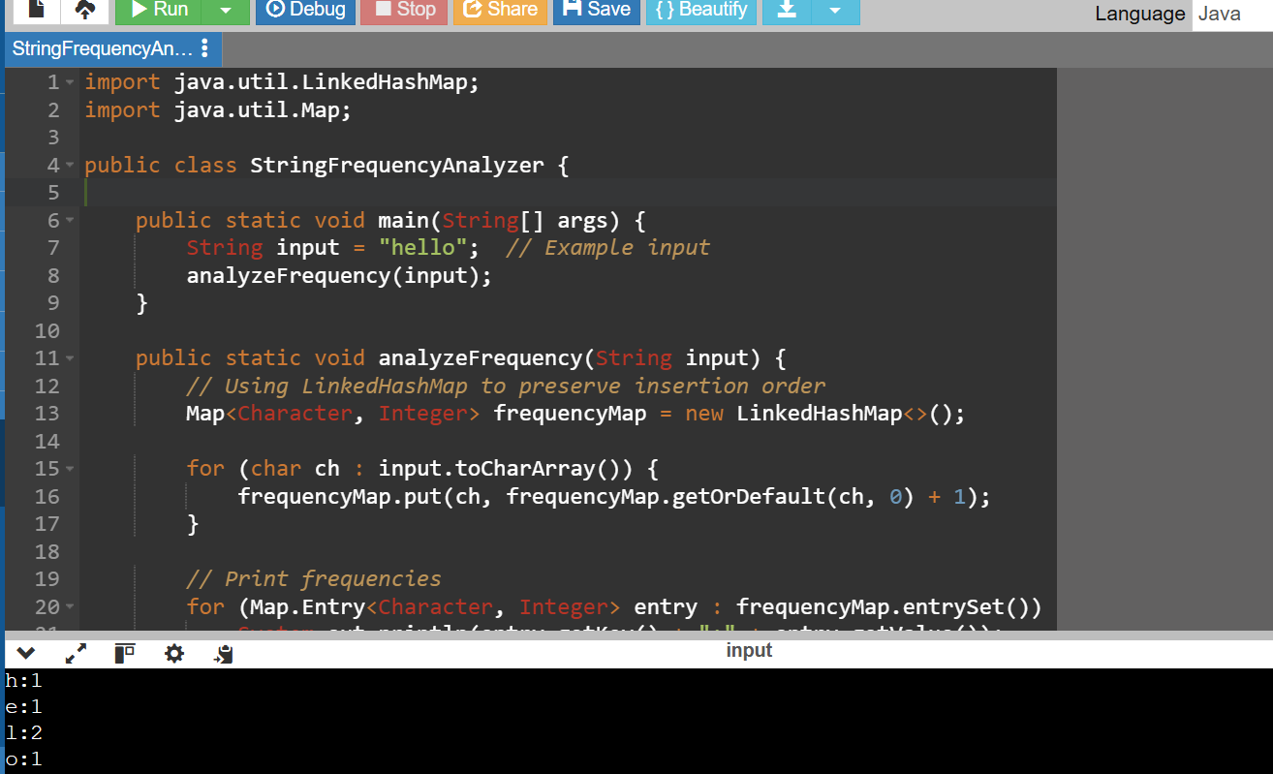

Problem Statement 8: Electricity Bill Generator Bill rules:
First 100 units → ₹5/unit Next 100 → ₹7/unit Above 200 → ₹10/unit

Input: 250
Bill: 1750
