**ASSIGNMENT FOR CLASS WORK**

**(Computer Networks Laboratory)**

**Name:** Kinjal Raykarmakar

**Enrolment No.:** 12018009019439

**Section:** 3H

**Roll No.:** 29

Design

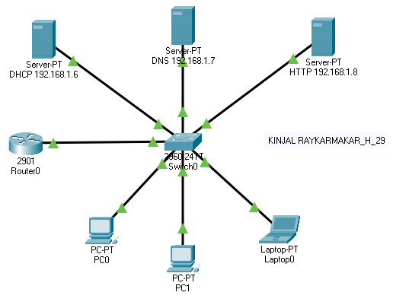

Configurations

# **DHCP Server**

