Protein Secondary Structure Prediction Project
Shrujana Kandadai, MSc Molecular Techniques in Life Science Spring 2026
Introduction
Protein secondary structure prediction is a fundamental challenge in computational biology because secondary structures form the bridge between a protein’s linear amino acid sequence and its functional three-dimensional structure. The three main structural elements—α-helices (H), β-strands (E), and random coils (C)—are stabilized by non-covalent interactions between residues. While α-helices are primarily governed by local hydrogen bonding, β-sheets often arise from interactions between residues that may be far apart in the primary sequence. Protein sequences also evolve over time, and residues important for structural stability or function tend to remain conserved or co-evolve with interacting partners. To capture this evolutionary signal, position-specific scoring matrices (PSSMs) derived from multiple sequence alignments are commonly used as input features for structure prediction models.
Deep learning approaches such as Recurrent Neural Networks (RNNs) are well suited for modelling biological sequences because they maintain a hidden state that propagates information across the sequence, enabling the capture of dependencies between distant residues. However, traditional RNNs often suffer from the vanishing gradient problem. This limitation can be addressed using gated architectures such as Gated Recurrent Units (GRUs), which regulate information flow and enable learning long-range relationships.
In this project, a Bidirectional GRU (Bi-GRU) network is implemented, trained on PSSM features, and by processing sequences in both forward and backward directions, it is able to capture local motifs and long-range interactions for accurate Q3 secondary structure prediction.
Materials/methods
- Dataset and Preprocessing
The model was trained and evaluated using protein sequences represented by Position-Specific Scoring Matrices (PSSM), where each amino acid residue is encoded as a 20-dimensional vector, capturing the evolutionary conservation and substitution probabilities derived from Multiple Sequence Alignment (MSA).
To ensure data alignment for batch processing, padding was used such that features (PSSM) were padded with 0.0, while structural labels (DSSP) were padded with -1. During the training phase, a binary masking approach was applied via the ignore_index parameter in the Cross-Entropy loss function, so only biological residues contributed to the gradient updates.
- Architecture
In this model, there are two parts, one is the “encoder” , featuring two stacked layers of Bidirectional Gated Recurrent Units (Bi-GRUs). Unlike sliding-window models, the Bi-GRU maintains a "hidden state" that captures long-range dependencies across the sequence. The bidirectional nature also allows the model to process information from both the N-terminal and C-terminal directions simultaneously, mimicking the global interactions that stabilize secondary structures. The second part is the “decoder” which consists of a linear classifier that projects these high-dimensional states into three-state logits (H, E, C).
- Training and Optimization
To optimise the model, firstly the 2 Bi-GRU layers were used followed by implementing a multi-layer perceptron (instead of the single linear classifier from before) which also comprises a ReLU activation and Dropout (0.3) to prevent vanishing gradients and overfitting, respectively. The model also uses a Cross-Entropy Loss with class weights to address the natural imbalance between Helices, Strands, and Coils. Optimization was performed using the Adam optimized, paired with a learning rate scheduler to ensure stable convergence as the model reached the global loss minimum.
Results
1. Baseline Model Performance : The initial phase of the study involved training a baseline Bi-GRU model with 64 hidden units, a fixed learning rate of 0.001, and unweighted Cross-Entropy loss. This model achieved an initial Q3 accuracy of approximately 66%. The training loss as well as the validation loss showed a steady decline, but the model seemed to be under-fit as it was ‘healthy’ but did not seem to reach its full potential (shown in Fig 1a).
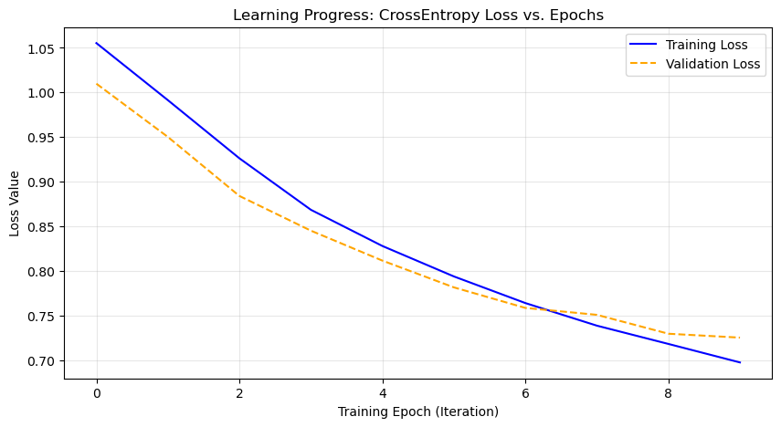
Figure 1. Loss curves for the ordinary Bi-GRU after 10 epochs
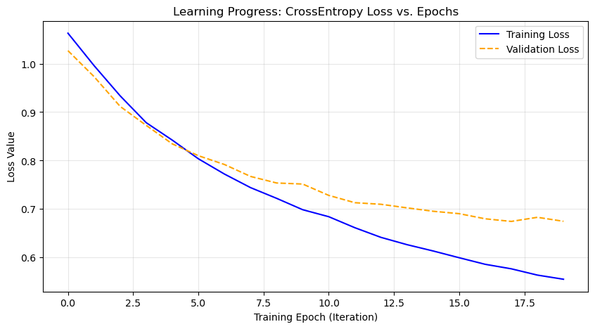
Figure 2. Loss curved for the ordinary Bi-GRU after 20 epochs.
In order to investigate the limitations of the baseline architecture, the model was trained for 20 epochs at a constant learning rate of 0.001 (Fig 2 ). While the Q3 accuracy improved to 71%, the validation learning curve showed some fluctuation between 0.69 and 0.70 after 10 epochs, indicating that the learning rate was too fast for it to settle to a global minimum (still underfit and slow convergence). Also, the widening gap between training and validation curves was indicative that the model may start overfitting. Hence, in the improved model regularization and learning rate decay using a scheduler is used to improve structural prediction.
As seen in Fig 3, for the model trained on 10 epochs, the confusion matrix revealed that while Alpha-Helices (H) were predicted with high precision, the model significantly struggled with Beta-Sheets (E), often misclassifying them as Coils (C).
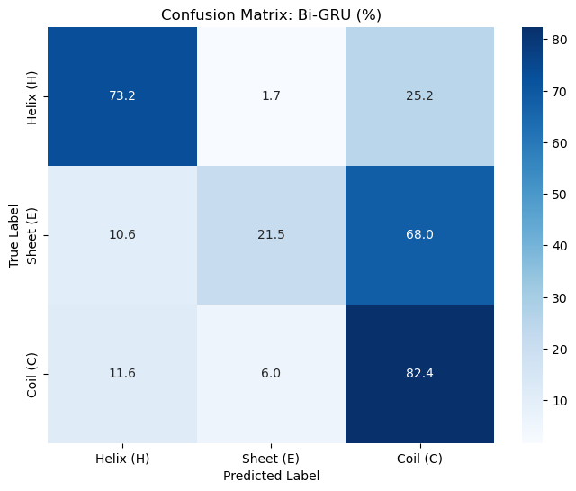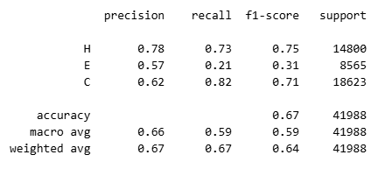
Figure 3. Confusion matrix and metrics for the ordinary Bi-GRU trained on 10 epochs.
Optimization and Refinement: To address the limitations of the baseline, three specific optimizations were implemented. First, class weights were introduced in the Cross Entropy Loss to compensate for the lower frequency of Beta-strands in the dataset. This forced the model to prioritize the correct identification of 'E' residues, by giving that class more weight. I also implemented a StepLR scheduler to reduce the learning rate by 0.1 every 5 epochs. This allowed for rapid initial learning followed by fine-tuning of the weights, leading to a smoother loss convergence, as seen in Fig 4. After optimization, the Q3 accuracy improved to 73%. As seen in Fig 5, the precision for Beta-strands increased by 4% and recall increased by 50%, demonstrating that the model improved slightly at classifying true positives beta strands but improved greatly for just identifying many of the beta strands, respectively.
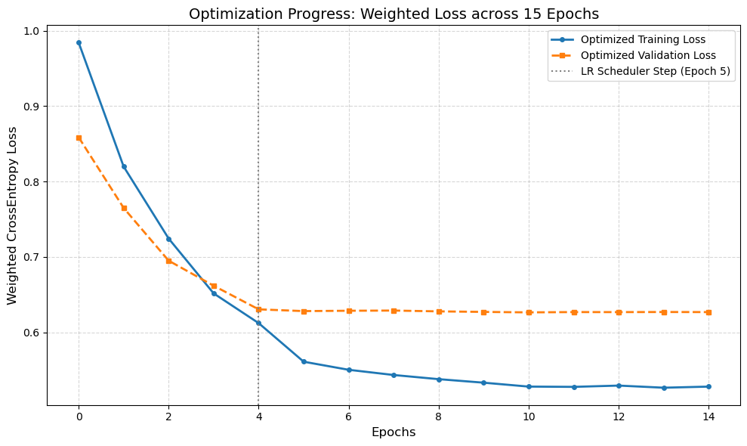
Figure 4. Loss curves for the optimised Bi-GRU run for 15 epochs.
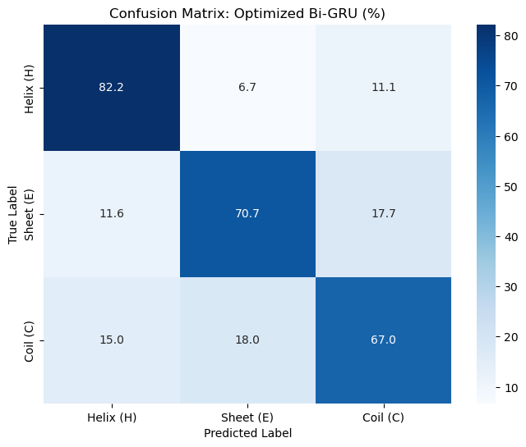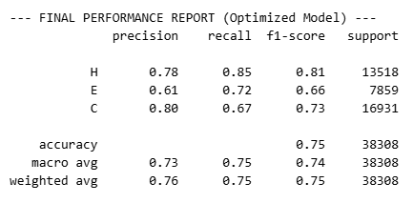
Figure 5 Confusion matrix and metrics for optimised Bi-GRU model trained for 15 epochs.
Ablation Studies – to further understand how parameters affect the Q3 accuracy I ablated these:
First, I compared the number of stacked Bi-GRU layers to find the optimal balance between model capacity and generalization. The 3-layer model outperformed the single layer by 3.5% in Q3 accuracy (thus achieving 77%), suggesting that the second layer is necessary to capture higher-order structural motifs that a shallower network cannot represent.
Second, I compared the learning Rate Sensitivity, to find the optimal step size that allows the model to descend the loss landscape without oscillating or stalling. A rate of 0.1 led to "exploding gradients" where the model failed to converge, while 0.0001 was too slow, for the given number of 10 epochs . The 0.001 rate was therefore used for stable and efficient training.
Third, I evaluated the effect of Hidden Layer Size which determines how much contextual information the Bi-GRU can retain about a residue’s environment. A size of 32 resulted in underfitting, while 256 led to overfitting on the training set. A hidden size of 128 was chosen as the optimal capacity, providing enough dimensionality to encode complex residue dependencies without sacrificing the model's ability to generalize to unseen validation data.
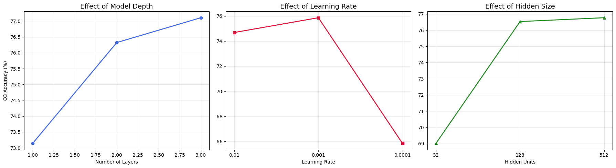
Figure 6 Changes in Q3 accuracy during ablation of model depth (number of GRU layers, learning rate and hidden size)
Conclusion/discussion
The results suggest that Bidirectional GRU architectures are well suited for protein secondary structure prediction. The final model achieved a Q3 accuracy of 73%, indicating that recurrent architectures can learn meaningful structural patterns directly from protein sequence data when combined with evolutionary information.
- One reason the model performs well is its ability to retain contextual information across the sequence. Protein folding is not purely local; structural elements such as β-sheets often depend on interactions between residues that are distant in sequence. By processing the sequence in both forward and backward directions, the Bi-GRU can incorporate information from surrounding residues when predicting the structural state of each position.
- Additionally, since PSSMs encode evolutionary conservation, the model also learns which residues are structurally constrained. This likely gives the network stronger cues about which positions are important for maintaining stable structural motifs.
- The ablation studies further suggest that increasing model depth and hidden dimension improves performance. This may reflect the model learning hierarchical representations, where lower layers capture local sequence patterns and deeper layers integrate broader structural context. Despite these improvements, predicting β-strands and coil regions remains challenging, likely because their formation depends on complex and flexible long-range interactions.
Credits: Gemini and ChatGPT was used for writing the code and understanding the outputs.
Link to public colab: https://colab.research.google.com/drive/1LAVcFecMEipg3SyLZvbNibTsZMSHoTZV?usp=sharing
References
- The model was inspired by a much more complex implementation in this paper:
- Wang, Y., Mao, H., & Yi, Z. (2017). Protein secondary structure prediction by using deep learning method. Knowledge-Based Systems, 118, 115–123. https://doi.org/10.1016/j.knosys.2016.11.015
- For the introduction
- Huang, Y. F., & Chen, S. Y. (2013). Extracting physicochemical features to predict protein secondary structure. TheScientificWorldJournal, 2013, 347106. https://doi.org/10.1155/2013/347106
- Mienye, I. D., Swart, T. G., & Obaido, G. (2024). Recurrent Neural Networks: A Comprehensive Review of Architectures, Variants, and Applications. Information, 15(9), 517. https://doi.org/10.3390/info15090517

