ReactJS Setup
Step 1:
Install Node
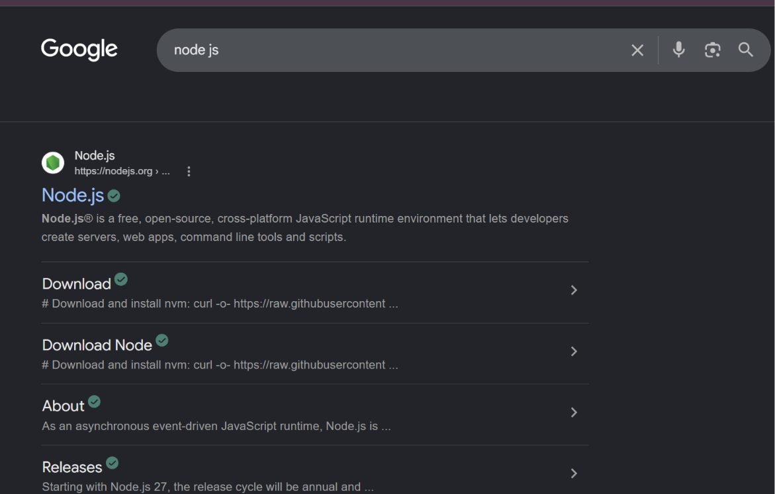
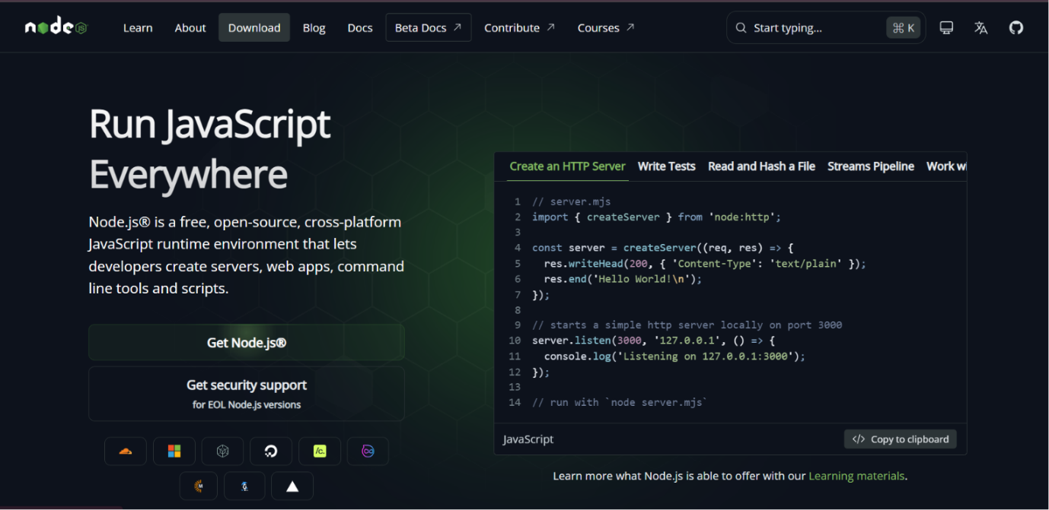
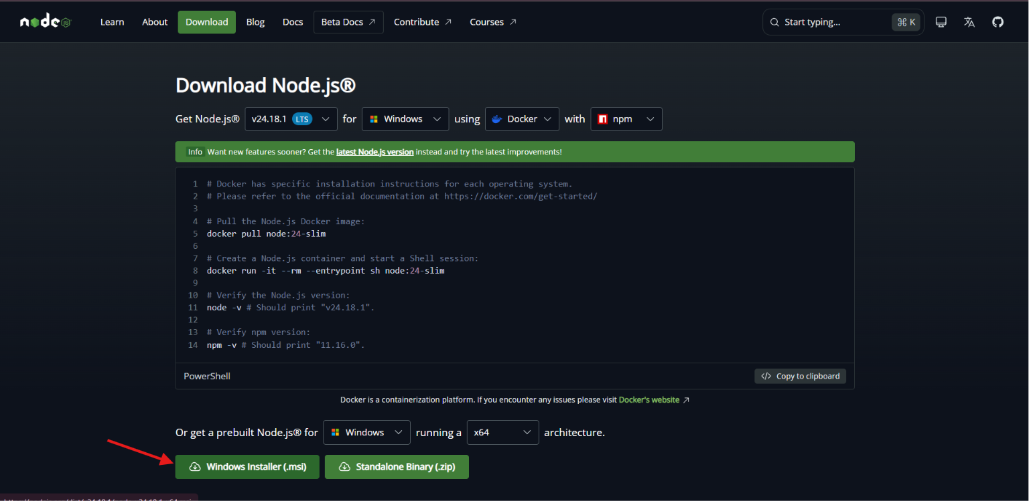
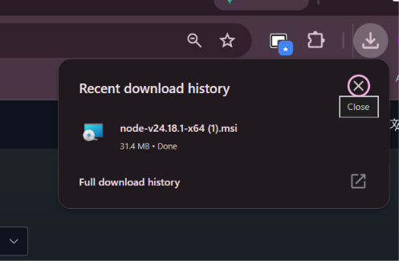
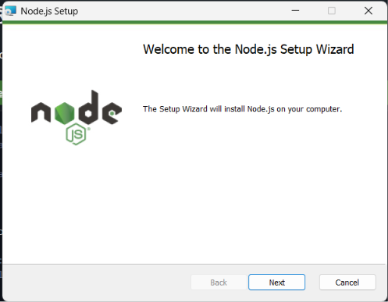
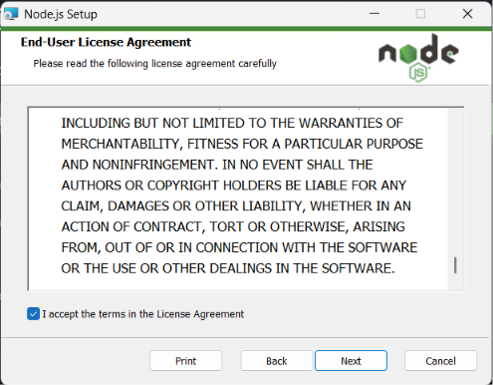
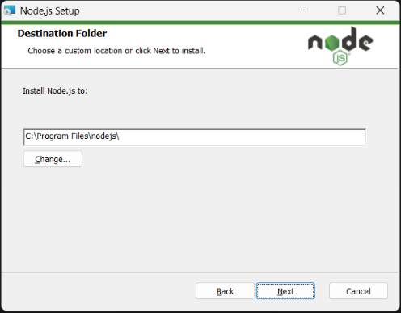
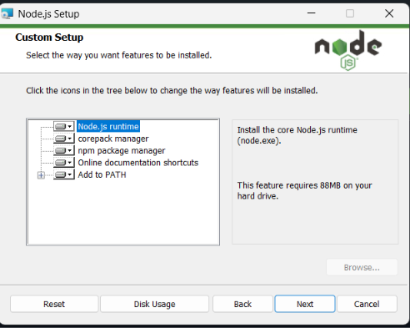
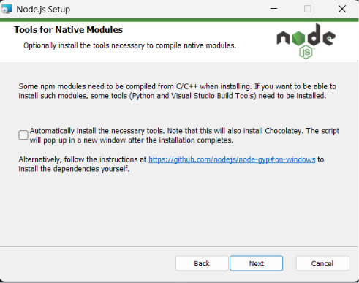
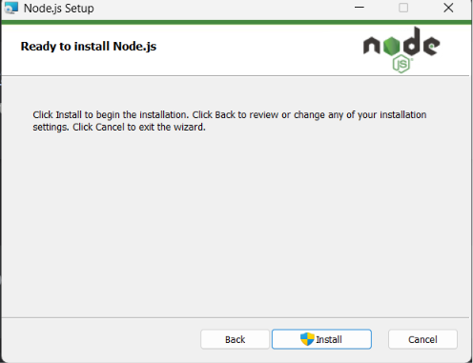
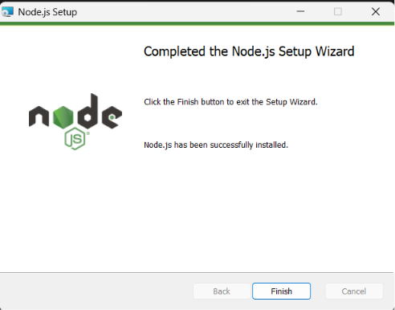

Check if its installed in cmd by : node -v command
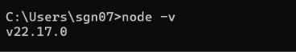

Step2 Installation of ReactJS
(Disclaimer: Throughout the semester we will use this projectFolder. Every labs from now on will be performed and implemented in this folder.
This will be your folder structure in the ProjectFolder that we create for lab work.
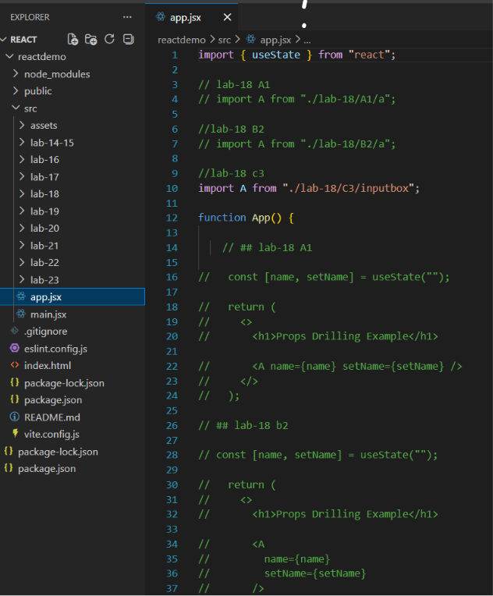
).

Installation by Vite(Recommended)
npm create vite@latest 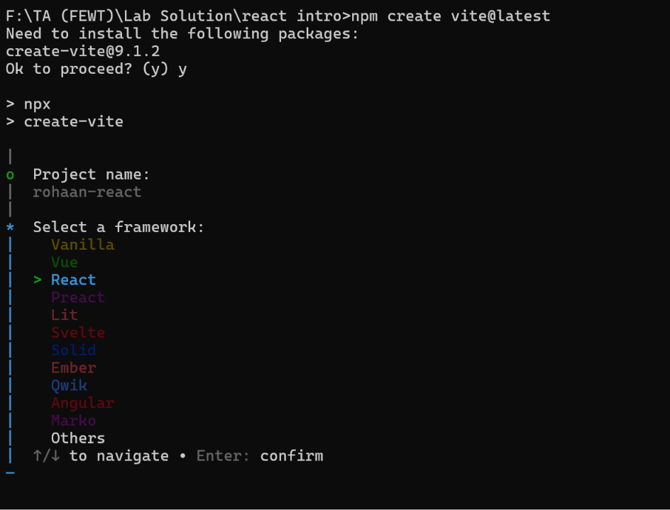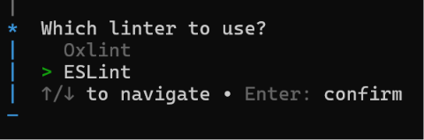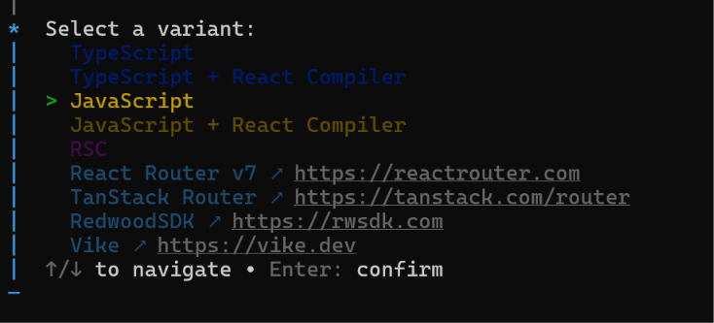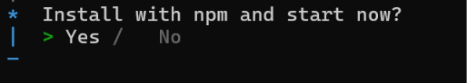

Command to stop the localhost: Ctrl + C (in cmd)
To start localhost:
Go to the project folder:
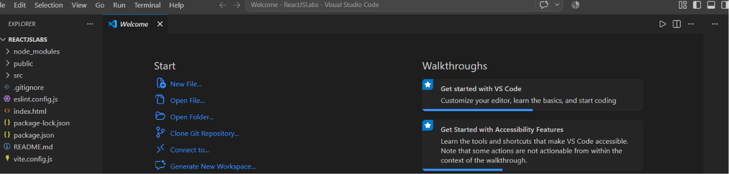

Open the terminal(shortcut: CTRL + J)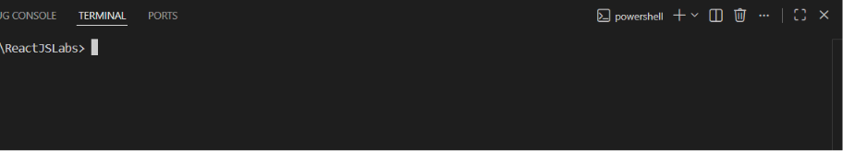

Switch powershell to command prompt:
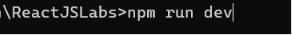
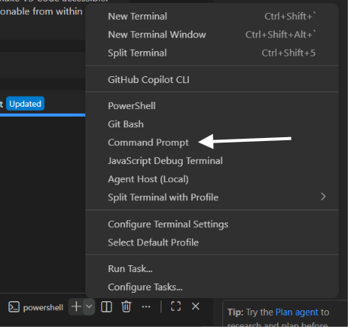
Run the following command:
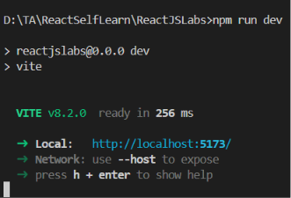Output

React Installation without Vite(W)
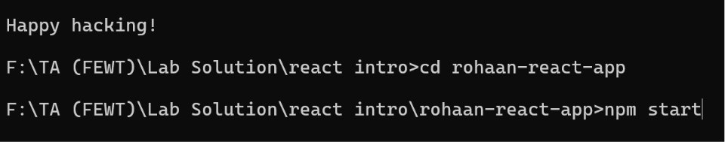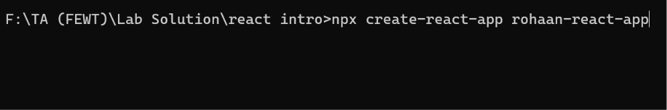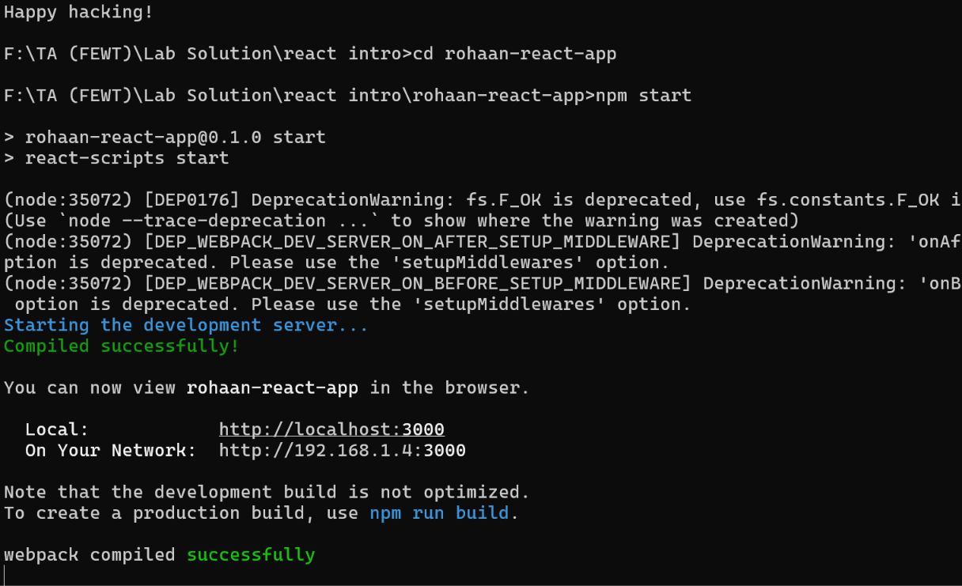

What is ReactJS?
React JS is a Javascript Library used majorly for frontend development.
How does it build?
It builds using Components . Components are UI elements of the project.
Example: Your Project: Movie Review Database Frontend.
Components: Header, MovieSlider, MovieItems, Trailers, LatestNews and Footer
How does it work?
Basically it doesn’t change the Document Object Model ( DOM ) in the browser directly.
Instead It creates a Virtual DOM and then updates the original DOM only the amnt it is needed.
React only changes what needs to be changed.

What is .jsx?
JSX stands for Javascript XML. It helps us to write HTML in a way that ReactJS accepts it.
const demoElement = <h1>This is only possible if we use JSX </h1>;
otherwise we will have to:
const demoElement = React.createElement('h1', {}, ‘This does not use jsx so we have to explicitly write this to convert in ReactUnderstandable format.');

