Git and Github
Assignment 1
Experiment 1: Introduction to Git
Objectives:
- Understand the basics of version control and the role of Git.
- Learn how to install and configure Git.
Tasks:
- Install Git on your local machine.
- Configure your Git username and email.
- Initialize a new Git repository.
- Understand the structure and purpose of the .git directory.
Output:
- Installation of Git on the local machine:
- Go to chrome or any browser.
- Search for Github login. And then u can access Github through a browser.

- Configure your Git username and email.
- After the Github login page opens up, it will look like something like the below.
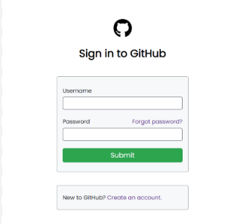
- Fill in the blank as directed.
- Then u have a Github account.
