Experiment 2
Creating a Local Repository and Understanding Git Workflow
Git workflow stages:
Working Directory → Staging Area → Repository
Procedure:
Create a folder and initialize Git.
mkdir myproject
cd myproject
git init
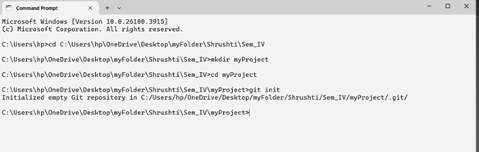
Output:
Git creates a hidden .git folder.
Result:
Local Git repository created successfully.

