Experiment 3
Git Basic Commands
Commands:
Initialize repository
git init
Create file
echo "Hello Git" > file.txt
Add file to staging area
git add file.txt
Commit changes
git commit -m "First commit"
Check repository status
git status
View commit history
git log
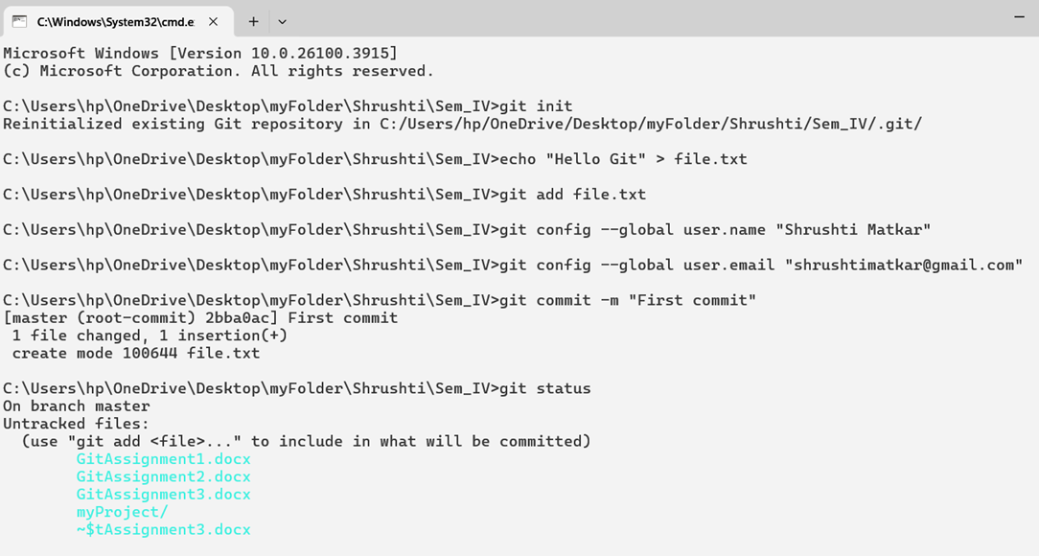
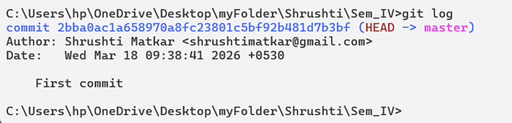

Result
Basic Git commands executed successfully.

