Experiment 4
Working with Branches
Aim
To create, switch, and delete branches.
Commands
Create branch
git branch feature
Switch branch
git checkout feature
Check branches
git branch
Delete branch
git branch -d feature

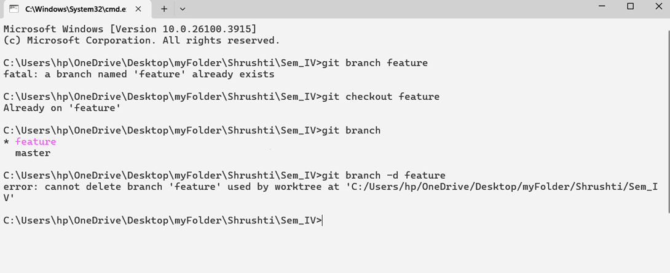

Result
Branch management operations performed successfully.

