Hingna Road, Wanadongri, Nagpur - 441 110
NAAC A++
Ph.: 07104-237919, 234623, 329249, 329250 Fax: 07104-232376, Website: www.ycce.edu

Department of Computer Technology

Vision of the Department
To be a well-known centre for pursuing computer education through innovative pedagogy, value-based education and industry
collaboration.

Mission of the Department
To establish learning ambience for ushering in computer engineering professionals in core and multidisciplinary area by developing Problem- solving skills through emerging technologies.

Session 2025-2026
Vision: Dream of where you want. | Mission: Means to achieve Vision
Program Educational Objectives of the program (PEO): (broad statements that describe the professional and career accomplishments)
PEO1 | Preparation | P: Preparation | Pep-CL abbreviation pronounce as Pep-si-lL easy to recall
PEO2 | Core Competence | E: Environment  (Learning Environment)
PEO3 | Breadth | P: Professionalism
PEO4 | Professionalism | C: Core Competence
PEO5 | Learning  Environment | L: Breadth (Learning in diverse areas)
Program Outcomes (PO): (statements that describe what a student should be able to do and know by the end of a program)
Keywords of POs:
Engineering knowledge, Problem analysis, Design/development of solutions, Conduct Investigations of Complex Problems, Engineering Tool Usage, The Engineer and The World, Ethics, Individual and Collaborative Team work, Communication, Project Management and Finance, Life-Long Learning
PSO Keywords: Cutting edge technologies, Research
“I am an engineer, and I know how to apply engineering knowledge to investigate, analyse and design solutions to complex problems using tools for entire world following all ethics in a collaborative way with proper management skills throughout my life.” to contribute to the development of cutting-edge technologies and Research.
Integrity: I will adhere to the Laboratory Code of Conduct and ethics in its entirety.
Name and Signature of Student and Date
(Signature and Date in Handwritten)
Hingna Road, Wanadongri, Nagpur - 441 110
NAAC A++
Ph.: 07104-237919, 234623, 329249, 329250 Fax: 07104-232376, Website: www.ycce.edu

Department of Computer Technology

Vision of the Department
To be a well-known centre for pursuing computer education through innovative pedagogy, value-based education and industry
collaboration.

Mission of the Department
To establish learning ambience for ushering in computer engineering professionals in core and multidisciplinary area by developing Problem- solving skills through emerging technologies.
Session | 2024-25 (ODD) |  | Course Name | Advanced Data Structure lab
Semester | 4 |  | Course Code | 23 ADS1404
Roll No | 120 |  | Name of Student | Shrusti Katakwar
Practical Number |  | 08
Course Outcome |  | - Understand pattern matching algorithms for searching in text  - Learn how to search for specific entries in an unsorted file efficiently  - Apply text processing for real-life problems like guest management  - Develop skills in file handling and string comparison
Aim |  | Program based on pattern matching
Problem Definition |  | A wedding planner is managing a guest list for an upcoming  wedding. The planner needs to quickly check whether a  specific guest&#39;s name is on the list. Since the guest list is stored  as a simple text document, the planner decides to use a pattern  matching algorithm to search for the name in the document.  Design a system that can:  1. Take a guest name as input (pattern).  2. Search for this name in an unsorted guest list stored in a  text file.  Return &quot;Guest Found&quot; if the name is in the list, or  &quot;Guest Not Found&quot; if the name is not in the list.
Theory (100 words) |  | In wedding planning, managing a large guest list can be challenging. The guest list is stored as a text file, which may not be sorted. To check if a specific guest is invited:  - Pattern matching can be used to search for the guest’s name  - A pattern is the name of the guest to be searched  - The system reads the file line by line and compares each entry with the input pattern
Procedure and Execution  (100 Words) |  | Algorithm :  • Input the guest name to search (pattern)  • Open the guest list file  • Read each line from the file:  - Compare the line with the input name  - If match found → print “Guest Found” and exit  • If the end of the file is reached without a match → print “Guest Not Found”  • Close the file
 |  | Code : 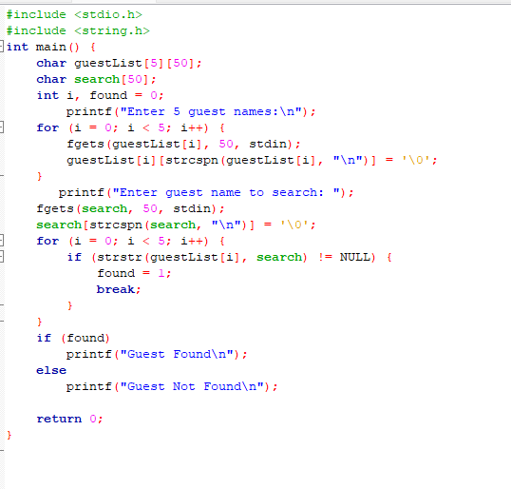
Output:

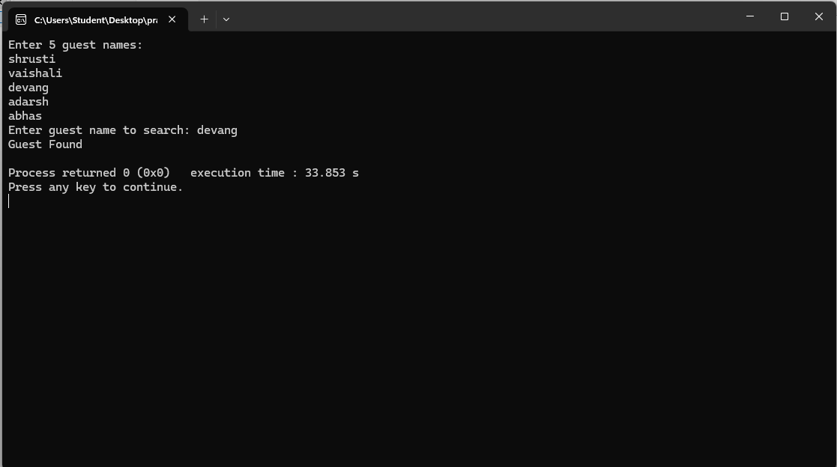

Output Analysis |  | Case 1: Guest Found  - Guest list contains:  Rahul Sharma  Anita Mehta  Priya Singh  - Input: Priya Singh  - Output:  Guest Found  ✅ Case 2: Guest Not Found  - Guest list contains:  Rahul Sharma  Anita Mehta  Priya Singh  - Input: Rohit Verma  - Output:  Guest Not Found
Link of student Github profile where lab assignment has

been uploaded
Conclusion | • Pattern matching allows quick verification of guests  • Avoids manual searching in large guest lists  • Can be applied to any file-based search problem  • Ensures accuracy and efficiency in event management
Plag Report  (Similarity index <  12%) | 
Date | 01/04/26

