Hingna Road, Wanadongri, Nagpur - 441 110
NAAC A++
Ph.: 07104-237919, 234623, 329249, 329250 Fax: 07104-232376, Website: www.ycce.edu

Department of Computer Technology

Vision of the Department
To be a well-known centre for pursuing computer education through innovative pedagogy, value-based education and industry
collaboration.

Mission of the Department
To establish learning ambience for ushering in computer engineering professionals in core and multidisciplinary area by developing Problem- solving skills through emerging technologies.

Session 2025-2026
Vision: Dream of where you want. | Mission: Means to achieve Vision
Program Educational Objectives of the program (PEO): (broad statements that describe the professional and career accomplishments)
PEO1 | Preparation | P: Preparation | Pep-CL abbreviation pronounce as Pep-si-lL easy to recall
PEO2 | Core Competence | E: Environment  (Learning Environment)
PEO3 | Breadth | P: Professionalism
PEO4 | Professionalism | C: Core Competence
PEO5 | Learning  Environment | L: Breadth (Learning in diverse areas)
Program Outcomes (PO): (statements that describe what a student should be able to do and know by the end of a program)
Keywords of POs:
Engineering knowledge, Problem analysis, Design/development of solutions, Conduct Investigations of Complex Problems, Engineering Tool Usage, The Engineer and The World, Ethics, Individual and Collaborative Team work, Communication, Project Management and Finance, Life-Long Learning
PSO Keywords: Cutting edge technologies, Research
“I am an engineer, and I know how to apply engineering knowledge to investigate, analyse and design solutions to complex problems using tools for entire world following all ethics in a collaborative way with proper management skills throughout my life.” to contribute to the development of cutting-edge technologies and Research.
Integrity: I will adhere to the Laboratory Code of Conduct and ethics in its entirety.
Name and Signature of Student and Date
(Signature and Date in Handwritten)
Hingna Road, Wanadongri, Nagpur - 441 110
NAAC A++
Ph.: 07104-237919, 234623, 329249, 329250 Fax: 07104-232376, Website: www.ycce.edu

Department of Computer Technology

Vision of the Department
To be a well-known centre for pursuing computer education through innovative pedagogy, value-based education and industry
collaboration.

Mission of the Department
To establish learning ambience for ushering in computer engineering professionals in core and multidisciplinary area by developing Problem- solving skills through emerging technologies.
Session | 2024-25 (ODD) |  | Course Name | Advanced Data Structure lab
Semester | 4 |  | Course Code | 23 ADS1404
Roll No | 120 |  | Name of Student | Shrusti Katakwar
Practical Number |  | 06
Course Outcome |  | • Represent a city road network as a weighted graph  • Learn how to compute the shortest path between locations  • Apply Dijkstra’s algorithm to determine optimal routes  • Analyze travel distances and efficiency in urban networks
Aim |  | Design a navigation system for a city road network where  intersections are represented as nodes and roads with travel  distances are represented as weighted edges.  Apply Dijkstra’s algorithm to compute the shortest travel  path from a selected source location to all other destinations, helping users choose the most efficient route.
Problem Definition |  | Design a navigation system for a city road network where  intersections are represented as nodes and roads with travel  distances are represented as weighted edges.  Apply Dijkstra’s algorithm to compute the shortest travel  path from a selected source location to all other destinations, helping users choose the most efficient route.
Theory (100 words) |  | A city road network can be modeled using a weighted graph:  - Nodes (vertices) → intersections or locations  - Edges → roads connecting intersections  - Weights → travel distance, time, or cost for each road
Procedure and Execution  (100 Words) |  | Algorithm :  • Create a weighted graph of the city network  • Set distance[source] = 0 and distance[other nodes] = ∞  • While unvisited nodes exist:  - Pick node u with smallest distance  - For each neighbor v of u:  - If distance[u] + weight(u,v) < distance[v]  → update distance[v]  - Mark u as visited  • Continue until all nodes are visited  • Output shortest distances and paths
Code:

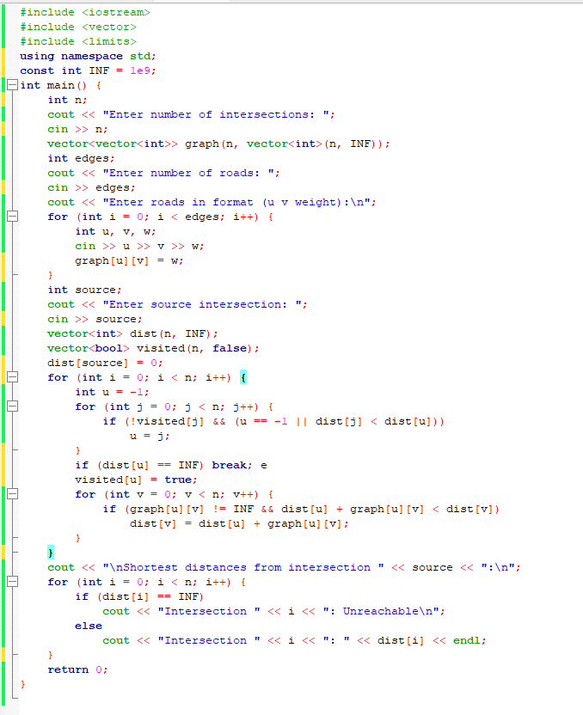

Output:
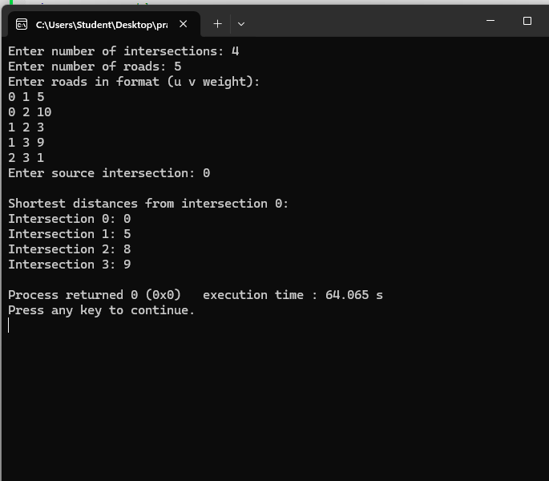

Output Analysis |  | Example Case  City Network:  - Nodes: A, B, C, D  - Roads with distances:  A → B = 5, A → C = 10  B → C = 3, B → D = 9  C → D = 1  Source: A  Output:  Shortest distance from A:  A → A = 0  A → B = 5  A → C = 8 (via B)  A → D = 9 (via C)  Interpretation:  - The system finds the minimum travel distance to all intersections  - Suggests efficient routes to avoid longer paths
Link of student Github profile where lab assignment has
Hingna Road, Wanadongri, Nagpur - 441 110
NAAC A++
Ph.: 07104-237919, 234623, 329249, 329250 Fax: 07104-232376, Website: www.ycce.edu

Department of Computer Technology

Vision of the Department
To be a well-known centre for pursuing computer education through innovative pedagogy, value-based education and industry
collaboration.

Mission of the Department
To establish learning ambience for ushering in computer engineering professionals in core and multidisciplinary area by developing Problem- solving skills through emerging technologies.
been uploaded
Conclusion | • Dijkstra’s algorithm is effective for urban navigation systems  • Helps plan routes efficiently and reduce travel time  • Supports traffic management, GPS navigation, and smart city planning  • Ensures that users reach their destination by the shortest path
Plag Report  (Similarity index <  12%) | 
Date | 01/04/26

