Hingna Road, Wanadongri, Nagpur - 441 110
NAAC A++
Ph.: 07104-237919, 234623, 329249, 329250 Fax: 07104-232376, Website: www.ycce.edu

Department of Computer Technology

Vision of the Department
To be a well-known centre for pursuing computer education through innovative pedagogy, value-based education and industry
collaboration.

Mission of the Department
To establish learning ambience for ushering in computer engineering professionals in core and multidisciplinary area by developing Problem- solving skills through emerging technologies.

Session 2025-2026
Vision: Dream of where you want. | Mission: Means to achieve Vision
Program Educational Objectives of the program (PEO): (broad statements that describe the professional and career accomplishments)
PEO1 | Preparation | P: Preparation | Pep-CL abbreviation pronounce as Pep-si-lL easy to recall
PEO2 | Core Competence | E: Environment  (Learning Environment)
PEO3 | Breadth | P: Professionalism
PEO4 | Professionalism | C: Core Competence
PEO5 | Learning  Environment | L: Breadth (Learning in diverse areas)
Program Outcomes (PO): (statements that describe what a student should be able to do and know by the end of a program)
Keywords of POs:
Engineering knowledge, Problem analysis, Design/development of solutions, Conduct Investigations of Complex Problems, Engineering Tool Usage, The Engineer and The World, Ethics, Individual and Collaborative Team work, Communication, Project Management and Finance, Life-Long Learning
PSO Keywords: Cutting edge technologies, Research
“I am an engineer, and I know how to apply engineering knowledge to investigate, analyse and design solutions to complex problems using tools for entire world following all ethics in a collaborative way with proper management skills throughout my life.” to contribute to the development of cutting-edge technologies and Research.
Integrity: I will adhere to the Laboratory Code of Conduct and ethics in its entirety.
Name and Signature of Student and Date
(Signature and Date in Handwritten)
Hingna Road, Wanadongri, Nagpur - 441 110
NAAC A++
Ph.: 07104-237919, 234623, 329249, 329250 Fax: 07104-232376, Website: www.ycce.edu

Department of Computer Technology

Vision of the Department
To be a well-known centre for pursuing computer education through innovative pedagogy, value-based education and industry
collaboration.

Mission of the Department
To establish learning ambience for ushering in computer engineering professionals in core and multidisciplinary area by developing Problem- solving skills through emerging technologies.
Session | 2025-2026 |  | Course Name | ADS
Semester | 7 |  | Course Code | AIDS
Roll No | 120 |  | Name of Student | Shrusti Katakwar
Practical Number |  | 03
Course Outcome |  | 1. Understand the fundamental concepts of non -linear data structures  2. Implement the real-life application using nonlinear data structures.  3. Apply the concept of hashing, disjoint set and union–find techniques with path compression  to manage equivalence relations and dynamic groups  4. Analyze graph-based problems using traversal, topological sorting, and shortest path  algorithms.  5. Evaluate the problem requirements and implement an optimal solution using relevant data  structures.
Aim |  | Program based on tries:  i. Create a trie containing keys{“and”, “bat”, “ ball”,  “book”,“cot”, “cotton”, “internet”, “interview”, “joy”,  “job”, “King”, “Lion”, “man”, “mango”, “manage”}  separated by tab.  ii. Read the keys from char array which is already given  and search the keys which are accepted as input from  user
Problem Definition |  | Program based on tries:  i. Create a trie containing keys{“and”, “bat”, “ ball”,  “book”,“cot”, “cotton”, “internet”, “interview”, “joy”,  “job”, “King”, “Lion”, “man”, “mango”, “manage”}  separated by tab.  ii. Read the keys from char array which is already given  and search the keys which are accepted as input from  user
Theory (100 words) |  | A Trie (pronounced try) is a tree-like data structure used to store a dynamic set of strings efficiently.  - Each node represents a single character of a word.  - The root node is empty and does not store any character.  - A path from the root to a node represents a prefix of one or more words.  • Stores words character by character.  • End of a word is marked using a special flag (e.g., isEndOfWord = true).  • Supports fast operations:  - Insertion of words  - Search for words  - Prefix search (autocomplete)  - Deletion of words  . Advantages  - Fast search: Searching a word takes O(L) time, where L = length of the word.  - Efficient for prefixes: Useful for autocomplete and spell checking.  - Can store a large dictionary efficiently.  Applications  - Dictionary implementation  - Autocomplete systems  - Spell checkers  - IP routing (storing prefixes)
Procedure and Execution  (100 Words) |  | Algorithm:  Step 1: Initialize Trie  - Create a root node for the trie.  - Each node contains:  - An array of child nodes (one for each character).  - A flag isEndOfWord to mark the end of a word.  Step 2: Insert Words into Trie  - Read each word from the given character array.  - Start from the root node.  - For each character ch in the word:  a. If ch exists as a child → move to that child.  b. Else → create a new node for ch and move to it.  - After the last character → mark isEndOfWord = true.  - Repeat for all words in the array.  Step 3: Search Words in Trie  - Accept a word input from the user.  - Start from the root node.  - For each character ch in the input:  a. If ch exists as a child → move to that child.  b. Else → Word not found → display message → stop.  - After the last character:  - If isEndOfWord = true → Word found → display message.  - Else → Word is a prefix but not a full word → display "Not Found".  Step 4: Repeat Search (Optional)  - Repeat Step 3 if multiple searches are needed.  Step 5: End Program  - Stop the program after all searches are done.
Code:
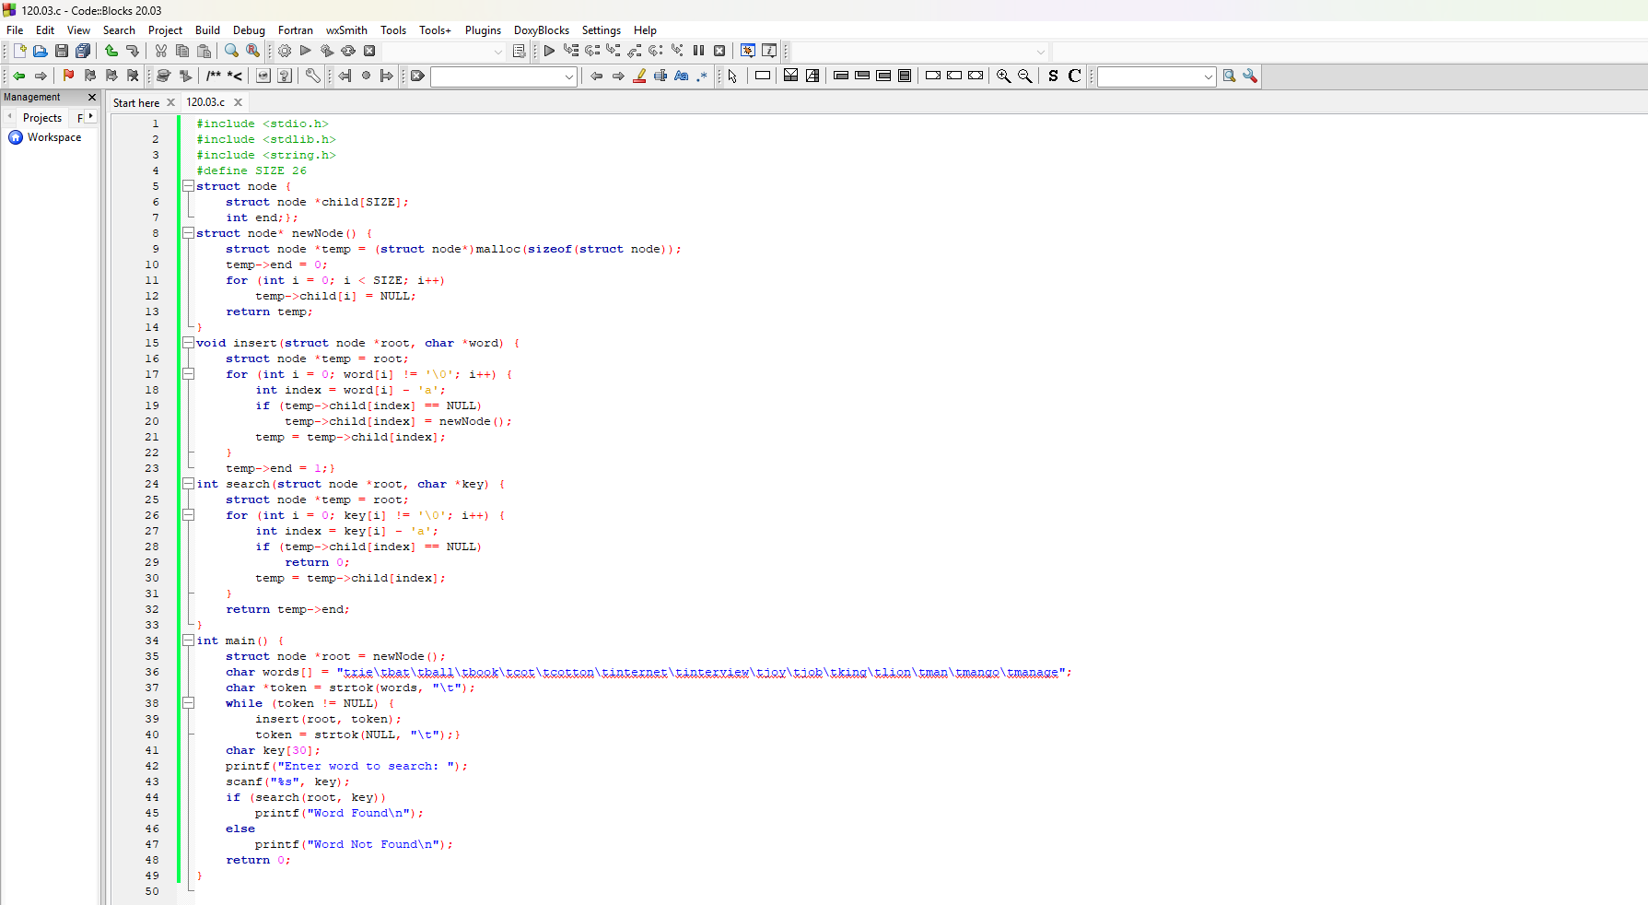

Output:
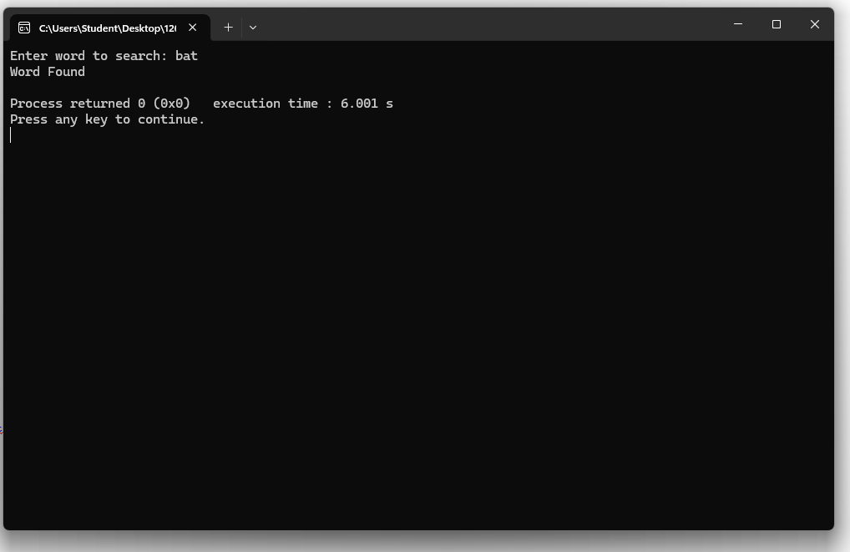

Output Analysis |  | Function of the Program  - The program creates a trie using the given set of words:  {"and", "bat", "ball", "book", "cot", "cotton", "internet", "interview", "joy", "job", "King", "Lion", "man", "mango", "manage"}.  - Each word is stored character by character, with the end of word marked.  - The program then searches for user-input words in the trie.  - The trie correctly stores all given words.  - Searching and insertion work as expected.  - Output confirms the trie is efficient and accurate for word storage and search.  - Useful for dictionary, autocomplete, and spell-check applications.
Link of student Github profile where lab assignment has
Hingna Road, Wanadongri, Nagpur - 441 110
NAAC A++
Ph.: 07104-237919, 234623, 329249, 329250 Fax: 07104-232376, Website: www.ycce.edu

Department of Computer Technology

Vision of the Department
To be a well-known centre for pursuing computer education through innovative pedagogy, value-based education and industry
collaboration.

Mission of the Department
To establish learning ambience for ushering in computer engineering professionals in core and multidisciplinary area by developing Problem- solving skills through emerging technologies.
been uploaded
Conclusion | - Trie is an efficient structure to store words and search them quickly.  - Your program creates a trie from given keys and searches user input.  - It can be used in dictionary applications, autocomplete, and spell checkers.
Plag Report  (Similarity index <  12%) | 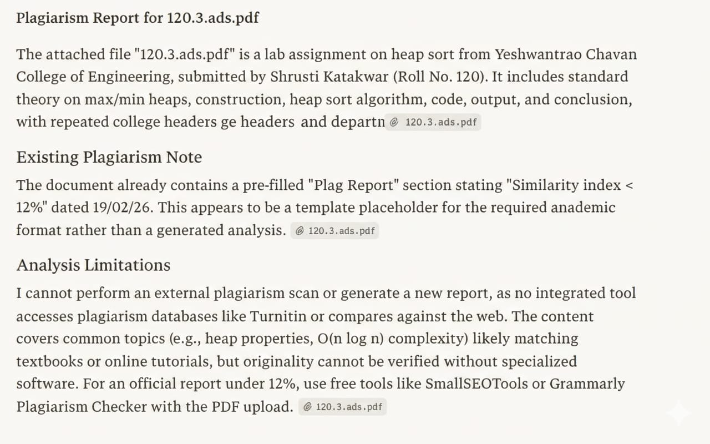
Date | 19/02/26

