Hingna Road, Wanadongri, Nagpur - 441 110
NAAC A++
Ph.: 07104-237919, 234623, 329249, 329250 Fax: 07104-232376, Website: www.ycce.edu

Department of Computer Technology

Vision of the Department
To be a well-known centre for pursuing computer education through innovative pedagogy, value-based education and industry
collaboration.

Mission of the Department
To establish learning ambience for ushering in computer engineering professionals in core and multidisciplinary area by developing Problem- solving skills through emerging technologies.

Session 2025-2026
Vision: Dream of where you want. | Mission: Means to achieve Vision
Program Educational Objectives of the program (PEO): (broad statements that describe the professional and career accomplishments)
PEO1 | Preparation | P: Preparation | Pep-CL abbreviation pronounce as Pep-si-lL easy to recall
PEO2 | Core Competence | E: Environment  (Learning Environment)
PEO3 | Breadth | P: Professionalism
PEO4 | Professionalism | C: Core Competence
PEO5 | Learning  Environment | L: Breadth (Learning in diverse areas)
Program Outcomes (PO): (statements that describe what a student should be able to do and know by the end of a program)
Keywords of POs:
Engineering knowledge, Problem analysis, Design/development of solutions, Conduct Investigations of Complex Problems, Engineering Tool Usage, The Engineer and The World, Ethics, Individual and Collaborative Team work, Communication, Project Management and Finance, Life-Long Learning
PSO Keywords: Cutting edge technologies, Research
“I am an engineer, and I know how to apply engineering knowledge to investigate, analyse and design solutions to complex problems using tools for entire world following all ethics in a collaborative way with proper management skills throughout my life.” to contribute to the development of cutting-edge technologies and Research.
Integrity: I will adhere to the Laboratory Code of Conduct and ethics in its entirety.
Name and Signature of Student and Date
(Signature and Date in Handwritten)
Hingna Road, Wanadongri, Nagpur - 441 110
NAAC A++
Ph.: 07104-237919, 234623, 329249, 329250 Fax: 07104-232376, Website: www.ycce.edu

Department of Computer Technology

Vision of the Department
To be a well-known centre for pursuing computer education through innovative pedagogy, value-based education and industry
collaboration.

Mission of the Department
To establish learning ambience for ushering in computer engineering professionals in core and multidisciplinary area by developing Problem- solving skills through emerging technologies.
Session | 2024-25 (ODD) |  | Course Name | Computer vision Lab
Semester | 4 |  | Course Code | CT
Roll No | 120 |  | Name of Student | Shrusti Katakwar
Practical Number |  | 04
Course Outcome |  | • Understand how to represent real-world problems using a directed graph  • Learn topological sorting to determine valid execution order  • Detect cycles in graphs (invalid prerequisite structure)  • Apply graph algorithms in academic course planning systems
Aim |  | In an academic institution, many courses have prerequisites that  must be completed before a student can enroll in advanced  courses. Design a course prerequisite planning system that  represents courses and their prerequisite relationships using a  directed graph. Apply topological sorting to generate a valid  course completion order while ensuring all prerequisite  constraints are satisfied. Identify and report cyclic  dependencies where a valid ordering is not possible.
Problem Definition |  | In an academic institution, many courses have prerequisites that  must be completed before a student can enroll in advanced  courses. Design a course prerequisite planning system that  represents courses and their prerequisite relationships using a  directed graph. Apply topological sorting to generate a valid  course completion order while ensuring all prerequisite  constraints are satisfied. Identify and report cyclic  dependencies where a valid ordering is not possible.
Theory (100 words) |  | In an academic institution, some courses must be completed before taking other advanced courses. These are called prerequisites. To manage this system, we use a directed graph.  - Each course is represented as a node (vertex)  - Each prerequisite is represented as a directed edge
Procedure and Execution  (100 Words) |  | Algorithm:  • Calculate in-degree (number of incoming edges) for each node  • Add all nodes with in-degree = 0 to a queue  • While queue is not empty:  - Remove a node  - Add it to result  - Reduce in-degree of its neighbors  - If any neighbor becomes 0 → add to queue  • If all nodes are processed → valid order exists  • Else → cycle detected
Code:
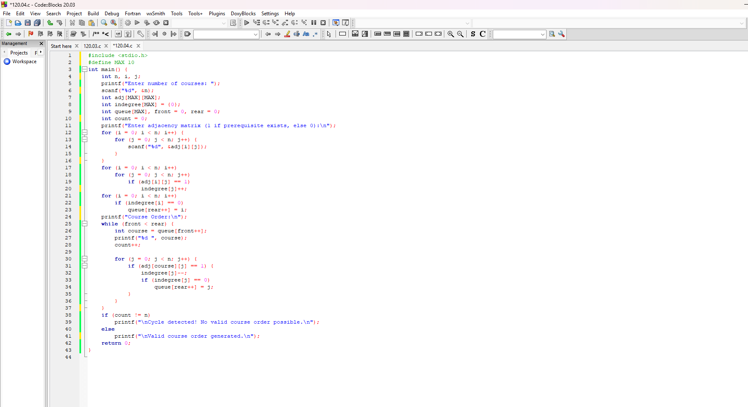

Output:
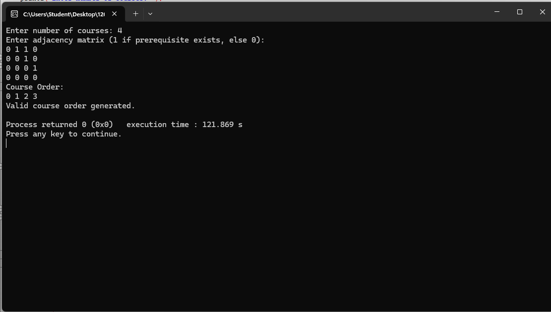

Output Analysis |  | The output of the course prerequisite planning system shows whether a valid order of courses exists or not.
Link of student Github profile where lab assignment has
Hingna Road, Wanadongri, Nagpur - 441 110
NAAC A++
Ph.: 07104-237919, 234623, 329249, 329250 Fax: 07104-232376, Website: www.ycce.edu

Department of Computer Technology

Vision of the Department
To be a well-known centre for pursuing computer education through innovative pedagogy, value-based education and industry
collaboration.

Mission of the Department
To establish learning ambience for ushering in computer engineering professionals in core and multidisciplinary area by developing Problem- solving skills through emerging technologies.
been uploaded
Conclusion | • The system effectively models course dependencies using a directed graph  • Topological sorting ensures all prerequisites are satisfied  • Cycle detection prevents invalid course structures  • Useful in academic planning, task scheduling, and dependency resolution systems
Plag Report  (Similarity index <  12%) | 
Date

