Hingna Road, Wanadongri, Nagpur - 441 110
NAAC A++
Ph.: 07104-237919, 234623, 329249, 329250 Fax: 07104-232376, Website: www.ycce.edu

Department of Computer Technology

Vision of the Department
To be a well-known centre for pursuing computer education through innovative pedagogy, value-based education and industry
collaboration.

Mission of the Department
To establish learning ambience for ushering in computer engineering professionals in core and multidisciplinary area by developing Problem- solving skills through emerging technologies.

Session 2025-2026
Vision: Dream of where you want. | Mission: Means to achieve Vision
Program Educational Objectives of the program (PEO): (broad statements that describe the professional and career accomplishments)
PEO1 | Preparation | P: Preparation | Pep-CL abbreviation pronounce as Pep-si-lL easy to recall
PEO2 | Core Competence | E: Environment  (Learning Environment)
PEO3 | Breadth | P: Professionalism
PEO4 | Professionalism | C: Core Competence
PEO5 | Learning  Environment | L: Breadth (Learning in diverse areas)
Program Outcomes (PO): (statements that describe what a student should be able to do and know by the end of a program)
Keywords of POs:
Engineering knowledge, Problem analysis, Design/development of solutions, Conduct Investigations of Complex Problems, Engineering Tool Usage, The Engineer and The World, Ethics, Individual and Collaborative Team work, Communication, Project Management and Finance, Life-Long Learning
PSO Keywords: Cutting edge technologies, Research
“I am an engineer, and I know how to apply engineering knowledge to investigate, analyse and design solutions to complex problems using tools for entire world following all ethics in a collaborative way with proper management skills throughout my life.” to contribute to the development of cutting-edge technologies and Research.
Integrity: I will adhere to the Laboratory Code of Conduct and ethics in its entirety.
Name and Signature of Student and Date
(Signature and Date in Handwritten)
Hingna Road, Wanadongri, Nagpur - 441 110
NAAC A++
Ph.: 07104-237919, 234623, 329249, 329250 Fax: 07104-232376, Website: www.ycce.edu

Department of Computer Technology

Vision of the Department
To be a well-known centre for pursuing computer education through innovative pedagogy, value-based education and industry
collaboration.

Mission of the Department
To establish learning ambience for ushering in computer engineering professionals in core and multidisciplinary area by developing Problem- solving skills through emerging technologies.
Session | 2024-25 (ODD) |  | Course Name | Advanced Data Structure lab
Semester | 4 |  | Course Code | 23 ADS1404
Roll No | 120 |  | Name of Student | Shrusti Katakwar
Practical Number |  | 05
Course Outcome |  | • Understand how networks can be represented using graphs  • Learn to identify critical nodes (articulation points) in a network  • Analyze how failure of a single node affects connectivity  • Apply graph algorithms in network reliability and fault detection
Aim |  | Program for detection of single node failure in a network
Problem Definition |  | Program for detection of single node failure in a network
Theory (100 words) |  | A computer network can be represented as a graph, where:  - Nodes (vertices) represent computers/routers  - Edges represent communication links  In such a network, a single node failure means one node stops working. This may break the network into disconnected parts.  A node is called a critical node or articulation point if:  - Removing it increases the number of disconnected components in the graph
Procedure and Execution  (100 Words) |  | Algorithm :  - Represent the network as a graph  - Initialize arrays:  - Discovery time (disc[])  - Lowest reachable node (low[])  - Parent array  - Perform Depth First Search (DFS)  - For each node:  - Track discovery time and low value  - Check conditions:  - Root node with more than one child → articulation point  - Non-root node where low[child] ≥ disc[node] → articulation point  - Mark such nodes as critical nodes
Code:
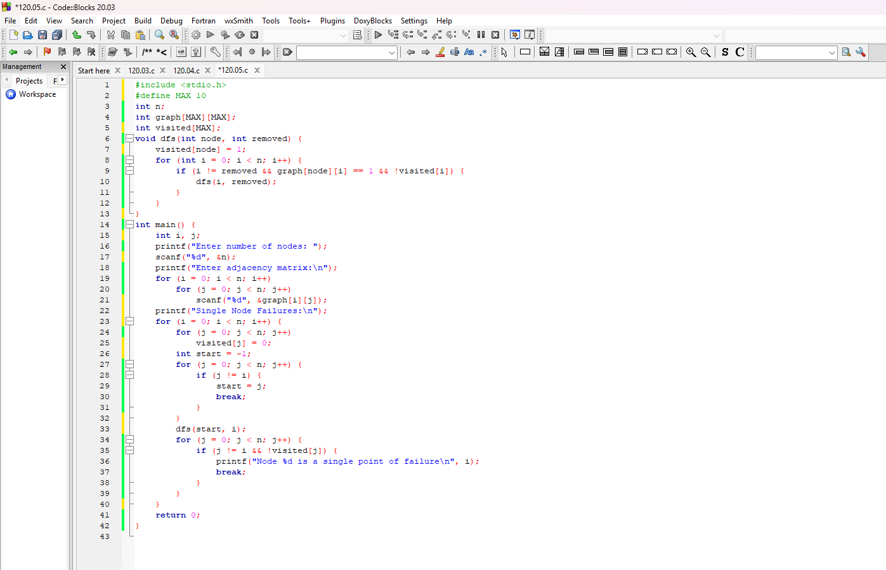

Output:
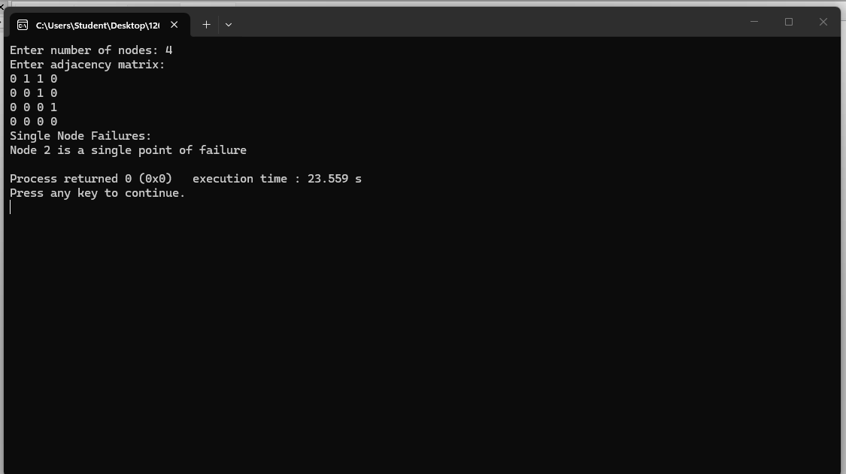

Output Analysis |  | The output of the system identifies whether there are any critical nodes (articulation points) in the network. These are nodes whose failure can disrupt the connectivity of the entire network.
Link of student Github profile where lab assignment has
Hingna Road, Wanadongri, Nagpur - 441 110
NAAC A++
Ph.: 07104-237919, 234623, 329249, 329250 Fax: 07104-232376, Website: www.ycce.edu

Department of Computer Technology

Vision of the Department
To be a well-known centre for pursuing computer education through innovative pedagogy, value-based education and industry
collaboration.

Mission of the Department
To establish learning ambience for ushering in computer engineering professionals in core and multidisciplinary area by developing Problem- solving skills through emerging technologies.
been uploaded
Conclusion | • The system helps detect single points of failure in a network  • Identifying articulation points improves network design and reliability  • Ensures better fault tolerance and communication stability  • Useful in computer networks, power grids, and transportation systems
Plag Report  (Similarity index <  12%) | 
Date | 01/04/26

