Hingna Road, Wanadongri, Nagpur - 441 110
NAAC A++
Ph.: 07104-237919, 234623, 329249, 329250 Fax: 07104-232376, Website: www.ycce.edu

Department of Computer Technology

Vision of the Department
To be a well-known centre for pursuing computer education through innovative pedagogy, value-based education and industry
collaboration.

Mission of the Department
To establish learning ambience for ushering in computer engineering professionals in core and multidisciplinary area by developing Problem- solving skills through emerging technologies.

Session 2025-2026
Vision: Dream of where you want. | Mission: Means to achieve Vision
Program Educational Objectives of the program (PEO): (broad statements that describe the professional and career accomplishments)
PEO1 | Preparation | P: Preparation | Pep-CL abbreviation pronounce as Pep-si-lL easy to recall
PEO2 | Core Competence | E: Environment  (Learning Environment)
PEO3 | Breadth | P: Professionalism
PEO4 | Professionalism | C: Core Competence
PEO5 | Learning  Environment | L: Breadth (Learning in diverse areas)
Program Outcomes (PO): (statements that describe what a student should be able to do and know by the end of a program)
Keywords of POs:
Engineering knowledge, Problem analysis, Design/development of solutions, Conduct Investigations of Complex Problems, Engineering Tool Usage, The Engineer and The World, Ethics, Individual and Collaborative Team work, Communication, Project Management and Finance, Life-Long Learning
PSO Keywords: Cutting edge technologies, Research
“I am an engineer, and I know how to apply engineering knowledge to investigate, analyse and design solutions to complex problems using tools for entire world following all ethics in a collaborative way with proper management skills throughout my life.” to contribute to the development of cutting-edge technologies and Research.
Integrity: I will adhere to the Laboratory Code of Conduct and ethics in its entirety.
Name and Signature of Student and Date
(Signature and Date in Handwritten)
Hingna Road, Wanadongri, Nagpur - 441 110
NAAC A++
Ph.: 07104-237919, 234623, 329249, 329250 Fax: 07104-232376, Website: www.ycce.edu

Department of Computer Technology

Vision of the Department
To be a well-known centre for pursuing computer education through innovative pedagogy, value-based education and industry
collaboration.

Mission of the Department
To establish learning ambience for ushering in computer engineering professionals in core and multidisciplinary area by developing Problem- solving skills through emerging technologies.
Session | 2024-25 (ODD) |  | Course Name | Advanced Data Structure lab
Semester | 4 |  | Course Code | 23 ADS1404
Roll No | 120 |  | Name of Student | Shrusti Katakwar
Practical Number |  | 07
Course Outcome |  | • Understand how hash tables can be applied in real-world problems  • Learn collision handling techniques such as linear probing  • Design a system to efficiently assign parking spots  • Improve skills in data structure applications for real-life scenarios
Aim |  | Program based on Hashing
Problem Definition |  | Program based on Hashing:  In a busy city, a parking system is designed to manage  available parking spots using a hash table. The system assigns a  unique parking spot ID to each vehicle entering the parking lot.  When a vehicle arrives, the system computes a hash value  based on the vehicle&#39;s registration number, and uses this value  to assign a parking spot.  The parking system needs to ensure that when two vehicles  hash to the same parking spot (i.e., a collision occurs), a  mechanism is in place to handle the collision and assign a new  parking spot. Design a parking system that:  1. Hashes each vehicle’s registration number to determine an  available parking spot.  2. Handles hash collisions using open addressing: Using  techniques like linear probing to find the next available  spot when a collision occurs.  3. Resolves collisions efficiently to avoid any vehicle being  denied a parking spot.  Returns the parking spot ID for the vehicle after collision  resolution.
Theory (100 words) |  | In a busy city parking system:  - Each vehicle has a unique registration number  - Parking spots are represented in a hash table  - The hash function converts the registration number into a parking spot ID  🔑 Collision Problem  - Two vehicles may hash to the same spot  - This is called a collision  - To resolve collisions, open addressing is used:  - Linear Probing: Check the next available spot in sequence until an empty one is found  🔹 Working Principle  - Compute hash index from registration number  - If spot is empty, assign the vehicle  - If spot is occupied, check the next spot (linear probing)  - Repeat until a free spot is found  This ensures no vehicle is denied parking and all spots are efficiently used.
Procedure and Execution  (100 Words) |  | Algorithm :  • Initialize a hash table of size N (number of parking spots)  • Take vehicle registration number as input  • Compute hash index:  index = hash_function(reg_no) % N  • Check collision:  - If table[index] is empty → assign spot  - Else → move to next spot (index + 1) % N (linear probing)  - Repeat until an empty spot is found  • Return assigned parking spot ID  • Repeat for each incoming vehicle
Code:
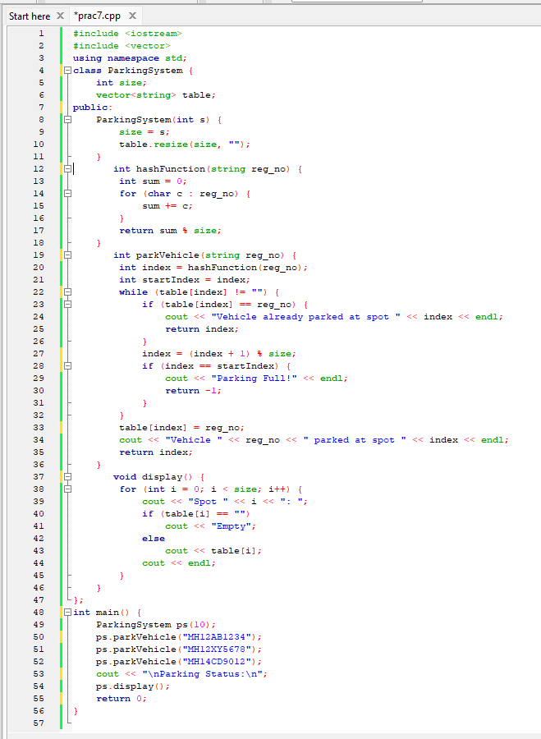

Output:
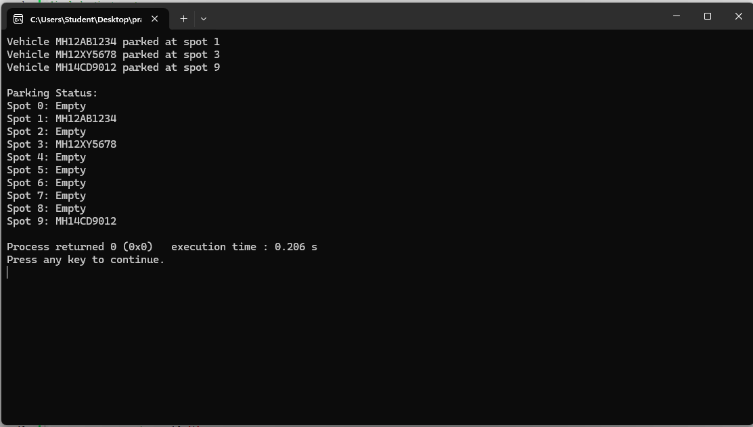

Output Analysis |  | Case 1: No Collision  - Vehicle “MH12AB1234” hashes to spot 3  - Spot 3 is empty → assigned  - Output:  Vehicle MH12AB1234 parked at spot 3  ✅ Case 2: Collision Occurs  - Vehicle “MH12XY5678” hashes to spot 3 (already occupied)  - Linear probing moves to spot 4 → empty  - Output:  Vehicle MH12XY5678 parked at spot 4
Link of student Github profile where lab assignment has

been uploaded
Conclusion | • Hashing is an efficient way to assign parking spots  • Linear probing resolves collisions without losing data  • The system ensures fast retrieval and insertion  • Real-world applications: urban parking management, ticketing systems, storage allocation
Plag Report  (Similarity index <  12%) | 
Date | 01/04/26

