Mission of the Department
To nurture computer engineering professionals by offering: Dynamic learning environment that encourages problem-solving using emerging technology, · National Education Policy aligned evidence-based technical education, fostering innovation, research, and industry–institute collaboration, Holistic, ethical and sustainable development for lifelong success.

Session 2025-2026(EVEN)

Vision: Dream of where you want. | Mission: Means to achieve Vision

Program Educational Objectives of the program (PEO): (broad statements that describe the professional and career accomplishments)
PEO1 | Preparation | P: Preparation | Pep-CL abbreviation pronounce as Pep-si-lL easy to recall
PEO2 | Core Competence | E: Environment  (Learning Environment)
PEO3 | Breadth | P: Professionalism
PEO4 | Professionalism | C: Core Competence
PEO5 | Learning  Environment | L: Breadth (Learning in diverse areas)

Program Outcomes (PO): (statements that describe what a student should be able to do and know by the end of a program)
Keywords of POs:
Engineering knowledge, Problem analysis, Design/development of solutions, Conduct Investigations of Complex Problems, Engineering Tool Usage, The Engineer and The World, Ethics, Individual and Collaborative Team work, Communication, Project Management and Finance, Life-Long Learning

PSO Keywords: Cutting edge technologies, Research

“I am an engineer, and I know how to apply engineering knowledge to investigate, analyse and design solutions to complex problems using tools for entire world following all ethics in a collaborative way with proper management skills throughout my life.” to contribute to the development of cutting-edge technologies and Research.

Integrity: I will adhere to the Laboratory Code of Conduct and ethics in its entirety.

Name and Signature of Student and Date
(Signature and Date in Handwritten)

18-02-2026

Mission of the Department
To nurture computer engineering professionals by offering: Dynamic learning environment that encourages problem-solving using emerging technology, · National Education Policy aligned evidence-based technical education, fostering innovation, research, and industry–institute collaboration, Holistic, ethical and sustainable development for lifelong success.

Session | 2024-25 (EVEN) | Course Name | Java Full Stack Development Lab
Semester | 4 | Course Code | 23ADS1407
Roll No | 120 | Name of Student | Shrusti Katakwar

Practical Number | 4
Course Outcome | Upon successful completion of this implementation, the ,we will be able to demonstrate a fundamental mastery of data manipulation and algorithmic logic within the Java environment. We will have gained the practical skill of translating abstract pseudocode into functional, executable Java code, specifically focusing on the use of nested loops and conditional branching. Furthermore, the exercise ensures that we can differentiate between searching and sorting operations, providing a baseline understanding of how data organization impacts retrieval speed. Ultimately, we will be prepared to evaluate the computational efficiency of these basic techniques, forming a foundation for more advanced topics like complex data structures.
Aim | WAP to implement Searching ( linear search ) and Sorting (Bubble Sort ) in Java.
Problem Definition | WAP to implement Searching ( linear search ) and Sorting (Bubble Sort ) in Java.
Theory  (100 words) | Linear Search:Linear Search is the most basic searching algorithm. It works by starting at the beginning of a list and checking every single element one by one until a match is found or the

Mission of the Department
To nurture computer engineering professionals by offering: Dynamic learning environment that encourages problem-solving using emerging technology, · National Education Policy aligned evidence-based technical education, fostering innovation, research, and industry–institute collaboration, Holistic, ethical and sustainable development for lifelong success.

end of the list is reached. Because it doesn't require the data to be sorted, it is highly versatile but can be inefficient for very large datasets. In the worst-case scenario, you end up checking every single item, giving it a time complexity of $O(n)$.

Insertion Sort:Insertion Sort builds a sorted array one item at a time. It takes each element from the "unsorted" portion and inserts it into its correct position within the "sorted" portion by shifting larger elements out of the way. It’s much like how you might sort a hand of playing cards. It is very efficient for small datasets or lists that are already mostly sorted.

Bubble Sort:Bubble Sort is a simple comparison-based sorting algorithm. It works by repeatedly stepping through the list, comparing adjacent elements, and swapping them if they are in the wrong order. This process "bubbles" the largest unsorted element to its correct position at the end of the list in each pass. While easy to understand and implement, it is generally inefficient for large lists with a worst-case time complexity of $O(n^2)$.
Procedure and Execution  (100 Words) | Step for Implementation:  LINEAR SEARCH:  Define the Function: Create a method that takes an integer array and a target value as parameters.  Initialize a Loop: Use a for loop starting from index 0 to the array.length - 1.

Mission of the Department
To nurture computer engineering professionals by offering: Dynamic learning environment that encourages problem-solving using emerging technology, · National Education Policy aligned evidence-based technical education, fostering innovation, research, and industry–institute collaboration, Holistic, ethical and sustainable development for lifelong success.

Compare Elements: Inside the loop, check if the current element arr[i] is equal to the target.
Return Index: If a match is found, immediately return the current index i.
Handle "Not Found": If the loop finishes without finding the target, return a sentinel value like -1.
Display Result: In the main method, print the returned index or a message stating the element doesn't exist.

INSERTION SORT:
Iterate from Second Element: Start a for loop from index 1 (the second element) to the end of the array, assuming the first element is already a "sorted" sub-list.
Pick a Key: Store the value of the current element in a temporary variable called the key.
Compare with Sorted Section: Use a while loop to look at elements to the left of the key.
Shift Elements: If the element to the left is greater than the key, shift that element one position to the right to make room.
Insert the Key: Once you find an element smaller than the key (or reach the start of the array), insert the key into the empty slot.
Repeat: Move to the next index and repeat the process until the entire array is sorted.
BUBBLE SORT:

Mission of the Department
To nurture computer engineering professionals by offering: Dynamic learning environment that encourages problem-solving using emerging technology, · National Education Policy aligned evidence-based technical education, fostering innovation, research, and industry–institute collaboration, Holistic, ethical and sustainable development for lifelong success.

Outer Pass Loop: Create a loop that runs from $0$ to $n-1$. Each pass ensures the next largest element "bubbles" up to its correct final position.
Inner Comparison Loop: Inside the first loop, create a second loop that runs from $0$ to $n-i-1$ to compare adjacent elements.
Compare Neighbors: Check if the current element arr[j] is greater than the next element arr[j+1].
Swap Logic: If the left element is larger, swap them using a temporary variable (temp = arr[j]; arr[j] = arr[j+1]; arr[j+1] = temp;).
Reduce Search Space: With each completion of the outer loop, ignore the last sorted element to make the next pass faster.
Finalize: Once both loops conclude, the array is fully sorted in ascending order.
Code:
LINEAR SEARCH:
public class LinearSearch {
static int search(int arr[], int len, int key) { for (int i = 0; i < len; i++) { if (arr[i] == key) { return i;
}
}

Mission of the Department
To nurture computer engineering professionals by offering: Dynamic learning environment that encourages problem-solving using emerging technology, · National Education Policy aligned evidence-based technical education, fostering innovation, research, and industry–institute collaboration, Holistic, ethical and sustainable development for lifelong success.

return -1;
}
public static void main(String[] args) { int[] arr = {3, 4, 1, 7, 5}; int len = arr.length; int key = 4;
int index = search(arr, len, key); if (index == -1) {
System.out.println("element is not present in the array");
} else {
System.out.println("element found at index " + index);
}
}
}

INSERTION SORT :
public class InsertionSortProgram {
static void insertionSort(int arr[], int length) { for (int i = 1; i < length; i++) { int key = arr[i]; int j = i - 1;
while (j >= 0 && arr[j] > key) { arr[j + 1] = arr[j]; j = j - 1;

Mission of the Department
To nurture computer engineering professionals by offering: Dynamic learning environment that encourages problem-solving using emerging technology, · National Education Policy aligned evidence-based technical education, fostering innovation, research, and industry–institute collaboration, Holistic, ethical and sustainable development for lifelong success.

}
arr[j + 1] = key;
}
}
public static void main(String[] args) { int[] arr = {3, 4, 5, 6, 1}; int n = arr.length; insertionSort(arr, n);
System.out.println("Sorted array:"); for (int i = 0; i < n; i++) {
System.out.print(arr[i] + " ");
}
System.out.println();
}
}

BUBBLE SORT:
public class BubbleSort {
public static void main(String[] args) { int[] arr = {5, 3, 8, 4, 2}; int n = arr.length;
for (int i = 0; i < n - 1; i++) { for (int j = 0; j < n - 1 - i; j++) { if (arr[j] > arr[j + 1]) { int temp = arr[j];

Mission of the Department
To nurture computer engineering professionals by offering: Dynamic learning environment that encourages problem-solving using emerging technology, · National Education Policy aligned evidence-based technical education, fostering innovation, research, and industry–institute collaboration, Holistic, ethical and sustainable development for lifelong success.

arr[j] = arr[j + 1]; arr[j + 1] = temp;
}
}
}
System.out.println("Sorted array using Bubble Sort:"); for (int num : arr) {
System.out.print(num + " ");
}
}
}

Output:
LINEARSEARCH:
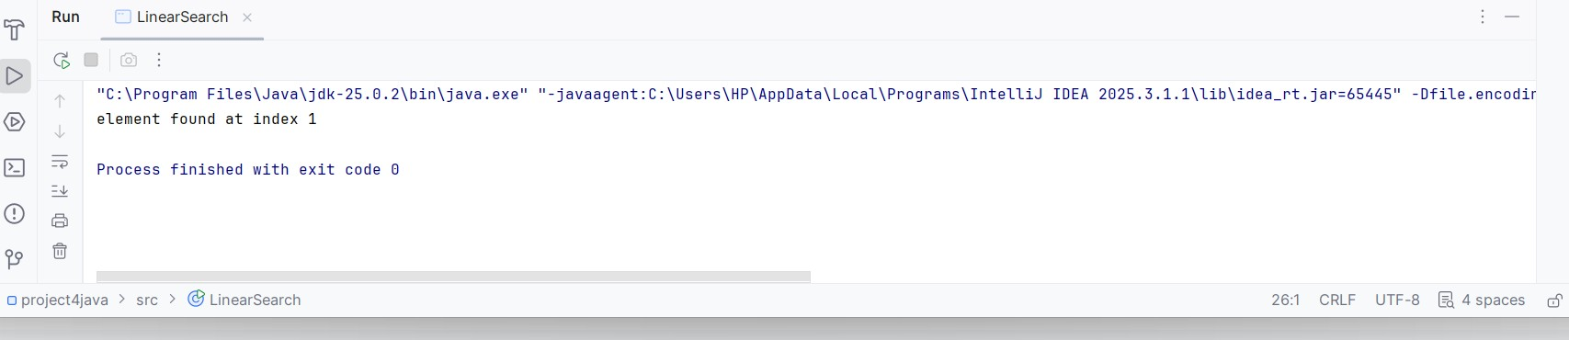
INSERTIONSORT:
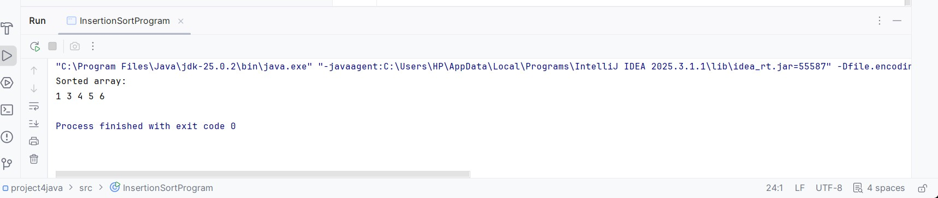
BUBBLE SORT:
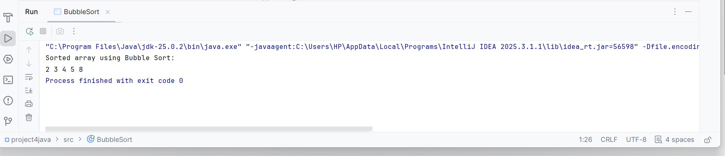

Mission of the Department
To nurture computer engineering professionals by offering: Dynamic learning environment that encourages problem-solving using emerging technology, · National Education Policy aligned evidence-based technical education, fostering innovation, research, and industry–institute collaboration, Holistic, ethical and sustainable development for lifelong success.

Output Analysis | Linear Search: The output is a simple index number or a "Not Found" message. Its performance is entirely dependent on the target's position; finding an item at the start is nearly instant ($O(1)$), while finding one at the end takes $n$ steps ($O(n)$).  Insertion Sort: The output shows a "sorted sub-list" growing from left to right. It performs fewer operations than Bubble Sort when the data is already partially ordered  Bubble Sort: The output reflects a high number of swaps initially, with the largest numbers moving to the final positions first. It is the most "active" visually but the least efficient for large datasets.
Link of student Github profile where lab assignment has been uploaded
Conclusion | This implementation demonstrates the practical application of basic data organization through Bubble Sort, Insertion Sort, and Linear Search. While Bubble Sort is simple to understand, Insertion Sort proves more efficient for small or nearly sorted datasets because it reduces the number of unnecessary swaps by shifting elements into their correct positions.  These algorithms highlight the trade-offs between code simplicity and execution speed. Through this exercise, we have successfully applied iterative logic to manage arrays, establishing that Linear Search remains a reliable, if slower, method for locating data, while different

Mission of the Department
To nurture computer engineering professionals by offering: Dynamic learning environment that encourages problem-solving using emerging technology, · National Education Policy aligned evidence-based technical education, fostering innovation, research, and industry–institute collaboration, Holistic, ethical and sustainable development for lifelong success.

 | sorting techniques offer varied levels of optimization for organizing it.
Plag Report  (Similarity index <  12%) | 
Date | 18-02-2026

Observation copy screenshot
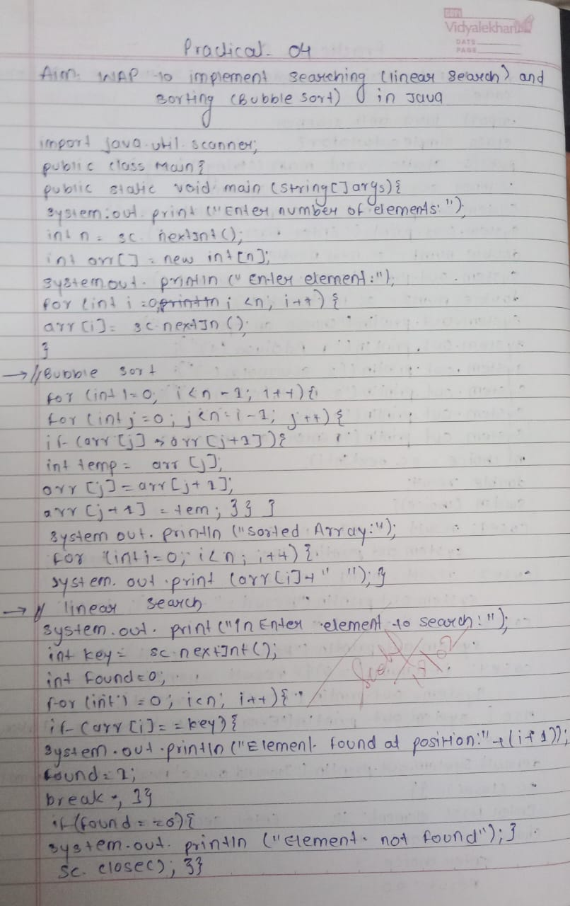

Vision of the Department
To be a preferred hub for nurturing computer engineering aspirants through innovative, ethical, value-based technical education, impactful research, and industry collaboration, to become successful professionals contributing for the betterment of society.

Mission of the Department
To nurture computer engineering professionals by offering: Dynamic learning environment that encourages problem-solving using emerging technology, · National Education Policy aligned evidence-based technical education, fostering innovation, research, and industry–institute collaboration, Holistic, ethical and sustainable development for lifelong success.

Vision of the Department
To be a preferred hub for nurturing computer engineering aspirants through innovative, ethical, value-based technical education, impactful research, and industry collaboration, to become successful professionals contributing for the betterment of society.

Mission of the Department
To nurture computer engineering professionals by offering: Dynamic learning environment that encourages problem-solving using emerging technology, · National Education Policy aligned evidence-based technical education, fostering innovation, research, and industry–institute collaboration, Holistic, ethical and sustainable development for lifelong success.

