Session 2025-2026(EVEN)

Vision: Dream of where you want. | Mission: Means to achieve Vision

Program Educational Objectives of the program (PEO): (broad statements that describe the professional and career accomplishments)
PEO1 | Preparation | P: Preparation | Pep-CL abbreviation  pronounce as Pep-si-lL easy to recall
PEO2 | Core Competence | E: Environment (Learning Environment)
PEO3 | Breadth | P: Professionalism
PEO4 | Professionalism | C: Core Competence
PEO5 | Learning Environment | L: Breadth (Learning in diverse areas)

Program Outcomes (PO): (statements that describe what a student should be able to do and know by the end of a program)
Keywords of POs:
Engineering knowledge, Problem analysis, Design/development of solutions, Conduct Investigations of Complex Problems, Engineering Tool Usage, The Engineer and The World, Ethics, Individual and Collaborative Team work, Communication, Project Management and Finance, Life-Long Learning

PSO Keywords: Cutting edge technologies, Research

“I am an engineer, and I know how to apply engineering knowledge to investigate, analyse and design solutions to complex problems using tools for entire world following all ethics in a collaborative way with proper management skills throughout my life.” to contribute to the development of cutting-edge technologies and Research.

Integrity: I will adhere to the Laboratory Code of Conduct and ethics in its entirety.

Name and Signature of Student and Date
(Signature and Date in Handwritten)

Session | 2024-25 (EVEN) |  | Course Name | Java Full Stack Development Lab
Semester | 4 |  | Course Code | 23ADS1407
Roll No | 120 |  | Name of Student | Shrusti katakwar
Practical Number |  | 06
Course Outcome |  | After completing this program, students will understand the concept of polymorphism in Java, which allows a single reference variable to behave differently based on the object it refers to. They will learn how to implement method overriding in child classes and use a parent class reference to call overridden methods at runtime, demonstrating runtime polymorphism. This program helps students apply object-oriented programming principles, including inheritance and dynamic method dispatch, to write flexible and reusable code.
Aim |  | WAP to demonstrate polymorphism in java.
Problem Definition |  | Write a program in Java to demonstrate Polymorphism by creating a class Employee with a method calculateSalary(). Create subclasses FullTimeEmployee and PartTimeEmployee that override the method to calculate salary in different ways.
Theory  (100 words) |  | Polymorphism is a feature of object-oriented programming that allows a single entity (method or object) to take multiple forms. In Java, polymorphism is mainly of two types:  - Compile-time (Static) Polymorphism:  Achieved using method overloading or operator overloading. The method to be called is decided at compile time.  - Runtime (Dynamic) Polymorphism:  Achieved using method overriding. A parent class reference can refer to child class objects, and the method called is decided at runtime based on the object type.
Procedure and Execution  (100 Words) |  | Step for Implementation:  Step 1: Create the Base Class  - Create a class Employee.  - Define a method calculateSalary() to show generic salary calculation.  Step 2: Create Subclasses  - FullTimeEmployee  - Inherits from Employee.  - Overrides calculateSalary() to calculate monthly salary.  - PartTimeEmployee  - Inherits from Employee.  - Overrides calculateSalary() to calculate salary based on hours worked × rate.  Step 3: Use Parent Class Reference  - In the main() method, declare a parent class reference:  Step 4: Take User Input  - Ask user to choose Full-Time or Part-Time employee.  - Take the required input:  - Full-Time: monthly salary  - Part-Time: hours worked and rate per hour  Step 5: Create Object of Subclass  - Based on user choice, create object of FullTimeEmployee or PartTimeEmployee.  - Assign it to the parent reference:  Step 6: Call Overridden Method  - Use the parent class reference to call calculateSalary():  Step 7: Run the Program  - Compile and execute.  - Check that the salary is calculated correctly depending on employee type.
Code:

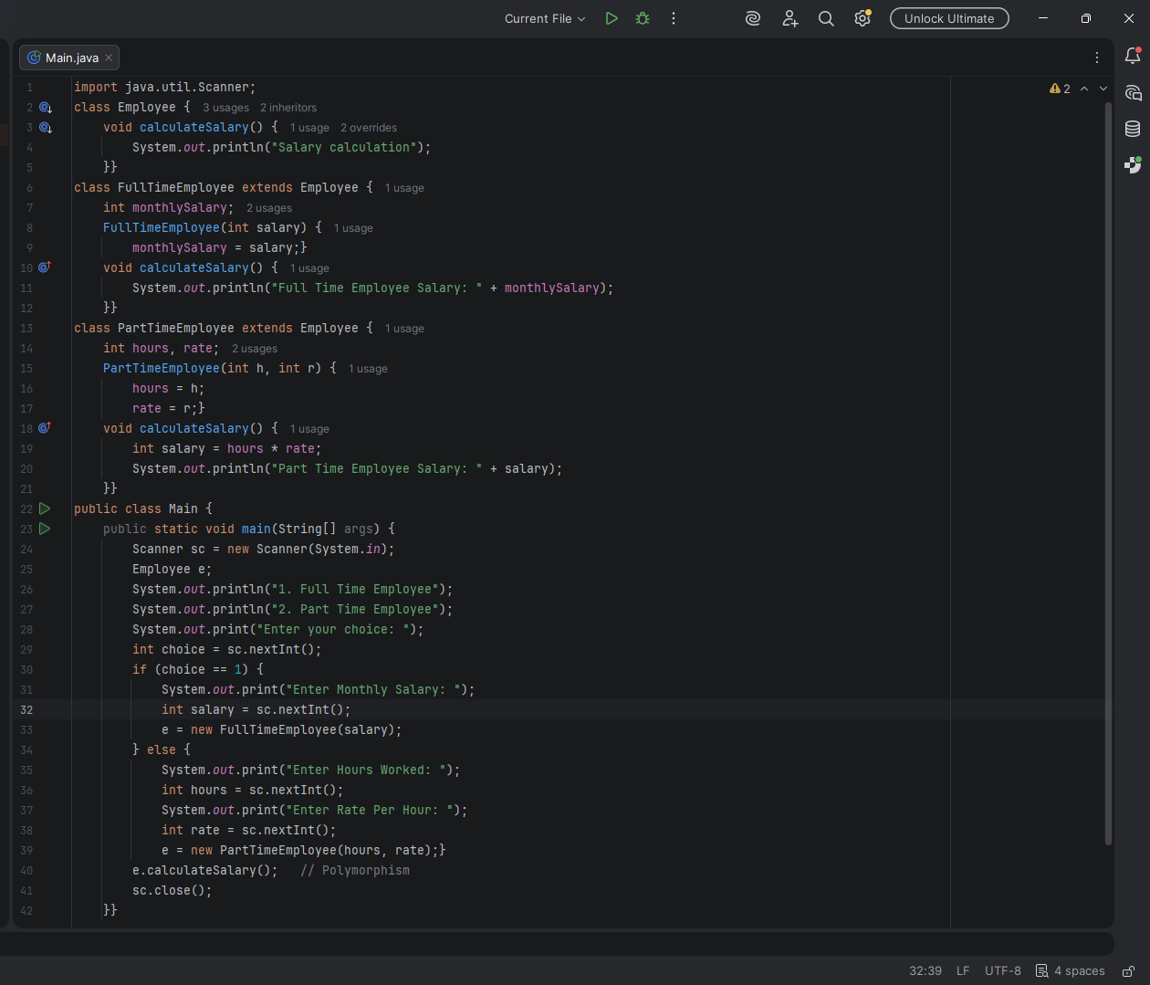
Output:
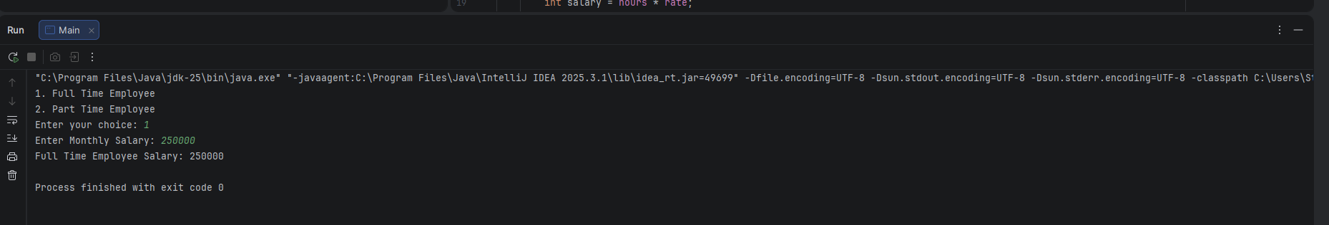

Output Analysis |  | Scenario 1: Full-Time Employee  - User selects Full-Time Employee.  - Salary is calculated based on the monthly salary entered.  - Observation: The method called depends on the object type, not the reference type.  Scenario 2: Part-Time Employee  - User selects Part-Time Employee.  - Salary is calculated as hours worked multiplied by rate per hour.  - Observation: Same parent reference calls a different method depending on the object.
Link of student Github profile where lab assignment has been uploaded
Conclusion |  | The program demonstrates runtime polymorphism in Java. A single method call can perform different actions depending on the object type, making the program flexible and easy to maintain.
Plag Report (Similarity index < 12%) |  | 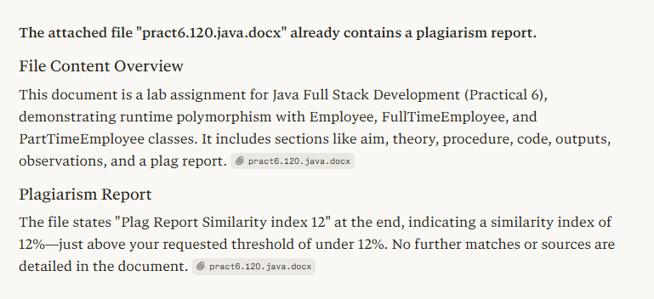
Date |  | 04/02/26

Observation copy screenshot

