Session 2025-2026(EVEN)

Vision: Dream of where you want. | Mission: Means to achieve Vision

Program Educational Objectives of the program (PEO): (broad statements that describe the professional and career accomplishments)
PEO1 | Preparation | P: Preparation | Pep-CL abbreviation  pronounce as Pep-si-lL easy to recall
PEO2 | Core Competence | E: Environment (Learning Environment)
PEO3 | Breadth | P: Professionalism
PEO4 | Professionalism | C: Core Competence
PEO5 | Learning Environment | L: Breadth (Learning in diverse areas)

Program Outcomes (PO): (statements that describe what a student should be able to do and know by the end of a program)
Keywords of POs:
Engineering knowledge, Problem analysis, Design/development of solutions, Conduct Investigations of Complex Problems, Engineering Tool Usage, The Engineer and The World, Ethics, Individual and Collaborative Team work, Communication, Project Management and Finance, Life-Long Learning

PSO Keywords: Cutting edge technologies, Research

“I am an engineer, and I know how to apply engineering knowledge to investigate, analyse and design solutions to complex problems using tools for entire world following all ethics in a collaborative way with proper management skills throughout my life.” to contribute to the development of cutting-edge technologies and Research.

Integrity: I will adhere to the Laboratory Code of Conduct and ethics in its entirety.

Name and Signature of Student and Date
(Signature and Date in Handwritten)

Session | 2024-25 (EVEN) |  | Course Name | Java Full Stack Development Lab
Semester | 4 |  | Course Code | 23ADS1407
Roll No | 120 |  | Name of Student | Shrusti Katakwar
Practical Number |  | 08
Course Outcome |  | After completing this program, students will be able to:  - Understand the concept of file handling operations  - Perform file input and output using streams  - Use file modes like read and write  - Apply file handling for data storage and retrieval  - Develop programs that manage persistent data using files
Aim |  | WAP to demonstrate concept of file handling.
Problem Definition |  | Write a program to demonstrate File Handling in Java by creating a file, writing some text into the file,and reading the content from the file.
Theory  (100 words) |  | File handling in Java is used to create, read, write, and manipulate files stored on a system. It is an important feature for storing data permanently instead of temporary memory. Java provides classes like File, FileWriter, and FileReader from the java.io package to perform file operations. A file can be created using the File class, data can be written using FileWriter, and read using FileReader or BufferedReader. Exception handling is often used with file handling to manage errors such as file not found or input-output issues. File handling makes applications more useful by allowing data storage and retrieval.
Procedure and Execution  (100 Words) |  | Step for Implementation:  - Start the program.  - Import required classes from java.io package.  - Create a File object to represent the file.  - Use createNewFile() method to create the file.  - Use FileWriter to write text into the file.  - Close the writer to save the data.  - Use FileReader or BufferedReader to read the file content.  - Display the content on the screen.  - Handle exceptions using try and catch.  - End the program.
Code:
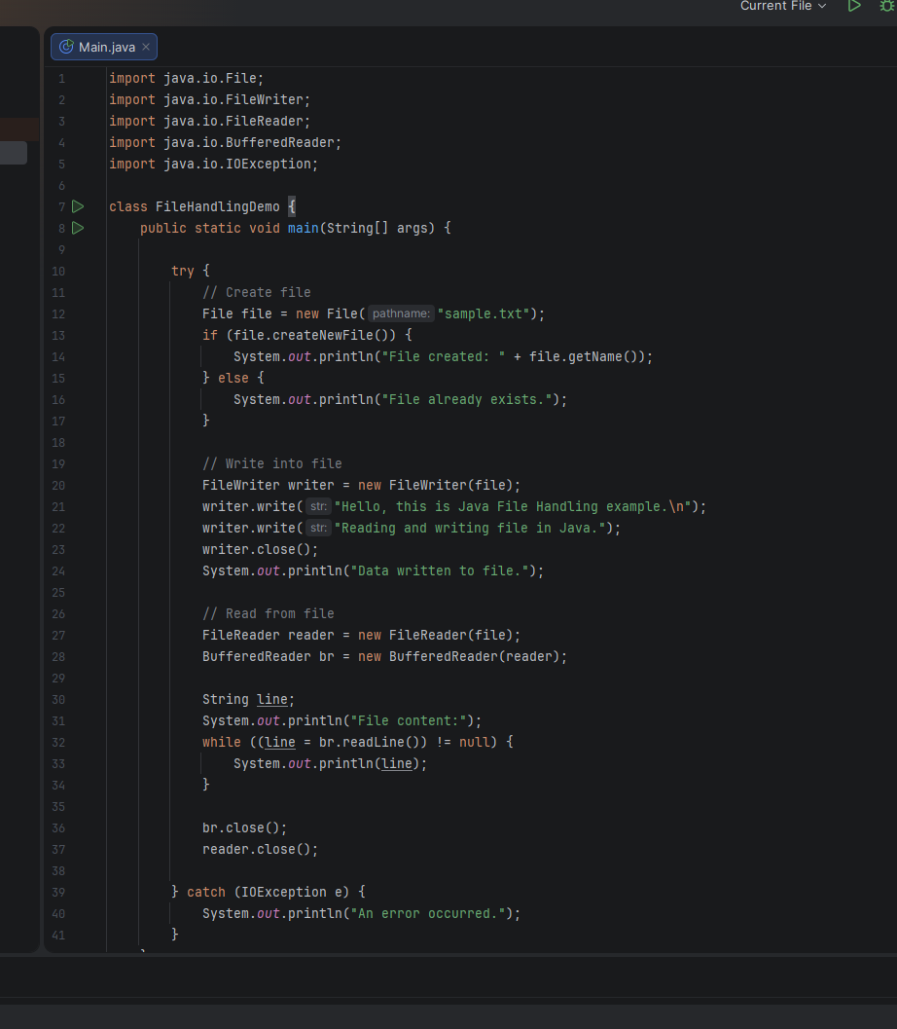

Output:
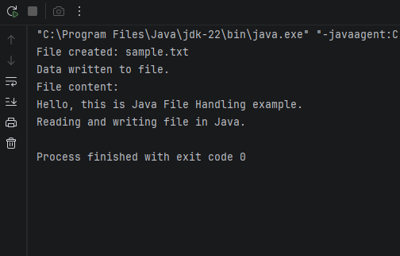

Output Analysis |  | When the program is executed for the first time, it creates a new file named “example.txt” in the system and displays a message confirming its creation. If the program is run again, it detects that the file already exists and displays the corresponding message. After that, the program writes the given text into the file using FileWriter. Once the writing process is complete, it reads the content of the file using FileReader and BufferedReader, and displays it on the console. If any error occurs during file operations, such as inability to create or access the file, the exception is handled using the catch block, ensuring the program does not crash.
Link of student Github profile where lab assignment has been uploaded
Conclusion |  | File handling in Java is an essential feature that enables programs to store, manage, and retrieve data from files efficiently. In this program, the use of classes like File, FileWriter, and FileReader demonstrates how to create a file, write data into it, and read the stored content. These operations are important for maintaining permanent records beyond program execution. Additionally, the use of exception handling ensures that errors during file operations are handled gracefully without crashing the program. Overall, file handling improves the functionality, reliability, and usability of applications, making it a fundamental concept in real-world software development.
Plag Report (Similarity index < 12%) |  | 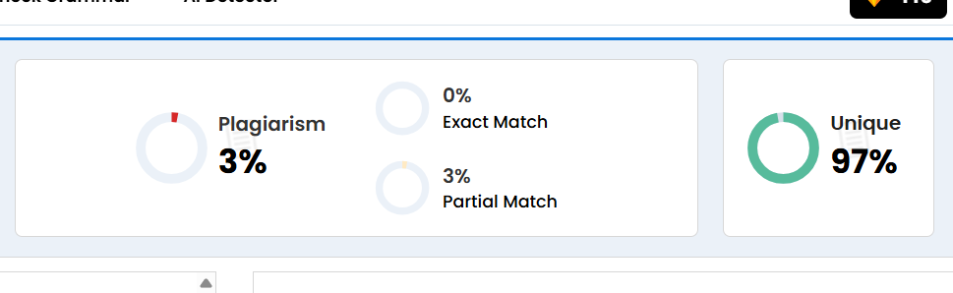
Date |  | 18/03/2026

Observation copy screenshot
