To establish learning ambience for ushering in computer engineering professionals in core and multidisciplinary area by developing Problemsolving skills through emerging technologies.

Session 2025-2026

Vision: To be a well-known centre for pursuing computer education through innovative pedagogy, value-based education and industry collaboration | Mission: To establish learning ambience for ushering in computer engineering professionals in core and multidisciplinary area by developing Problem-solving skills through emerging technologies.

Program Educational Objectives of the program (PEO): (broad statements that describe the professional and career accomplishments)
PEO1 | Preparation | P: Preparation | Pep-CL abbreviation pronounce as Pep-si-lL easy to recall
PEO2 | Core Competence | E: Environment  (Learning Environment)
PEO3 | Breadth | P: Professionalism
PEO4 | Professionalism | C: Core Competence
PEO5 | Learning  Environment | L: Breadth (Learning in diverse areas)

Program Outcomes (PO): (statements that describe what a student should be able to do and know by the end of a program)
Keywords of POs:
Engineering knowledge, Problem analysis, Design/development of solutions, Conduct Investigations of Complex Problems, Engineering Tool Usage, The Engineer and The World, Ethics, Individual and Collaborative Team work, Communication, Project Management and Finance, Life-Long Learning

PSO Keywords: Cutting edge technologies, Research

“I am an engineer, and I know how to apply engineering knowledge to investigate, analyse and design solutions to complex problems using tools for entire world following all ethics in a collaborative way with proper management skills throughout my life.” to contribute to the development of cutting-edge technologies and Research.

Integrity: I will adhere to the Laboratory Code of Conduct and ethics in its entirety.

Name and Signature of Student and Date
(Signature and Date in Handwritten)

To establish learning ambience for ushering in computer engineering professionals in core and multidisciplinary area by developing Problemsolving skills through emerging technologies.

Session | 2025-26 (EVEN) | Course Name | JAVA FSD Lab
Semester | 4th | Course Code | 23ADS1407
Roll No | 120 | Name of Student | Shrusti katakwar

Practical Number | 09
Course Outcome | - Understand how Java applications connect to databases using JDBC.  - Learn to execute SQL queries from a Java program.  - Develop skills to perform CRUD operations (Create, Read, Update, Delete).  - Gain knowledge of database drivers and connection handling.
Aim | WAP to demonstrate database connectivity using JDBC
Problem Definition | WAP to demonstrate database connectivity using JDBC
Theory  (100 words) | JDBC (Java Database Connectivity) is a standard API provided by Java that enables Java applications to interact with databases. It allows a program to connect to a database, send SQL queries, and process the results.  JDBC acts as a bridge between the Java application and the database. It provides methods and interfaces to establish a connection, execute queries, and handle data returned from the database.  Advantages of JDBC  - Platform-independent (Write Once, Run Anywhere)  - Supports multiple databases  - Provides simple and easy database connectivity  - Enables execution of SQL queries from Java programs  - Supports transaction management  Applications of JDBC  - Banking systems  - Student management systems  - Online registration systems  - E-commerce applications
To establish learning ambience for ushering in computer engineering professionals in core and multidisciplinary area by developing Problemsolving skills through emerging technologies.

Procedure and Execution  (100 Words) | Algorithm | :  - Start  - Import required packages  - Load JDBC driver  - Establish connection with database  - Create statement object  - Execute SQL query  - Store result in ResultSet  - Display the data  - Close connection  - • Stop
Code: 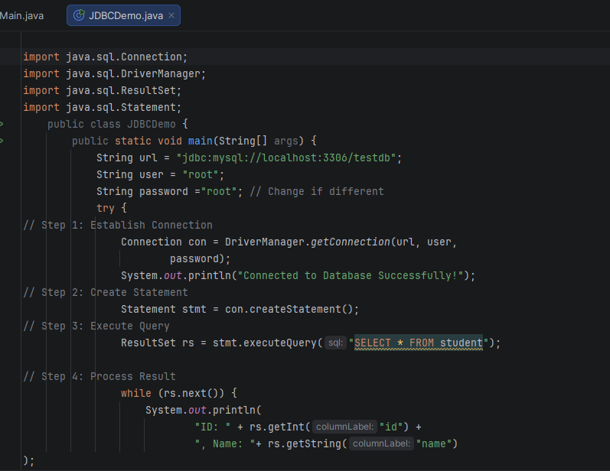
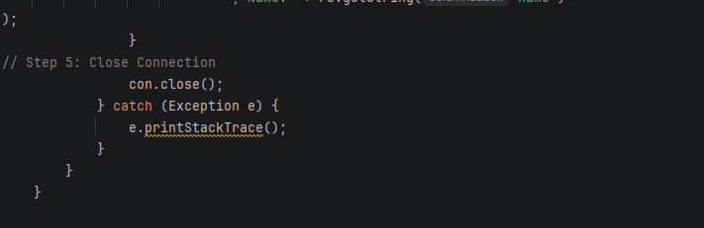

 | Output: 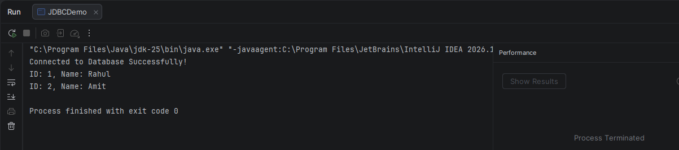
Output Analysis | - The program connects successfully to the database.  - It retrieves all records from the student table.  - Each record is displayed with roll number, name, and marks.  - If connection fails, an exception message is shown.
Link of student Github profile where lab assignment has been uploaded
Conclusion | - JDBC enables seamless interaction between Java applications and databases.  - It simplifies executing SQL queries and retrieving results.  - Proper exception handling ensures reliability.  - This program demonstrates basic database connectivity and data retrieval.
Plag Report  (Similarity index <  12%) | 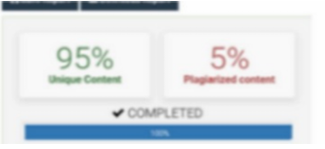
.

Mission of the Department
To establish learning ambience for ushering in computer engineering professionals in core and multidisciplinary area by developing Problemsolving skills through emerging technologies.

Date | 28/03/26

Paste here Faculty signed page
