Session 2025-2026(EVEN)

Vision: Dream of where you want. | Mission: Means to achieve Vision

Program Educational Objectives of the program (PEO): (broad statements that describe the professional and career accomplishments)
PEO1 | Preparation | P: Preparation | Pep-CL abbreviation  pronounce as Pep-si-lL easy to recall
PEO2 | Core Competence | E: Environment (Learning Environment)
PEO3 | Breadth | P: Professionalism
PEO4 | Professionalism | C: Core Competence
PEO5 | Learning Environment | L: Breadth (Learning in diverse areas)

Program Outcomes (PO): (statements that describe what a student should be able to do and know by the end of a program)
Keywords of POs:
Engineering knowledge, Problem analysis, Design/development of solutions, Conduct Investigations of Complex Problems, Engineering Tool Usage, The Engineer and The World, Ethics, Individual and Collaborative Team work, Communication, Project Management and Finance, Life-Long Learning

PSO Keywords: Cutting edge technologies, Research

“I am an engineer, and I know how to apply engineering knowledge to investigate, analyse and design solutions to complex problems using tools for entire world following all ethics in a collaborative way with proper management skills throughout my life.” to contribute to the development of cutting-edge technologies and Research.

Integrity: I will adhere to the Laboratory Code of Conduct and ethics in its entirety.

Name and Signature of Student and Date
(Signature and Date in Handwritten)

Session | 2024-25 (EVEN) |  | Course Name | Java Full Stack Development Lab
Semester | 4 |  | Course Code | 23ADS1407
Roll No | 120 |  | Name of Student | Shrusti Katakwar
Practical Number |  | 07
Course Outcome
Aim |  | WAP to demonstrate exception handling in java.
Problem Definition |  | Write a program to demonstrate Exception Handling by performing division of two numbers. Handle the  error that occurs when a number is divided by zero using try, catch, and finally.
Theory  (100 words) |  | Exception handling is an important concept in programming that allows developers to manage runtime errors effectively without stopping the execution of a program abruptly. These errors, known as exceptions, may occur due to invalid input, logical mistakes, or unexpected conditions such as dividing a number by zero. In languages like Java, exception handling is implemented using try, catch, and finally blocks. The try block contains the code that might generate an exception. If an exception occurs, control is transferred to the catch block, where the error is handled appropriately. The finally block is always executed, regardless of whether an exception occurs or not, and is generally used for cleanup operations. Handling exceptions improves program reliability, prevents crashes, and provides meaningful feedback to users, making the application more robust and user-friendly.
Procedure and Execution  (100 Words) |  | Step for Implementation:  - Begin the program execution.  - Import necessary classes such as Scanner for user input.  - Declare variables to store two numbers and the result.  - Prompt the user to enter the first and second numbers.  - Use the Scanner class to read user input.  - Place the division operation inside the try block.  - Add a catch block to handle ArithmeticException (division by zero).  - Display a meaningful error message if an exception occurs.  - Use a finally block to print a message indicating the end of execution.  - Close the scanner object.  - End the program successfully.
Code:
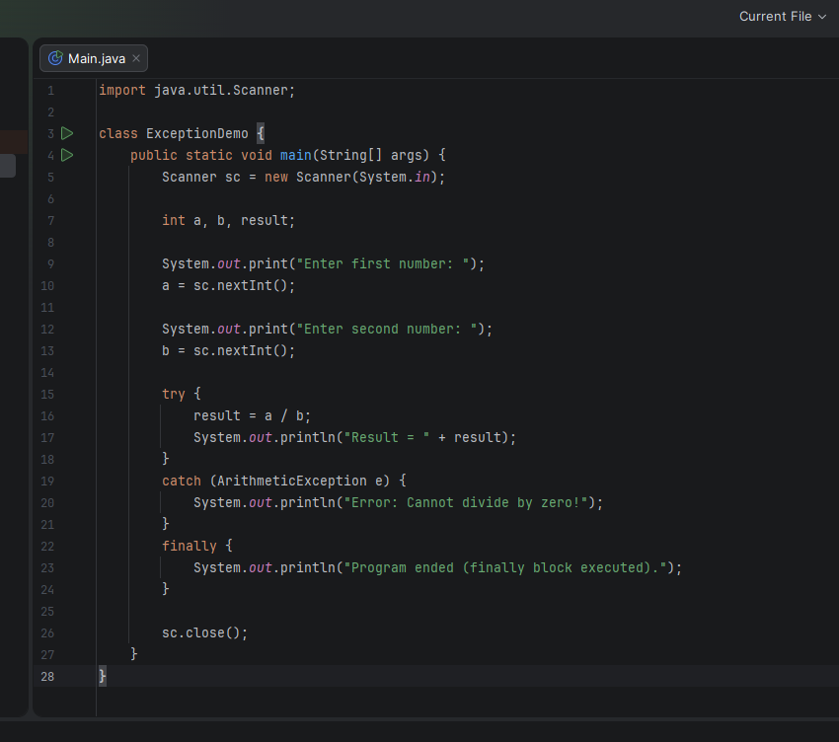

 |  | Output: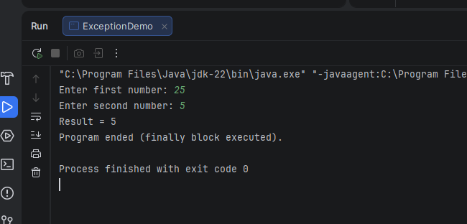
Output Analysis |  | The program behaves differently depending on the input provided by the user. When valid inputs are given, such as 20 and 4, the division operation is successfully performed inside the try block, and the result (5) is displayed on the screen. In this case, no exception occurs, so the catch block is skipped, but the finally block still executes and displays the message indicating the completion of the program. However, when the user enters zero as the second number, such as 10 and 0, an ArithmeticException is generated because division by zero is not allowed. Instead of terminating abruptly, the program transfers control to the catch block, which handles the exception and displays a user-friendly error message. After handling the exception, the finally block executes as expected. This demonstrates that the program can handle both normal and exceptional cases smoothly.
Link of student Github profile where lab assignment has been uploaded
Conclusion |  | Exception handling is an essential concept that helps programs manage runtime errors effectively. In this program, try, catch, and finally blocks handle division by zero without crashing the program. It ensures smooth execution by displaying meaningful error messages and always executing important statements in the finally block. Overall, exception handling improves program reliability, user experience, and makes the code more robust and maintainable.
Plag Report (Similarity index < 12%) |  | 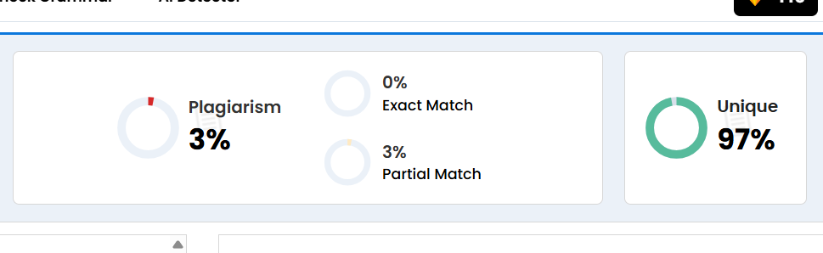
Date |  | 18/03/2026

Observation copy screenshot
