Mission of the Department
To nurture computer engineering professionals by offering: Dynamic learning environment that encourages problem-solving using emerging technology, · National Education Policy aligned evidence-based technical education, fostering innovation, research, and industry–institute collaboration, Holistic, ethical and sustainable development for lifelong success.

Session 2025-2026(EVEN)

Vision: Dream of where you want. | Mission: Means to achieve Vision

Program Educational Objectives of the program (PEO): (broad statements that describe the professional and career accomplishments)
PEO1 | Preparation | P: Preparation | Pep-CL abbreviation pronounce as Pep-si-lL easy to recall
PEO2 | Core Competence | E: Environment  (Learning Environment)
PEO3 | Breadth | P: Professionalism
PEO4 | Professionalism | C: Core Competence
PEO5 | Learning  Environment | L: Breadth (Learning in diverse areas)

Program Outcomes (PO): (statements that describe what a student should be able to do and know by the end of a program)
Keywords of POs:
Engineering knowledge, Problem analysis, Design/development of solutions, Conduct Investigations of Complex Problems, Engineering Tool Usage, The Engineer and The World, Ethics, Individual and Collaborative Team work, Communication, Project Management and Finance, Life-Long Learning

PSO Keywords: Cutting edge technologies, Research

“I am an engineer, and I know how to apply engineering knowledge to investigate, analyse and design solutions to complex problems using tools for entire world following all ethics in a collaborative way with proper management skills throughout my life.” to contribute to the development of cutting-edge technologies and Research.

Integrity: I will adhere to the Laboratory Code of Conduct and ethics in its entirety.

Name and Signature of Student and Date
(Signature and Date in Handwritten)

18-02-2026

Mission of the Department
To nurture computer engineering professionals by offering: Dynamic learning environment that encourages problem-solving using emerging technology, · National Education Policy aligned evidence-based technical education, fostering innovation, research, and industry–institute collaboration, Holistic, ethical and sustainable development for lifelong success.

Session

2024-25

(
EVEN
)

Course

Name

Java

Full

Stack

Development

Lab

Semester

4

Course

Code

23
ADS
1407

Roll

No

120

Name

of

Student

Shrusti Katakwar.

Practical Number | 3
Course Outcome | The mastery of selection logic and input-driven execution. Students transition from writing static code to creating dynamic, responsive programs that can navigate multiple logical paths based on real-time data. Beyond syntax, the outcome emphasizes robustness; by learning to handle "edge cases" (like invalid menu choices or illegal mathematical operations), students develop a professional mindset toward software reliability. Ultimately, this exercise bridges the gap between basic variable manipulation and the construction of a functional, state-based application.
Aim | WAP to design a simple calculator using switch case statement
Problem Definition | WAP to design a simple calculator using switch case statement
Theory  (100 words) | A switch-case calculator is built on four fundamental programming concepts:  1. Selection Logic: The switch statement is a multi-way branch. It compares the value of a single variable (the operator) against a list of

Mission of the Department
To nurture computer engineering professionals by offering: Dynamic learning environment that encourages problem-solving using emerging technology, · National Education Policy aligned evidence-based technical education, fostering innovation, research, and industry–institute collaboration, Holistic, ethical and sustainable development for lifelong success.

predefined constants (the cases). This is more computationally efficient than long if-else if chains because the compiler can often optimize the jump to the correct case.
2. Input Parsing: The program must distinguish between two different data types:
○ Numeric operands: Usually stored as float or double to handle decimal points.
 | ○ | Character operator: A char type (like +, -,  *, /) that serves as the "key" for the switch statement.
- The Fall-Through Mechanism & break: In most
C-style languages, execution continues into the next case unless a break statement is encountered. In a calculator, we use break after every operation to ensure that if a user asks for addition, the program doesn't accidentally execute subtraction and multiplication as well.
- Exception Handling (The Default Case): The default keyword handles the "else" scenario. If a user enters a symbol like @ or &, the default block provides a graceful way to inform the user that the input is invalid rather than letting the program fail silently.

Procedure and Execution  (100 Words) | Step for Implementation:  Step 1: Initialization: The program allocates memory for the numbers and the operator.  Step 2: Input: The user provides the data. The order usually follows: Operand 1 → Operator → Operand 2.  Step 3: Matching: The switch(operator) evaluates the character. It looks for a matching case.

Mission of the Department
To nurture computer engineering professionals by offering: Dynamic learning environment that encourages problem-solving using emerging technology, · National Education Policy aligned evidence-based technical education, fostering innovation, research, and industry–institute collaboration, Holistic, ethical and sustainable development for lifelong success.

Step 4: Calculation: Once a match is found (e.g., case
'*'), the specific arithmetic instruction is sent to the CPU's
Arithmetic Logic Unit (ALU).
Step 5: Output: The result is formatted and displayed on the console.
Step 6: Termination: The break sends the control to the end of the switch block, and the program finishes.

Code:
import java.util.Scanner; public class Calculator {
public static void main(String[] args) { Scanner sc = new Scanner(System.in); int a, b, result, choice;
System.out.println(" Java Calculator ");
System.out.println("1. Addition (+)\n2. Subtraction
(-)\n3. Multiplication (*)\n4. Division (/)"); System.out.print("Enter your choice (1-4): "); choice = sc.nextInt();
System.out.print("Enter first number: "); a = sc.nextInt();
System.out.print("Enter second number: "); b = sc.nextInt(); switch (choice) { case 1:
result = a + b;
System.out.println("Addition result: " + result);

Mission of the Department
To nurture computer engineering professionals by offering: Dynamic learning environment that encourages problem-solving using emerging technology, · National Education Policy aligned evidence-based technical education, fostering innovation, research, and industry–institute collaboration, Holistic, ethical and sustainable development for lifelong success.

break; case 2:
result = a - b;
System.out.println("Subtraction result: " + result);
break; case 3:
result = a * b;
System.out.println("Multiplication result: " + result);
break; case 4:
if (b != 0) { result = a / b;
System.out.println("Division result: " + result);
} else {
System.out.println("Error: Cannot divide by zero.");
} break; default:
System.out.println("Invalid choice! Please select 1-4.");
}

Mission of the Department
To nurture computer engineering professionals by offering: Dynamic learning environment that encourages problem-solving using emerging technology, · National Education Policy aligned evidence-based technical education, fostering innovation, research, and industry–institute collaboration, Holistic, ethical and sustainable development for lifelong success.

sc.close();
}
}

Output:
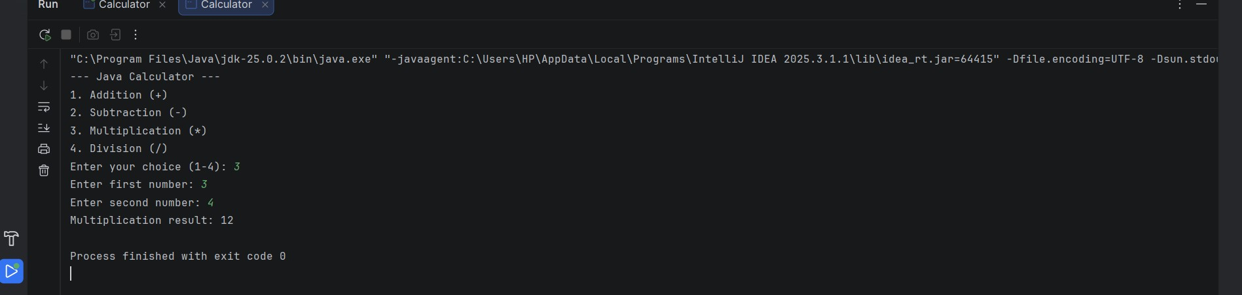
Output Analysis | The output analysis of a switch-case calculator focuses on logical branching and data precision. When a user  selects a menu option, the switch statement acts as a high-speed router, jumping directly to the matching  case while ignoring others. The break command is the most critical component here; it ensures only the  chosen operation runs, preventing "fall-through" where multiple calculations would execute accidentally.  From a mathematical perspective, using double instead of int ensures that division results are accurate (e.g., $5  / 2 = 2.5$ instead of $2$). The program also maintains robustness by using an if check to catch division-by-zero errors and a default case to handle invalid menu  numbers. Finally, the looping structure allows the  output to be continuous, resetting the interface after every calculation until the user explicitly chooses to exit.
Link of student
Github profile where

Mission of the Department
To nurture computer engineering professionals by offering: Dynamic learning environment that encourages problem-solving using emerging technology, · National Education Policy aligned evidence-based technical education, fostering innovation, research, and industry–institute collaboration, Holistic, ethical and sustainable development for lifelong success.

lab assignment has been uploaded
Conclusion | The conclusion of this simple calculator project highlights the efficiency of using selection-based control structures in software development. By implementing a  switch-case statement, the program achieves a clean and modular design that is far more readable and  maintainable than an equivalent chain of if-else  blocks. This structure acts as a logical router, ensuring that the CPU executes only the code relevant to the user's specific mathematical choice.  Furthermore, the integration of a do-while loop and a default case transforms the script into a robust  application capable of handling repeated use and invalid inputs without crashing. The inclusion of safety checks, such as preventing division by zero, demonstrates the importance of defensive programming—anticipating  potential runtime errors before they occur. Ultimately,  this project serves as a foundational exercise in building a state-driven interface, providing a scalable framework that can easily be expanded to include more complex scientific functions or graphical user elements in the future.
Plag Report  (Similarity index <  12%) | 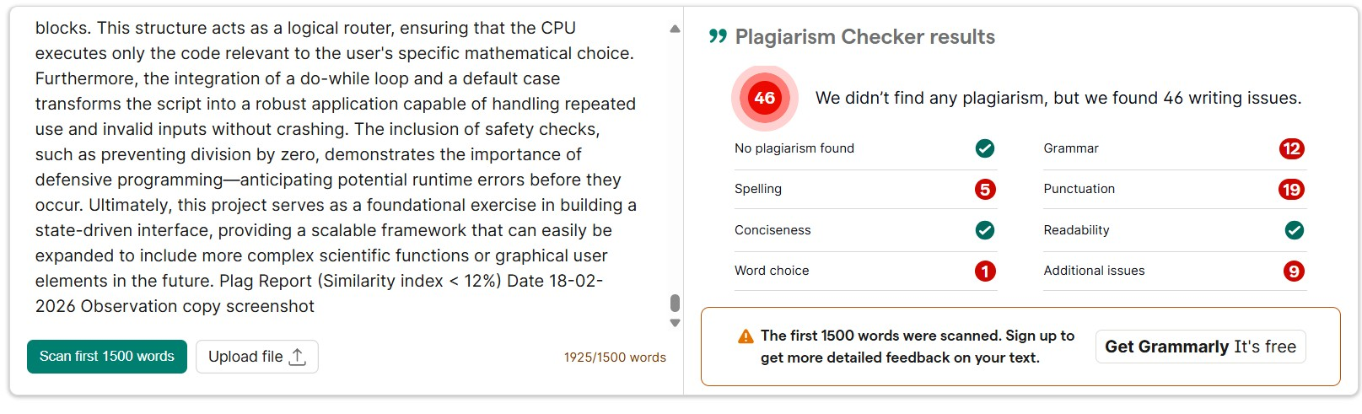
Date | 18-02-2026

To be a preferred hub for nurturing computer engineering aspirants through innovative, ethical, value-based technical education, impactful research, and industry collaboration, to become successful professionals contributing for the betterment of society.

Mission of the Department
To nurture computer engineering professionals by offering: Dynamic learning environment that encourages problem-solving using emerging technology, · National Education Policy aligned evidence-based technical education, fostering innovation, research, and industry–institute collaboration, Holistic, ethical and sustainable development for lifelong success.
Observation copy screenshot
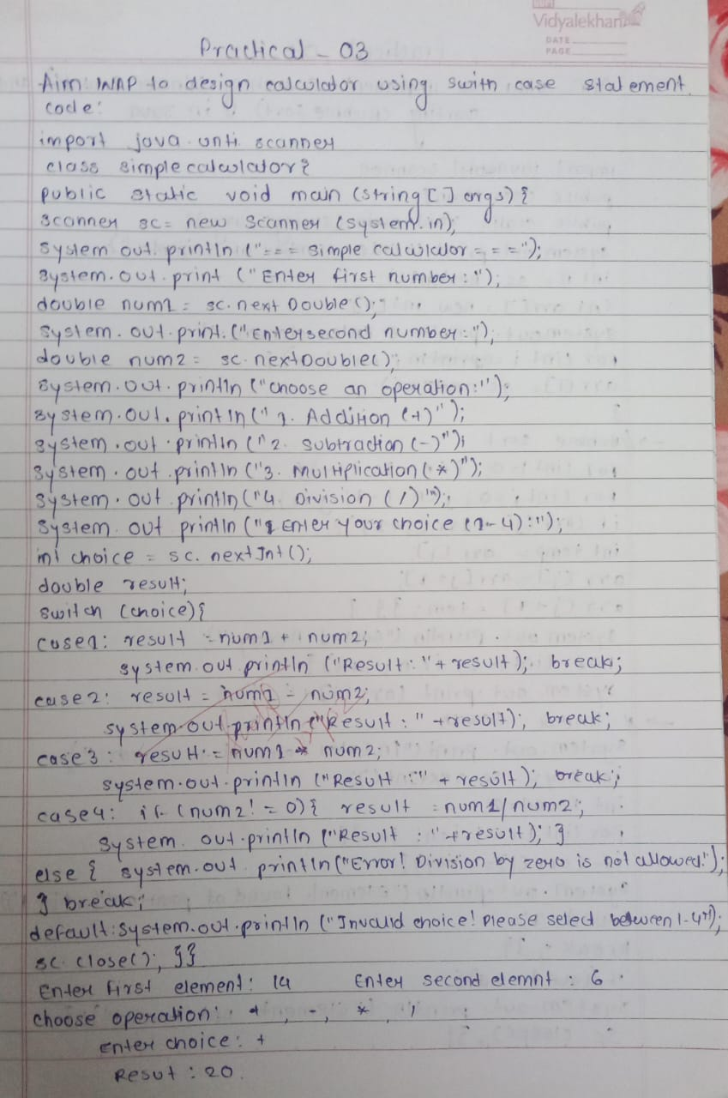

To be a preferred hub for nurturing computer engineering aspirants through innovative, ethical, value-based technical education, impactful research, and industry collaboration, to become successful professionals contributing for the betterment of society.

Mission of the Department
To nurture computer engineering professionals by offering: Dynamic learning environment that encourages problem-solving using emerging technology, · National Education Policy aligned evidence-based technical education, fostering innovation, research, and industry–institute collaboration, Holistic, ethical and sustainable development for lifelong success.

Vision of the Department
To be a preferred hub for nurturing computer engineering aspirants through innovative, ethical, value-based technical education, impactful research, and industry collaboration, to become successful professionals contributing for the betterment of society.

Mission of the Department
To nurture computer engineering professionals by offering: Dynamic learning environment that encourages problem-solving using emerging technology, · National Education Policy aligned evidence-based technical education, fostering innovation, research, and industry–institute collaboration, Holistic, ethical and sustainable development for lifelong success.

