Session 2025-2026(EVEN)

Vision: Dream of where you want. | Mission: Means to achieve Vision

Program Educational Objectives of the program (PEO): (broad statements that describe the professional and career accomplishments)
PEO1 | Preparation | P: Preparation | Pep-CL abbreviation  pronounce as Pep-si-lL easy to recall
PEO2 | Core Competence | E: Environment (Learning Environment)
PEO3 | Breadth | P: Professionalism
PEO4 | Professionalism | C: Core Competence
PEO5 | Learning Environment | L: Breadth (Learning in diverse areas)

Program Outcomes (PO): (statements that describe what a student should be able to do and know by the end of a program)
Keywords of POs:
Engineering knowledge, Problem analysis, Design/development of solutions, Conduct Investigations of Complex Problems, Engineering Tool Usage, The Engineer and The World, Ethics, Individual and Collaborative Team work, Communication, Project Management and Finance, Life-Long Learning

PSO Keywords: Cutting edge technologies, Research

“I am an engineer, and I know how to apply engineering knowledge to investigate, analyse and design solutions to complex problems using tools for entire world following all ethics in a collaborative way with proper management skills throughout my life.” to contribute to the development of cutting-edge technologies and Research.

Integrity: I will adhere to the Laboratory Code of Conduct and ethics in its entirety.

Name and Signature of Student and Date
(Signature and Date in Handwritten)

Session | 2025-26 (EVEN) |  | Course Name | Java Full Stack Development Lab
Semester | 4 |  | Course Code | 23ADS1407
Roll No | 120 |  | Name of Student | Shrusti katakwar
Practical Number |  | 05
Course Outcome |  | After completing this program, students will be able to:  - Understand the concept of multilevel inheritance in Java.  - Implement classes and subclasses to store and process data efficiently.  - Perform calculations using methods in derived classes.  - Display results and grades based on computed data.  - Develop structured, modular, and reusable object-oriented programs.
Aim |  | WAP to demonstrate inheritance in java
Problem Definition |  | ESE Result Processing  Create a base class Student with fields rollNo and name.  Create a derived class Exam that stores marks of five subjects and calculates total marks.  Create another derived class Result that calculates percentage and displays grade
Theory  (100 words) |  | Inheritance is an object-oriented concept where a class (called child or derived class) can acquire the properties and methods of another class (called parent or base class).  Key Points:  - Parent Class (Student):  - Stores common attributes like roll number and name.  - Can have methods to display these details.  - Child Class (Exam):  - Inherits all properties and methods from the parent class.  - Adds its own fields like marks and its own methods.  - Advantages of Inheritance:  - Code Reusability: No need to write the same code again.  - Modularity: Each class handles specific tasks.  - Extensibility: Easy to add new features in child classes.  In this program:  - The Exam class inherits rollNo and name from the Student class.  - The displayStudent() method is reused by Exam.  - This demonstrates single-level inheritance.
Procedure and Execution  (100 Words) |  | Step for Implementation:  - Create the Base Class (Student)  - Include fields rollNo and name.  - Can include methods to input and display student details.  - Create Derived Class (Exam)  - Inherit from Student.  - Include fields for 5 subject marks and total.  - Add a method to calculate total marks.  - Create Final Derived Class (Result)  - Inherit from Exam.  - Include fields for percentage and grade.  - Add methods to:  - Calculate percentage = (total / 5)  - Assign grade based on percentage:  - ≥ 90 → A  - ≥ 75 → B  - ≥ 60 → C  - ≥ 50 → D  - < 50 → F  - Display all student details, total, percentage, and grade.  - Use in Main Program  - Create an object of Result class.  - Take user input for roll number, name, and 5 marks.  - Call methods in order: calculateTotal(), calculateResult(), display().
Code:
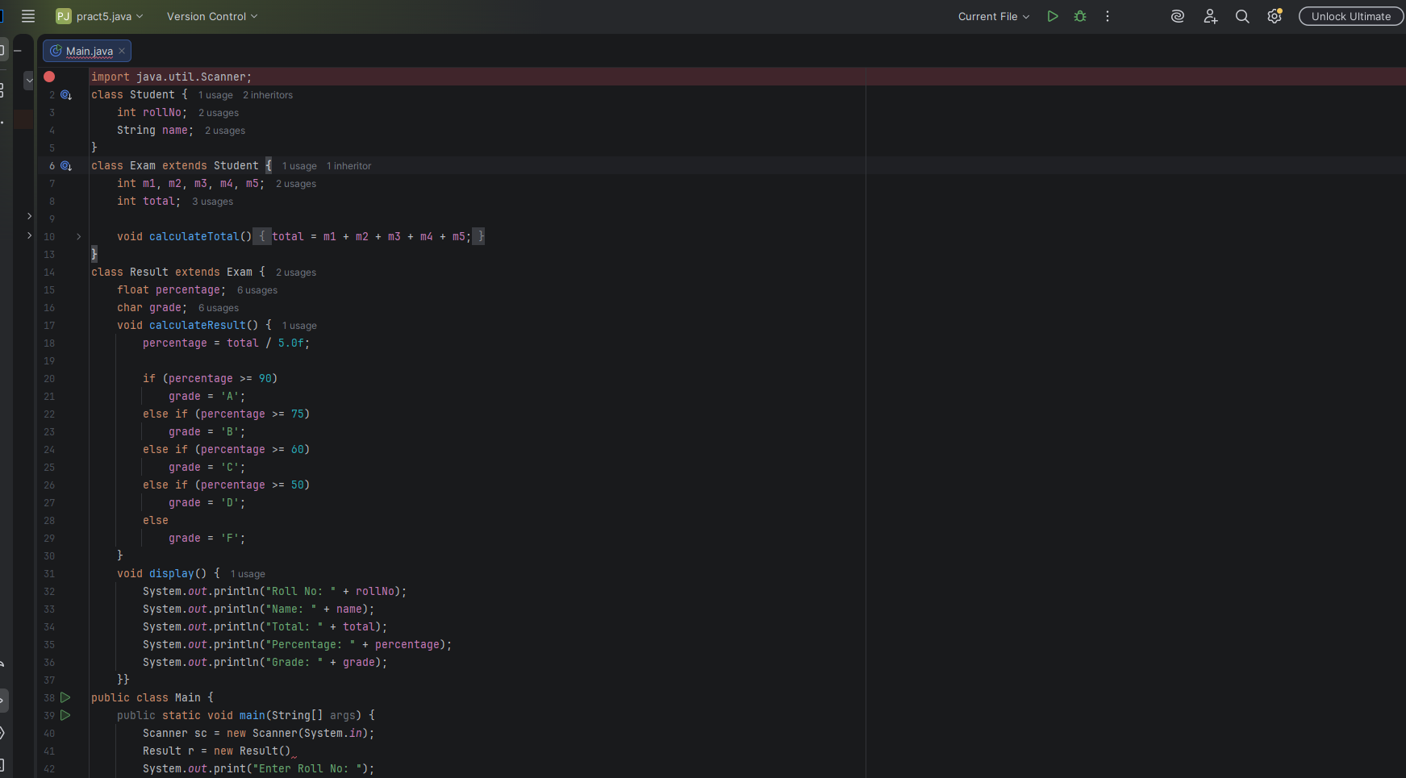
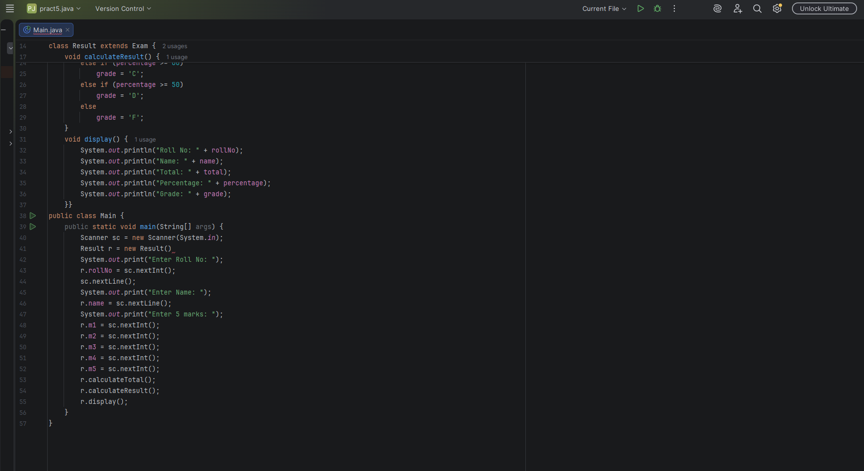

Output:
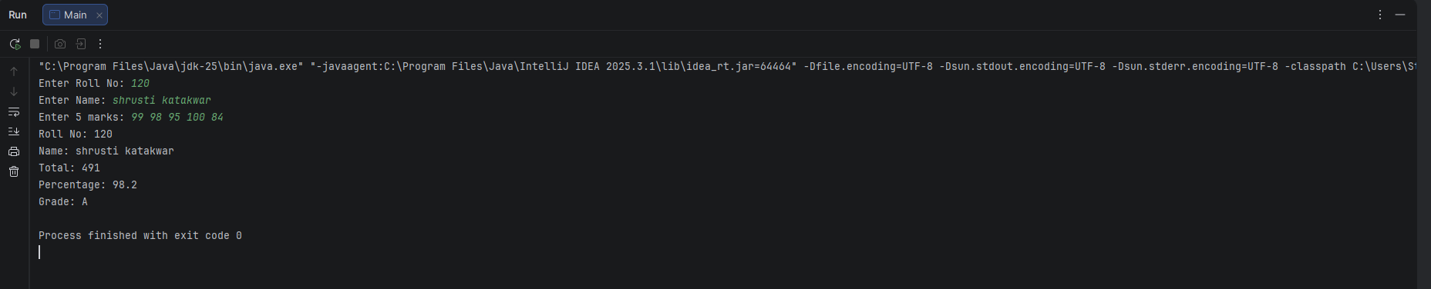

Output Analysis |  | Example Input:  Roll No: 101  Name: Shrusti Katakwar  Marks: 85 78 90 92 80  Execution Steps:  - calculateTotal() → Adds all marks → 85+78+90+92+80 = 425  - calculateResult() → Percentage = 425 / 5 = 85% → Grade = B  - display() → Shows roll number, name, total, percentage, and grade.  Output:  Roll No: 101  Name: Shrusti Katakwar  Total Marks: 425  Percentage: 85.0%  Grade: B
Link of student Github profile where lab assignment has been uploaded
Conclusion |  | • This program demonstrates multilevel inheritance in Java.  • Base class stores general student info, derived classes handle exam marks and results.  • Shows how inheritance allows data reuse and structured program design.  • Makes program modular, maintainable, and easy to extend.
Plag Report (Similarity index < 12%) |  | 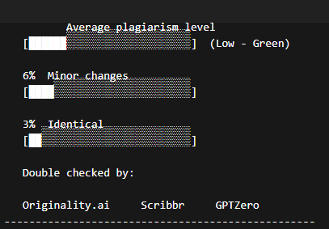
Date |  | 04/02/26

Observation copy screenshot
