**J2EE Web Components**

**Project Phase 1**

**Section: ITE-5332-0NA**

**Expense Tracker Application**

***Team Composition:***

***Team Lead:***

*Student Name: Urja Tej Bhemat, Student Number: N01648980*

***Frontend Developer:***

*Student Name: Sameeha Shaik, Student Number: N01649346*

***Backend Developer:***

*Student Name: Kalwala Siddhartha Reddy, Student Number: N01649317*

***Database Developer:***

*Student Name: Shrusti Nileshbhai Parmar, Student Number: N01652302*

***Tester:***

*Student Name: Shreyabahen Purvesh Italia, Student Number: N01650072*

## **Business Case Requirements**

#### **1.1 Problem Statement:**

Managing personal finances is a challenging task for many individuals. Often, people find it difficult to track their expenses, categorize spending, and stay within their monthly budgets. Traditional methods such as keeping a paper ledger or using spreadsheets are cumbersome and prone to human error. Without a structured approach, it becomes hard for individuals to understand their spending habits and control their finances.

The **Expense Tracker Application** seeks to address this problem by providing a convenient, intuitive, and reliable platform for users to track and manage their daily expenses, categorize them, and set monthly budgets. This will empower users to gain a clear understanding of their financial situation and improve their financial planning.

#### **1.2 Target Audience:**

The target audience for this application includes:

* **Young Professionals**: Individuals who are beginning to manage their finances independently.
* **Families**: People managing household expenses, budgeting for long-term savings, and investments.
* **Students**: College students managing their personal finances with limited budgets.
* **Freelancers**: Independent workers who need to track irregular income and expenses.

The primary needs of the target audience are:

* Easy tracking and categorization of expenses.
* Clear visualization of their financial status through graphs and charts.
* A simple tool to set and manage monthly budgets.
* Ability to review, edit, or delete expenses.

#### **1.3 Proposed Solution:**

The **Expense Tracker Application** provides the following features:

**A. User Management**

* User Registration
* User Login
* Password stored securely (hashed)
* Session management (Logout)

**B. Expense Tracking**

**Add, Edit, and Delete Expenses**: Users can log their expenses in real-time, making it easy to track their financial activities

* Add Expense (Amount, Category, Date, Notes)
* Edit Expense
* Delete Expense
* View List of Expenses
* Categorize Expenses (e.g., Food, Transportation, Entertainment) - to better understand spending patterns
* Set Monthly Budgets for Each Category - helping them stay on track and avoid overspending
* View Expense Reports (Monthly/Weekly) - reports on their spending habits
* Notifications & Alerts for Budget Limits - for users to keep track of budget limits or when they are approaching a budget limit

**C. Income Tracking**

* Add Income Source & Amount

**D. Dashboard**

* Total Income vs. Expenses (Charts and Graphs)
* List of Recent Transactions

The solution will be developed using **Java EE (J2EE)** for backend services, ensuring scalability and reliability. The front end will include user-friendly interfaces for a smooth user experience.

#### **1.4 Scope:**

* **Mandatory Core Functionalities**:
  + User registration and login
  + Add, edit, and delete expenses
  + Categorize expenses
  + Set and track monthly budgets
  + Visual reports and charts on expenses
  + Notification and alert system
* **Optional Enhancements**:
  + Expense export to CSV or PDF
  + Multi-user accounts for shared household or family budgets
  + Integration with bank APIs for automated expense tracking
  + Cloud synchronization for accessing the app across devices

## **Business Case Justification**

#### **2.1 Relevance:**

The **Expense Tracker** application is highly relevant in today’s fast-paced world, where financial literacy is key to managing personal and household finances. With an increasing number of people living paycheck to paycheck, there is a strong demand for tools that allow individuals to track their spending, manage budgets, and save efficiently. The application fulfills this need by providing a user-friendly tool for financial management.

#### **2.2 Expected Outcomes:**

* **Increased Financial Awareness**: Users will gain better insight into their spending habits, allowing them to make informed financial decisions.
* **Better Budget Management**: The application will help users track their budget and prevent overspending, contributing to better financial health.
* **User Retention**: With real-time updates and visual reports, users are more likely to engage regularly with the application to track and manage their finances.

#### **2.3 Feasibility:**

The project is feasible within the allotted timeline and resources. Java EE (J2EE) will provide a robust backend that can scale with the increasing number of users and data. The front-end interface will be simple and intuitive, ensuring that users can navigate the app without a steep learning curve. With the available resources, the core functionalities can be developed within a few months, and additional features can be rolled out in phases.

1. **UML Diagrams**

**3.1 Class Diagram:**

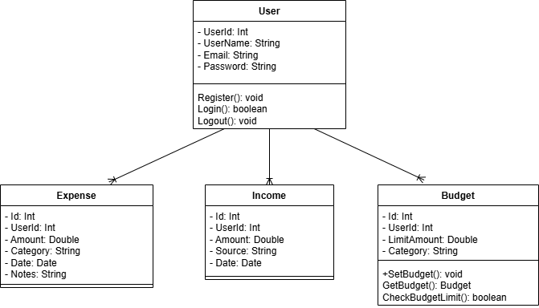

**3.2 Sequence Diagram:**

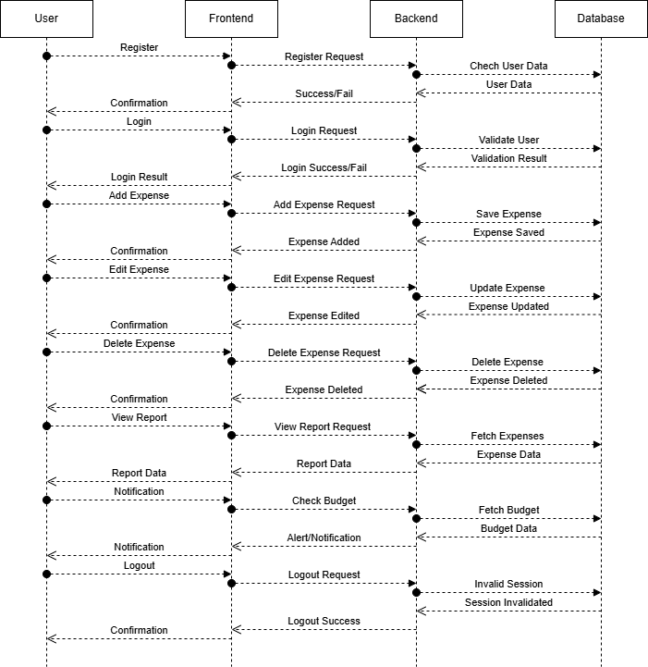

**J2EE Application Level Sequence Diagram**

