**Lab Practical #05:**

Study the concept of VLAN using packet tracer.

**Practical Assignment #05:**

1. **Implement the different network structures in VLAN and VLAN trunking. Also check connectivity between them using ping command or PDU utility.**

* **First Diagram**

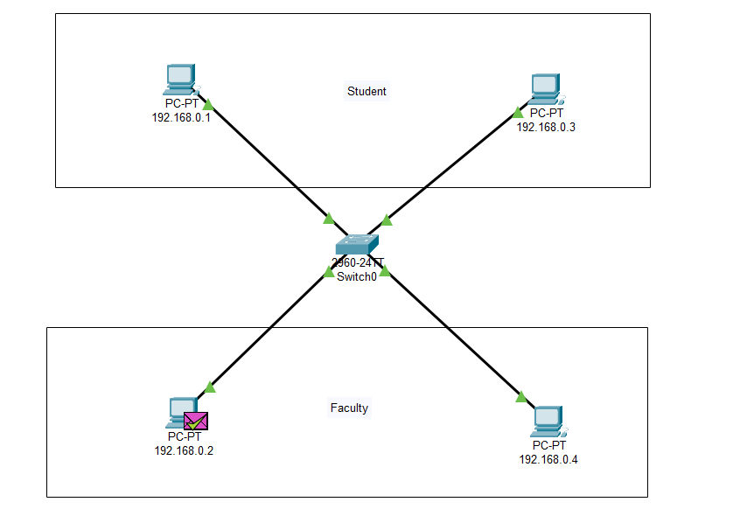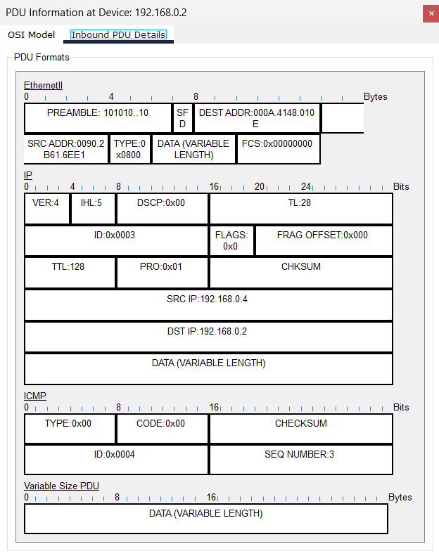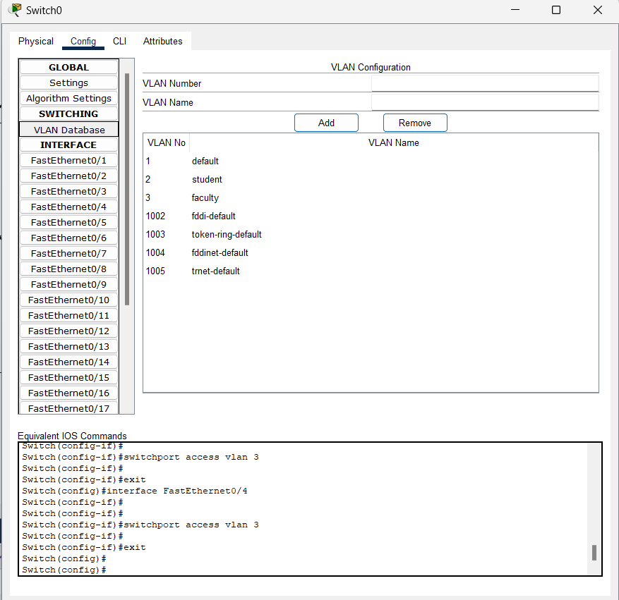

* **Second Diagram**

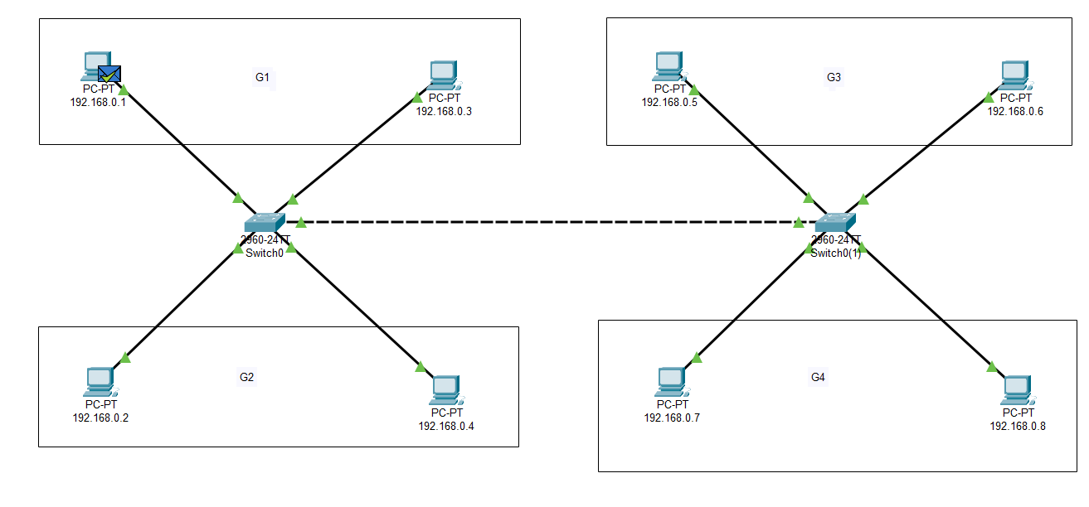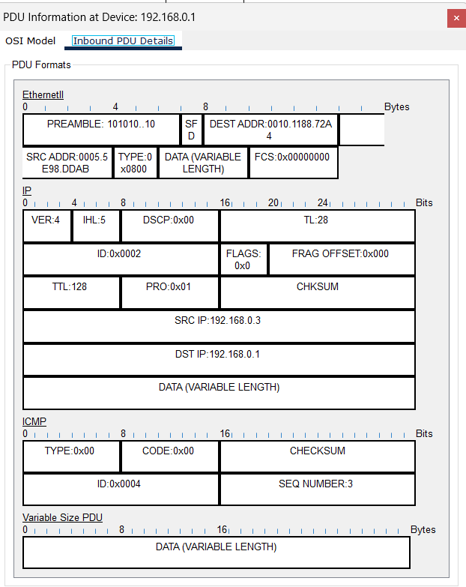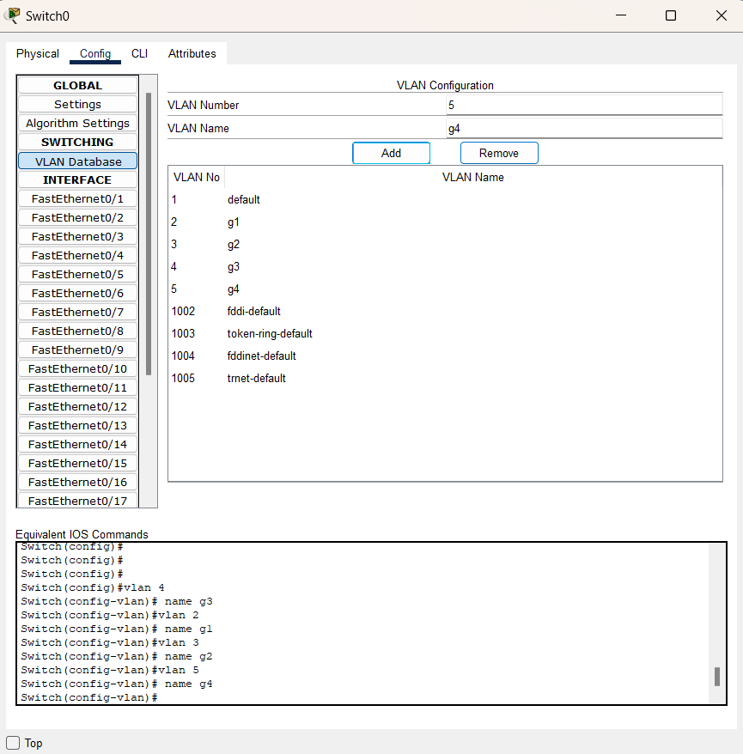

* **Third Diagram**

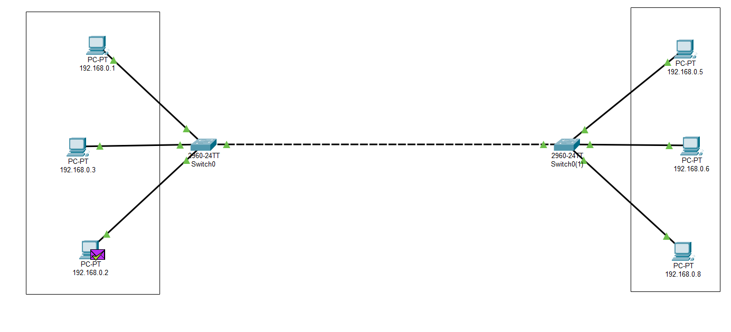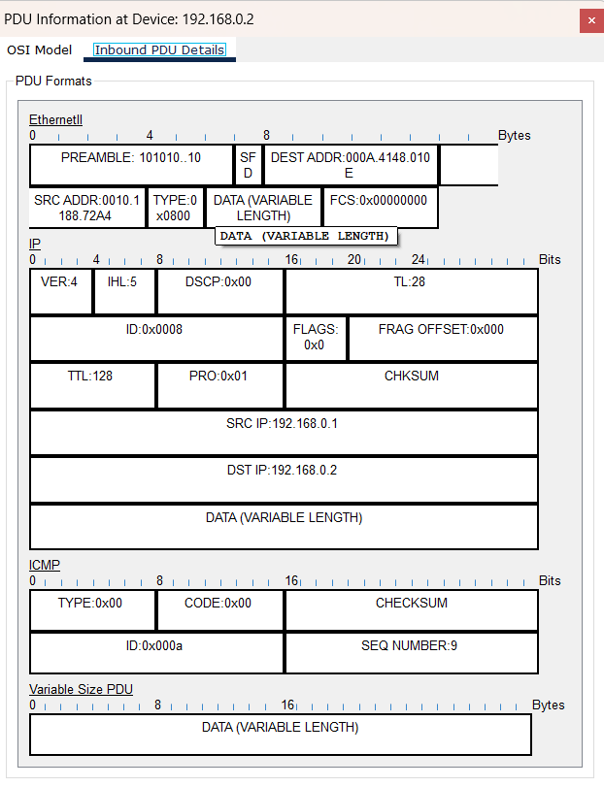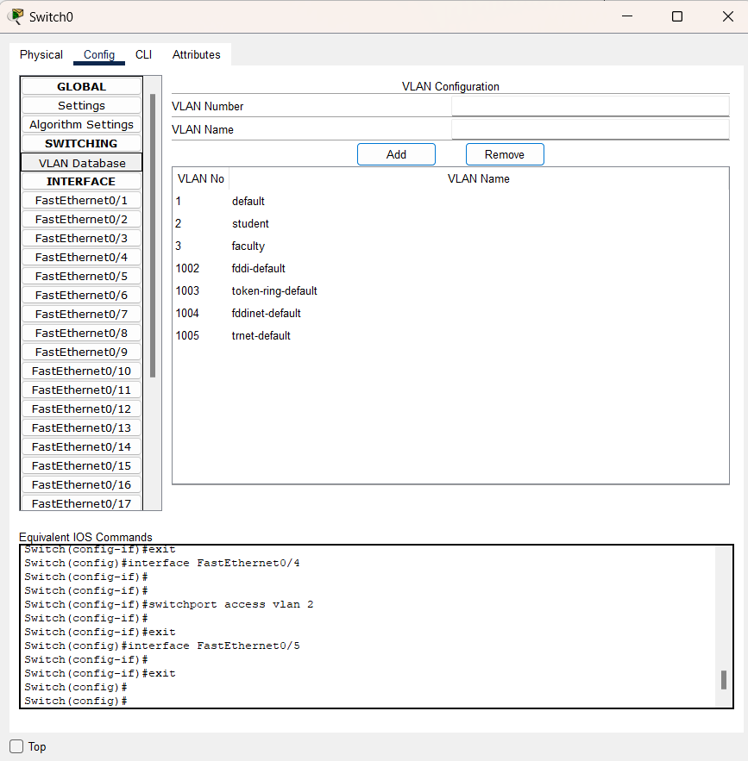

* **Forth Diagram**

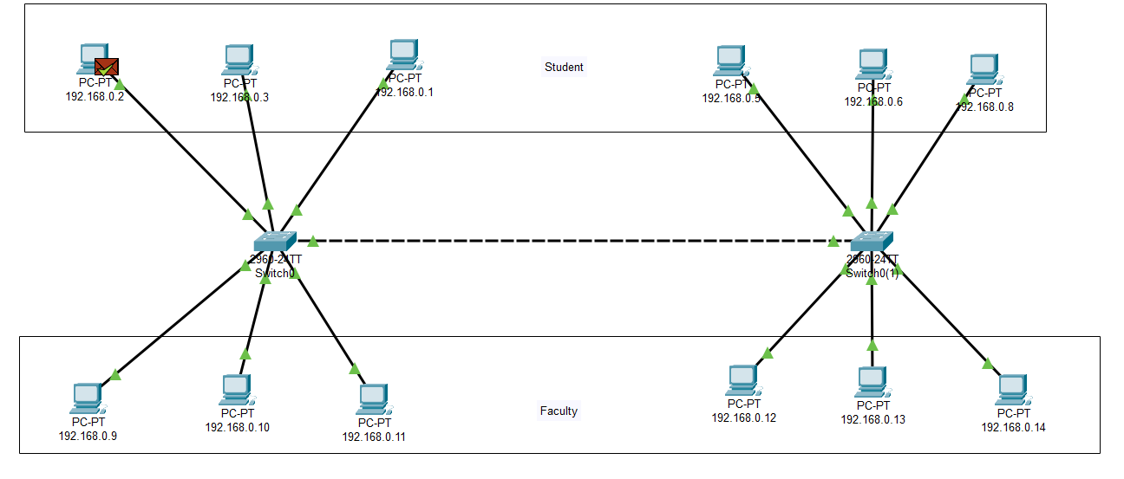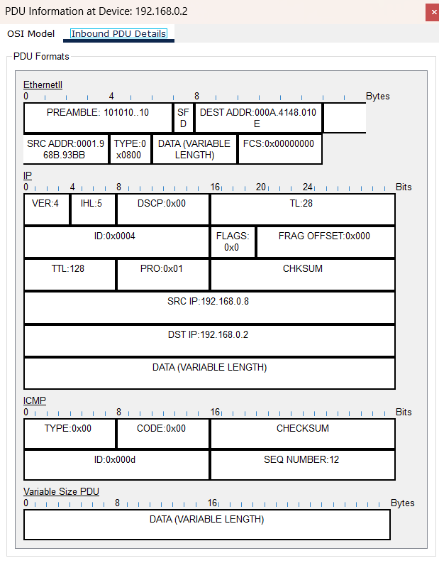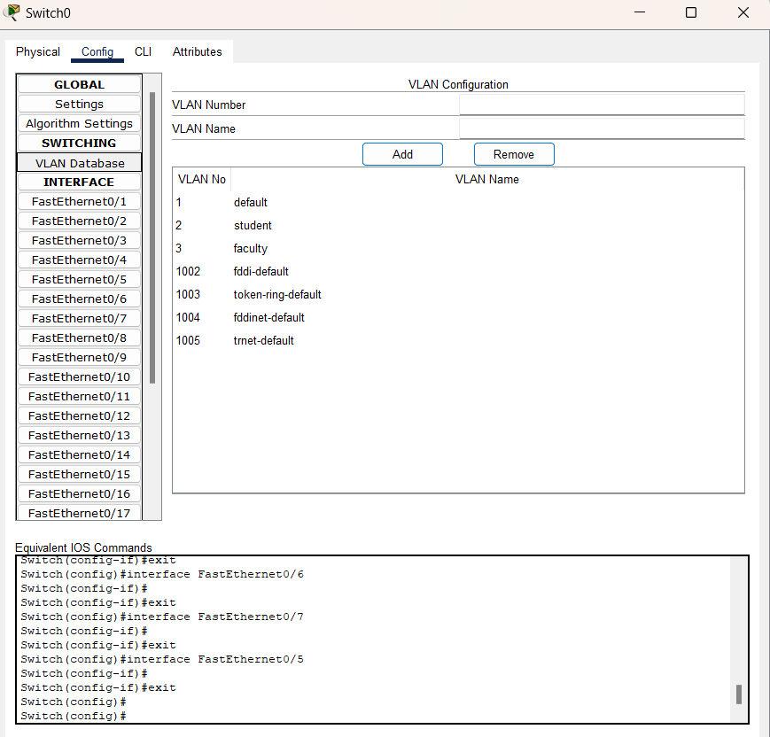

**Steps to perform this above diagrams :**

**Step 1:** You need to open cisco packet tracer.

**Step 2:** You need drag at least one switch and drop into workspace and add few end devices like pc to the workspace using drag-drop and ensure that you need to change all the pc ‘name’ and pc ‘IP-address’.

**Step 3:** Connect all the pc in the switch use of below ‘orange’ symbol called connections and pick first symbol.

**Step 4:** Create 2 VLANs the name of first VLAN is VLAN-G1 and the second VLAN is VLAN-G2. To configure VLANs we have to go to the switch switch0 and move to config → switching→ VLAN Database. Now let us take the VLAN Number for G1 is 101 and for G2is 201 and add these numbers to VLAN Database. Select the hosts under VLAN-G1. Here I have put hosts with IP addresses from 192.168.10.1 to 192.168.10.3 under VLAN-G1. To do so we have to select the switch switch0 → config →interface, here we choose FastEthernet0/1 corresponding to the host 192.168.10.1 which we consider to be in VLAN-G1. Now we select the down arrow beside VLAN and select 101:G1, which is for student VLAN. Similarly, we do this same process for FastEthernet0/2 and FastEthernet0/3.

**Step 5:** Now we have to configure the hosts under VLAN-G2. Here I have put hosts with IP-addresses 192.168.10.4 to 192.168.10.6 under VLAN-G2. To do so, just follow the process mentioned in step 4, but instead of selecting the VLAN Number 101:G1, select 201:G2 for FastEthernet0/4, FastEthernet0/5, and FastEthernet0/6.

**Step 6:** Change the switch port mode from access to trunk for FastEthernet0/7.

**Step 7:** Lastly, you drag the email symbol the apply any two pcs (as per your choice) and click the simulation button then run.

**Step 8:** If in below right side in your screen successful message is show then your VLAN is complete, otherwise not.