**Lab Practical #03:**

Study of different network devices in detail.

**Practical Assignment #03:**

1. Give difference between below network devices.

* Hub and Switch
* Switch and Router
* Router and Gateway

1. Working of below network devices:
   * Switch
   * Router
   * Gateway

# Hub and Switch

|  |  |  |
| --- | --- | --- |
| No. | Hub | Switch |
| 1 | [Hub](https://www.geeksforgeeks.org/advantages-and-disadvantages-of-hub/) is operated on **Physical layer of OSI model**. | [Switch](https://www.geeksforgeeks.org/what-is-a-network-switch-and-how-does-it-work/) is operated on **Data link**[**layer of OSI Model**](https://www.geeksforgeeks.org/layers-of-osi-model/). |
| 2 | Hub is a broadcast type transmission. | Switch is a Unicast, multicast and broadcast type transmission. |
| 3 | Hub have 4/12 ports. | Switch can have 24 to 48 ports. |
| 4 | In hub, there is only one collision domain. | In switch, different ports have own collision domain. |
| 5 | Hub is a half duplex transmission mode. | Switch is a full duplex transmission mode. |
| 6 | Hub cannot be used as a repeater. | Switch can be used as a repeater. |
| 7 | Hub is not an intelligent device that sends message to all ports hence it is comparatively inexpensive. | Switch is an intelligent device that sends message to selected destination so it is expensive. |
| 8 | Hub is simply old type of device and is not generally used. | Switch is very sophisticated device and widely used. |
| 9 | Hacking of systems attached to hub is complex. | Hacking of systems attached to switch is little easy. |
| 10 | Speed of original hub 10Mbps and modern internet hub is 100Mbps. | Maximum speed is 10Mbps to 100Mbps. |

# Switch and Router

|  |  |  |
| --- | --- | --- |
| No. | Switch | Router |
| 1 | The main objective of switch is to connect various devices simultaneously. | The main objective of router is to connect various networks simultaneously. |
| 2 | It works in [data link layer](https://www.geeksforgeeks.org/data-link-layer/). | It works in [network layer](https://www.geeksforgeeks.org/network-layer-gq/). |
| 3 | Switch is used by only LAN. | Router is used by [LAN](https://www.geeksforgeeks.org/lan-full-form/) as well as [MAN](https://www.geeksforgeeks.org/man-full-form/). |
| 4 | Through switch data is sent in the form of  frame. | Through the router, data is sent in the form of packets. |
| 5 | There is no collision taking place in full duplex switch. | There is less collision taking place in the router. |
| 6 | Switch is an expensive device than [hub](https://www.geeksforgeeks.org/what-is-network-hub-and-how-it-works/). but cheaper than router. | [Router](https://www.geeksforgeeks.org/introduction-of-a-router/) is a relatively much more expensive device than switch. |
| 7 | Maximum speed is 10Mbps to 100Mbps. | Maximum speed for wireless is 1-10 Mbps and maximum speed for wired connections is 100 Mbps. |
| 8 | Switch needs at least single network is to connect. | Router needs at least two networks to connect. |

# Router and Gateway

|  |  |  |
| --- | --- | --- |
| No. | Router | Gateway |
| 1 | It is a hardware device which is responsible for receiving, analyzing and forwarding the data packets to other networks. | It is a device that is used for the communication among the networks which have a different set of protocols. |
| 2 | It supports the dynamic routing. | It does not support dynamic routing. |
| 3 | The main function of a router is routing the traffic from one network to the other. | The main function of a gateway is to translate one protocol to the other. |
| 4 | A router operates on layer 3 and layer 4 of the OSI model. | A gateway operates upto layer 5 of the OSI model. |
| 5 | Working principle of a router is to install routing details for multiple networks and routing traffic based upon the destination address. | Working principle of a gateway is to differentiate what is inside the network and what is outside the network. |
| 6 | It is hosted on only the dedicated applications. | It is hosted on dedicated applications, physical servers or virtual applications. |
| 7 | The additional features provided by a router are Wireless networking, Static routing, NAT, DHCP server etc. | The additional features provided by a gateway are network access control, protocol conversion etc. |

# Working of below network devices:

1. **Switch**
   * **The Switch is a network device that is used to segment the networks into different subnetworks called subnets or LAN segments. It is responsible for filtering and forwarding the packets between LAN segments based on**[**MAC address**](https://www.geeksforgeeks.org/introduction-of-mac-address-in-computer-network/)**.**
   * **When the source wants to send the data packet to the destination, the packet first enters the switch and the switch reads its header and finds the MAC address of the destination to identify the device then it sends the packet out through the appropriate ports that lead to the destination devices.**
   * **Switch establishes a temporary connection between the source and destination for communication and terminates the connection once the conversation is done. Also, it offers full bandwidth to network traffic going to and from a device simultaneously to reduce collision.**

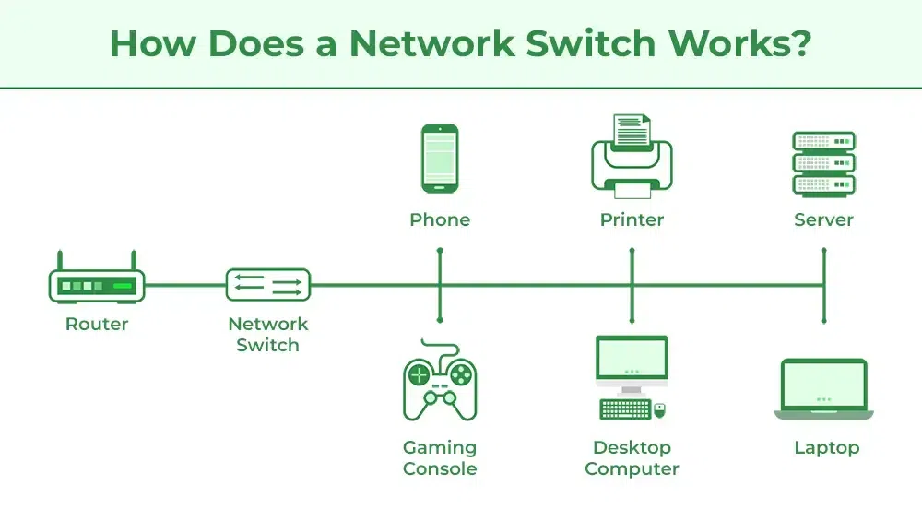

1. **Router**
   * **A Router is a networking device that forwards data packets between computer networks. One or more** [**packet-switched networks**](https://www.geeksforgeeks.org/packet-switched-network-psn-in-networking/) **or subnetworks can be connected using a router. By sending data packets to their intended IP addresses, it manages traffic between different networks and permits several devices to share an Internet connection. Although there are many kinds of routers, the majority of them transfer data between LANs (local area networks) and WANs (wide area networks).**
   * **Consider a router as an air traffic controller, and consider data packets as planes flying to various airports (or networks). Each packet must be directed as quickly as possible to its destination, just as each plane has a distinct destination and travels a distinct route. A router assists in guiding data packets to their intended**[**IP address**](https://www.geeksforgeeks.org/what-is-an-ip-address/)**, just like an air traffic controller ensures that aircraft reach their destinations without getting lost or experiencing significant disruptions in a route.**
   * **An internal**[**routing table**](https://www.geeksforgeeks.org/routing-tables-in-computer-network/)**, which is a list of routes to different network destinations, is used by a router to effectively direct packets. In order to determine the destination of a packet, the router first scans its header. Then, it consults the routing table. Forward packet to next packet.**

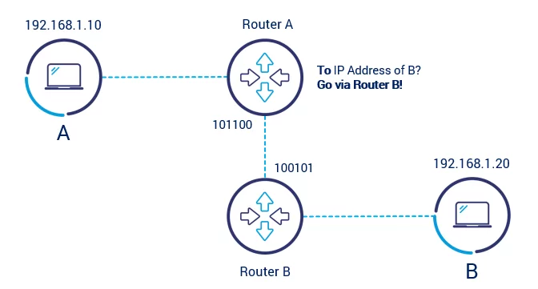

1. **Gateway**
   * **A gateway is a connecting point of any network that helps it to connect with different networks. The gateway monitors and controls all the incoming and outgoing traffic of the network. Suppose there are two different networks and they want to communicate with each other, so they need to set up a path between them. Now that path will be made between gateways of those different networks. Gateways are also known as protocol converters because they help to convert protocol supported by traffic of the different networks into that are supported by this network. Because of that, it makes smooth communication between two different networks.**
   * **Gateway has a simple working methodology of five steps:**
     1. **Step 1: It gets data from the network**
     2. **Step 2: It intercepts and analyzes the received data.**
     3. **Step 3: It routes the data to the destination address.**
     4. **Step 4: It converts the received data to make that compatible with the receiver network.**
     5. **Step 5: It sends the final data inside the network.**

