

**IUP Online Publishing House**

Concept Note

25 September 2024

**IUP Online Publishing House**

**1. Introduction:**

CIT aims to revamp the IUP website’s publication process of books, articles, magazines, etc., and the purchasing system to align with the international academic publishing standards. The redesigned system will focus on a streamlined user experience (UX), ensuring ease of navigation, responsive design, accessibility, and visual aesthetics, while maintaining robust security and transaction features that simplifies article submission and purchasing for both authors and readers allowing individual purchases and subscription models. The new platform integrates key features of publishing process flow such as automated submission, review, publishing, distribution, and sales. This document provides an outline of the key requirements ,prepared in consultation with department.

**Outline for the Online Publishing House**

**Objective:** Develop an automated system for publishing books, articles, journals, and magazines, with selected open access options.

**Stakeholders:**

* Authors
* Research Associates
* Editors (Chief, Editors, Reviewers)
* Readers/Subscribers
* Admins

**Key Functionalities:**

* ORCID-based User Authentication
* Submission and Review System
* Custom publishing process by type (Books, Journals, etc.)
* Payment Gateway Integration
* Metadata management (title, keywords, DOI, etc.)
* Notifications and Automated Updates
* Admin Dashboard for Management, Analytics, and Support

**Key Publishing Processes**

1. **User Authentication and Role Assignment:**
   * Registration and role-based access rights for all stakeholders.
   * Admin can customize roles and permissions.
2. **Submission Process:**
   * **Authors:** Submit manuscripts (DOCX, PDF), choose submission type (open access, book, etc.), perform automated plagiarism checks, and enter metadata.
   * **Editors:** Assign reviewers, track reviews, and approve/reject submissions.
   * **Reviewers:** Review, proofread, and provide feedback or revision suggestions.
3. **Review and Approval Workflow:**
   * Automated notifications at each stage.
   * Editors approve, reject, or request changes; authors revise as needed.
4. **Publication Process:**
   * Approved manuscripts are formatted, typeset, and published (ePub, PDF).
   * ISBNs, ISSNs, and DOIs are auto-generated.
   * Publications indexed and made searchable.
5. **Distribution and Access:**
   * **Paid Access:** Payment gateways for buying and subscription models.
   * **Open Access:** Free access for select publications; authors may pay for this.
6. **Analytics and Management:**
   * Admin dashboard tracks submissions, reviews, sales, user activity, and generates reports.
7. **Maintenance and Updates:**
   * Continuous feedback and system improvements for submission and review workflows.

### 4. Proposed IUP Automated Online Publishing Process

An online publishing process workflow for journals is depicted below. Individual custom processes to suit various categories of publications pertaining to books, and magazines will be incorporated into the online portal.

**Proposed IUP Automated Online Publishing Process Flow for Journals**

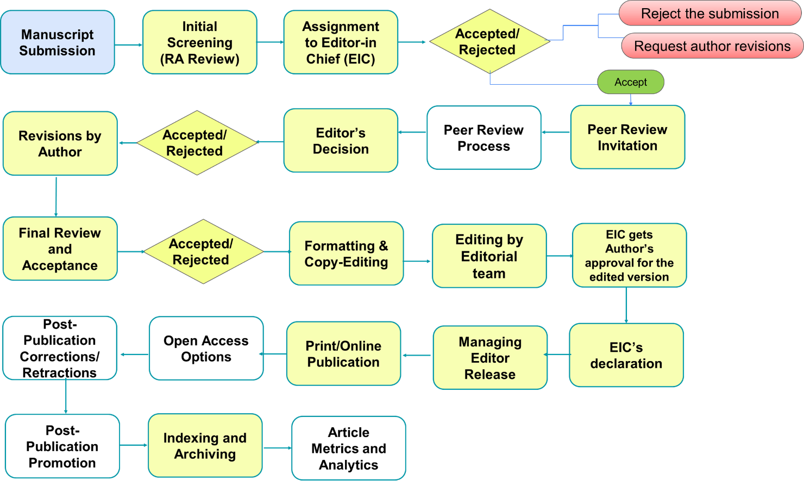

|  |  |
| --- | --- |
| **Online Publishing Process** | **Details** |
| **1. Manuscript Submission** | - Authors submit their manuscripts through an online submission platform (e.g., ScholarOne or Editorial Manager). - Submission guidelines include formatting, ethical declarations, and reference styles. - System supports various file formats (Word, LaTeX). - Copyright declaration from Author  - Acknowledgement with submission number to author & editorial team after successful submission. |
| **2. Initial Screening (Desk Review)** | - The editorial team screens the manuscript for scope, novelty, plagiarism (using software like Turnitin), and compliance with submission guidelines. - Manuscripts not adhering to journal standards are rejected or sent back for modifications. |
| **3. Assignment to Editor-in Chief (EiC)** | - Suitable manuscripts are assigned to a subject editor with expertise in the relevant field. - The editor checks the manuscript for completeness and assigns it for peer review. - Message to Author – Your Article has been put under referral process - Acceptance and Rejection by Editor - Peer allocation by Editor |
| **4. Peer Review Invitation** | - Reviewers are selected based on expertise, availability, and potential conflicts of interest. - Reviewers are invited (via email or platform) to assess the manuscript, following a double-blind, single-blind, or open review process, depending on journal policy. - Mail to Author to edit and send alert,  - Assigning to the Peer by Editor in Chief |
| **5. Peer Review Process** | - Reviewers evaluate the manuscript for quality, rigor, novelty, ethical standards, and methodology. - Reviewers provide recommendations (accept, minor/major revisions, or reject) and detailed feedback for both the author and editor. |
| **6. Editor’s Decision** | - The editor consolidates reviewer comments and makes a preliminary decision. - If revisions are required, authors are given reviewer feedback and a timeline for resubmission. - If accepted, the manuscript moves forward to the production stage. |
| **7. Revisions by Author** | - Authors revise their manuscript according to reviewer comments and resubmit through the platform. - Authors may need to provide a response letter explaining how they addressed each comment. |
| **8. Final Review and Acceptance** | - The editor reviews the revised manuscript and, if necessary, sends it back for further review or makes a final decision. - Upon acceptance, authors are notified, and the manuscript moves to production. |
| **9. Copy-Editing and Formatting** | - Manuscript undergoes professional copy-editing, ensuring clarity, consistency, grammar, and adherence to journal style. - The layout team formats the manuscript for both online and print publication, including figures, tables, and references. |
| **10(A) Proof Review** | - Authors receive galley proofs for final review, focusing on correcting minor typographical or formatting errors. - Any significant content changes at this stage may be subject to editorial approval. |
| **10(B) Confirmation by Author** | -Author has to agree of all the changes, as a confirmation for the publication. |
| **11. Print Publication** | - The article is assigned to a specific issue for print publication. - It is included in the Table of Contents (ToC) of the journal's print edition. |
| **12. Online First Publication** | - The final version of the manuscript is published online (Online First) before the print version. -DOI Implementation -Allocation of Issue (ex: Oct. 2024) -Allocation of Volume -Provision to change ISSN |
| **13. Indexing and Archiving** | - The article is indexed in major academic databases (Scopus, Proquest, Ebsco, etc.) for broader visibility. - Archival services ensure long-term preservation of the article, making it accessible through institutional repositories |
| **14. Copyright and Licensing** | For subscription-based publications, the publisher retains copyright, granting authors limited rights for sharing preprints. |
| **15. Article Metrics and Analytics** | - Article metrics, including downloads, citations, and Altmetric scores, are provided to authors. - Publishers promote the article through email campaigns, social media, and integration with platforms like Research Gate, Mendeley, or academic databases. |
| **16. Post-Publication Promotion and Activities** | - The publisher promotes articles via press releases, podcasts, social media, and collaborations with academic blogs.  - Article sharing through repositories, author profiles, and academic networks is encouraged.  - Corrections, retractions, and content updates follow COPE guidelines and EiC action.  - SEO, metadata optimization, and reader engagement tools enhance visibility and interaction. |

**Proposed IUP Automated Online Publishing Process Flow for Magazines**

### 

### 5. Operational Requirements

### A. Editorial and Review Team

### *Editors*: Oversee content quality, assign reviewers, and manage publication timelines.

### *Reviewers*: Empaneled subject matter experts who assess submission quality.

### *Author Management*: Support authors through submission and review.

### B. Publishing Contracts and Rights

### *Contracts*: Outline rights, royalties, and open access terms.

### *Copyright Management*: Define ownership policies for published content.

### *Creative Commons Licensing*: Offer authors copyright or open access options.

### C. Marketing and Distribution

### *Marketing Team*: Promote via email, social media, and academic networks.

### *Distribution*: Use platforms like Google Books, Amazon Kindle, and JSTOR.

### *SEO and Indexing*: Ensure visibility in search engines and academic directories.

### D. Customer Support

### *Helpdesk*: Address technical and submission issues.

### *Knowledge Base*: Provide FAQs, guidelines, and tutorials.

### E. Monetization and Financial Management

### *Revenue Models*: Set income streams (subscriptions, publication fees, sales).

### *Royalty Management*: Automate royalty distribution.

### *Accounting*: Integrate with accounting software for transactions.

### F. Legal and Compliance

### *Copyright and Licensing*: Ensure intellectual property compliance.

### *Tax Compliance*: Adhere to tax laws for sales.

### *Regulations*: Follow data protection and regional legal requirements.

**6. Future Scope**

**AI and Machine Learning Integration**

* *Automated Content Curation*: AI suggests related content based on user preferences, similar to platforms like Elsevier and Springer.
* *AI-powered Peer Review*: Use AI for plagiarism checks, grammar, and guideline adherence to streamline initial review processes.
* *Predictive Analytics*: Provide authors insights on paper acceptance likelihood and predicted impact factors using machine learning.

**Author Tools and Support Services**

* *Manuscript Assistance*: Offer tools for formatting, plagiarism checks, grammar correction, and reference management.
* *Translation Services*: Provide multilingual and translation support for non-English authors to reach a global audience.

**Partnerships and Collaborations**

* *Institutional Partnerships*: Partner with universities and research institutions for credibility and distribution.
* *Cross-Publisher Collaborations*: Collaborate with other publishers and databases for shared content and cross-platform access.

**Payment and Revenue Distribution**

* Authors can monitor sales, royalties, or publication fees.
* Revenue share management for authors, editors, and platforms.
* Automatic revenue distribution based on predefined rules.

**Phase-wise Implementation of the above Proposal:**

**Phase – I Implementation of complete Revamped portal comes with a prerequisite of making current IUP website functional**

1. Making Current Website Functional and improving Navigation
2. Payment gateway integration for buying of Article online
3. Provision for Uploading of Articles by IUP Department

**Phase – 2 (Make Online Publishing Portal Including all process flows)**

1. Design approval of New IUP portal & development
2. Submission of Article process
3. Subscription process online and offline
4. Digital Conversion of previous Articles
5. Retraction process

References Enclosed.