**Exercise 2: E-commerce Platform Search Function**

**Objective**

You are building a search feature for an e-commerce platform. Customers should be able to search for products by name or category. The goal is to optimize this search functionality for high performance.

**Understanding Asymptotic Notation**

**What is Big O Notation?**

Big O notation is a mathematical concept used to describe the efficiency of an algorithm. It expresses the time or space complexity in terms of input size (n), focusing primarily on the worst-case scenario. It helps us understand how an algorithm scales as the size of input data increases.

**Why is Big O Important?**

* It allows comparison of algorithm efficiency.
* Helps predict algorithm behavior on large datasets.
* Guides developers in choosing the most optimal solution.

In real-time platforms like e-commerce, search optimization is critical. Understanding Big O notation is essential for designing scalable and responsive systems.

**Advanced Optimization Concepts**

As systems grow in scale, the following data structures and techniques may be used for enhanced performance:

* **Hash Maps**: Provide O(1) average-case lookup time.
* **Inverted Indexes**: Commonly used in search engines for quick lookups.
* **Database Indexing**: Improves query speed by indexing product fields.

**Linear Search**: Scans each element until the desired one is found. Works on unsorted data.

**Binary Search**: Efficiently divides the array and searches by comparing midpoints. Requires the array to be sorted.

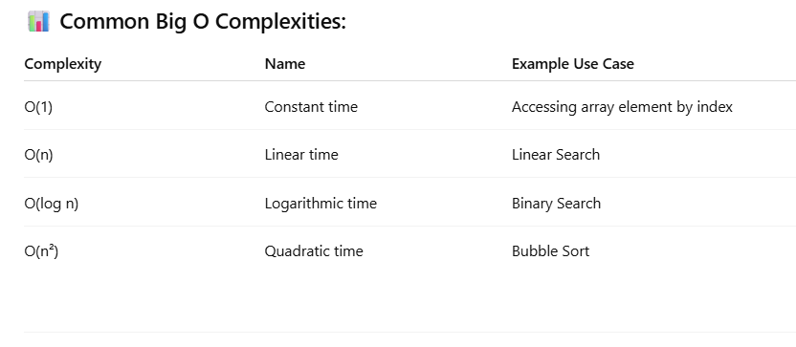

**Analysis**

* **Linear Search**  
  Suitable for small datasets or unsorted collections where the overhead of sorting does not justify the performance gain. It is easy to implement but inefficient for large datasets.
* **Binary Search**  
  Highly efficient for large datasets due to its logarithmic time complexity. However, it requires that the array is sorted in advance. Maintaining a sorted array dynamically can add complexity and overhead.

**Conclusion**

Given that e-commerce platforms often handle **large inventories** and need **fast search performance**, **binary search** is typically more appropriate. While sorting and maintaining the data adds overhead, the improved search speed is often worth it.

For large-scale production systems, a **hybrid approach** or more advanced data structures like **balanced binary search trees** or **hash tables** can be used to provide even better performance and flexibility.