

**DEPARTMENT OF**

**COMPUTER SCIENCE ENGINEERING**

**VASAVI COLLEGE OF ENGINEERING**

**IBRAHIMBAGH, HYDERABAD-31**

***Affiliated to***

***OSMANIA UNIVERSITY***

***HYDERABAD***

Project Documentation

On

Supermarket billing system

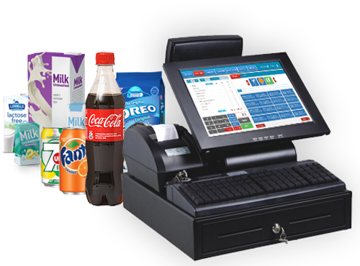

Presented by:

Shruthi Reddy - 1602-18-733-104

Vishwachand - 1602-18-733-120

Content:

* Abstract
* Introduction
* Work flow
* Source code
* Output
* Conclusion

Abstract

The project is on Supermarket billing. Supermarket is the place where customers come to purchase their daily using products and pay for that. So there is need to calculate how many products are sold and to generate the bill for the customer.

To make software fast in processing, with good user interface so that user can change it and it should be used for a long time without error and maintenance.

INTRODUCTION

INTRODUCTION:

This project does the same work that is calculating the bill, gives it to the customer and maintain proper database. They are accurate in calculation and printing.

OBJECTIVE:

To make software fast in processing, with good interface so that user can change it and it should be used for a long time without error and maintenance.

SCOPE:

1.Calculate the bill.

2.Store the products list and display.

3.Store the prices of the products.

4.Can avail discounts.

5.Can create a user account.

Work flow

Work in the Supermarket will be done in the following way:

* The product will come in store.
* Data entry operator will enter the information of the product in database.
* The customer will come and take the basket with him/her and choose the product and take it to the counter.
* The bill calculating operator will check the products and enter the quantity then bill will be calculated and total payment is shown.

SOURCE CODE

#include<stdio.h>

#include<stdlib.h>

#include<string.h>

int length=30;

int size=-1;

typedef struct node

{

char name[30];

int quantity;

struct node *next;

}node;

node *top,*top1,*tem;

typedef struct super

{

char name[40];

int price;

int quantity;

}super;

typedef struct user

{

char username[30];

char password[30];

long int num;

struct user *next;

}user;

user *temp=NULL,*p=NULL,*q=NULL,*ptr=NULL;

FILE *fp;

void push(char item[],int qua)

{

tem=(node *)malloc(sizeof(node *));

strcpy(tem->name,item);

tem->quantity=qua;

tem->next=NULL;

if(top==NULL)

{

top=tem;

}

else

{

tem->next=top;

top=tem;

}

}

int pop(super x[])

{

int sum=0;

char n[20];

int qua;

int i;

if(top==NULL)

{

printf("you didn't choose any item\n");

printf("please make sure to choose atleast 1 item\n");

return;

}

else

{

top1=top;

printf("the items u have purchased with their quantity are \n");

while(top1!=NULL)

{

strcpy(n,top1->name);

qua=top1->quantity;

printf("\t%12s",n);

printf("\t\t%d\n",qua);

for(i=0;i<length;i++)

{

if(strcmp(x[i].name,n)==0)

{

sum=sum+x[i].price*qua;

}

}

top1=top1->next;

}

}

return sum;

}

void display(super x[])

{

int i,q,bill;

char c[5],item[20];

for(i=0;i<length;i++)

{

printf("%12s",x[i].name);

printf("%20d ",x[i].price);

printf("\t%10d ",x[i].quantity);

printf("\n");

}

abcd:

printf("press yes to shop the item present in the menu else press no\n");

scanf("%s",c);

if(strcmp(c,"yes")==0)

{

printf("enter the name of the item and quantity only if they are available in the menu\n");

scanf("%s %d",item,&q);

push(item,q);

goto abcd;

}

else

return;

}

void search(super x[])

{

char item[30];

int i;

char c[30];

int q;

wxyz:

printf("enter the name of the item u want to search\n");

scanf("%s",item);

for(i=0;i<length;i++)

{

if(strcmp(x[i].name,item)==0)

{

printf("item you entered is present in the list\n");

printf("press yes if u want to purchase the entered item else press no\n");

scanf("%s",c);

if(strcmp(c,"yes")==0)

{

size++;

printf("enter quantity of the item u want to store\n");

scanf("%d",&q);

push(item,q);

printf("press yes if u want to continue purchase else press no\n");

scanf("%s",c);

if(strcmp(c,"yes")==0)

goto wxyz;

else

return;

}

}

}

printf("not found\n");

return;

}

void add(super x[])

{

char addname[30];

int addprice;

int addquantity;

printf("enter the name of the item u want to add\n");

scanf("%s",addname);

printf("enter the price of the item\n");

scanf("%d",&addprice);

printf("enter the quantity of the item either in kgs or pieces");

scanf("%d",&addquantity);

strcpy(x[length].name,addname);

x[length].price=addprice;

x[length].quantity=addquantity;

length++;

}

void edit(super x[])

{

char itemname[30];

char edititem[30];

int editprice;

int editquantity;

int p=0;

int i;

printf("enter the name of the item u want to edit\n");

scanf("%s",itemname);

for(i=0;i<length;i++)

{

if(strcmp(x[i].name,itemname)==0)

{

printf("enter the name of the item to be editted\n");

scanf("%s",edititem);

printf("enter the price of the item to be editted\n");

scanf("%d",&editprice);

printf("enter the quantity of the item either in kgs or pieces to be editted");

scanf("%d",&editquantity);

strcpy(x[i].name,edititem);

x[i].price=editprice;

x[i].quantity=editquantity;

p++;

}

}

if(p==0)

printf("the item you entered is not found to edit\n");

}

void billingreport(super x[])

{

int choice;

int sum;

float total_sum=0;

char username[30];

char password[30];

sum=pop(x);

if(sum==0)

{

printf("you have not choosen any item so your bill is rupees 0\n");

}

else{

printf("total bill before applying any coupon is:%d",sum);

if(sum>1000){

printf("\nenter appropriate option as per deals of the day\n");

printf("\t\t press 1:shop for rupees 1000 and get 100 CASHBACk\n");

printf("\t\tpress 2:shop for 3000 and get 500 pay-tm amount\n");

printf("\t\tpress 3:register and get 20 percent cash-back for the first time and 10 percent from next time\n");

scanf("%d",&choice);

switch(choice)

{

case 1:{

if(sum>=1000)

total_sum=sum-100;

else

total_sum=sum;

break;

}

case 2:{

if(sum>=3000)

{

printf("paytm cashback is successfull for your given number\n");

total_sum=sum;

break;

}

else

{

total_sum=sum;

break;

}

}

case 3:{

q=p;

printf("\n\n");

printf("\t\tEnter Username:\n\t\t");

scanf("%s",username);

print f("\n\t\tEnter Password:\n\t\t");

scanf(" %s",password);

while(q!=NULL)

{

if((strcmp(q->username,username)==0) && (strcmp(q- >password,password)==0))

{

printf("\n\t\tLogin successful!\n");

total_sum=sum*20/100;

return;

}

else if((strcmp(q->username,username)==0) && (strcmp(q->password,password)!=0))

{

printf("Password mismatch\n");

total_sum=sum;

return;

}

q=q->next;

}

printf("Sorry, no such user record was found\n");

break;

}}

printf("total BILL:%d\t\t",total_sum);}

}

}

void registe()

{

int password[30],i=0,c[30];

temp=(user *)malloc(sizeof(user *));

printf("enter user-name\n");

scanf("%s",&temp->username);

do{

printf("enter password\n");\

i=0;

do{

password[i]=getch();

if(password[i]=='\r'){

password[i]='\0';

printf("\n");

break;

}

printf("*");

i++;

}while(1);

printf("confirm your password\n");

i=0;

do{

c[i]=getch();

if(c[i]=='\r'){

c[i]='\0';

printf("\n");

break;

}

printf("*");

i++;

}while(1);

if(strcmp(password,c) == 0){

strcpy(temp->password,password);

break;}

printf("password mismatch\n");

printf("try again!!\n");

}while(1);

printf("enter your phone number\n");

scanf("%ld",&temp->num);

temp->next=NULL;

q=p;

if(p==NULL)

{

p=temp;

}

else

{

while(q->next!=NULL)

{

q=q->next;

}

q->next=temp;

}

fp=fopen("users.txt","w");

q=p;

while(q!=NULL)

{

fprintf(fp,"%s %s %ld\n",q->username,q->password,q->num);

q=q->next;

}

fclose(fp);

}

void main()

{

int choice;

super x[50];

char aoe[5];

char password[10]="sv311";

char ep[5];

char regist[5];

strcpy(x[0].name,"rice");

x[0].price=75;

x[0].quantity=1;

strcpy(x[1].name,"dal");

x[1].price=100;

x[1].quantity=1;

strcpy(x[2].name,"parachute");

x[2].price=100;x[2].quantity=1;

strcpy(x[3].name,"ashirvad");

x[3].price=40;x[3].quantity=1;

strcpy(x[4].name,"detergent");

x[4].price=134;

x[4].quantity=1;

strcpy(x[5].name,"oil");

x[5].price=90;

x[5].quantity=1;

strcpy(x[6].name,"body soap");

x[6].price=50;

x[6].quantity=1;

strcpy(x[7].name,"perfume");

x[7].price=175;

x[7].quantity=1;

strcpy(x[8].name,"toothpaste");

x[8].price=75;

x[8].quantity=1;

strcpy(x[9].name,"groundnut");

x[9].price=80;x[9].quantity=1;

strcpy( x[10].name,"coco-cola");

x[10].price=95;

x[10].quantity=1;

strcpy(x[11].name,"red-label");

x[11].price=75;

x[11].quantity=1;

strcpy( x[12].name,"washing soap");

x[12].price=55;

x[12].quantity=1;

strcpy( x[13].name,"sugar");

x[13].price=40;

x[13].quantity=1;

strcpy(x[14].name,"vegetables");

x[14].price=125;

x[14].quantity=1;

strcpy(x[15].name,"fruits");

x[15].price=275;

x[15].quantity=1;

strcpy( x[16].name,"book");

x[16].price=55;

x[16].quantity=1;

strcpy( x[17].name,"chocolate");

x[17].price=10;

x[17].quantity=1;

strcpy(x[18].name,"ice-cream");

x[18].price=95;

x[18].quantity=1;

strcpy(x[19].name,"moong-dal");

x[19].price=75;x[19].quantity=1;

strcpy( x[20].name,"eggs");

x[20].price=5;

x[20].quantity=1;

strcpy(x[21].name,"boost");

x[21].price=155;x[21].quantity=1;

strcpy(x[22].name,"maggi");

x[22].price=75;

x[22].quantity=1;

strcpy(x[23].name,"salt");

x[23].price=45;

x[23].quantity=1;

strcpy(x[24].name,"mirchi-powder");

x[24].price=95;x[24].quantity=1;

strcpy(x[25].name,"body-lotion");

x[25].price=175;

x[25].quantity=1;

strcpy( x[26].name,"pen");

x[26].price=10;x[26].quantity=1;

strcpy(x[27].name,"biscuit");

x[27].price=20;

x[27].quantity=1;

strcpy(x[28].name,"chips");

x[28].price=25;x[28].quantity=1;

strcpy(x[29].name,"bread");

x[29].price=45;

x[29].quantity=1;

fp=fopen("users.txt","r");

if(fp==NULL)

{

p=NULL;

}

if(fgetc(fp)==EOF)

{

p=NULL;

}

rewind(fp);

temp=(user*)malloc(sizeof(user));

while(fscanf(fp,"%s %s %s %f %d",temp->username,temp->password,temp->num)!=EOF)

{

ptr=(user*)malloc(sizeof(user));

strcpy(ptr->username,temp->username);

strcpy(ptr->password,temp->password);

ptr->num=temp->num;

ptr->next=NULL;

if(p==NULL)

p=ptr;

else

{

ptr->next=p;

p=ptr;

}

}

fclose(fp);

printf("\t========================================================================\n\n");

printf("\t-----------------------------WELCOME TO BIG BASKET------------------------");

do

{

rst:

printf("\n\t\tselect the appropriate option\n");

printf("\n\t\t1:Display the menu\n");

printf("\n\t\t2:search the item\n");

printf("\n\t\t3:add or edit item\n");

printf("\n\t\t4:view offers\n");

printf("\n\t\t5:Billing report\n");

scanf("%d",&choice);

switch(choice)

{

case 1:

display(x);

break;

case 2:

search(x);

break;

case 3:

printf("add or edit is possible if u know the password\n");

printf("enter YES if u know the password else press NO\n");

scanf("%s",ep);

if(strcmp(ep,"yes")==0)

{

printf("enter password\n");

scanf("%s",password);

if(strcmp(password,"sv311")==0)

{

pqr:

printf("choose either to ADD or EDIT the item\n");

scanf("%s",aoe);

if((strcmp(aoe,"add"))==0)

{

add(x);

}

else if((strcmp(aoe,"edit"))==0)

{

edit(x);

}

else

{

printf("invalid option\n");

printf("enter either ADD or EDIT\n");

goto pqr;

}

}

}

else

goto rst;

break;

case 4:

printf("\t\t1:shop for rupees 1000 and get 100 CASHBACk\n");

printf("\t\t2:shop for 3000 and get 500 paytm amount\n");

printf("\t\t3:register and get 20 percent cashback for the first time and 10 percent from next time\n");

printf("please enter yes if u want to register else no\n");

scanf("%s",&regist);

if(strcmp(regist,"yes")==0)

registe();

else

break;

case 5:

billingreport(x);

break;

case 6:printf("invalid option\n");

break;

}

}

while(choice!=6);

printf("\t\t\tTHANKYOU!!!!VISIT AGAIN\n");

*Output*

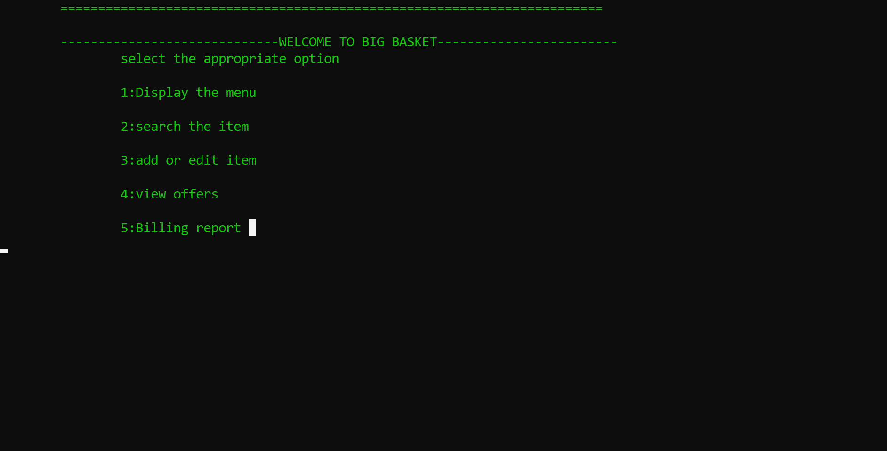

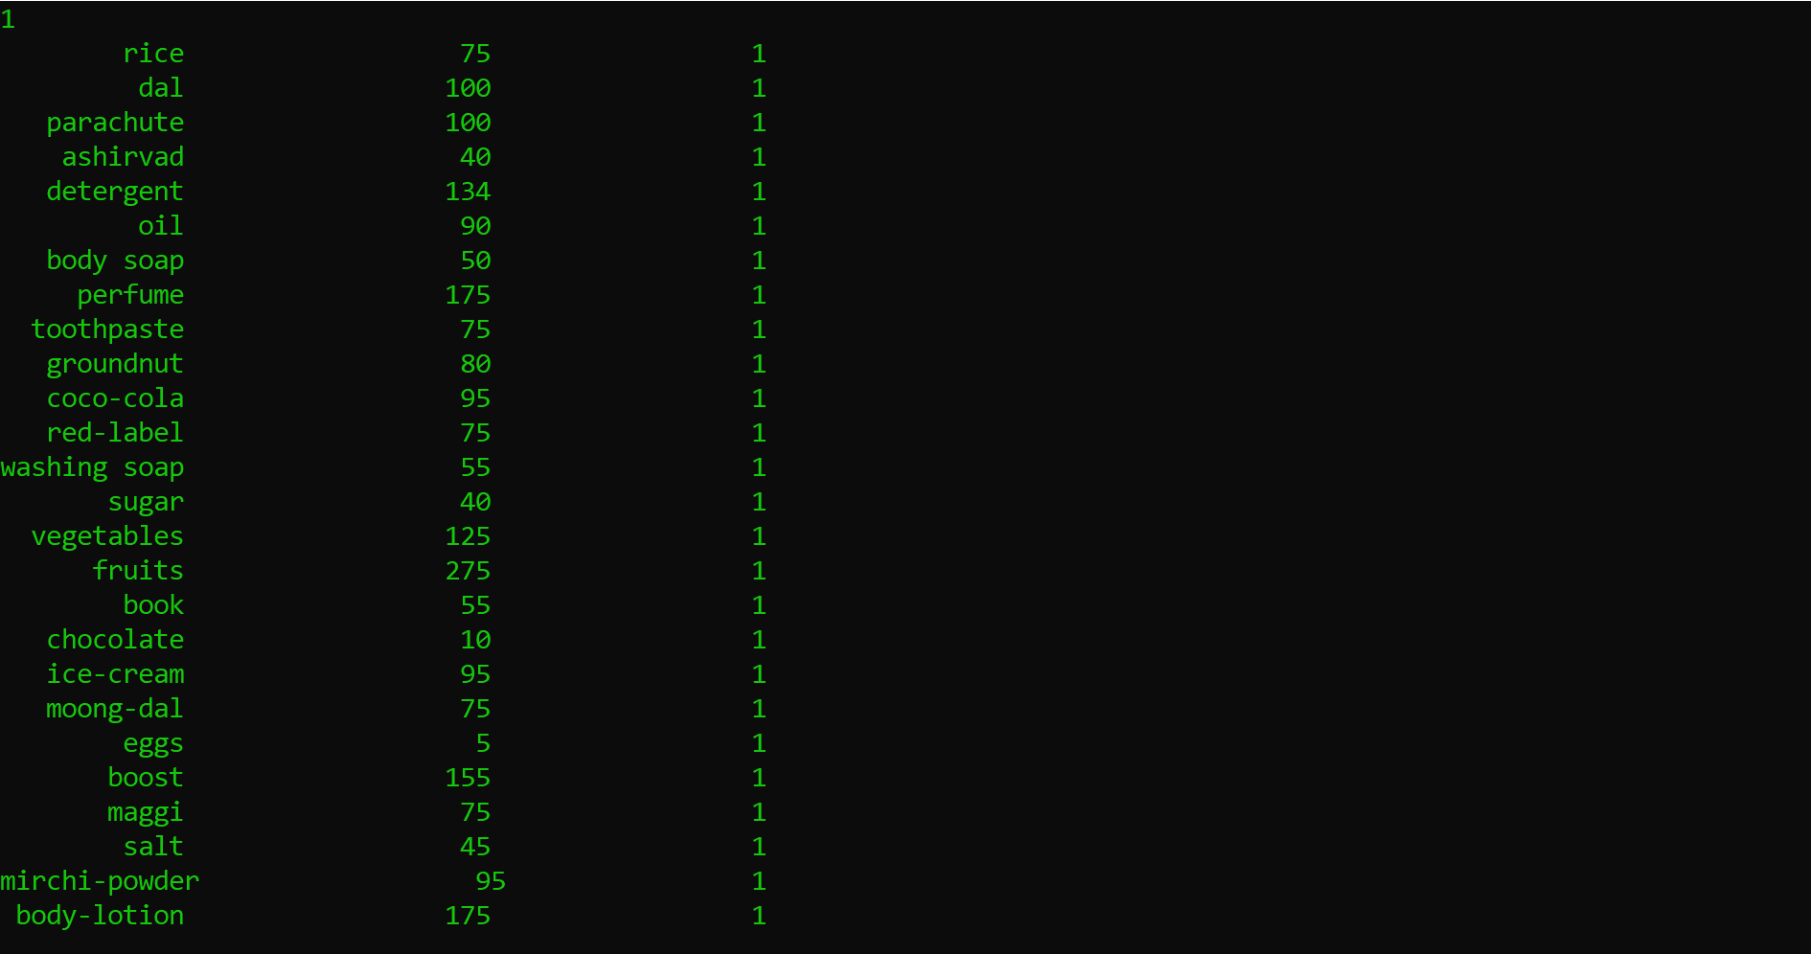

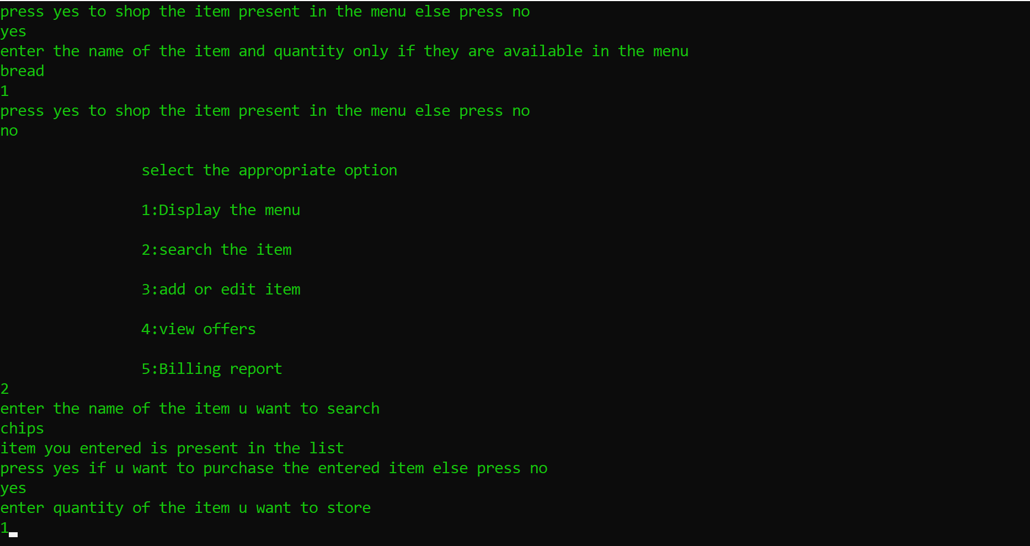

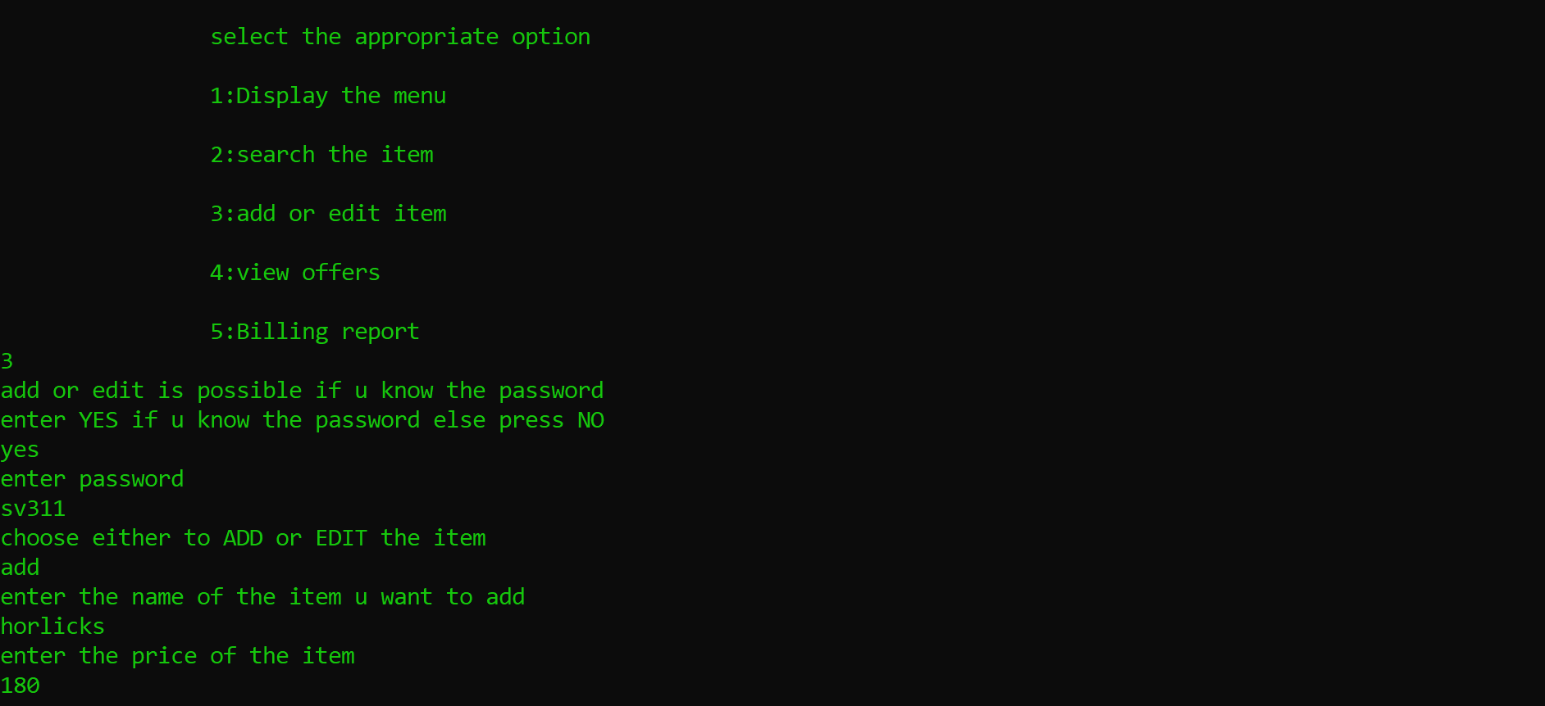

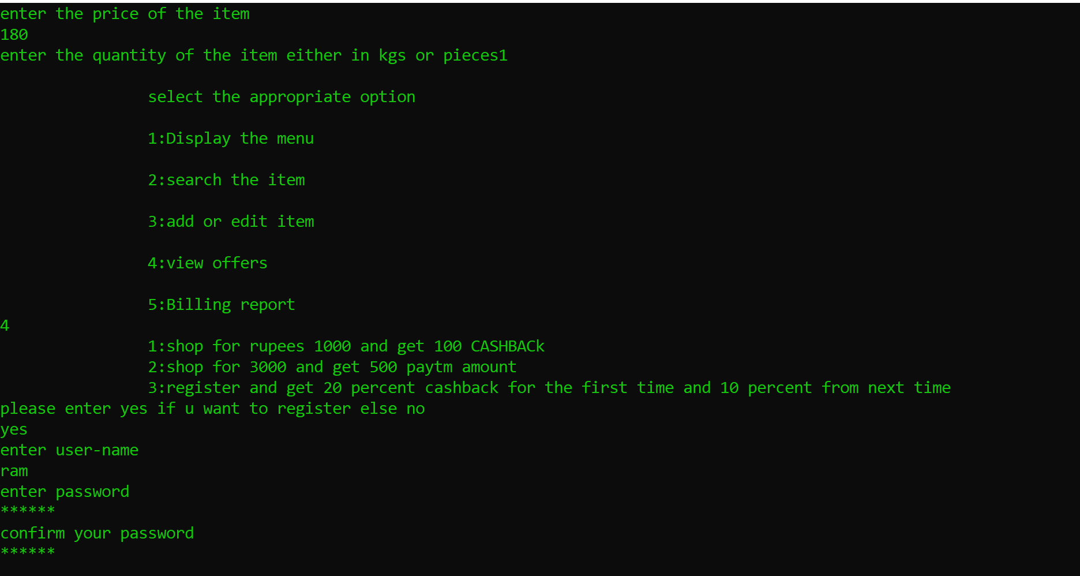

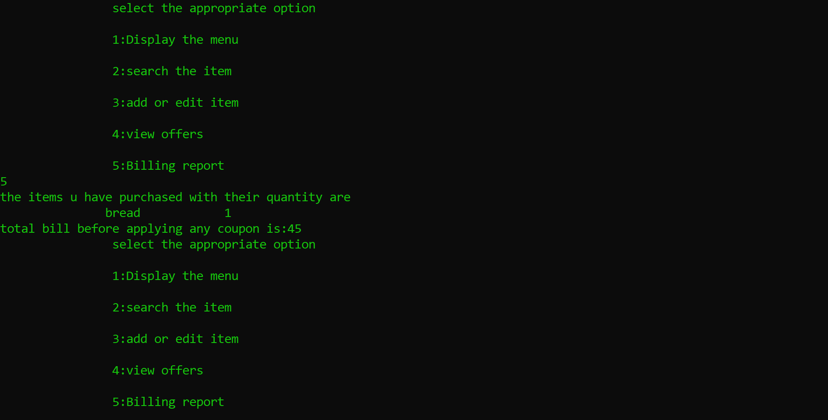

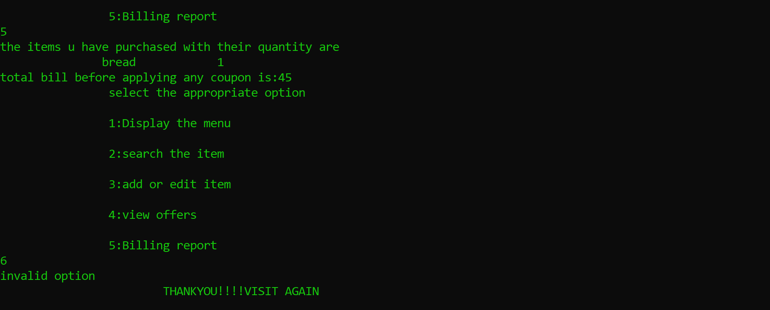

CONCLUSION

Our project is on supermarket Billing system. We have successfully completed it. We take this opportunity to express our sense of indebtedness and gratitude to all those people who helped us in completing this project.

This project has contributed a lot to our knowledge that has proved to be a value addition for us.