Game Design Document

Fill up the following document

1. Write the title of your project.

Ghost Hunter

1. What is the goal of the game?

To kill all the ghosts and get more points than the opponent

1. Write a brief story of your game.

The ghost hunter is a person who kills ghosts that stop him in his way.

He is present in a maze where the path he should go will be indicated by coins which he eats everytime. Each coin increases 2 points.

Sometimes instead of biscuits other prices will beb present in the game that will increase the score by 100 or 300.

1. Which are the playing characters of this game?

* Playing characters are the ones who respond to the user based on the input from the user.
* Cars, monkeys, dinos, wizards, etc., are the playing characters in the game.

|  |  |  |
| --- | --- | --- |
| Number | Character Name | What can this character do? |
| 1 | Ghost hunter | Kill the ghosts and get points |
| 2 | Coral(A pink ghost) | Move around and disturb the ghost hunter from its path |
| 3 | Chartreuse(A green ghost) | Move around and disturb the ghost hunter from its path |
| 4 | Rose(a red ghost) | Move around and disturb the ghost hunter from its path |
| 5 | Navy(a blue ghost) | Move around and disturb the ghost hunter from its path |
| 6 | peach(orange ghost) | Move around and disturb the ghost hunter from its path |
| 7 | Magneta(Purple ghost) | Move around and disturb the ghost hunter from its path |
| 8 |  |  |

1. Which are the Non-Playing Characters of this game?

* Non-Playing characters are the ones that don't have an action or behavior when the user interacts with the game.
* Hurdles, stones, bananas, coins, etc., are non-playing characters in the game.

|  |  |  |
| --- | --- | --- |
| Number | Character Name | What can this character do? |
| 1 | coins | It indicates the path and gives score. |
| 2 | maze | It is a confusing path |
| 3 |  |  |
| 4 |  |  |
| 5 |  |  |
| 6 |  |  |
| 7 |  |  |
| 8 |  |  |

Draw your imagination of this game. What does this game look like?

* Draw the game either on your computer or on paper.
* Add images of the game scenes to show each of the playing and non-playing characters at least once.

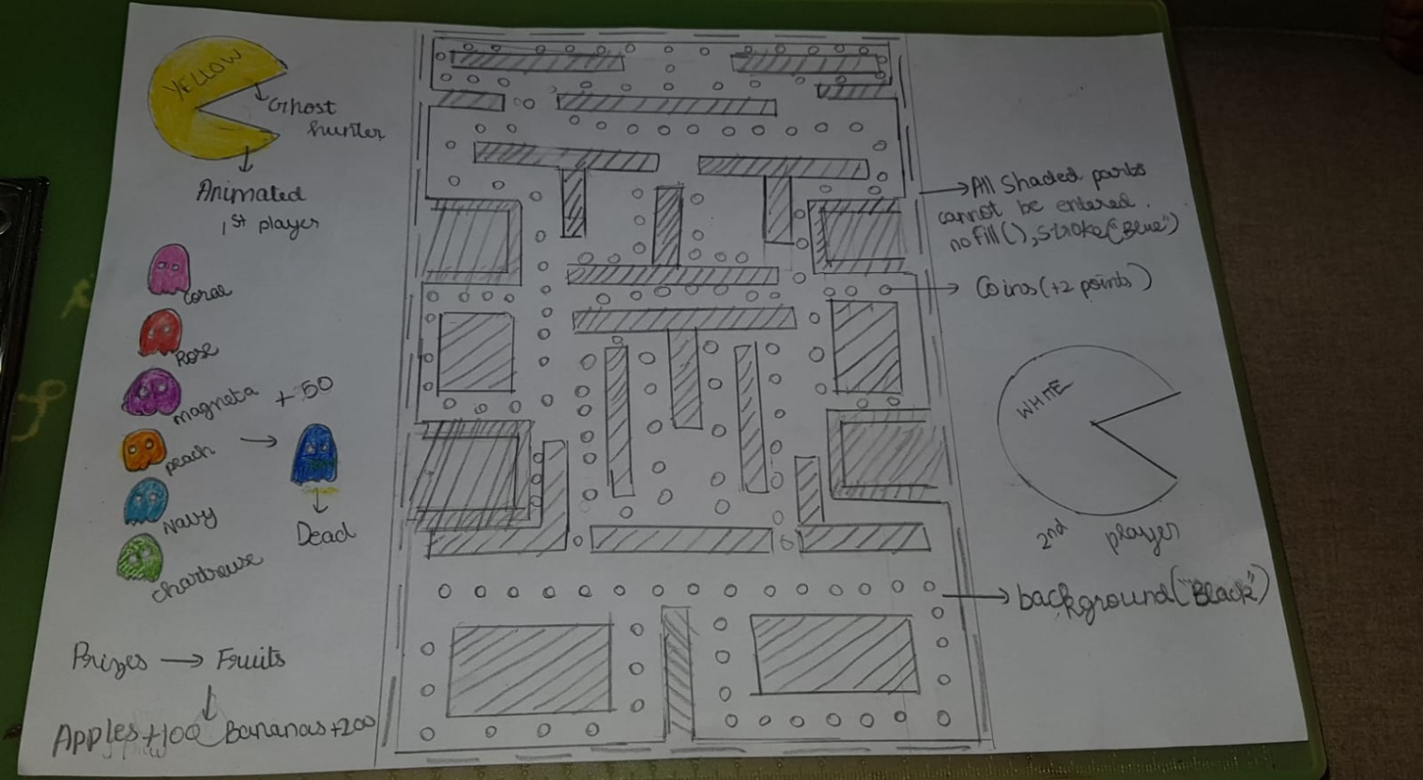

How do you plan to make your game engaging?

It is actually a already existing game but many people don’t know about this. It was founded by Toru Iwatani in the 1800s. I want to redesign it andn make it more engaging. I am gonna add coins indtead of biscuits. I am gonna add many rewards and obstacles. There won’t be different levels in my game but I will make sure it is very difficult.