1.NEED OF HIVE

It is a framework built on top of hadoop.

It is more similar to sql.

in hive we write in HQL(Hive Query Language)

Hive stores all its data in the hdfs.It stores it automatically into HDFS.

It also stores the data about the tables in its local storage.

It used incases of

i. static data analysis

ii. data that does not change often

iii. data that doesnot require quick responses.

2.IS HIVE SUITABLE FOR OLTP?

No hive is not suitable for OLTP

hive does not allow updation or insertion at row level.

3.METASTORE IN HIVE

Metastore is the central repository of hive.

It is used for storing the schema in the external database.

4.SHELL COMMANDS IN HIVE

Yes shell commands can be run in hive . the have to be prefixed with the ! symbol.

Mkdir command

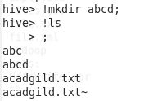

Ls command

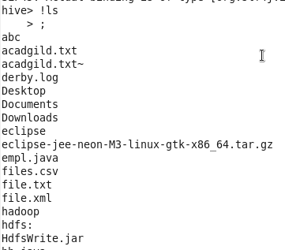

Rmdir and manls commands

10.1 iii.PNG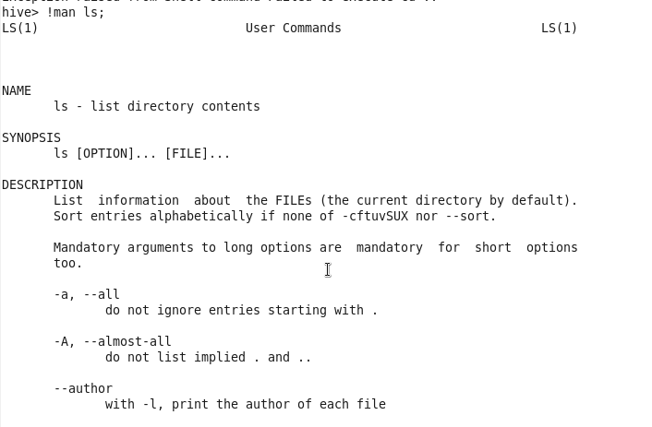

Rm command

10.1 v.PNG

5. HIVE CAN PROCESS ANY DATA FORMATS

Yes hive can process any data formats because it uses the serde interfaces for inout/output operations.

Different serde interfaces are used for different data types.