1.creating max-temp.txt in local system

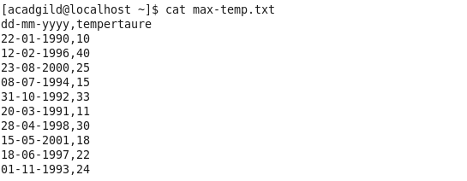

2.moving the file to hdfs /user/acadgild/hadoop

3.21.PNG

3. changing permissions

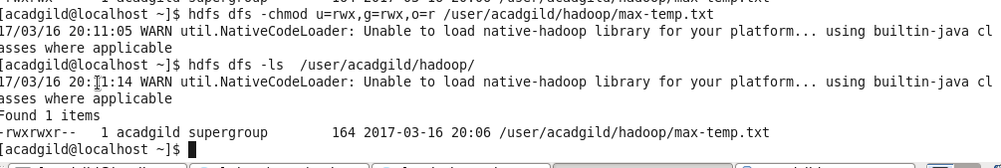

4.file in hdfs

