1. LOAD

Loads the data into Pig.

load.PNG

2. STORE

Stores the loaded data into file system.

store.PNG

3. DUMP

to print the contents of the relation on the console.

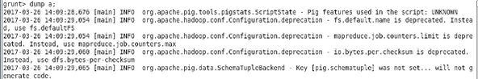

4. FOREACH

to generate specified data transformations on column data.

foreach.PNG

5. FILTER

Based on the condition it selects the tuples from the relation and filters the data and displays it .

foreach.PNG

6. GROUP BY

to group the data into one or more relation.

groupby.PNG

7. ORDER BY

display the contents of the relation in sorted order.

orderby.PNG

8. DESCRIBE

view the schema of the relation.

