1.pwd-Displays the current directory

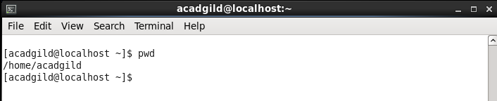

2.vi- creates and edits a file.

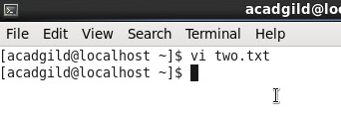

3.touch-to create a empty file

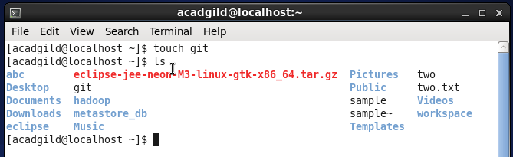

4.mkdir- to create a directory

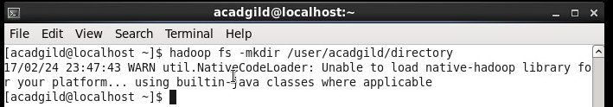

5.rm – to remove files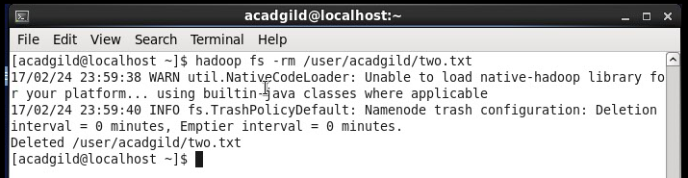

6.ls- list all the files and directories present

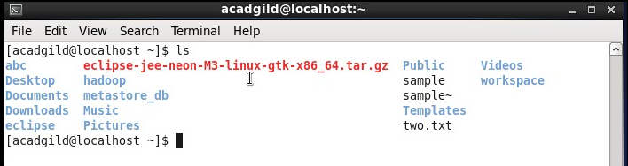

7.echo- used to print text.

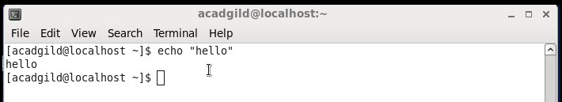

8.cat-display the contents in a file

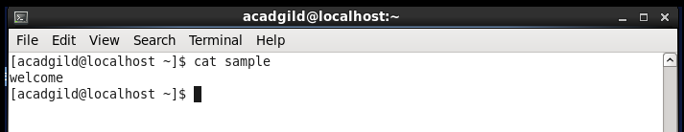

9.who- display the user login details

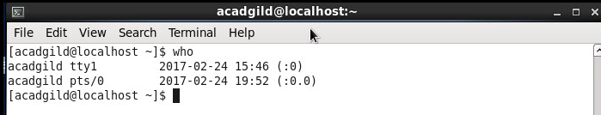

10.cd- change the directory

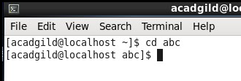

11.date- displayes the date.

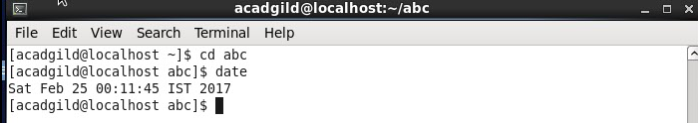

12.cal- displays the calendar of the specified month

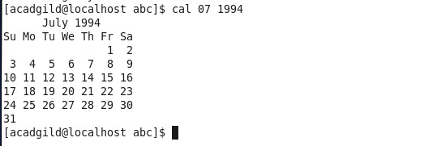

13.mv- to move files between directories.

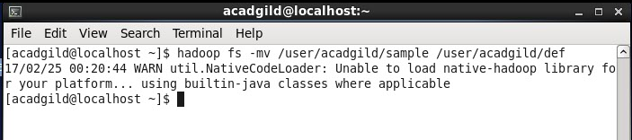

14.cp-copying from one file to another

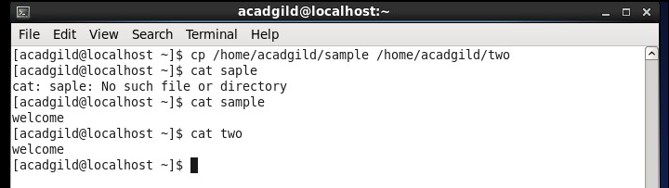

15.which-displays the version

