1. **What are Semantic tags?**

Explanation - Semantic tags refers to the use of HTML tags which convey the meaning or semantic of content contained within them.

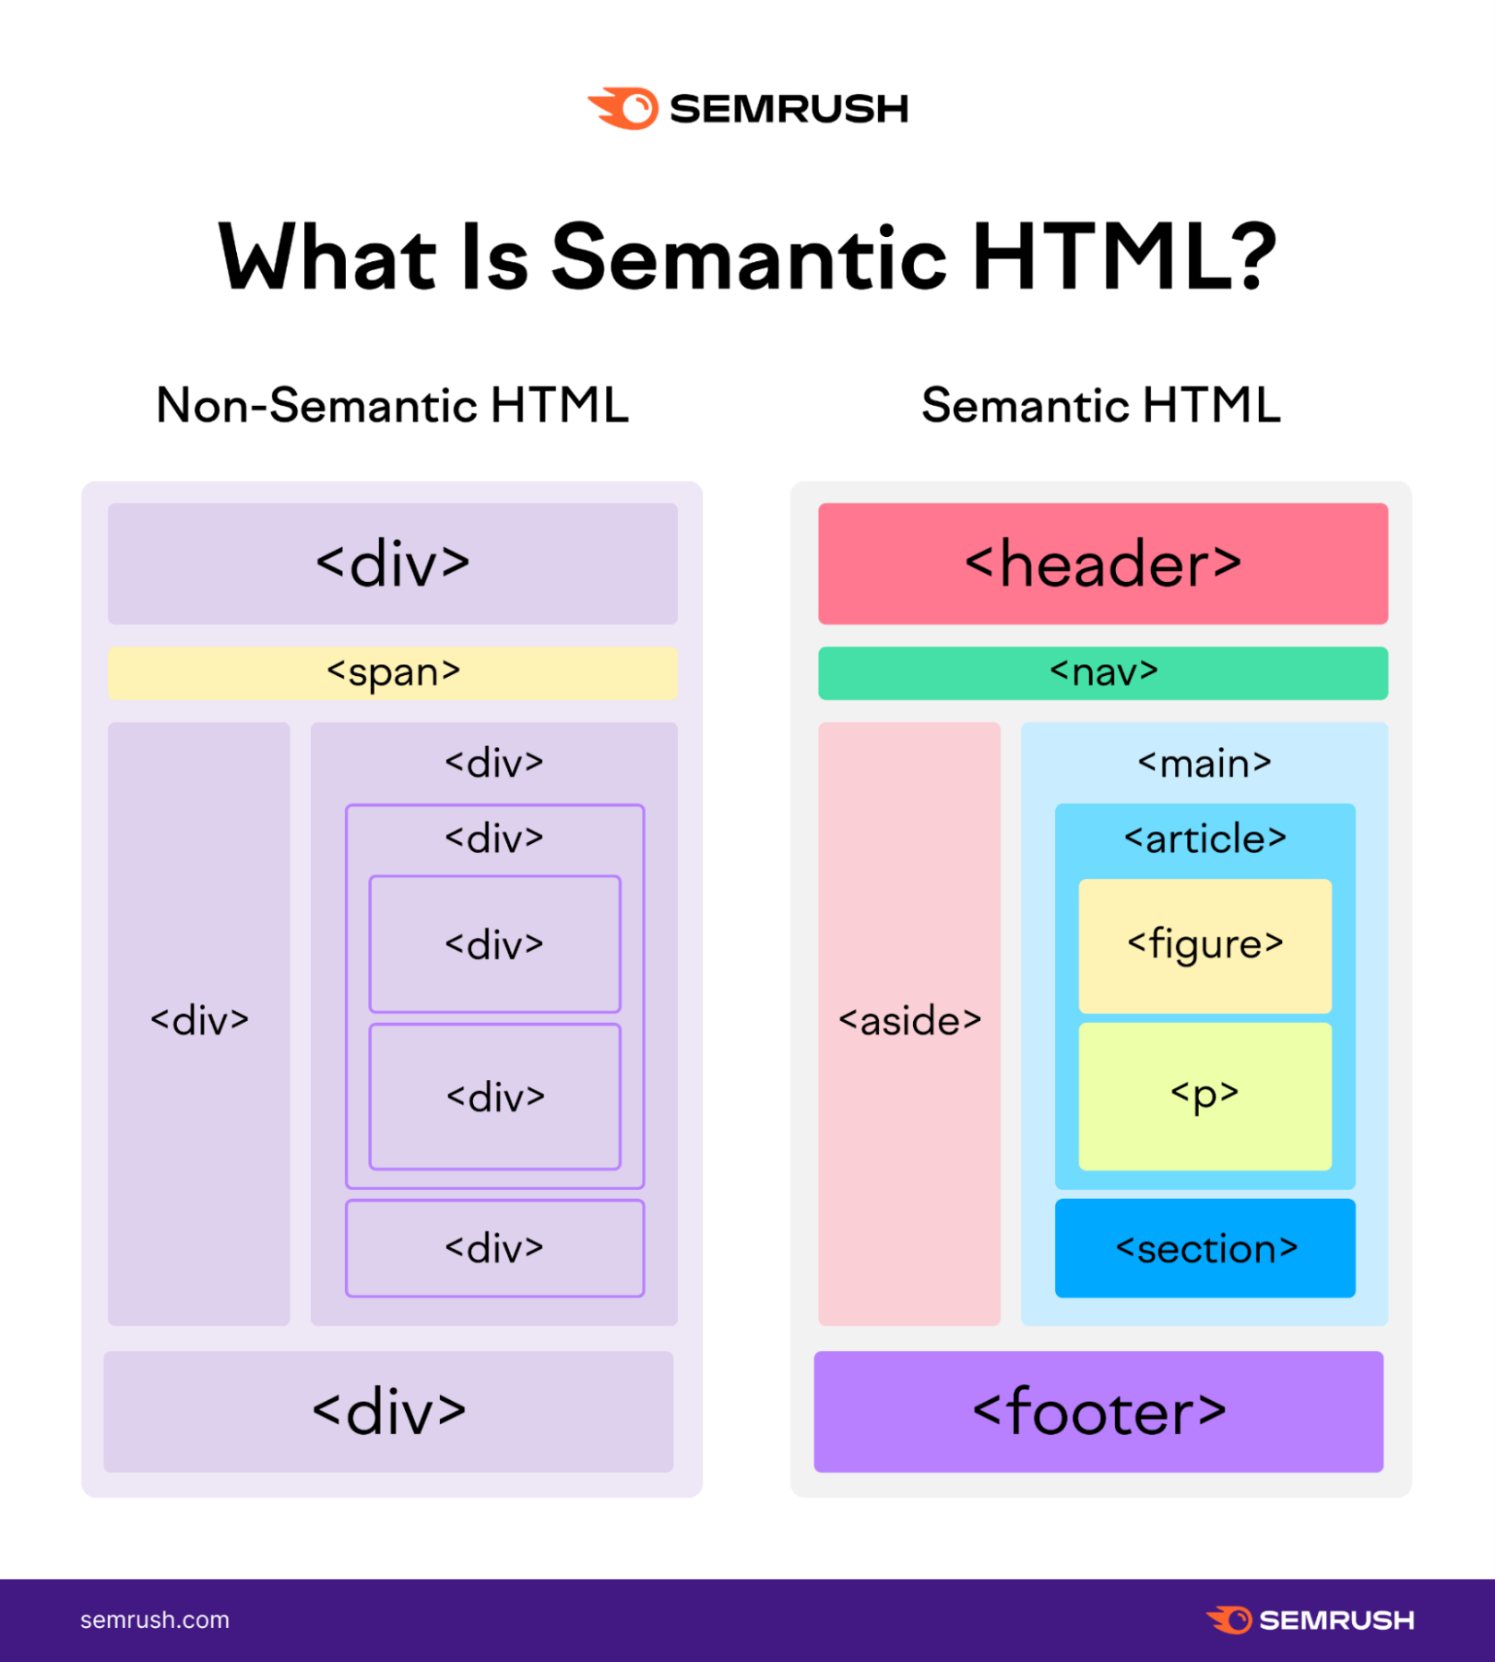By adding semantic tags to the page, we provide additional information, that describes the role and relative importance of the different parts of the page.

Main - Semantic tags are tags that define the content they contain.

Example: tags like <header>, <footer> and <article> are Semantic tags. They clearly defines the content they contain.

On the other hand, tags like <div> and <span> are examples on non-semantic tags.

<em> - used for text that should be emphasized (as italics).

<strong> - used for text that should be strongly emphasized (as bold).