**DAILY ONLINE ACTIVITIES SUMMARY**

|  |  |  |  |  |  |  |
| --- | --- | --- | --- | --- | --- | --- |
| **Date:** | | **20/05/2020** | | | | |
| **Name of the Faculty** | | **Shruthi Shetty J** | | | | |
| **No. of Students Allotted for monitoring** | | | | **26** | | |
| **Progress** | | | | **Good** | | |
| **Whether collected report from all the allotted students** | | | | **21** | | |
| **Online Test Summary** | | | | | | |
| **Subject** |  | | | | | |
| **Semester** |  | | | **Duration** |  | |
| **No. of students Taken** | | |  | **Passing %** |  | |
| **Certification Course Summary** | | | | | | |
| **Course** | | **Database Applications** | | | | |
| **Certificate Provider** | | **Alison** | | **Duration** | | **3 Hours** |
| **Coding Challenges** | | | | | | |
| **Problem Statement: Python programming** | | | | | | |
| **Status: Good** | | | | | | |
| **Uploaded the report in Github** | | | | **Yes** | | |
| **If yes Repository name** | | | | **https://github.com/orgs/alvas-education-foundation/teams/shruthi_team** | | |
| **Uploaded the report in slack** | | | | **Yes** | | |

Online Test Details: (Attach the snapshot and briefly write the report for the same)

Certification Course Details: (Attach the snapshot and briefly write the report for the same)

Coding Challenges Details: (Attach the snapshot and briefly write the report for the same)

**Certification Course Summary**

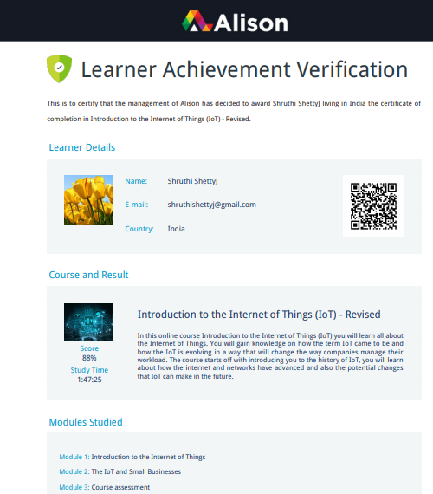

**Sample Students Report:**

