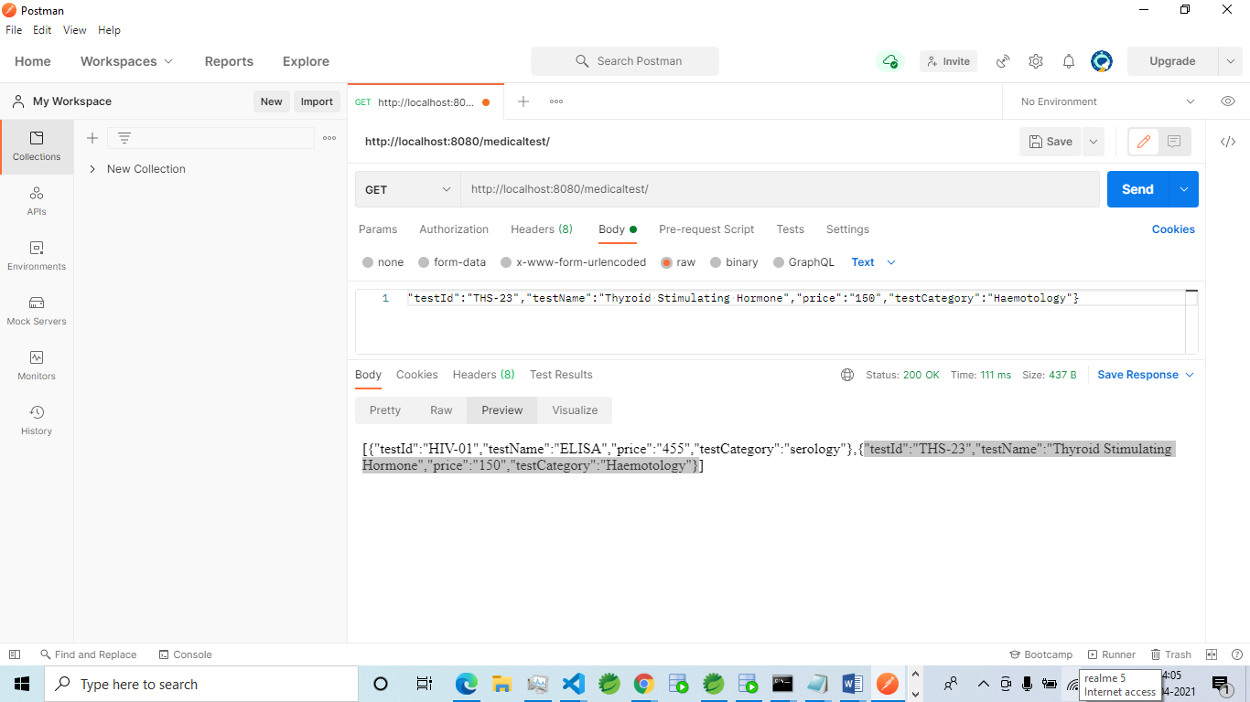

Review of GET Method using POSTMAN

Retrieval of all MedicalTest objects is done using GET Method in POSTMAN

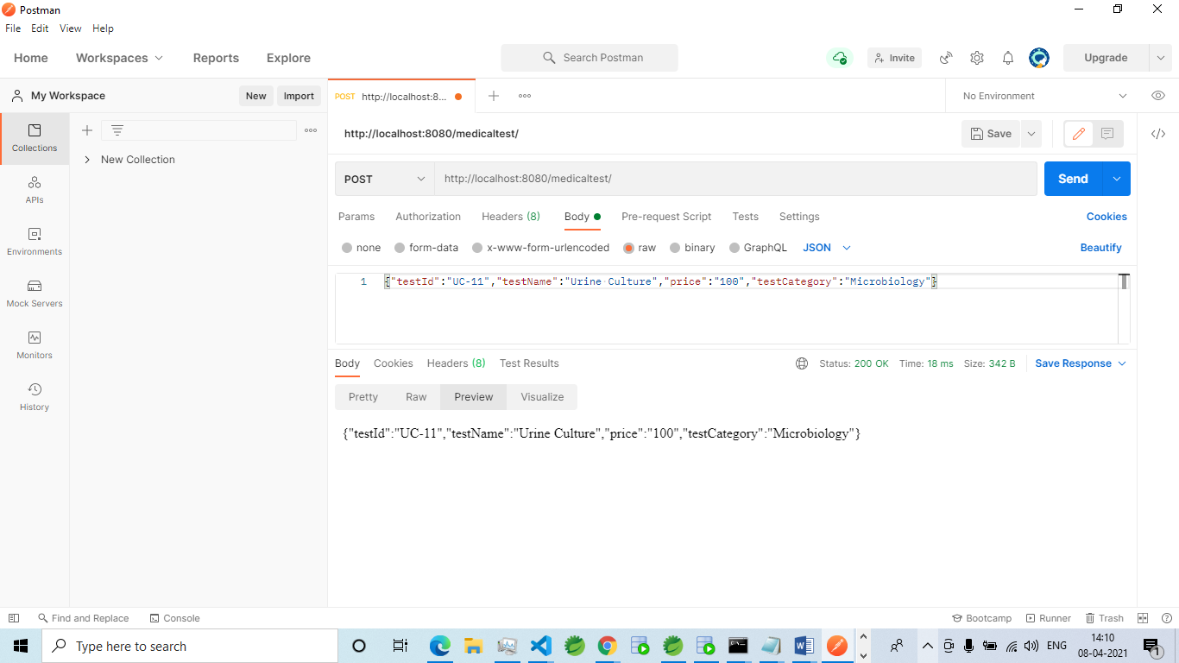

Review of POST Method using POSTMAN

Creation of a new object MedicalTest class is done using POST Method in POSTMAN

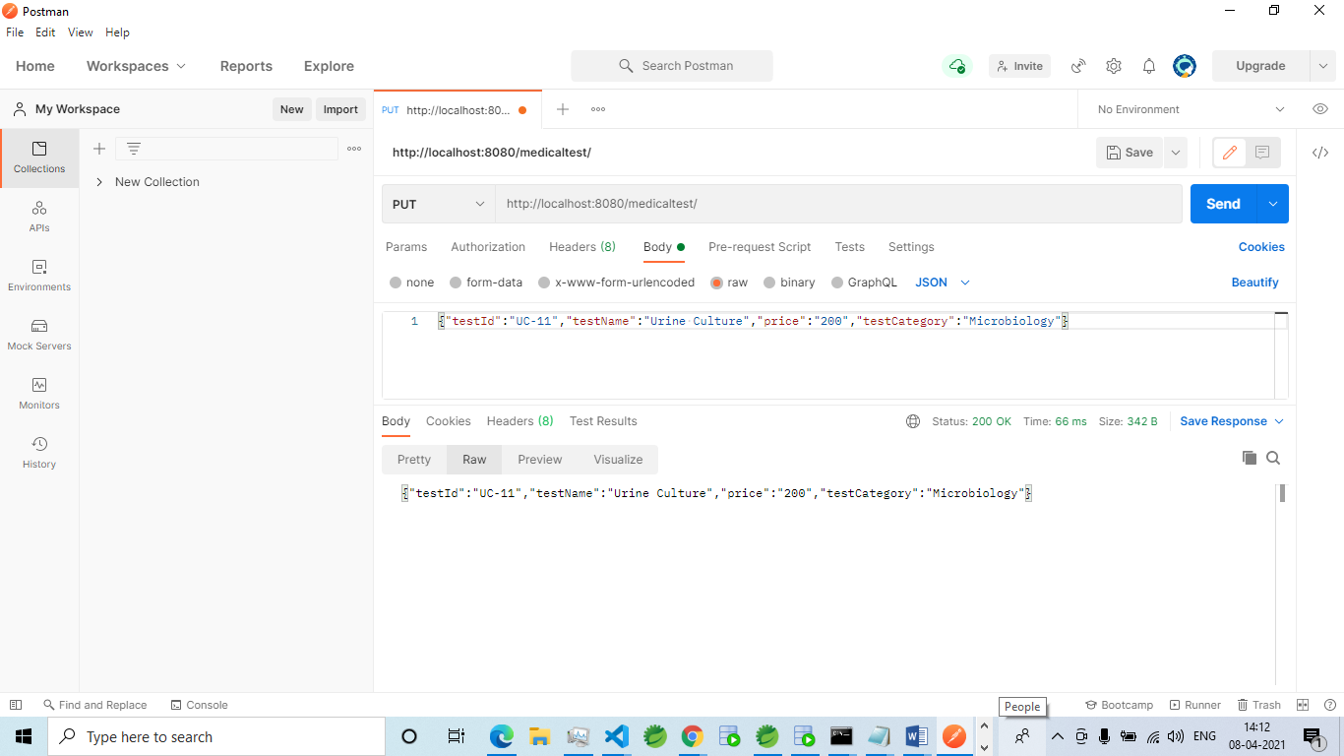

Review of PUT Method using POSTMAN

Updation of an object of MedicalTest class is done using PUT Method in POSTMAN

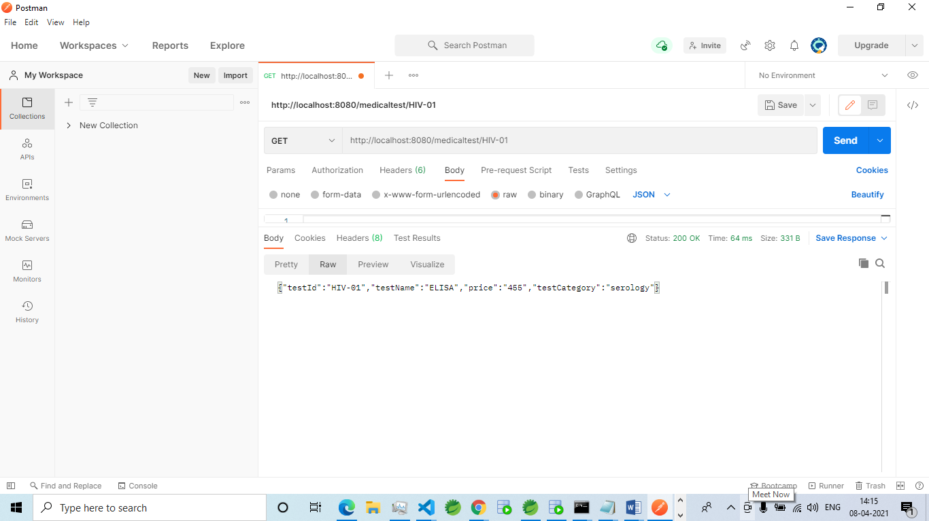  
Review of GET Method by testID using POSTMAN

Retrieving an object of MedicalTest class by Id is done using GETMethod by testID in POSTMAN

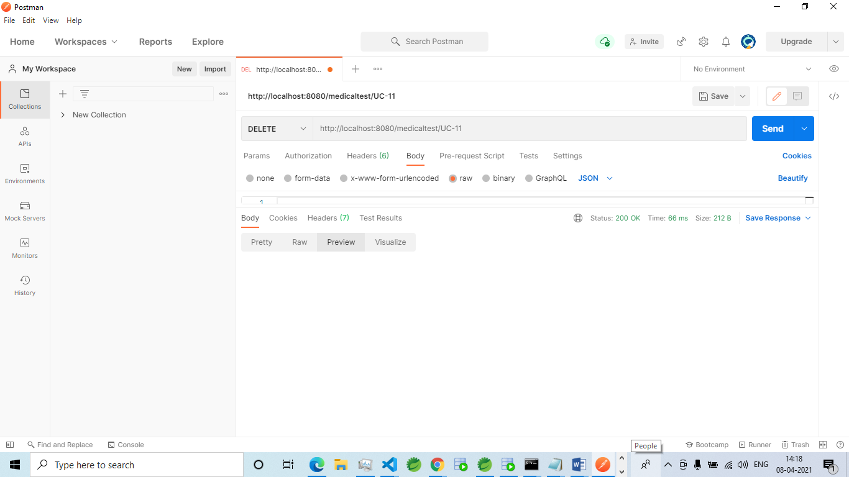

Review of DELETE Method using POSTMAN

Deleting of an object of MedicalTest class is done using DELETE Method by testIDin POSTMAN

POSTMAN SCREENSHOTS OF PATIENT TABLE

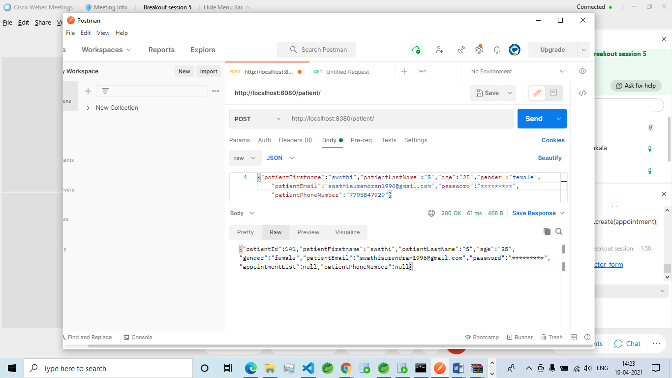

Review of POST Method using POSTMAN

Creation of Patient object using POST Method in POSTMAN

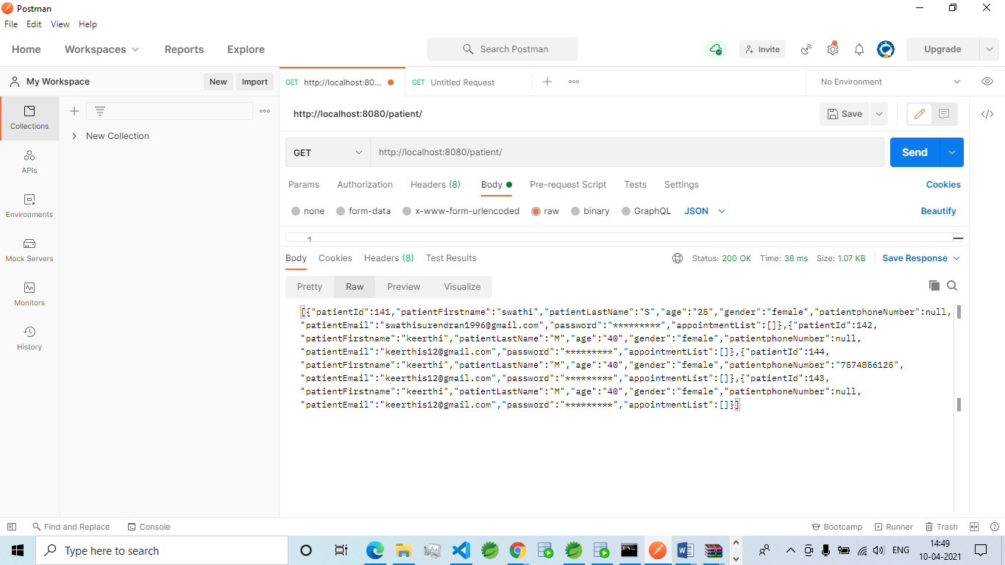

Review of Get Method using POSTMAN

Retrieval of all Patient objects using POST Method in POSTMAN

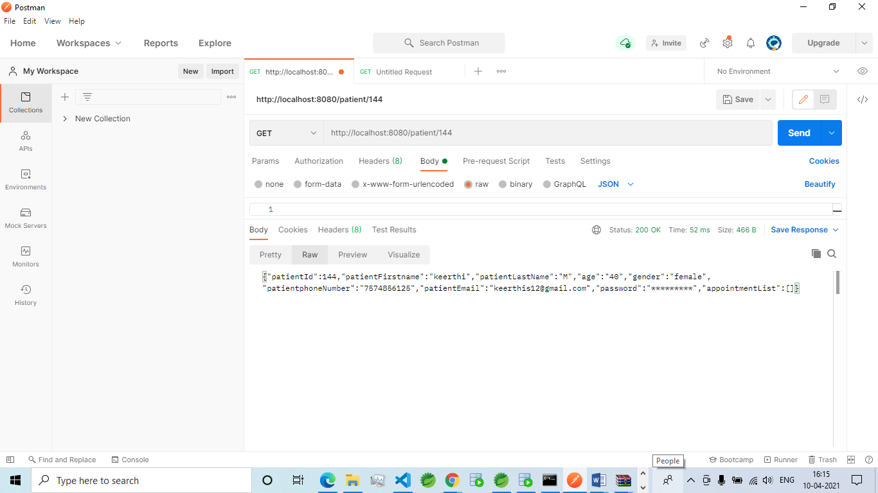

Review of Get Method by patientId using POSTMAN

Retrieval of a Patient object by patientId using POST Method in POSTMAN

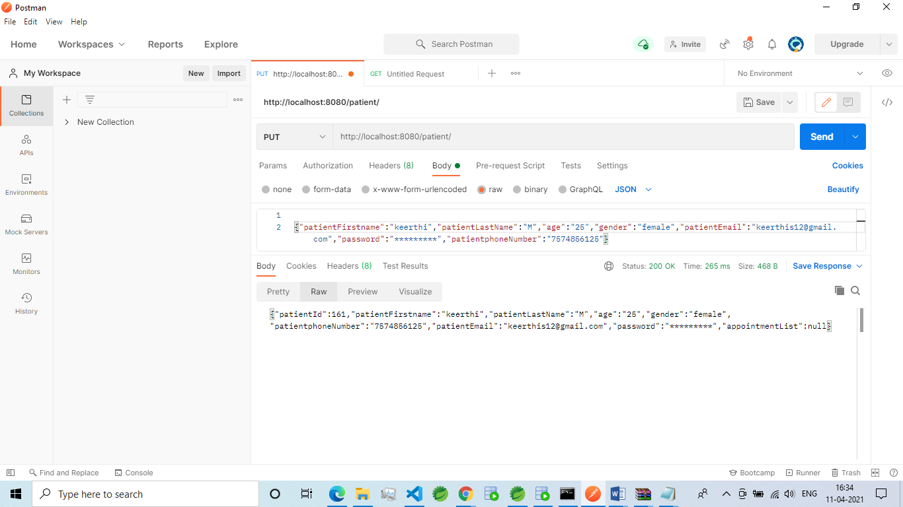

Review of PUT Method using POSTMAN

Updation of a Patient object field using PUT Method in POSTMAN

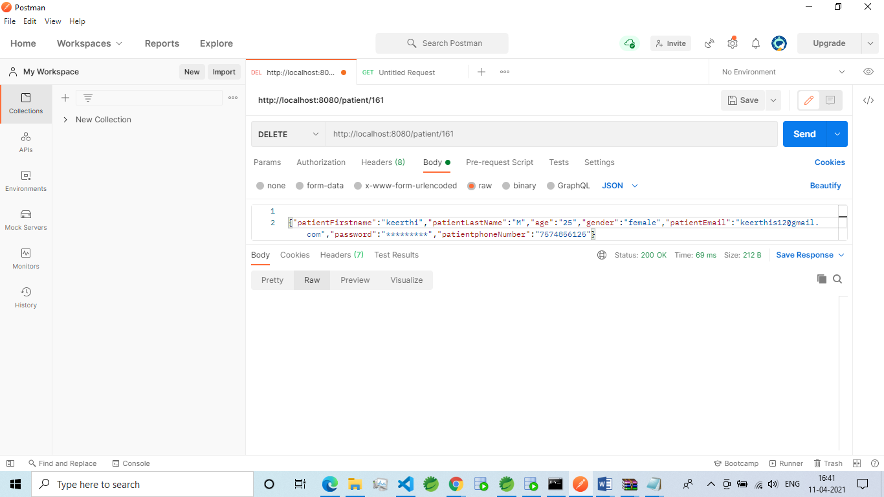

Review of DELETE Method using POSTMAN

Deletion of a Patient object using DELETE Method in POSTMAN

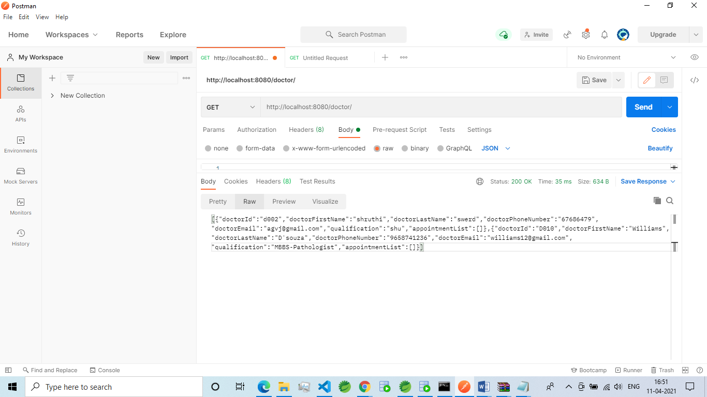

Review of GET Method using POSTMAN

Retrieval of Doctor object using GET Method in POSTMAN

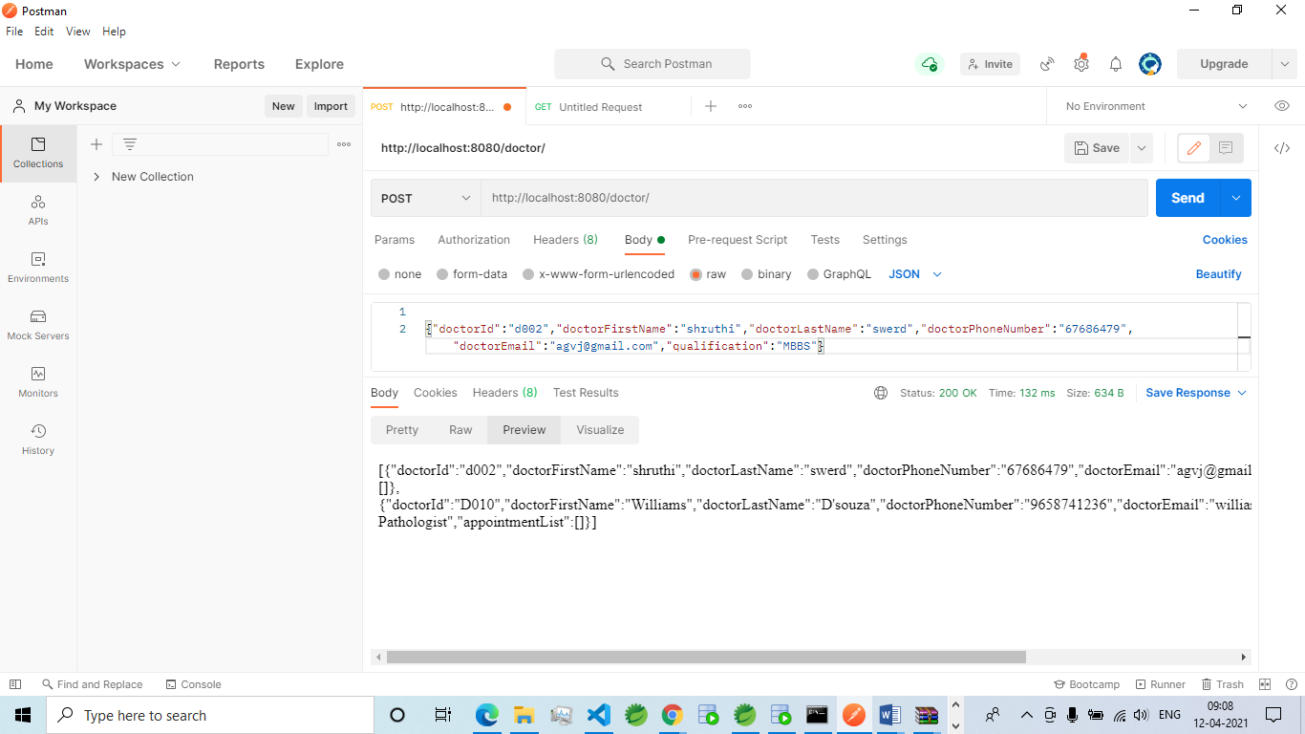

Review of POST Method using POSTMAN

Adding of Doctor object using POST Method in POSTMAN

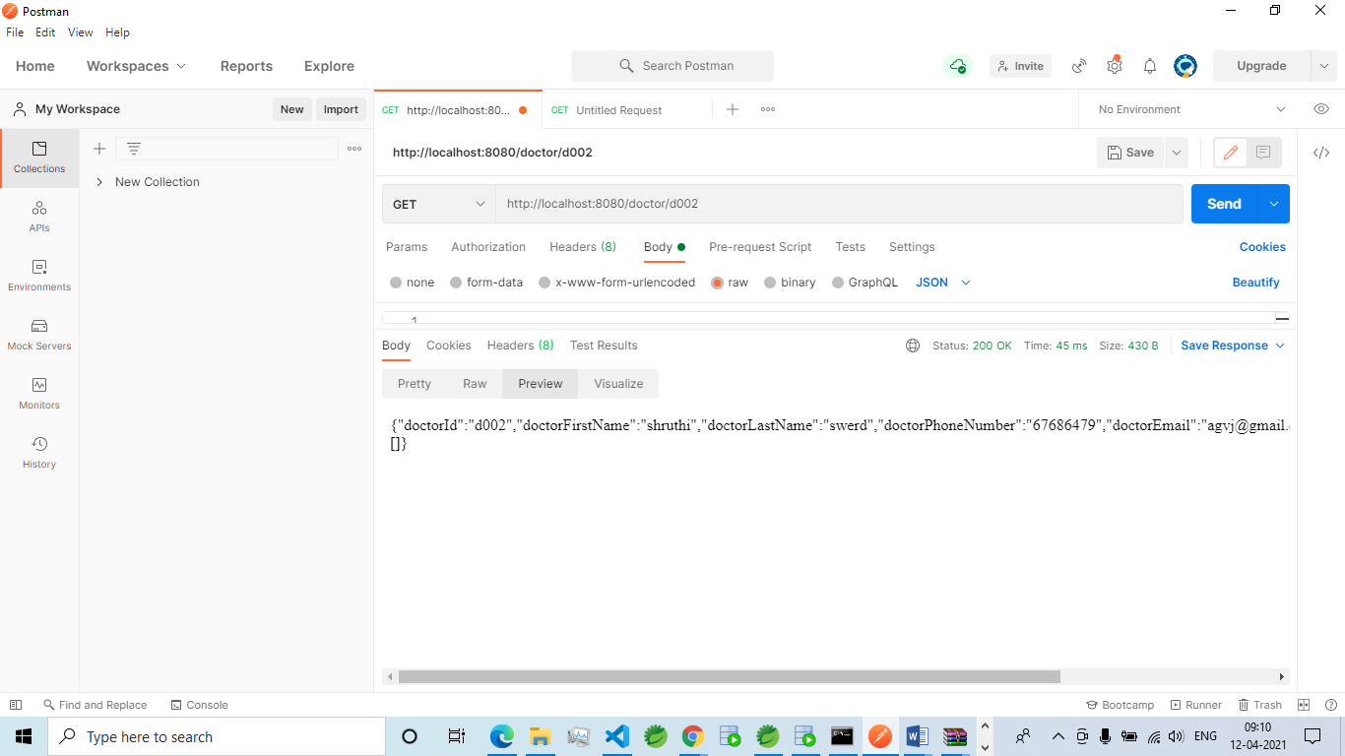  
Review of GET Method by Id using POSTMAN

Retrieval of a Doctor object by Id using POST Method in POSTMAN

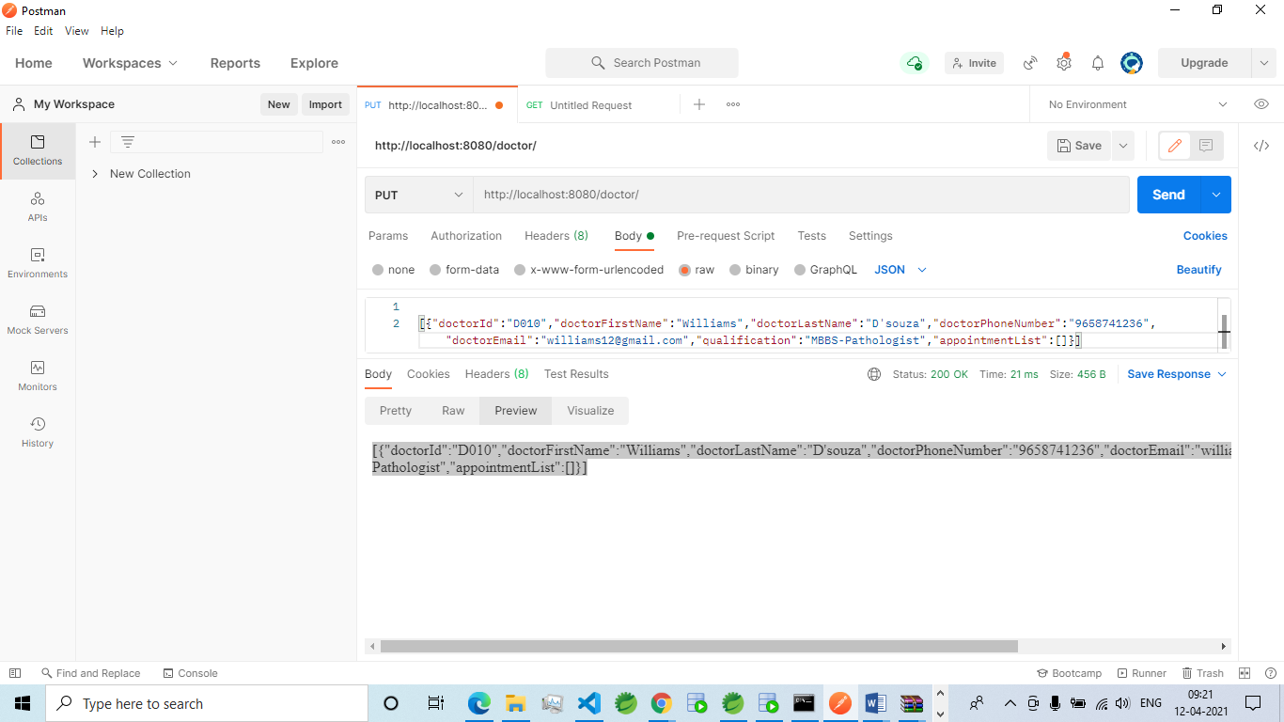

Review of PUT Method using POSTMAN

Updation of a Doctor object using PUT Method in POSTMAN

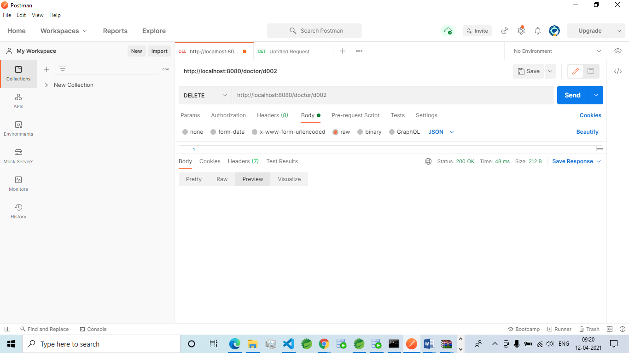

Review of DELETE Method by Id using POSTMAN

Deletion of a Doctor object by Id using DELETE Method in POSTMAN

TECHNICIAN

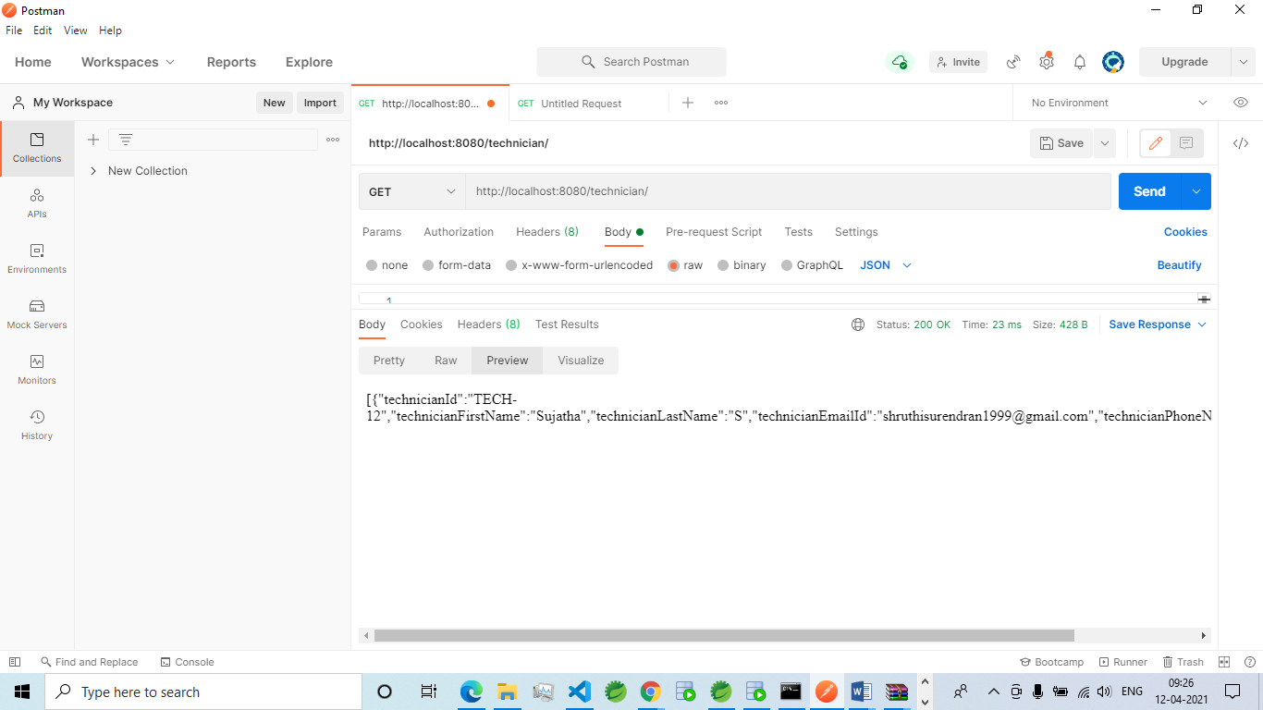

Review of GET Method using POSTMAN

Retrieval of a Technician object using GET Method in POSTMAN

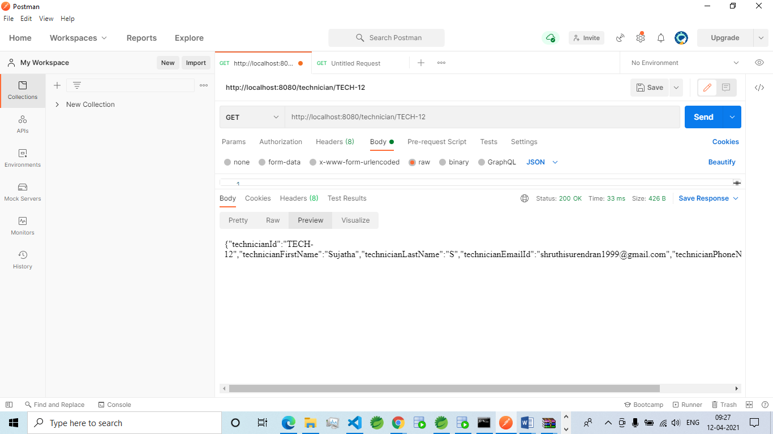

Review of GET Method by id using POSTMAN

Retrieval of a Technician object using GET by id Method in POSTMAN

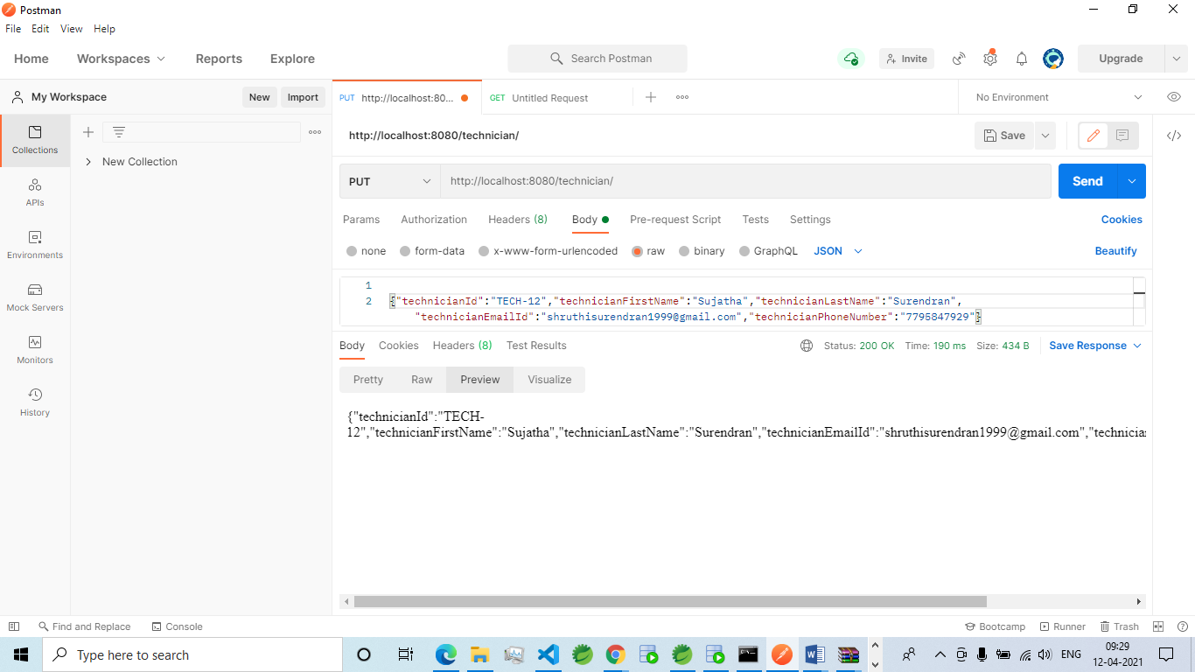Review of PUT Method using POSTMAN

Updation of a Technician object using PUT Method in POSTMAN

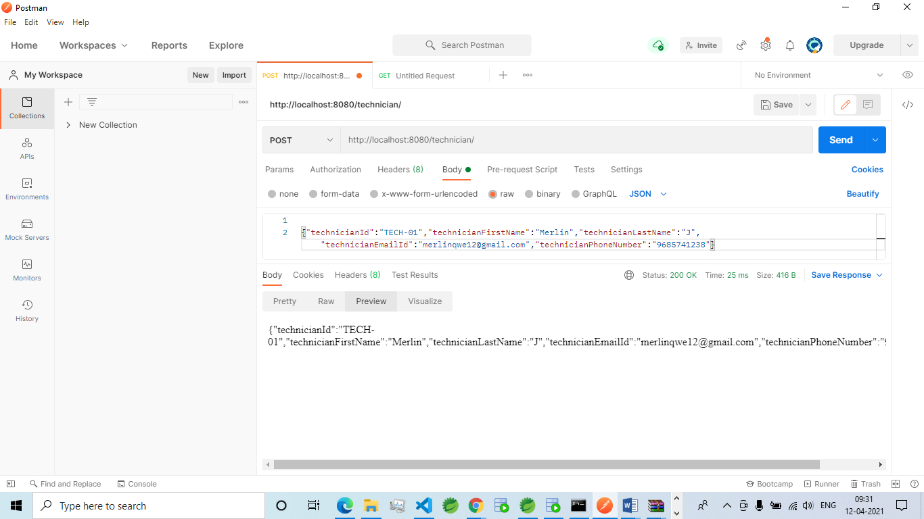

Review of POST Method using POSTMAN

Creation of a Technician object using POST Method in POSTMAN

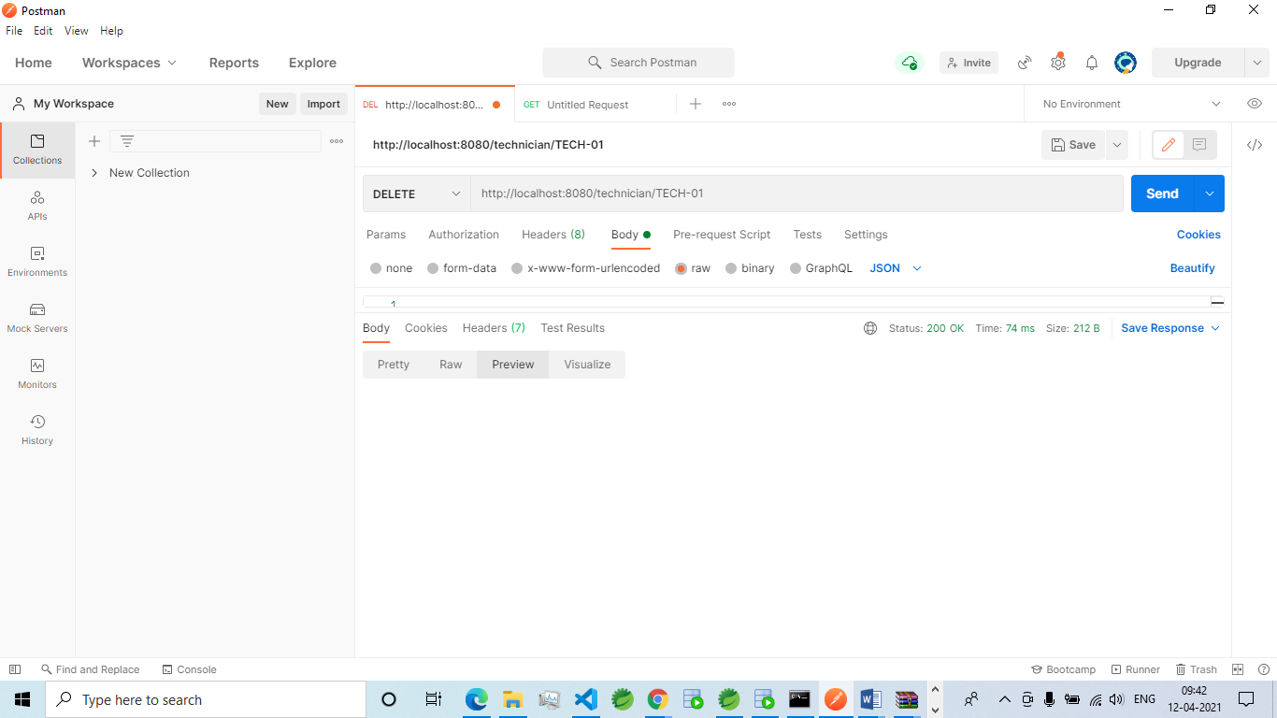

Review of DELETE Method using POSTMAN

Deletion of a Technician object using DELETE Method in POSTMAN