**Task-2.1**

**create  a brief report differentiating between public, private and hybrid clouds. include a diagram that represents each cloud model**

Private cloud

Providing services to selected users and organizations.

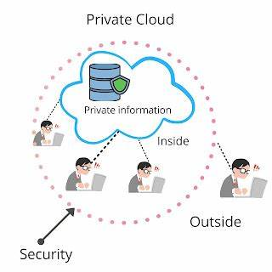

Ex: organization

Public cloud

Services offered to public internet; anyone can signup

Ex: train ticket booking

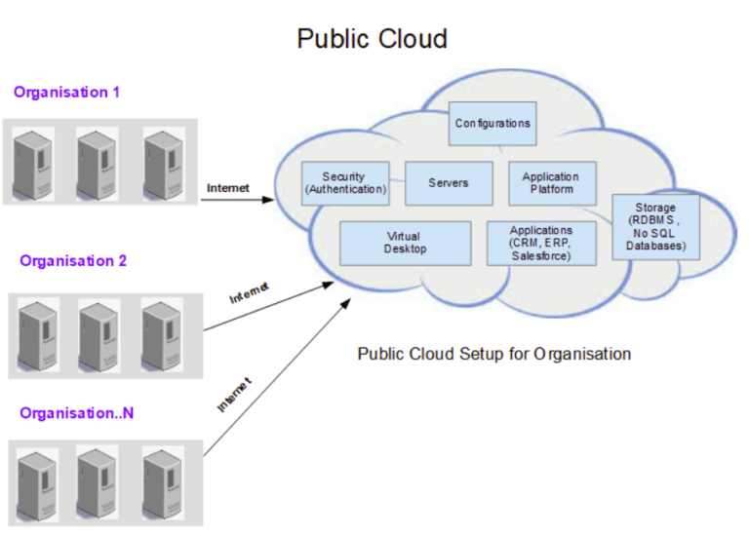

Hybrid cloud

Combination of public and private

Ex: bank

