**Lab TASK – create a Linux vm in azure and deploying a simple web page html and CSS code using that vm in azure.**

1. Azure Login from cmd

1. Create a resource group in Azure.

1. Check for all resource groups in azure.

1. Create a Virtual Machine in the resource group in Azure.



1. Check, if VM created or not

1. Login into Linux Vm

1. Check for packages latest version and update its info.



1. Download the nginx software.



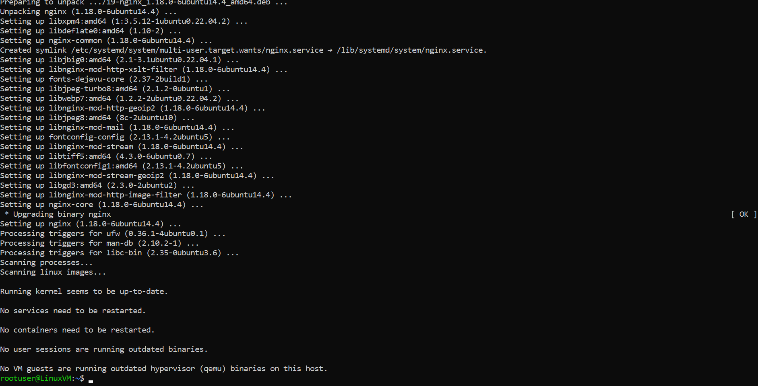

1. Check if nginx working or not.

1. add inbound c,which make this vm as web server

1. Inbuilt html file in nginx folder, Ip is vm public Ip using which it is running

1. Html and CSS file in local computer

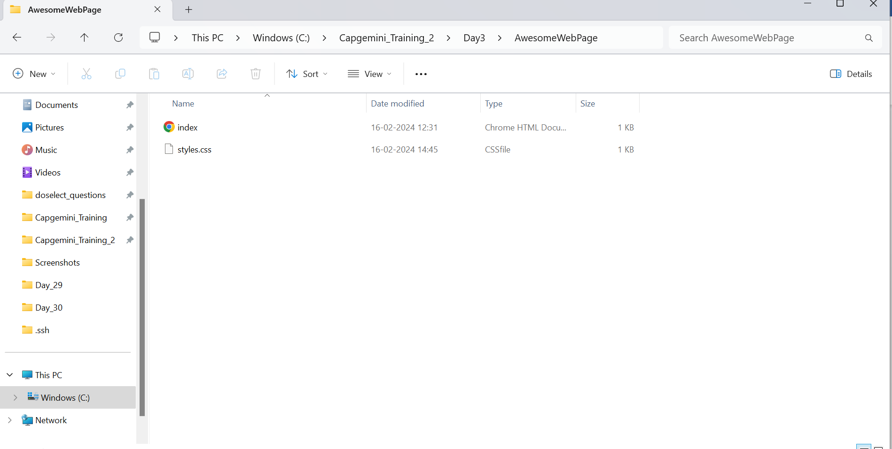

1. code to allow access to read and write or modify in html folder of nginx in vm



1. Exit from vm



1. Deploy html file from local computer to azure for hosting



1. Deploy css of html file from local computer to azure for hosting



