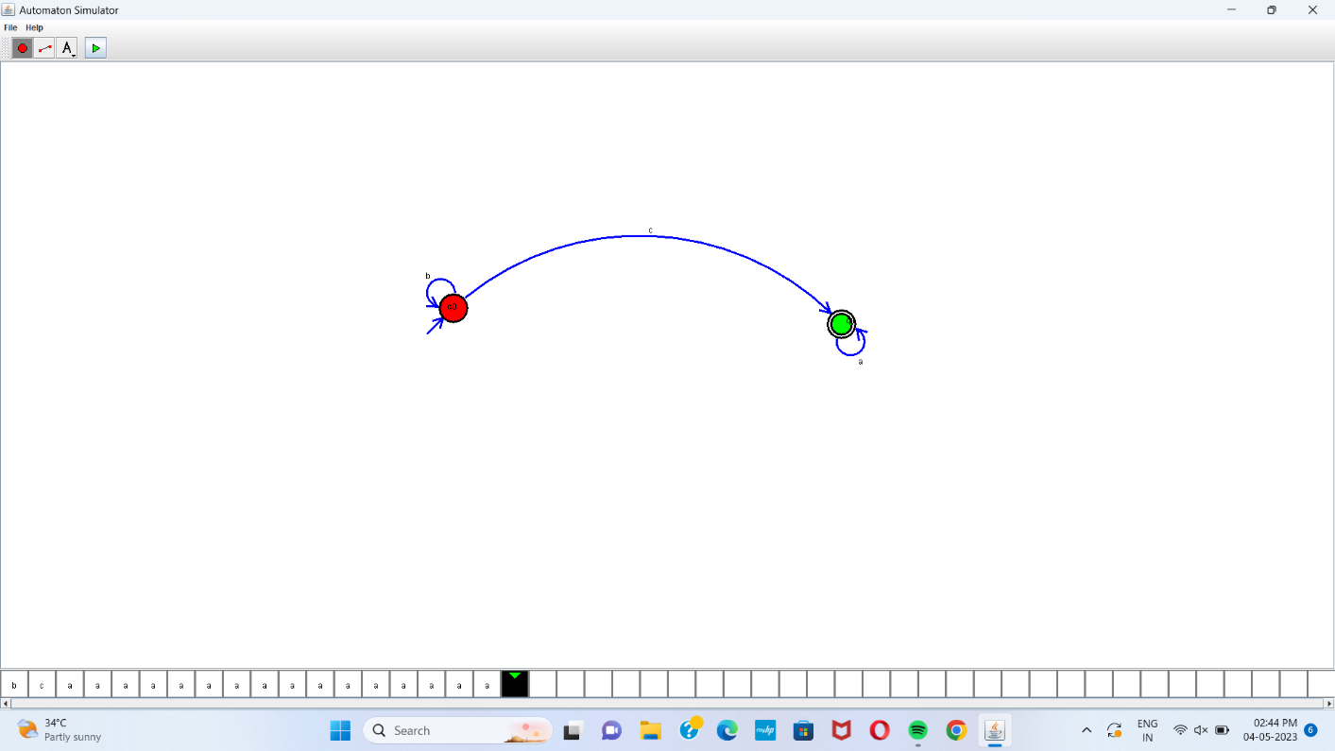

Automaton Simulator, v1.0

dfa {

alphabet {abcd\*}

state {

initial {yes}

coord {651 354}

}

state {

final {yes}

coord {1209 377}

}

edge 0 0 {

transits {b}

offset {2.2763645044801075}

}

edge 0 1 {

transits {c}

offset {0.7814126084899995}

}

edge 1 1 {

transits {a}

offset {-1.0963964440029892}

}

label {

text {q0}

font {SansSerif 12 -}

coord {642 356}

}

label {

text {q1}

font {SansSerif 12 -}

coord {1216 376}

}

}

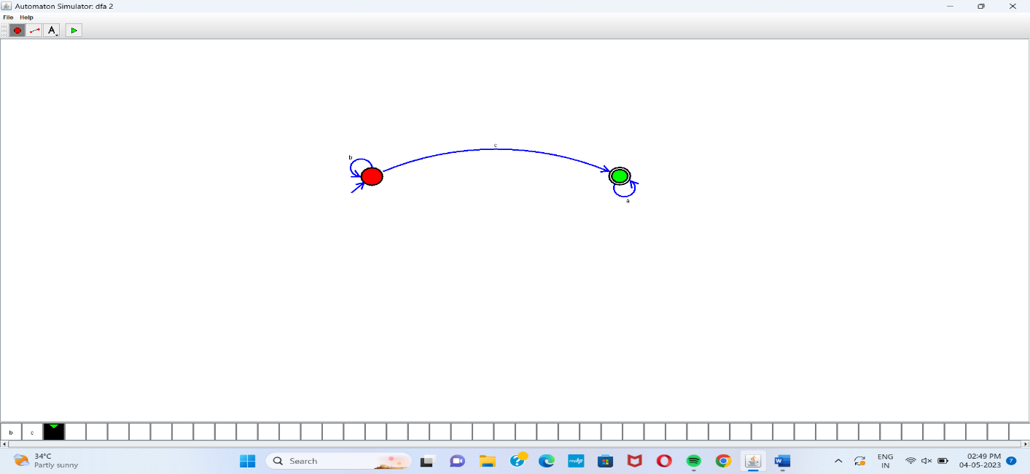

Automaton Simulator, v1.0

dfa {

alphabet {abcd\*}

state {

initial {yes}

coord {692 313}

}

state {

final {yes}

coord {1154 312}

}

edge 0 0 {

transits {b}

offset {2.356194490192345}

}

edge 1 1 {

transits {a}

offset {-1.2592494998922086}

}

edge 0 1 {

transits {c}

offset {0.5235987755982988}

}

}

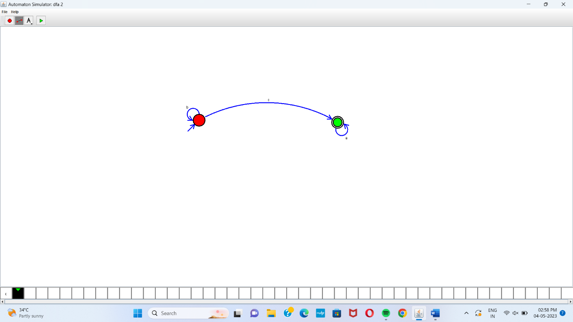

Automaton Simulator, v1.0

dfa {

alphabet {abcd\*}

state {

initial {yes}

coord {666 314}

}

state {

final {yes}

coord {1130 321}

}

edge 0 0 {

transits {b}

offset {2.356194490192345}

}

edge 0 1 {

transits {c}

offset {0.5235987755982988}

}

edge 1 1 {

transits {a}

offset {-1.0559115503906717}

}

}